SQL Order of Execution:

1. FROM and JOINs

The FROM clause, and subsequent JOINs are first executed to determine the total working set

of data that is being queried. This includes subqueries in this clause, and can cause temporary

tables to be created under the hood containing all the columns and rows of the tables being

joined.

2. WHERE

Once we have the total working set of data, the first-pass WHERE constraints are applied to the

individual rows, and rows that do not satisfy the constraint are discarded. Each of the

constraints can only access columns directly from the tables requested in the FROM clause.

Aliases in the SELECT part of the query are not accessible in most databases since they may

include expressions dependent on parts of the query that have not yet executed.

3. GROUP BY

The remaining rows after the WHERE constraints are applied are then grouped based on

common values in the column specified in the GROUP BY clause. As a result of the grouping,

there will only be as many rows as there are unique values in that column. Implicitly, this means

that you should only need to use this when you have aggregate functions in your query.

4. HAVING

If the query has a GROUP BY clause, then the constraints in the HAVING clause are then

applied to the grouped rows, discard the grouped rows that don't satisfy the constraint. Like the

WHERE clause, aliases are also not accessible from this step in most databases.

5. SELECT

Any expressions in the SELECT part of the query are finally computed.

6. DISTINCT

Of the remaining rows, rows with duplicate values in the column marked as DISTINCT will be

discarded.

7. ORDER BY

If an order is specified by the ORDER BY clause, the rows are then sorted by the specified data

in either ascending or descending order. Since all the expressions in the SELECT part of the

query have been computed, you can reference aliases in this clause.

8. LIMIT / OFFSET

Finally, the rows that fall outside the range specified by the LIMIT and OFFSET are discarded,

leaving the final set of rows to be returned from the query

**Set 1**

Q1. Query all columns for all American cities in the CITY table with populations larger than 100000.

The CountryCode for America is USA.

The CITY table is described as follows:

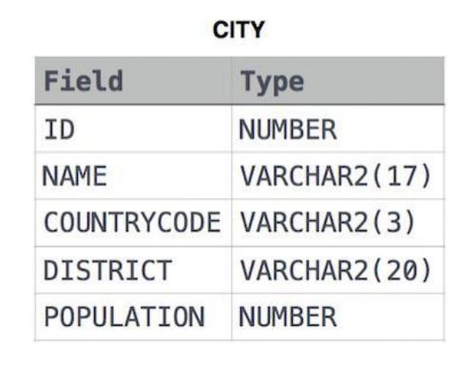

Ans:- CREATE TABLE city(

id INT,

name VARCHAR(17),

countrycode VARCHAR(3),

district VARCHAR(20),

population INT

);

|  |
| --- |
|  |

INSERT INTO city VALUES

(6,'Rotterdam','NLD','Zuid-Holland',593321),

(3878,'Scottsdale','USA','Arizona',202705),

(3965,'Corona','USA','California',124966),

(3973,'Concord','USA','California',121780),

(3977,'Cedar Rapids','USA','Iowa',120758),

(3982,'Coral Springs','USA','Florida',117549),

(4054,'Fairfield','USA','California',92256),

(4058,'Boulder','USA','Colorado',91238),

(4061,'Fall River','USA','Massachusetts',90555),

(1661,'NYC','USA','Newyork',90525),

(4333,'Mitaka','JPN','Tokyo',91155),

(4551,'Hino','JPN','Tokyo',45678);

SELECT *FROM city;

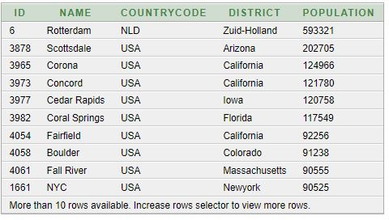

|  |
| --- |
|  |
|  |  |

SELECT

id,

name,

countrycode,

district,

population

FROM

city

WHERE

population > 100000

AND

countrycode = 'USA';

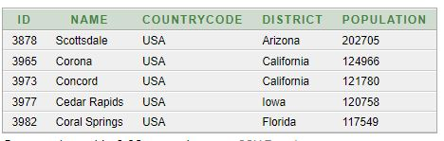

Q2. Query the NAME field for all American cities in the CITY table with populations larger than 120000.

The CountryCode for America is USA.

The CITY table is described as follows



Ans:- SELECT

name

FROM

city

WHERE

population > 120000

AND

countrycode = 'USA';

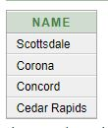

Q3. Query all columns (attributes) for every row in the CITY table.

The CITY table is described as follows:



Ans:-

|  |
| --- |
|  |
| SELECT |
|  | id, |
|  | name, |
|  | countrycode, |
|  | district, |
|  | population |
|  | FROM |
|  | city; |
|  |  |

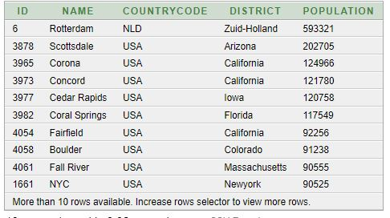

Q4. Query all columns for a city in CITY with the ID 1661.

The CITY table is described as follows:



Ans:- SELECT

id,

name,

countrycode,

district,

population

FROM

city

WHERE

id = 1661;

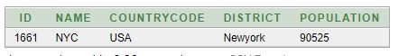

Q5. Query all attributes of every Japanese city in the CITY table. The COUNTRYCODE for Japan is

JPN.

The CITY table is described as follows



Ans:- SELECT

id,

name,

countrycode,

district,

population

FROM

city

WHERE

countrycode = 'JPN';

|  |
| --- |
|  |
|  |  |

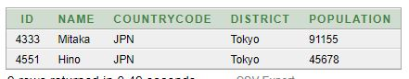

Q6. Query the names of all the Japanese cities in the CITY table. The COUNTRYCODE for Japan is

JPN.

The CITY table is described as follows:



Ans:- SELECT

name

FROM

city

WHERE

countrycode = 'JPN';

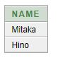

Q7. Query a list of CITY and STATE from the STA TION table.

The STATION table is described as follows:

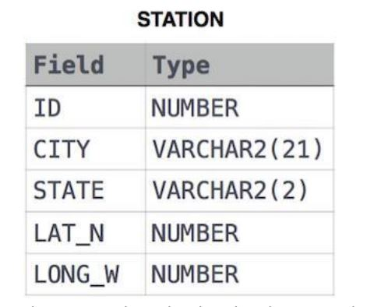

where LA T_N is the northern latitude and LONG_W is the western longitude.

Ans:- CREATE TABLE station(

id INT,

city VARCHAR(21),

state VARCHAR(2),

lat_n INT,

long_w INT

);

INSERT INTO station VALUES

(794,'Kissee Mills','MO',139,73),

(824,'Loma Mar','CA',48,130),

(603,'Sandy Hook','CT',72,148),

(478,'Tipton','IN',33,97),

(619,'Arlington','CO',75,92),

(711,'Turner','AR',50,101),

(839,'Slidell','LA',85,151),

(411,'Negreet','LA',98,105),

(588,'Glencoe','KY',46,136),

(665,'Chelsea','IA',98,59),

(342,'Chignik Lagoon','AK',103,153),

(733,'Pelahatchie','MS',38,28),

(441,'Hanna,City','IL',50,136),

(811,'Dorrance','KS',102,121),

(698,'Albany','CA',49,80),

(325,'Monument','KS',70,141),

(414,'Manchester','MD',73,37),

(113,'Prescott','IA',39,65),

(971,'Graettinger','IA',94,150),

(266,'Cahone','CO',116,127);

SELECT * FROM station;

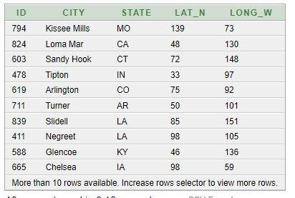

|  |
| --- |
| SELECT |
|  | city, |
|  | state |
|  | FROM |
|  | station; |

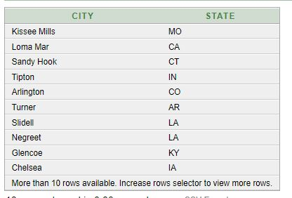

Q8. Query a list of CITY names from STATION for cities that have an even ID number . Print the results

in any order , but exclude duplicates from the answer .

The STATION table is described as follows:



where LA T_N is the northern latitude and LONG_W is the western longitude

Ans:-

|  |
| --- |
| SELECT |
|  | DISTINCT city |
|  | FROM |
|  | station |
|  | WHERE |
|  | id%2 = 0; |

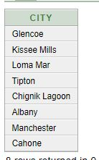

Q9. Find the difference between the total number of CITY entries in the table and the number of

distinct CITY entries in the table.

The STATION table is described as follows:



where LA T_N is the northern latitude and LONG_W is the western longitude.

For example, if there are three records in the table with CITY values 'New York', 'New York', 'Bengalaru',

there are 2 different city names: 'New York' and 'Bengalaru'. The query returns , because total number

of records - number of unique city names = 3-2 =1

Ans:-

|  |
| --- |
|  |
| SELECT |
|  | (COUNT(city) - COUNT(DISTINCT city)) AS difference |
|  | FROM |
|  | station; |
|  |  |

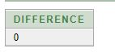

Q10. Query the two cities in STA TION with the shortest and longest CITY names, as well as their

respective lengths (i.e.: number of characters in the name). If there is more than one smallest or

largest city , choose the one that comes first when ordered alphabetically .

The STATION table is described as follows:



where LA T_N is the northern latitude and LONG_W is the western longitude.

Sample Input

For example, CITY has four entries: DEF , ABC, PQRS and WXY .

Sample Output

ABC 3

PQRS 4

Hint -When ordered alphabetically , the CITY names are listed as ABC, DEF , PQRS, and WXY , with lengths

and. The longest name is PQRS, but there are options for shortest named city . Choose ABC, because

it comes first alphabetically .

Note

You can write two separate queries to get the desired output. It need not be a single query

Ans:- Approach-1

|  |
| --- |
|  |
|  | |  |
|  | |  |
|  | |  |
|  | | (SELECT |
|  | | city, |
|  | | Length(city) AS len |
|  | | FROM |
|  | | Station |
|  | | ORDER BY |
|  | | Length(city), |
|  | | city |
|  | | LIMIT 1) |
|  | |  |
|  | | UNION ALL |
|  | |  |
|  | | (SELECT |
|  | | city, |
|  | | Length(city) AS len |
|  | | FROM |
|  | | Station |
|  | | ORDER BY |
|  | | Length(city) DESC, |
|  | | city |
|  | | LIMIT 1);  output12.JPG |
|  | |  |
|  | |  |
|  | |  |
|  | | -- APPROACH 2: |
|  | |  |
|  | |  |
|  | |  |
|  | | WITH temp_city AS ( |
|  | | SELECT |
|  | | city, |
|  | | LENGTH(city) as len, |
|  | | ROW_NUMBER() OVER (ORDER BY LENGTH(city), city) AS smallest, |
|  | | ROW_NUMBER() OVER (ORDER BY LENGTH(city) DESC, city) AS largest |
|  | | FROM |
|  | | Station |
|  | | ) |
|  | |  |
|  | | SELECT |
|  | | city, |
|  | | Len |
|  | | FROM |
|  | | temp_city |
|  | | WHERE |
|  | | smallest = 1 |
|  | | OR |
|  | | largest = 1 |
|  | | ORDER BY |
|  | | len; |
|  | |  |
|  | | **Output of Approach 2**  output12.JPG |

Q11. Query the list of CITY names starting with vowels (i.e., a, e, i, o, or u) from STA TION. Your result

cannot contain duplicates.

Input Format

The STATION table is described as follows:



where LA T_N is the northern latitude and LONG_W is the western longitude.

Ans:- -- Approach 1

SELECT

DISTINCT city

FROM

station

WHERE

LEFT(city , 1) IN ('a','e','i','o','u');

-- Approach 2

SELECT

DISTINCT city

FROM

station

WHERE

SUBSTR(city,1,1) IN ('A','E','I','O','U');

-- Approach 3

SELECT

DISTINCT city

FROM

station

WHERE

city RLIKE '^[aeiouAEIOU]';

-- Approach 4

SELECT

DISTINCT city

FROM

station

WHERE

city REGEXP '^[aeiouAEIOU]';

-- Approach 5

SELECT

DISTINCT city

FROM

station

WHERE

city REGEXP '^[aeiou]';

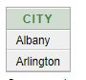

Q12. Query the list of CITY names ending with vowels (a, e, i, o, u) from STA TION. Your result cannot

contain duplicates.

Input Format

The STATION table is described as follows:



where LA T_N is the northern latitude and LONG_W is the western longitude.

Ans:-

|  |
| --- |
|  |
| -- Approach 1 |
|  |  |
|  |  |
|  | SELECT |
|  | DISTINCT city |
|  | FROM |
|  | station |
|  | WHERE |
|  | RIGHT(city , 1) IN ('a','e','i','o','u'); |
|  |  |
|  |  |
|  | -- Approach 2 |
|  |  |
|  |  |
|  | SELECT |
|  | DISTINCT city |
|  | FROM |
|  | station |
|  | WHERE |
|  | SUBSTR(city,-1,1) IN ('A','E','I','O','U'); |
|  |  |
|  |  |
|  | -- Approach 3 |
|  |  |
|  |  |
|  | SELECT |
|  | DISTINCT city |
|  | FROM |
|  | station |
|  | WHERE |
|  | city RLIKE '.*[aeiouAEIOU]$'; |
|  |  |
|  |  |
|  | -- Approach 4 |
|  |  |
|  |  |
|  | SELECT |
|  | DISTINCT city |
|  | FROM |
|  | station |
|  | WHERE |
|  | city REGEXP '.*[aeiouAEIOU]$'; |
|  |  |
|  |  |
|  | -- Approach 5 |
|  |  |
|  |  |
|  | SELECT |
|  | DISTINCT city |
|  | FROM |
|  | station |
|  | WHERE |
|  | city REGEXP '[aeiou]$'; |
|  |  |
|  |  |
|  |  |

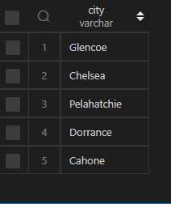

Q13. Query the list of CITY names from STATION that do not start with vowels. Your result cannot

contain duplicates.

Input Format

The STATION table is described as follows:



where LA T_N is the northern latitude and LONG_W is the western longitude.

Ans:- -- Approach 1

SELECT

DISTINCT city

FROM

station

WHERE

LEFT(city , 1) NOT IN ('a','e','i','o','u');

-- Approach 2

SELECT

DISTINCT city

FROM

station

WHERE

SUBSTR(city,1,1) NOT IN ('A','E','I','O','U');

-- Approach 3

SELECT

DISTINCT city

FROM

station

WHERE

city NOT RLIKE '^[aeiouAEIOU]';

-- Approach 4

SELECT

DISTINCT city

FROM

station

WHERE

city NOT REGEXP '^[aeiouAEIOU]';

-- Approach 5

SELECT

DISTINCT city

FROM

station

WHERE

city NOT REGEXP '^[aeiou]';

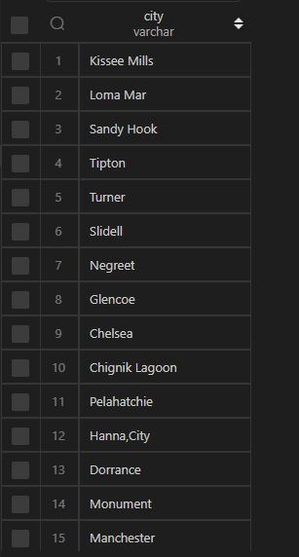

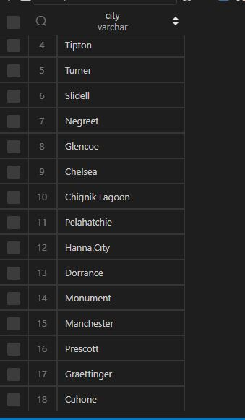

Q14. Query the list of CITY names from STATION that do not end with vowels. Your result cannot

contain duplicates.

Input Format

The STATION table is described as follows:



where LA T_N is the northern latitude and LONG_W is the western longitude.

Ans:-

|  |
| --- |
|  |
| -- Approach 1 |
|  |  |
|  |  |
|  | SELECT |
|  | DISTINCT city |
|  | FROM |
|  | station |
|  | WHERE |
|  | RIGHT(city , 1) NOT IN ('a','e','i','o','u'); |
|  |  |
|  |  |
|  | -- Approach 2 |
|  |  |
|  |  |
|  | SELECT |
|  | DISTINCT city |
|  | FROM |
|  | station |
|  | WHERE |
|  | SUBSTR(city,-1,1) NOT IN ('A','E','I','O','U'); |
|  |  |
|  |  |
|  | -- Approach 3 |
|  |  |
|  |  |
|  | SELECT |
|  | DISTINCT city |
|  | FROM |
|  | station |
|  | WHERE |
|  | city NOT RLIKE '.*[aeiouAEIOU]$'; |
|  |  |
|  |  |
|  | -- Approach 4 |
|  |  |
|  |  |
|  | SELECT |
|  | DISTINCT city |
|  | FROM |
|  | station |
|  | WHERE |
|  | city NOT REGEXP '.*[aeiouAEIOU]$'; |
|  |  |
|  |  |
|  | -- Approach 5 |
|  |  |
|  |  |
|  | SELECT |
|  | DISTINCT city |
|  | FROM |
|  | station |
|  | WHERE |
|  | city NOT REGEXP '[aeiou]$'; |
|  |  |
|  |  |
|  | output17.JPG |

Q15. Query the list of CITY names from STATION that either do not start with vowels or do not end

with vowels. Your result cannot contain duplicates.

Input Format

The STATION table is described as follows:



where LA T_N is the northern latitude and LONG_W is the western longitude.

Ans:-

|  |
| --- |
| -- Approach 1 |
|  |  |
|  |  |
|  | SELECT |
|  | DISTINCT city |
|  | FROM |
|  | station |
|  | WHERE |
|  | SUBSTR(city,1,1) NOT IN ('A','E','I','O','U') |
|  | OR |
|  | SUBSTR(city,-1,1) NOT IN ('A','E','I','O','U'); |
|  |  |
|  |  |
|  | -- Approach 2 |
|  |  |
|  |  |
|  | SELECT |
|  | DISTINCT city |
|  | FROM |
|  | station |
|  | WHERE |
|  | city RLIKE '^[^aeiouAEIOU].*|.*[^AEIOUaeiou]$'; |
|  |  |

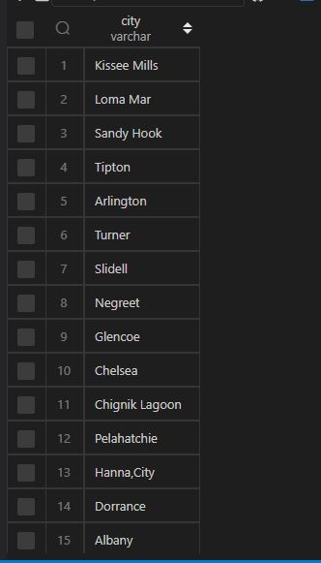

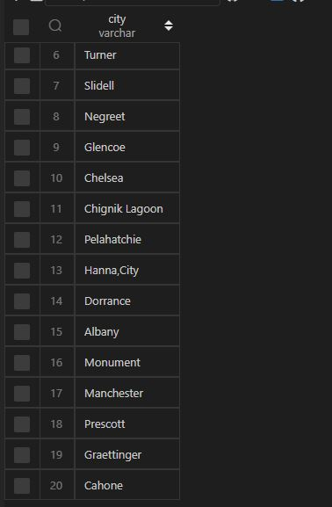

Q16. Query the list of CITY names from STATION that do not start with vowels and do not end with

vowels. Your result cannot contain duplicates.

Input Format

The STATION table is described as follows:



where LA T_N is the northern latitude and LONG_W is the western longitude.

Ans:-

|  |
| --- |
|  |
| -- Approach 1 |
|  |  |
|  |  |
|  | SELECT |
|  | DISTINCT city |
|  | FROM |
|  | station |
|  | WHERE |
|  | SUBSTR(city,1,1) NOT IN ('A','E','I','O','U') |
|  | AND |
|  | SUBSTR(city,-1,1) NOT IN ('A','E','I','O','U'); |
|  |  |
|  |  |
|  | -- Approach 2 |
|  |  |
|  |  |
|  | SELECT |
|  | DISTINCT city |
|  | FROM |
|  | station |
|  | WHERE |
|  | city NOT REGEXP '^[aeiou]|[aeiou]$'; |
|  |  |
|  |  |
|  | -- Approach 3 |
|  |  |
|  |  |
|  | SELECT |
|  | DISTINCT city |
|  | FROM |
|  | station |
|  | WHERE |
|  | city REGEXP '^[^aeiou].*[^aeiou]$'; |
|  |  |
|  |  |
|  |  |

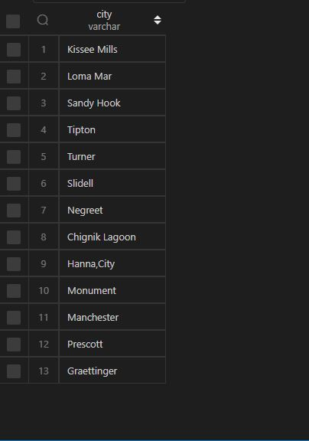

Q17.

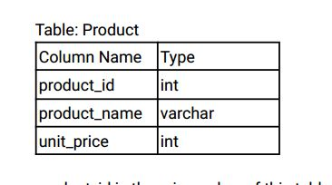

product_id is the primary key of this table.

Each row of this table indicates the name and the price of each product.

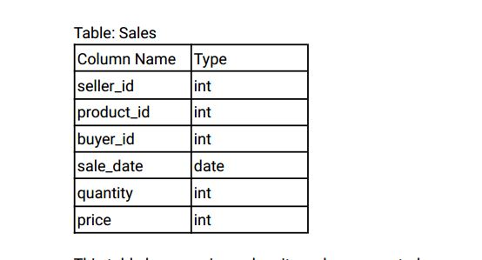

This table has no primary key , it can have repeated rows.

product_id is a foreign key to the Product table.

Each row of this table contains some information about one sale.

Write an SQL query that reports the products that were only sold in the first quarter of 2019. That is,

between 2019-01-01 and 2019-03-31 inclusive.

Return the result table in any order .

The query result format is in the following example.

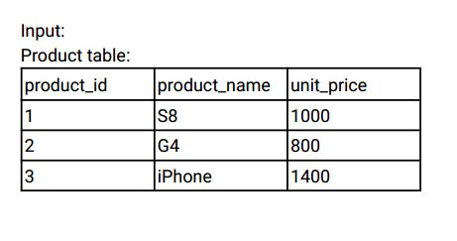

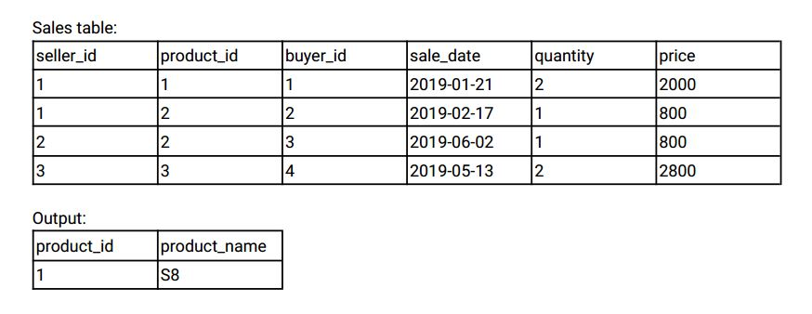

Explanation:

The product with id 1 was only sold in the spring of 2019.

The product with id 2 was sold in the spring of 2019 but was also sold after the spring of 2019.

The product with id 3 was sold after spring 2019.

We return only product 1 as it is the product that was only sold in the spring of 2019.

Ans:-

|  |
| --- |
|  |
| CREATE TABLE product( |
|  | product_id INT, |
|  | product_name VARCHAR(20), |
|  | unit_price INT, |
|  | CONSTRAINT prime_key PRIMARY KEY(product_id) |
|  | ); |
|  |  |
|  |  |
|  | INSERT INTO product VALUES |
|  | (1,'S8',1000), |
|  | (2,'G4',800), |
|  | (3,'iPhone',1400);  Select * from product; |
|  |  |
|  |  |
|  | CREATE TABLE sales( |
|  | seller_id INT, |
|  | product_id INT, |
|  | buyer_id INT, |
|  | sales_date DATE, |
|  | quantity INT, |
|  | price INT, |
|  | CONSTRAINT foriegn_key FOREIGN KEY(product_id) REFERENCES product(product_id) |
|  | ); |
|  |  |
|  |  |
|  | INSERT INTO sales VALUES |
|  | (1,1,1,'2019-01-21',2,2000), |
|  | (1,2,2,'2019-02-17',1,800), |
|  | (2,2,3,'2019-06-02',1,800), |
|  | (3,3,4,'2019-05-13',2,2800);  Select * from sales; |
|  |  |
|  |  |
|  |  |
|  | -- Approach 1 |
|  |  |
|  |  |
|  |  |
|  | SELECT |
|  | p.product_id, |
|  | p.product_name |
|  | FROM |
|  | product p |
|  | INNER JOIN |
|  | sales s |
|  | ON |
|  | p.product_id = s.product_id |
|  | WHERE |
|  | p.product_id |
|  | NOT IN ( |
|  | SELECT |
|  | product_id |
|  | FROM |
|  | sales |
|  | WHERE |
|  | sales_date > '2019-03-31' |
|  | ) |
|  | GROUP BY |
|  | p.product_id |
|  | HAVING |
|  | MAX(s.sales_date) <='2019-03-31' |
|  | AND |
|  | MIN(s.sales_date) >='2019-01-01'; |
|  |  |
|  |  |
|  |  |
|  | -- Approach 2 |
|  |  |
|  |  |
|  |  |
|  | SELECT |
|  | p.product_id, |
|  | p.product_name |
|  | FROM |
|  | product p |
|  | INNER JOIN |
|  | sales s |
|  | ON |
|  | p.product_id = s.product_id |
|  | GROUP BY |
|  | p.product_id, |
|  | p.product_name |
|  | HAVING |
|  | MIN(s.sales_date) >= '2019-01-01' AND MAX(s.sales_date) <= '2019-03-31'; |
|  |  |
|  |  |
|  | output20.JPG |

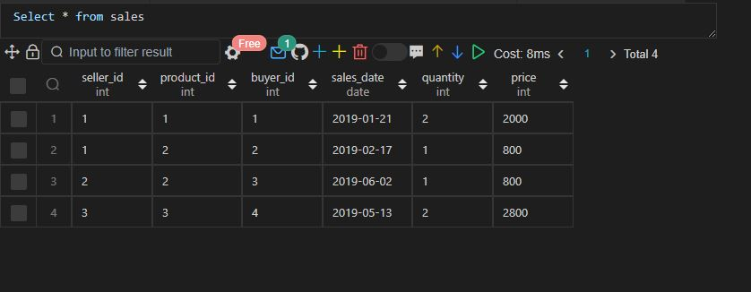

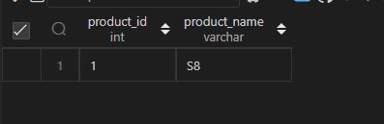

Q18.

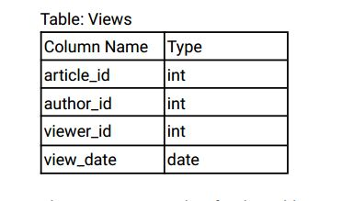

There is no primary key for this table, it may have duplicate rows.

Each row of this table indicates that some viewer viewed an article (written by some author) on some

date.

Note that equal author_id and viewer_id indicate the same person.

Write an SQL query to find all the authors that viewed at least one of their own articles.

Return the result table sorted by id in ascending order .

The query result format is in the following example.

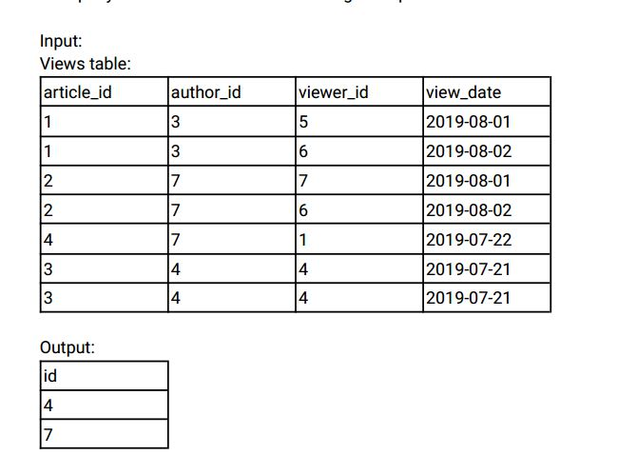

Ans:-

|  |
| --- |
|  |
| CREATE TABLE views( |
|  | article_id INT, |
|  | author_id INT, |
|  | viewer_id INT, |
|  | view_date DATE |
|  |  |
|  | ); |
|  |  |
|  |  |
|  | INSERT INTO views VALUES |
|  | (1,3,5,'2019-08-01'), |
|  | (1,3,6,'2019-08-02'), |
|  | (2,7,7,'2019-08-01'), |
|  | (2,7,6,'2019-08-02'), |
|  | (4,7,1,'2019-08-22'), |
|  | (3,4,4,'2019-07-21'), |
|  | (3,4,4,'2019-07-21'); |
|  |  |
|  |  |
|  |  |
|  | SELECT |
|  | DISTINCT a.author_id |
|  | FROM |
|  | views a |
|  | JOIN |
|  | views v |
|  | ON |
|  | a.author_id = v.viewer_id |
|  | ORDER BY |
|  | a.author_id; |
|  |  |
|  |  |
|  |  |

Select * from views;

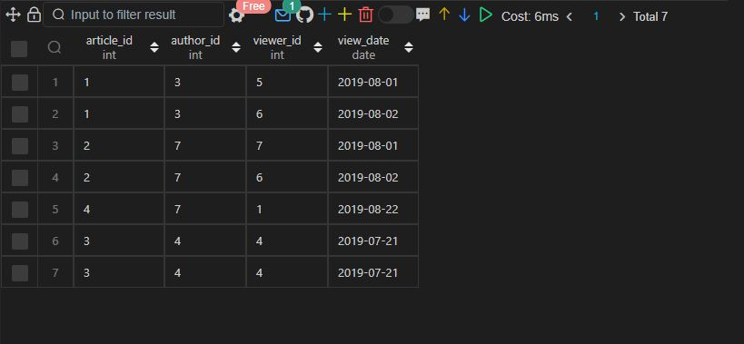

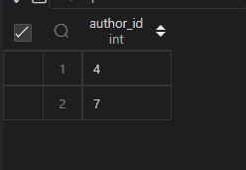

Q19.

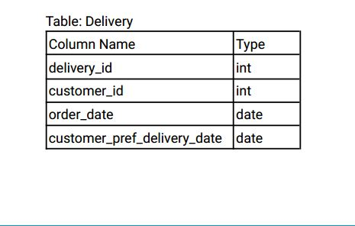

delivery_id is the primary key of this table.

The table holds information about food delivery to customers that make orders at some date and

specify a preferred delivery date (on the same order date or after it).

If the customer' s preferred delivery date is the same as the order date, then the order is called

immediately; otherwise, it is called scheduled.

Write an SQL query to find the percentage of immediate orders in the table, rounded to 2 decimal

places.

The query result format is in the following example.

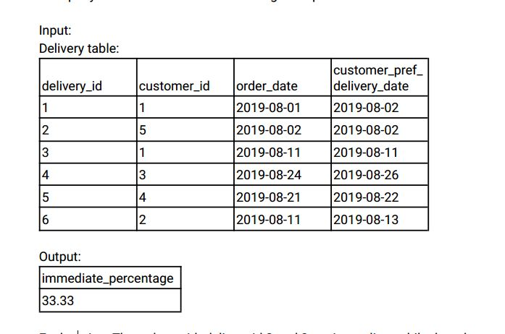

Explanation: The orders with delivery id 2 and 3 are immediate while the others are scheduled.

Ans:-

|  |
| --- |
|  |
| CREATE TABLE delivery( |
|  | delivery_id INT, |
|  | customer_id INT, |
|  | order_date DATE, |
|  | customer_preferred_delivery_date DATE |
|  |  |
|  | ); |
|  |  |
|  |  |
|  | INSERT INTO delivery VALUES |
|  | (1,1,'2019-08-01','2019-08-02'), |
|  | (2,5,'2019-08-02','2019-08-02'), |
|  | (3,1,'2019-08-11','2019-08-11'), |
|  | (4,3,'2019-08-24','2019-08-26'), |
|  | (5,4,'2019-08-21','2019-08-22'), |
|  | (6,2,'2019-07-11','2019-08-13'); |
|  |  |
|  |  |
|  |  |
|  | SELECT |
|  | ROUND(immediate_orders * 100 / total_orders, 2) AS immediate_orders_perct |
|  | FROM |
|  | ( |
|  | SELECT |
|  | COUNT( |
|  | CASE |
|  | WHEN order_date = customer_preferred_delivery_date |
|  | THEN customer_id |
|  | END |
|  | ) AS immediate_orders, |
|  | COUNT(delivery_id) AS total_orders |
|  | FROM |
|  | delivery |
|  | ) temp ; |
|  |  |
|  |  |
|  |  |

Select * from delivery;

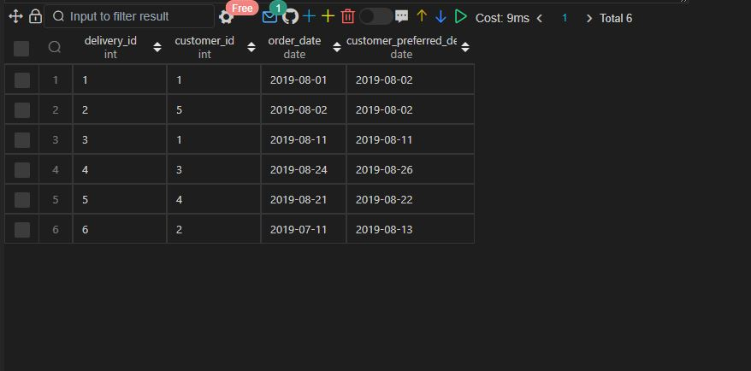

Q20.

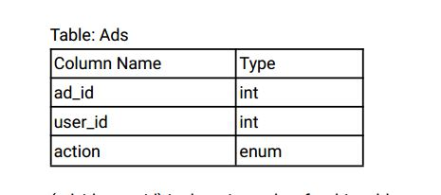

(ad_id, user_id) is the primary key for this table.

Each row of this table contains the ID of an Ad, the ID of a user , and the action taken by this user

regarding this Ad.

The action column is an ENUM type of ('Clicked', 'Viewed', 'Ignored').

A company is running Ads and wants to calculate the performance of each Ad.

Performance of the Ad is measured using Click-Through Rate (CTR) where:

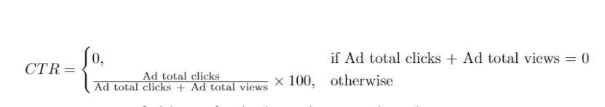

Write an SQL query to find the ctr of each Ad. Round ctr to two decimal points.

Return the result table ordered by ctr in descending order and by ad_id in ascending order in case of a

tie.

The query result format is in the following example.

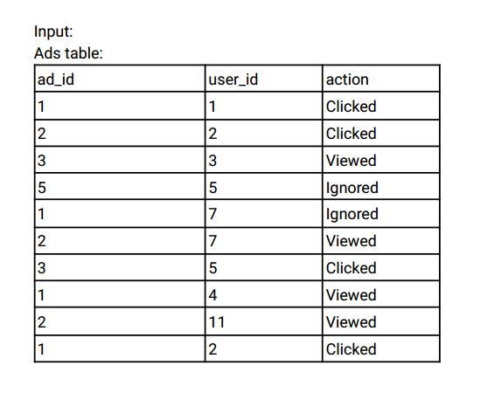

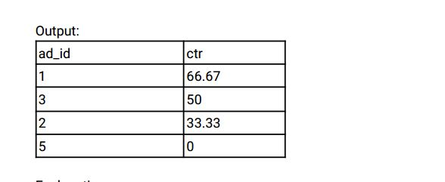

Explanation:

for ad_id = 1, ctr = (2/(2+1)) * 100 = 66.67

for ad_id = 2, ctr = (1/(1+2)) * 100 = 33.33

for ad_id = 3, ctr = (1/(1+1)) * 100 = 50.00

for ad_id = 5, ctr = 0.00, Note that ad_id = 5 has no clicks or views.

Note that we do not care about Ignored Ads.

Ans:-

|  |
| --- |
|  |
| CREATE TABLE ads( |
|  | ad_id INT, |
|  | user_id INT, |
|  | action ENUM('CLICKED','viewED','IGNORED'), |
|  | CONSTRAINT prime_key PRIMARY KEY(ad_id, user_id) |
|  | ); |
|  |  |
|  |  |
|  | INSERT INTO ads VALUES |
|  | (1,1,'CLICKED'), |
|  | (2,2,'CLICKED'), |
|  | (3,3,'VIEWED'), |
|  | (5,5,'IGNORED'), |
|  | (1,7,'IGNORED'), |
|  | (2,7,'VIEWED'), |
|  | (3,5,'CLICKED'), |
|  | (1,4,'VIEWED'), |
|  | (2,11,'VIEWED'), |
|  | (1,2,'CLICKED'); |
|  |  |
|  |  |
|  |  |
|  | SELECT |
|  | ad_id, |
|  | CASE |
|  | WHEN (num_of_clicks * 100) / (num_of_clicks + num_of_views) IS NULL THEN 0 |
|  | ELSE ROUND((num_of_clicks * 100) / (num_of_clicks + num_of_views), 2) |
|  | END AS ctr |
|  | FROM |
|  | ( |
|  | SELECT |
|  | ad_id, |
|  | COUNT( |
|  | CASE |
|  | WHEN action = 'CLICKED' THEN ad_id |
|  | END |
|  | ) AS num_of_clicks, |
|  | COUNT( |
|  | CASE WHEN action = 'VIEWED' THEN ad_id |
|  | END |
|  | ) AS num_of_views |
|  | FROM |
|  | ads |
|  | GROUP BY |
|  | ad_id |
|  | ) temp_ads |
|  | ORDER BY |
|  | ctr DESC, |
|  | ad_id ASC; |
|  |  |
|  |  |
|  |  |

  Select * from ads;

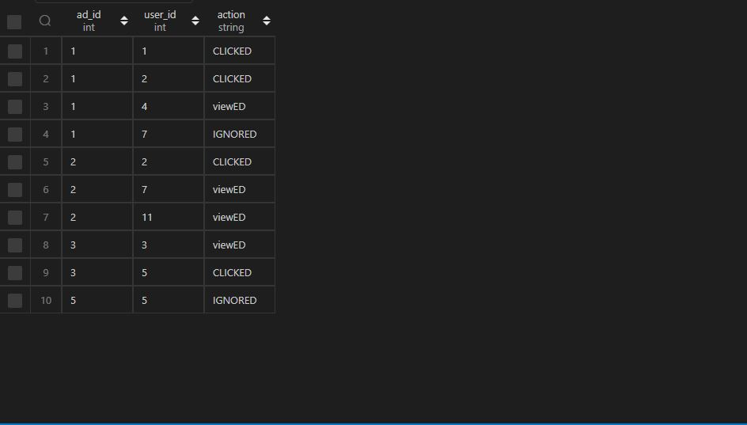

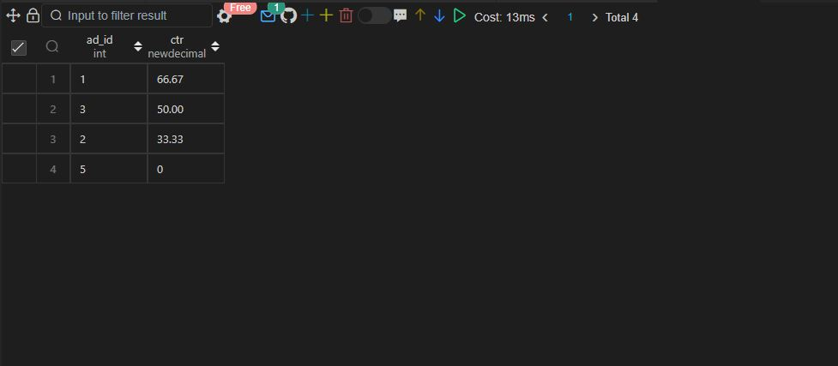

Q21.

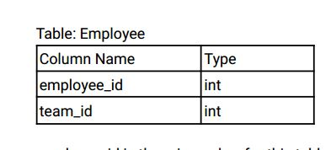

employee_id is the primary key for this table.

Each row of this table contains the ID of each employee and their respective team.

Write an SQL query to find the team size of each of the employees.

Return result table in any order .

The query result format is in the following example.

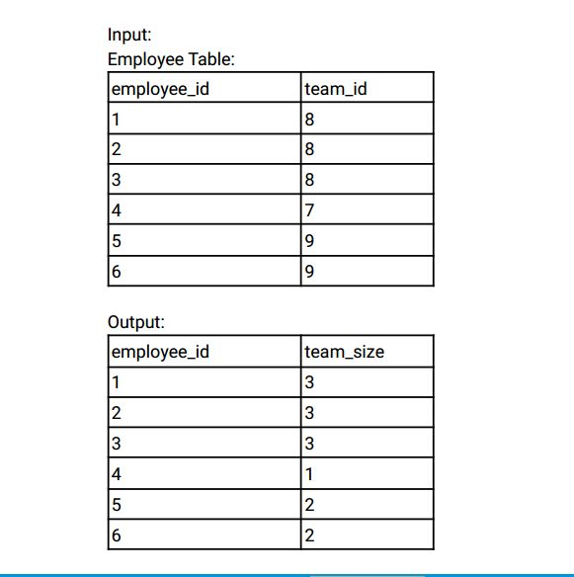

Explanation:

Employees with Id 1,2,3 are part of a team with team_id = 8.

An employee with Id 4 is part of a team with team_id = 7.

Employees with Id 5,6 are part of a team with team_id = 9.

Ans:-

|  |
| --- |
|  |
| CREATE TABLE employee( |
|  | employee_id INT, |
|  | team_id INT, |
|  | CONSTRAINT prime_key PRIMARY KEY(employee_id) |
|  | ); |
|  |  |
|  |  |
|  | INSERT INTO employee VALUES |
|  | (1,8), |
|  | (2,8), |
|  | (3,8), |
|  | (4,7), |
|  | (5,9), |
|  | (6,9); |
|  |  |
|  |  |
|  |  |
|  | SELECT |
|  | employee_id, |
|  | COUNT(employee_id) OVER(PARTITION BY team_id) AS team_size |
|  | FROM |
|  | employee |
|  | ORDER BY |
|  | employee_id; |
|  |  |
|  |  |
|  |  |

 Select * from employee;

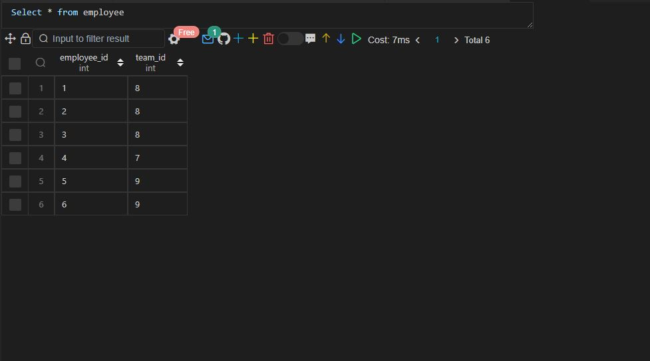

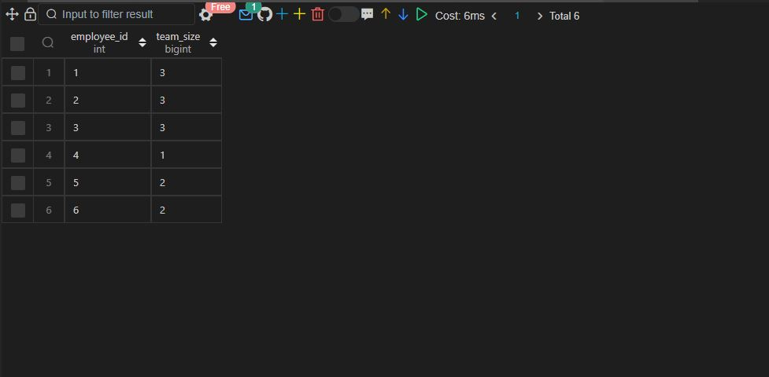

Q22.

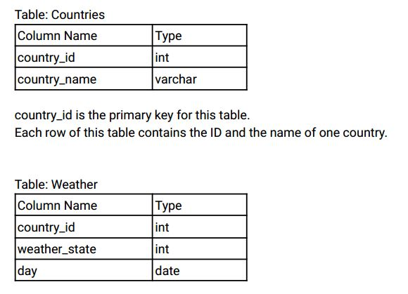

(country_id, day) is the primary key for this table.

Each row of this table indicates the weather state in a country for one day .

Write an SQL query to find the type of weather in each country for November 2019.

The type of weather is:

● Cold if the average weather_state is less than or equal 15,

● Hot if the average weather_state is greater than or equal to 25, and

● Warm otherwise.

Return result table in any order .

The query result format is in the following example.

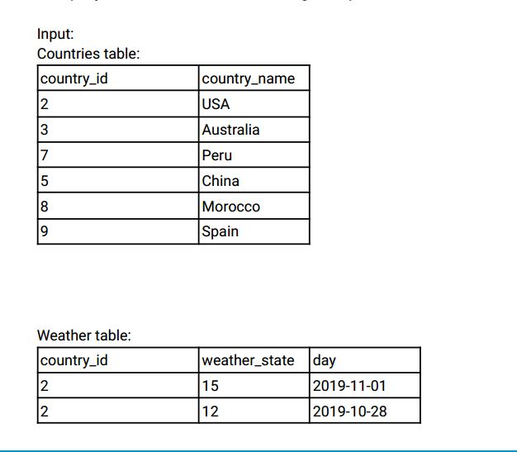

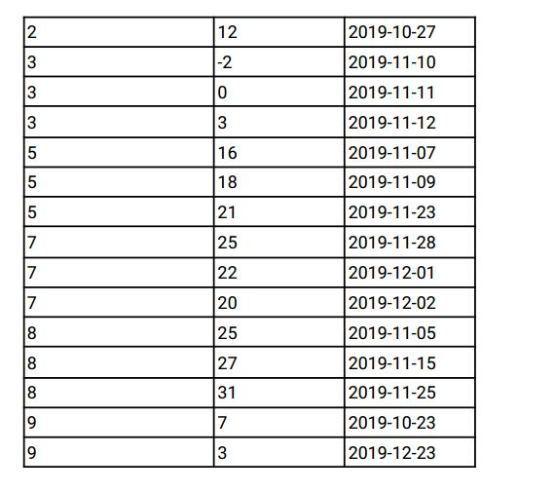

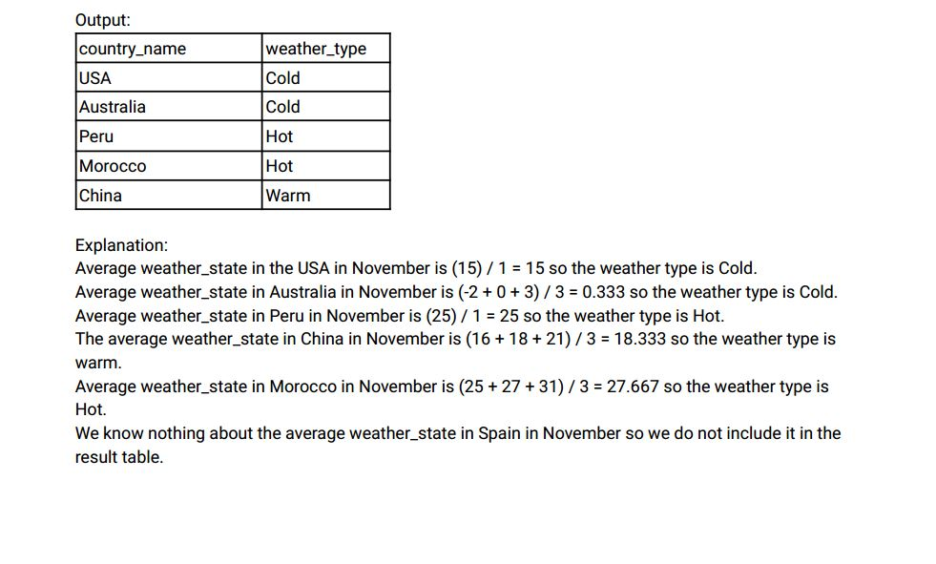

Ans:-

|  |
| --- |
|  |
| CREATE TABLE countries( |
|  | country_id INT, |
|  | country_name VARCHAR(20), |
|  | CONSTRAINT prime_key PRIMARY KEY(country_id) |
|  | ); |
|  |  |
|  |  |
|  | INSERT INTO countries VALUES |
|  | (2, 'USA'), |
|  | (3, 'AUSTRALIA'), |
|  | (7, 'PERU'), |
|  | (5, 'CHINA'), |
|  | (8, 'MOROCCO'), |
|  | (9, 'SPAIN'); |
|  |  |
|  |  |
|  | CREATE TABLE weather( |
|  | country_id INT, |
|  | weather_state INT, |
|  | day DATE, |
|  | CONSTRAINT prime_key PRIMARY KEY(country_id, day) |
|  | ); |
|  |  |
|  |  |
|  | INSERT INTO weather VALUES |
|  | (2,15,'2019-11-01'), |
|  | (2,12,'2019-10-28'), |
|  | (2,12,'2019-10-27'), |
|  | (3,-2,'2019-11-10'), |
|  | (3,0,'2019-11-11'), |
|  | (3,3,'2019-11-12'), |
|  | (5,16,'2019-11-07'), |
|  | (5,18,'2019-10-09'), |
|  | (5,21,'2019-10-23'), |
|  | (7,25,'2019-11-08'), |
|  | (7,22,'2019-12-01'), |
|  | (7,20,'2019-12-02'), |
|  | (8,25,'2019-11-05'), |
|  | (8,27,'2019-11-15'), |
|  | (8,31,'2019-11-25'), |
|  | (9,7,'2019-10-23'), |
|  | (9,3,'2019-12-23'); |
|  |  |
|  |  |
|  |  |
|  | SELECT |
|  | c.country_name, |
|  | CASE |
|  | WHEN AVG(weather_state) <= 15 THEN 'COLD' |
|  | WHEN AVG(weather_state) >= 25 THEN 'HOT' |
|  | ELSE 'WARM' |
|  | END AS avg_weather |
|  | FROM |
|  | countries c |
|  | INNER JOIN |
|  | weather w |
|  | ON |
|  | c.country_id = w.country_id |
|  | WHERE |
|  | day BETWEEN '2019-11-01' AND '2019-11-30' |
|  | GROUP BY |
|  | c.country_id, |
|  | c.country_name; |
|  |  |
|  |  |
|  |  |

Select * from countries;

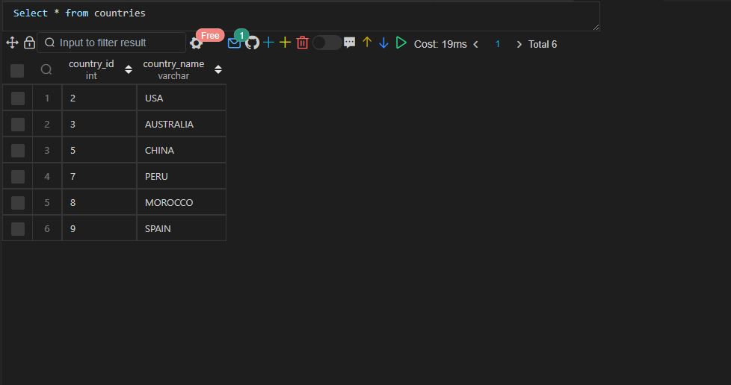

Select * from weather;

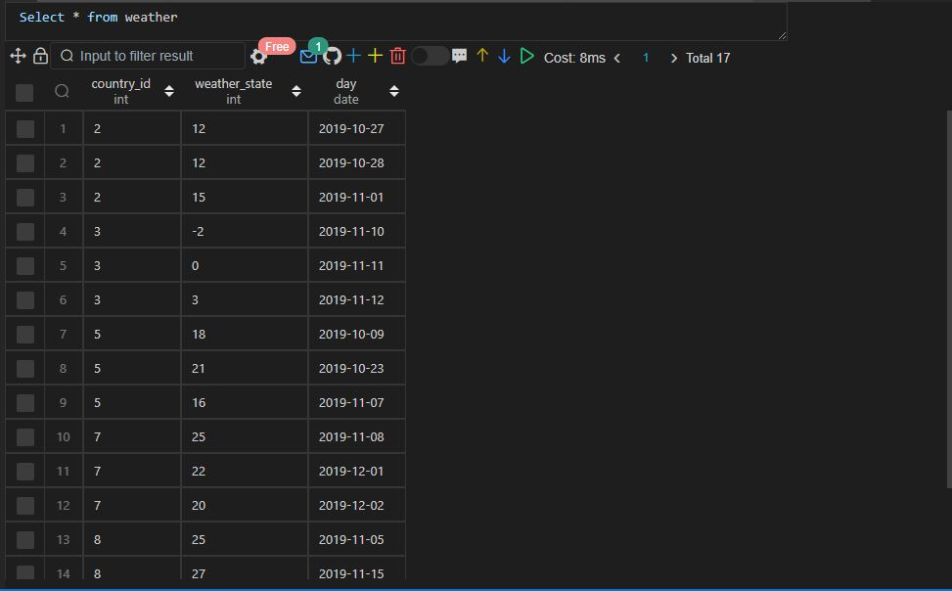

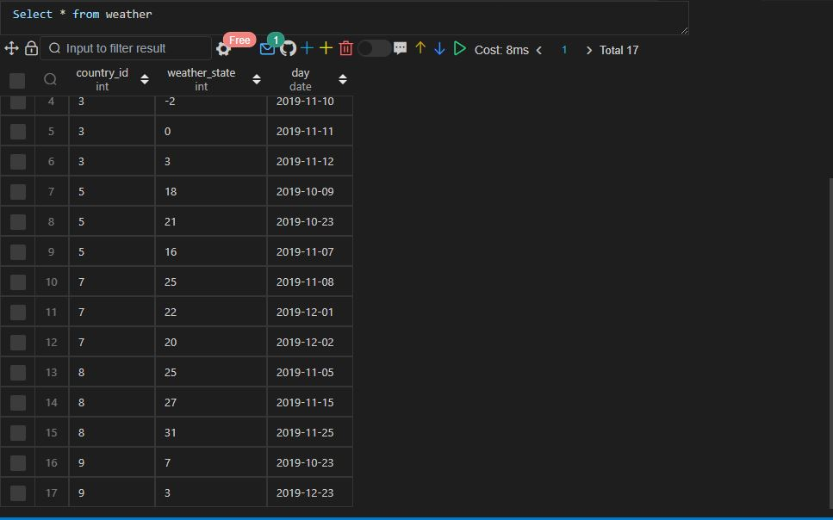

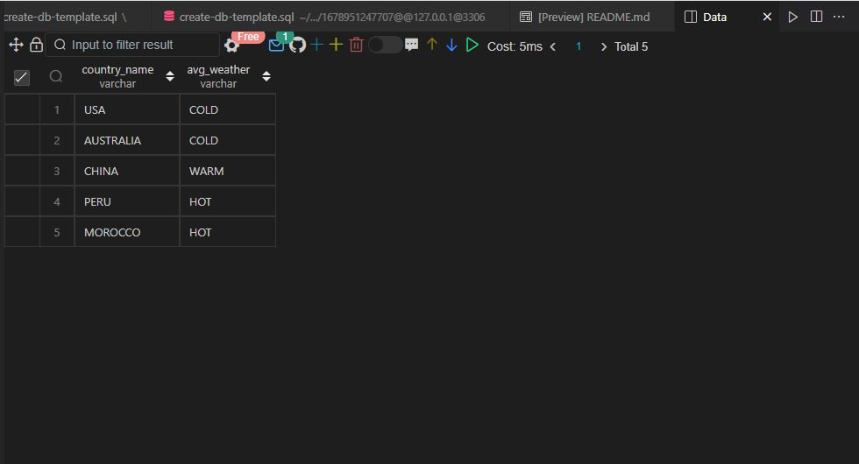

Q23.

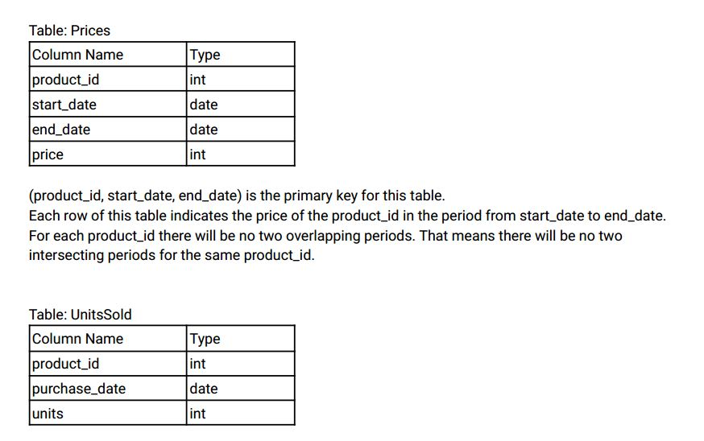

There is no primary key for this table, it may contain duplicates.

Each row of this table indicates the date, units, and product_id of each product sold.

Write an SQL query to find the average selling price for each product. average_price should be

rounded to 2 decimal places.

Return the result table in any order .

The query result format is in the following example.

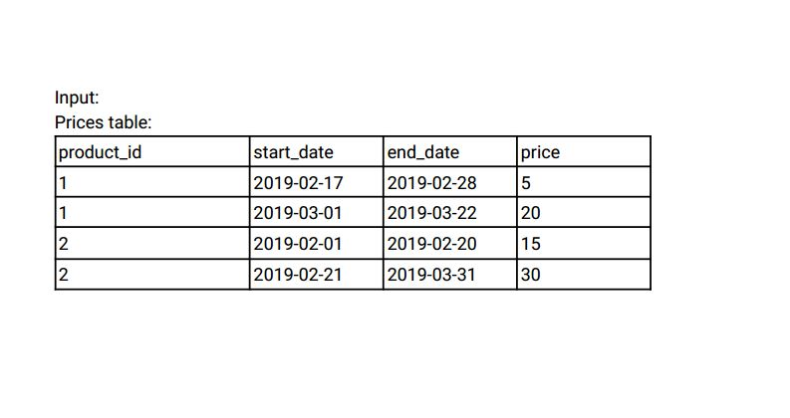

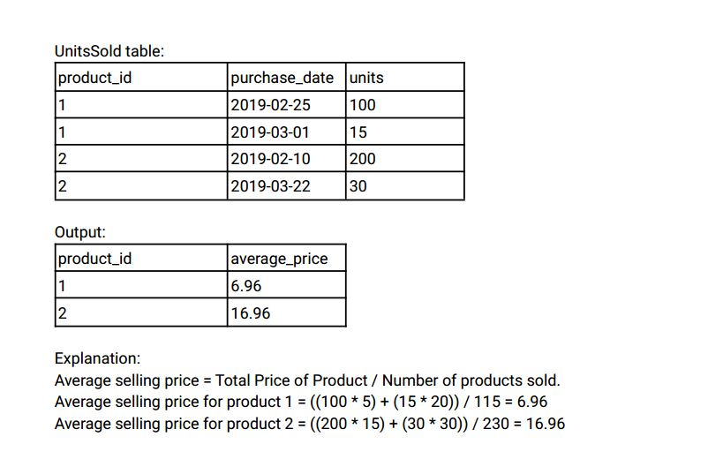

Ans:-

|  |
| --- |
|  |
| CREATE TABLE prices( |
|  | product_id INT, |
|  | start_date DATE, |
|  | end_date DATE, |
|  | price INT, |
|  | CONSTRAINT prime_key PRIMARY KEY(product_id, start_date, end_date) |
|  | ); |
|  |  |
|  |  |
|  | INSERT INTO prices VALUES |
|  | (1,'2019-02-17','2019-02-28',5), |
|  | (1,'2019-03-01','2019-03-22',20), |
|  | (2,'2019-02-01','2019-02-20',15), |
|  | (2,'2019-02-21','2019-03-31',30); |
|  |  |
|  |  |
|  | CREATE TABLE units_sold( |
|  | product_id INT, |
|  | purchase_date DATE, |
|  | units INT |
|  | ); |
|  |  |
|  |  |
|  | INSERT INTO units_sold VALUES |
|  | (1,'2019-02-25',100), |
|  | (1,'2019-03-01',15), |
|  | (2,'2019-02-10',200), |
|  | (2,'2019-02-22',30); |
|  |  |
|  |  |
|  |  |
|  | SELECT |
|  | p.product_id, |
|  | ROUND(SUM(p.price * u.units)/SUM(u.units), 2) AS average_price |
|  | FROM |
|  | units_sold u |
|  | INNER JOIN |
|  | prices p |
|  | ON |
|  | p.product_id = u.product_id |
|  | WHERE |
|  | u.purchase_date BETWEEN p.start_date AND p.end_date |
|  | GROUP BY |
|  | p.product_id; |
|  |  |
|  |  |
|  |  |

 Select * from prices;

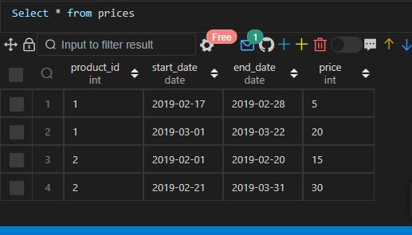

Select * from units_sold;

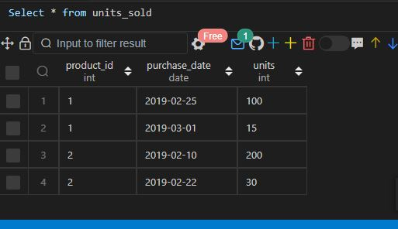

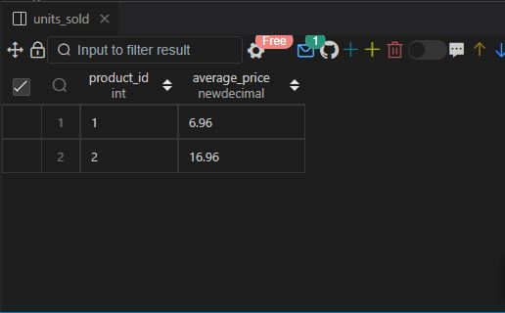

Q24.

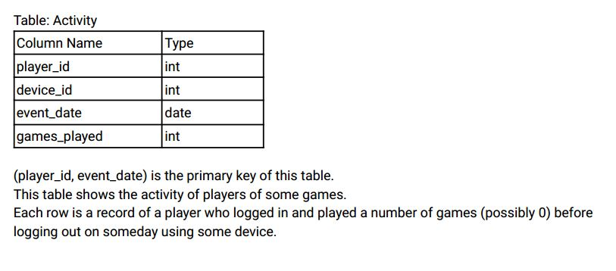

Write an SQL query to report the first login date for each player .

Return the result table in any order .

The query result format is in the following example.

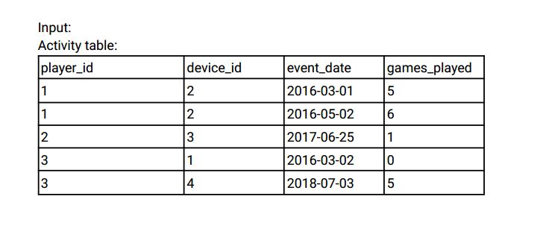

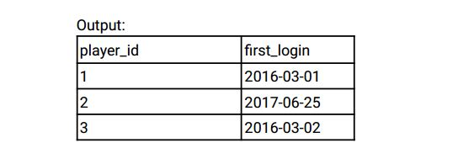

Ans:-

|  |
| --- |
|  |
| CREATE TABLE activity( |
|  | player_id INT, |
|  | device_id INT, |
|  | event_date DATE, |
|  | games_played INT, |
|  | CONSTRAINT prime_key PRIMARY KEY(player_id, event_date) |
|  | ); |
|  |  |
|  |  |
|  | INSERT INTO activity VALUES |
|  | (1,2,'2016-03-01',5), |
|  | (1,2,'2016-03-02',6), |
|  | (2,3,'2017-06-25',1), |
|  | (3,1,'2016-03-02',0), |
|  | (3,4,'2018-07-03',5); |
|  |  |
|  |  |
|  |  |
|  | -- Approach 1 |
|  |  |
|  |  |
|  |  |
|  | WITH temp_activity AS ( |
|  | SELECT |
|  | player_id, |
|  | event_date as first_login, |
|  | ROW_NUMBER() OVER(PARTITION BY player_id ORDER BY event_date) as ranking |
|  | FROM |
|  | activity |
|  | ) |
|  |  |
|  | SELECT |
|  | player_id, |
|  | first_login |
|  | FROM |
|  | temp_activity |
|  | WHERE |
|  | ranking = 1; |
|  |  |
|  |  |
|  |  |
|  | -- Approach 2 |
|  |  |
|  |  |
|  |  |
|  | SELECT |
|  | player_id, |
|  | first_login |
|  | FROM ( |
|  | SELECT |
|  | player_id, |
|  | event_date as first_login, |
|  | ROW_NUMBER() OVER(PARTITION BY player_id ORDER BY event_date) ranking |
|  | FROM |
|  | activity |
|  | ) temp_activity |
|  | WHERE |
|  | ranking = 1; |
|  |  |
|  |  |
|  |  |

Select * from activity;

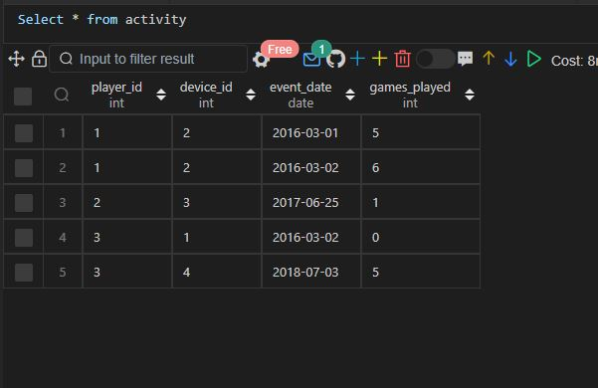

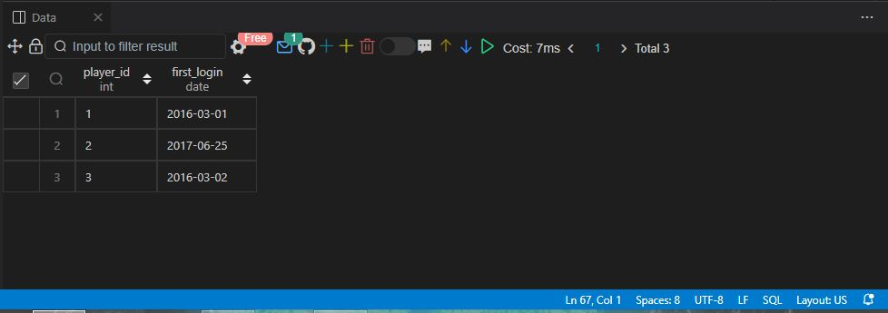

Q25.

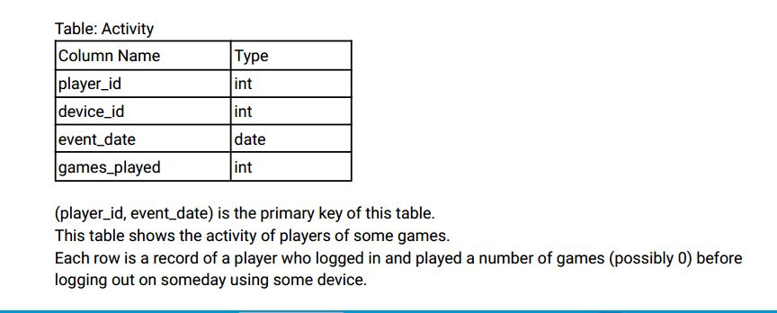

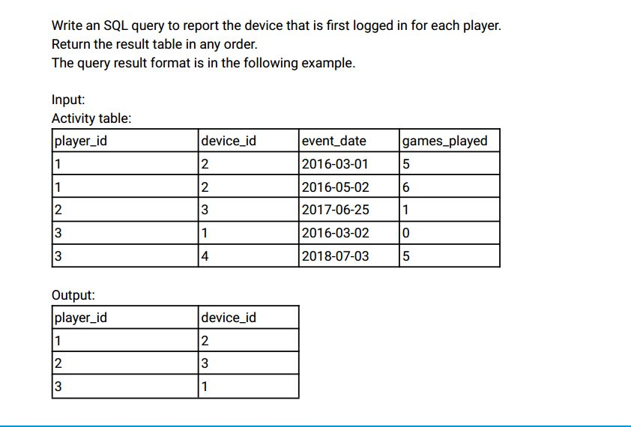

Ans:-

|  |
| --- |
|  |
| -- Approach 1 |
|  |  |
|  |  |
|  |  |
|  | WITH temp_activity AS ( |
|  | SELECT |
|  | player_id, |
|  | device_id, |
|  | ROW_NUMBER() OVER(PARTITION BY player_id ORDER BY device_id) ranking |
|  | FROM |
|  | activity |
|  | ) |
|  |  |
|  | SELECT |
|  | player_id, |
|  | device_id |
|  | FROM |
|  | temp_activity |
|  | WHERE |
|  | ranking = 1; |
|  |  |
|  |  |
|  | -- Approach 2 |
|  |  |
|  |  |
|  | SELECT |
|  | player_id, |
|  | device_id |
|  | FROM ( |
|  | SELECT |
|  | player_id, |
|  | device_id, |
|  | ROW_NUMBER() OVER(PARTITION BY player_id ORDER BY device_id) as ranking |
|  | FROM |
|  | activity |
|  | ) temp_activity |
|  | WHERE |
|  | ranking = 1; |
|  |  |
|  |  |
|  |  |

Approach 1

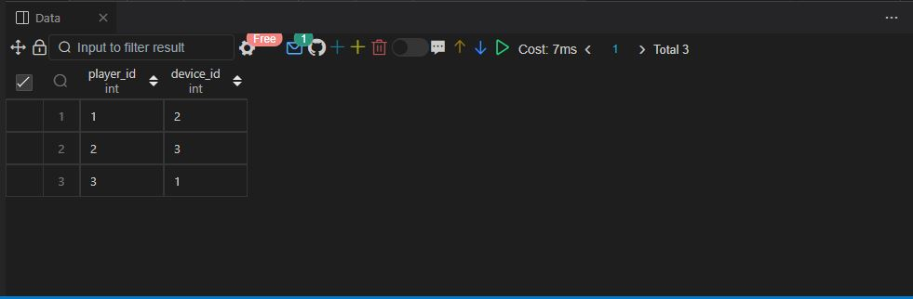

Approach 2

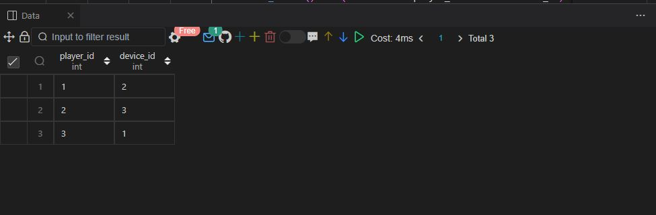

Q26.

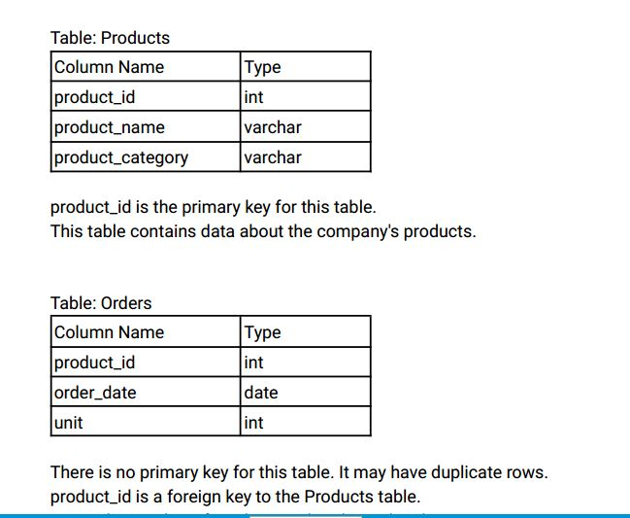

unit is the number of products ordered in order_date.

Write an SQL query to get the names of products that have at least 100 units ordered in February 2020

and their amount.

Return result table in any order .

The query result format is in the following example.

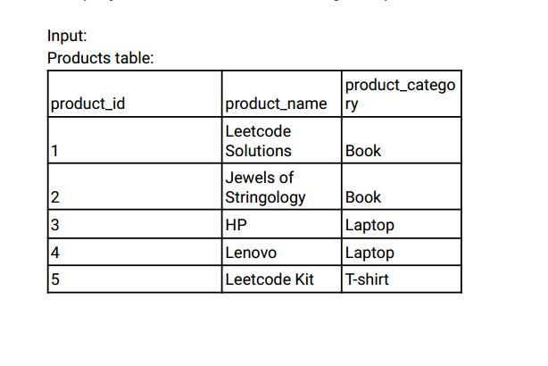

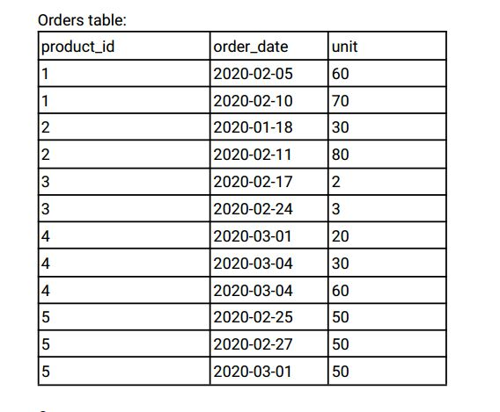

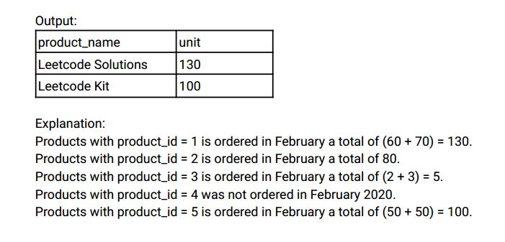

Ans:-

|  |
| --- |
|  |
| CREATE TABLE products( |
|  | product_id INT, |
|  | product_name VARCHAR(30), |
|  | product_category VARCHAR(20), |
|  | CONSTRAINT prime_key PRIMARY KEY(product_id) |
|  | ); |
|  |  |
|  |  |
|  | INSERT INTO products VALUES |
|  | (1,'LEETCODE SOLUTIONS','BOOK'), |
|  | (2,'JEWELS OF STRINGOLOGY','BOOK'), |
|  | (3,'HP','LAPTOP'), |
|  | (4,'LENOVO','LAPTOP'), |
|  | (5,'LEETCODE KIT','T-SHIRT'); |
|  |  |
|  |  |
|  | CREATE TABLE orders( |
|  | product_id INT, |
|  | order_date DATE, |
|  | unit INT, |
|  | CONSTRAINT foriegn_key FOREIGN KEY(product_id) REFERENCES products(product_id) |
|  | ); |
|  |  |
|  |  |
|  | INSERT INTO orders VALUES |
|  | (1,'2020-02-05',60), |
|  | (1,'2020-02-05',70), |
|  | (2,'2020-01-05',30), |
|  | (2,'2020-02-05',80), |
|  | (3,'2020-02-05',2), |
|  | (3,'2020-02-05',3), |
|  | (4,'2020-03-05',20), |
|  | (4,'2020-03-05',30), |
|  | (4,'2020-03-05',60), |
|  | (5,'2020-02-05',50), |
|  | (5,'2020-02-05',50), |
|  | (5,'2020-03-05',50); |
|  |  |
|  |  |
|  |  |
|  | SELECT |
|  | p.product_name, |
|  | SUM(o.unit) AS total_unit_sold |
|  | FROM |
|  | products p |
|  | INNER JOIN |
|  | orders o |
|  | ON |
|  | p.product_id = o.product_id |
|  | WHERE |
|  | order_date BETWEEN '2020-02-01' AND '2020-02-28' |
|  | GROUP BY |
|  | p.product_id |
|  | HAVING |
|  | SUM(o.unit) >= 100; |
|  |  |
|  |  |
|  |  |

Select * from products;

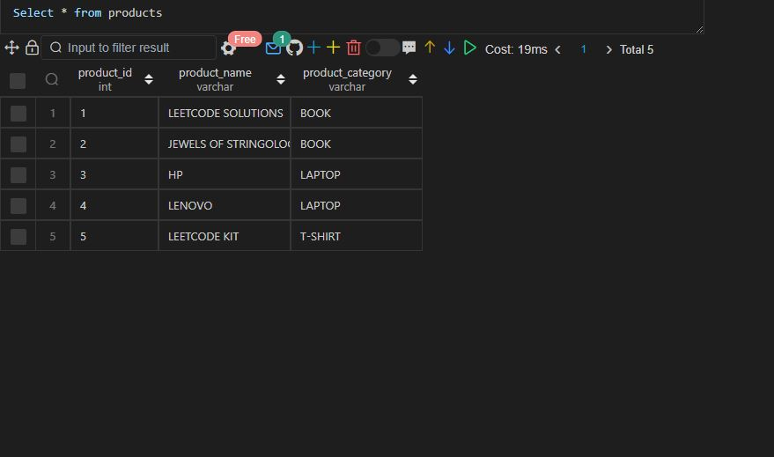

Select * from orders;

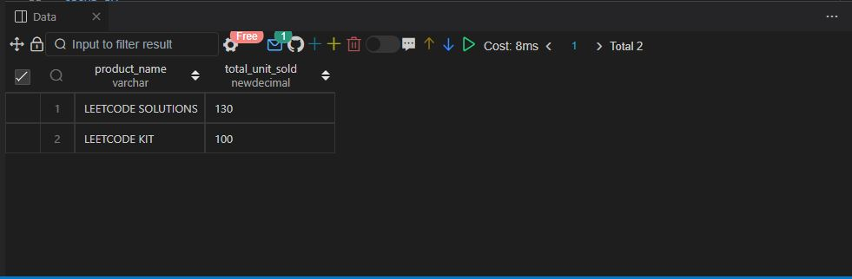

Q27.

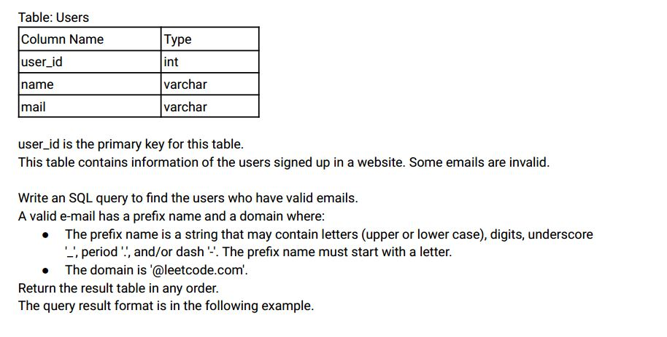

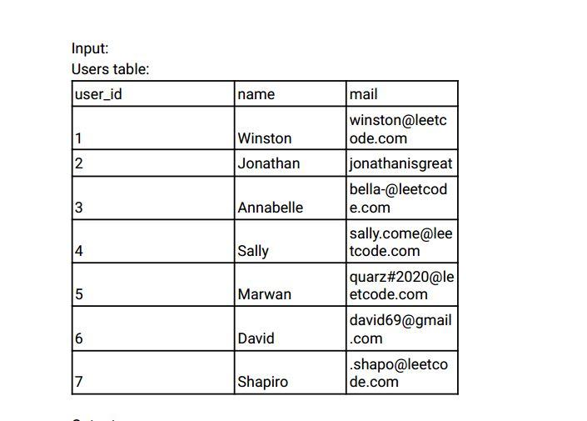

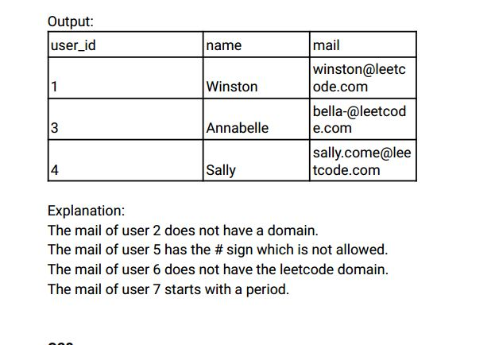

Ans:-

|  |
| --- |
|  |
| CREATE TABLE users( |
|  | user_id INT, |
|  | name VARCHAR(25), |
|  | mail VARCHAR(25), |
|  | CONSTRAINT prime_key PRIMARY KEY(user_id) |
|  | ); |
|  |  |
|  |  |
|  | INSERT INTO users VALUE |
|  | (1,'WINSTON','winston@leetcode.com'), |
|  | (2,'JONATHAN','jonathonisgreat'), |
|  | (3,'ANNABELLE','bella-@leetcode.com'), |
|  | (4,'SALLY','sally.come@leetcode.com'), |
|  | (5,'MARWAN','quarz-- 2020@leetcode.com'), |
|  | (6,'DAVID','david45@gmail.com'), |
|  | (7,'SHAPIRO','.shapo@leetcode.com'); |
|  |  |
|  |  |
|  |  |
|  | SELECT |
|  | user_id, |
|  | name, |
|  | mail |
|  | FROM |
|  | users |
|  | WHERE |
|  | mail LIKE '%@leetcode.com' AND mail REGEXP '^[a-zA-Z0-9][a-zA-Z0-9._-]*@[a-zA-Z0-9][a-zA-Z0-9._-]*\\.[a-zA-Z]{2,4}$'; |
|  |  |
|  |  |
|  |  |

Select * from users;

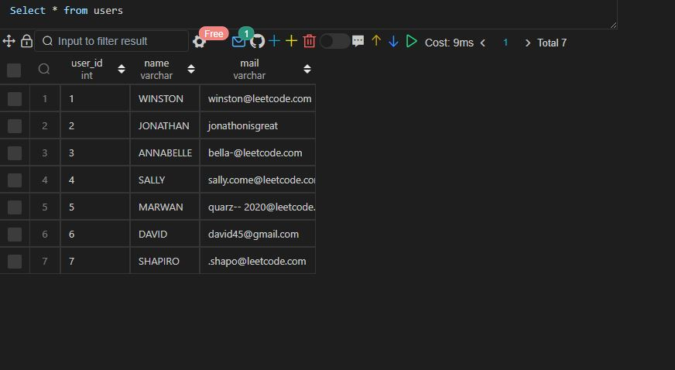

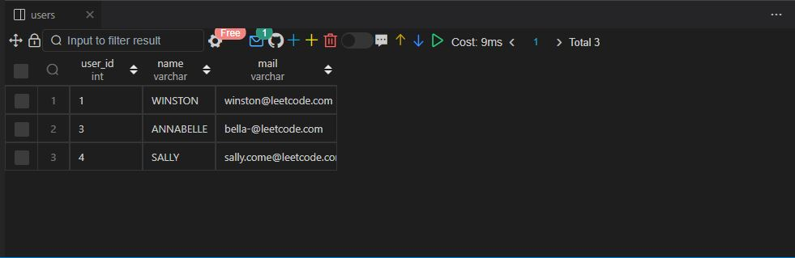

Q28.

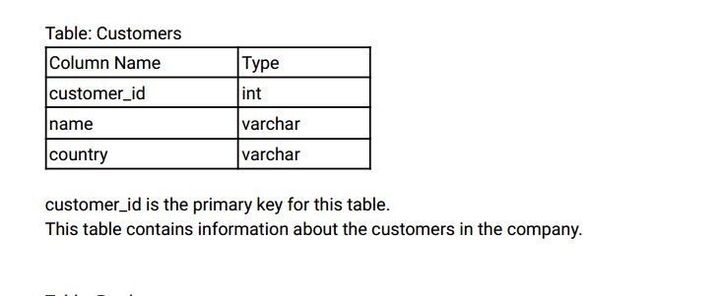

Table: Product

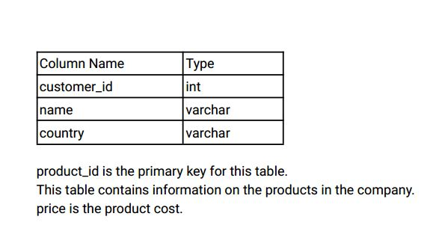

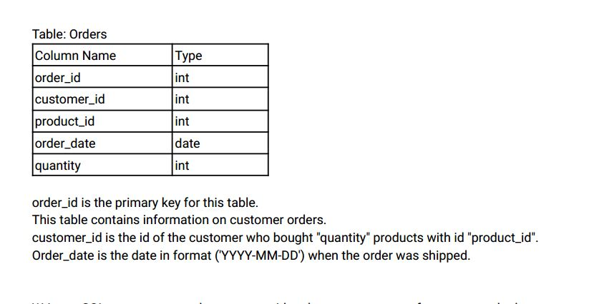

Write an SQL query to report the customer_id and customer_name of customers who have spent at

least $100 in each month of June and July 2020.

Return the result table in any order .

The query result format is in the following example.

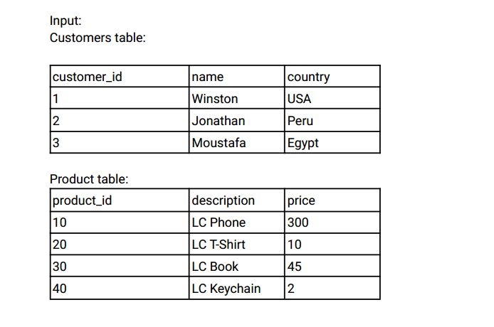

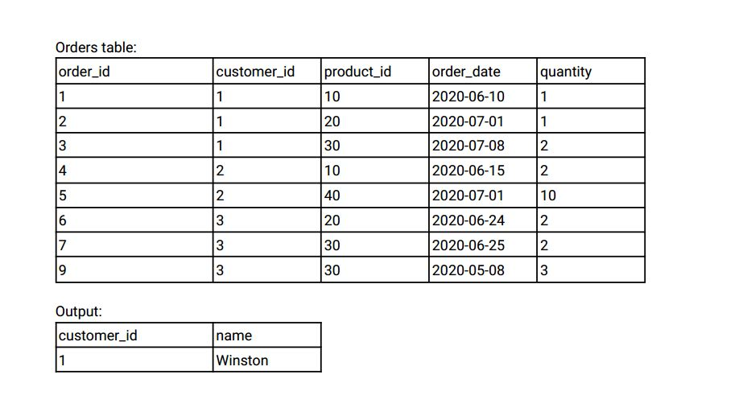

Explanation:

Winston spent $300 (300 * 1) in June and $100 ( 10 * 1 + 45 * 2) in July 2020.

Jonathan spent $600 (300 * 2) in June and $20 ( 2 * 10) in July 2020.

Moustafa spent $110 (10 * 2 + 45 * 2) in June and $0 in July 2020.

Ans:-

|  |
| --- |
|  |
| CREATE TABLE customers( |
|  | customer_id INT, |
|  | name VARCHAR(20), |
|  | country VARCHAR(20), |
|  | CONSTRAINT prime_key PRIMARY KEY(customer_id) |
|  | ); |
|  |  |
|  |  |
|  | CREATE TABLE orders( |
|  | order_id INT, |
|  | customer_id INT, |
|  | product_id INT, |
|  | order_date DATE, |
|  | quantity INT, |
|  | CONSTRAINT prime_key PRIMARY KEY(order_id) |
|  | ); |
|  |  |
|  |  |
|  | CREATE TABLE products( |
|  | product_id INT, |
|  | description VARCHAR(20), |
|  | price INT, |
|  | CONSTRAINT prime_key PRIMARY KEY(product_id) |
|  | ); |
|  |  |
|  |  |
|  | INSERT INTO customers VALUES |
|  | (1,'WINSTON','USA'), |
|  | (2,'JONATHON','PERU'), |
|  | (3,'MOUSTAFA','EGYPT'); |
|  |  |
|  |  |
|  | INSERT INTO products VALUES |
|  | (10,'LC PHONE',300), |
|  | (20,'LC T-SHIRT',10), |
|  | (30,'LC BOOK',45), |
|  | (40,'LC KEYCHAIN',2); |
|  |  |
|  |  |
|  | INSERT INTO orders VALUES |
|  | (1,1,10,'2020-06-10',1), |
|  | (2,1,20,'2020-07-01',1), |
|  | (3,1,30,'2020-07-08',2), |
|  | (4,2,10,'2020-06-15',2), |
|  | (5,2,40,'2020-07-01',10), |
|  | (6,3,20,'2020-06-24',2), |
|  | (7,3,30,'2020-06-25',2), |
|  | (9,3,30,'2020-05-08',3); |
|  |  |
|  |  |
|  |  |
|  | SELECT |
|  | customer_id, |
|  | name |
|  | FROM |
|  | ( |
|  | SELECT |
|  | c.customer_id, |
|  | c.name, |
|  | EXTRACT(MONTH FROM o.order_date) AS month_extracted, |
|  | SUM(o.quantity * p.price) AS total_spent |
|  | FROM |
|  | orders o |
|  | INNER JOIN |
|  | customers c |
|  | ON |
|  | c.customer_id = o.customer_id |
|  | INNER JOIN |
|  | products p |
|  | ON |
|  | p.product_id = o.product_id |
|  | WHERE |
|  | o.order_date BETWEEN '2020-06-01' AND '2020-07-31' |
|  | GROUP BY |
|  | c.customer_id, |
|  | c.name, |
|  | EXTRACT(MONTH FROM o.order_date) |
|  | ) temp_customers |
|  |  |
|  | WHERE |
|  | total_spent >= 100 |
|  | GROUP BY |
|  | customer_id |
|  | HAVING |
|  | COUNT(customer_id) = 2; |
|  |  |
|  |  |
|  |  |

Select * from customers;

        Select * from products;

        Select * from orders;

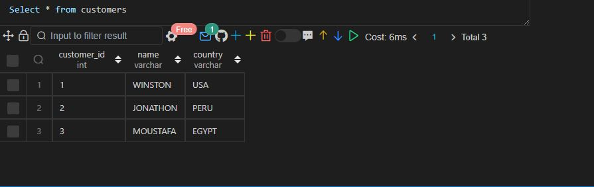

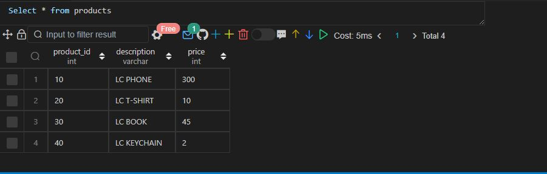

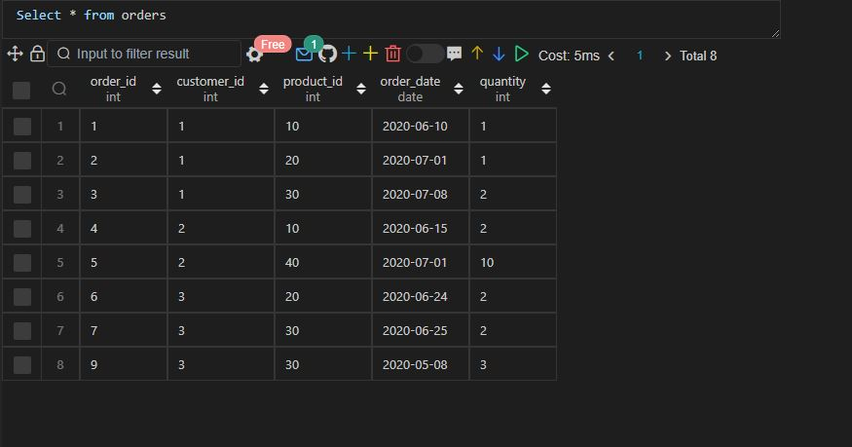

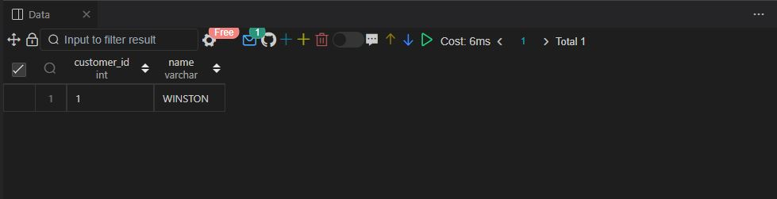

Q29.

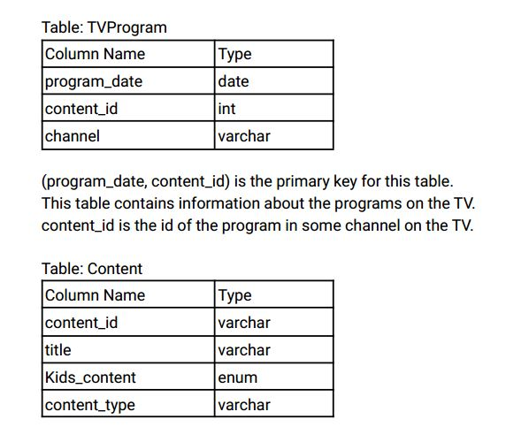

content_id is the primary key for this table.

Kids_content is an enum that takes one of the values ('Y', 'N') where:

'Y' means content for kids, otherwise 'N' is not content for kids.

content_type is the category of the content as movies, series, etc.

Write an SQL query to report the distinct titles of the kid-friendly movies streamed in June 2020.

Return the result table in any order .

The query result format is in the following example.

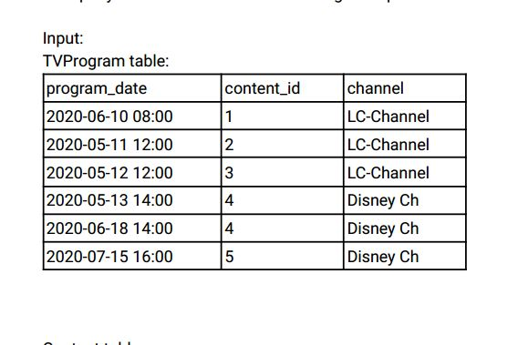

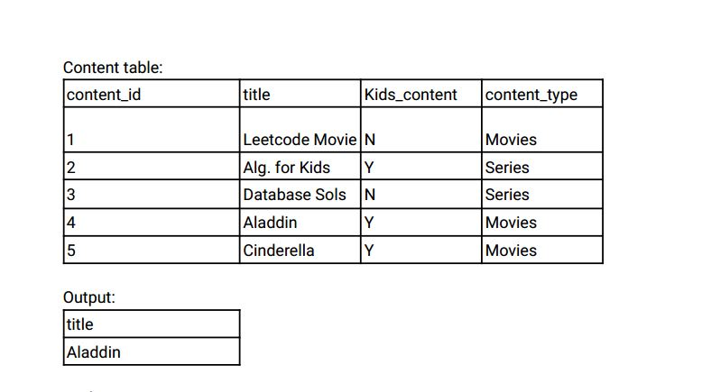

Explanation:

"Leetcode Movie" is not a content for kids.

" Alg. for Kids" is not a movie.

"Database Sols" is not a movie

" Alladin " is a movie, content for kids and was streamed in June 2020.

"Cinderella" was not streamed in June 2020.

Ans:-

|  |
| --- |
|  |
| CREATE TABLE tv_program( |
|  | program_date DATETIME, |
|  | content_id INT, |
|  | channel VARCHAR(20), |
|  | CONSTRAINT prime_key PRIMARY KEY(program_date, content_id) |
|  | ); |
|  |  |
|  |  |
|  | CREATE TABLE content( |
|  | content_id INT, |
|  | title VARCHAR(20), |
|  | kids_content ENUM('Y','N'), |
|  | content_type VARCHAR(20), |
|  | CONSTRAINT prime_key PRIMARY KEY(content_id) |
|  | ); |
|  |  |
|  |  |
|  | INSERT INTO content VALUES |
|  | (1,'LEETCODE MOVIE', 'N','MOVIES'), |
|  | (2,'ALG. FOR KidS', 'Y','SERIES'), |
|  | (3,'DATABASE SOLS', 'N','SERIES'), |
|  | (4,'ALADDIN', 'Y','MOVIES'), |
|  | (5,'CINDERELLA', 'Y','MOVIES'); |
|  |  |
|  |  |
|  | INSERT INTO tv_program VALUES |
|  | ('2020-06-10 18:00',1,'LC-channel'), |
|  | ('2020-05-11 12:00',2,'LC-channel'), |
|  | ('2020-05-12 12:00',3,'LC-channel'), |
|  | ('2020-05-13 14:00',4,'DISNEY-CH'), |
|  | ('2020-06-18 14:00',4,'DISNEY-CH'), |
|  | ('2020-07-15 16:00',5,'DISNEY-CH'); |
|  |  |
|  |  |
|  |  |
|  | SELECT |
|  | DISTINCT c.title |
|  | FROM |
|  | content c |
|  | INNER JOIN |
|  | tv_program t |
|  | ON |
|  | c.content_id = T.content_id |
|  | WHERE |
|  | c.kids_content = 'Y' |
|  | AND |
|  | c.content_type = 'movies' |
|  | AND |
|  | T.program_date BETWEEN '2020-06-01' AND '2020-06-30'; |
|  |  |
|  |  |
|  |  |

Select * from content;

Select * from tv_program;

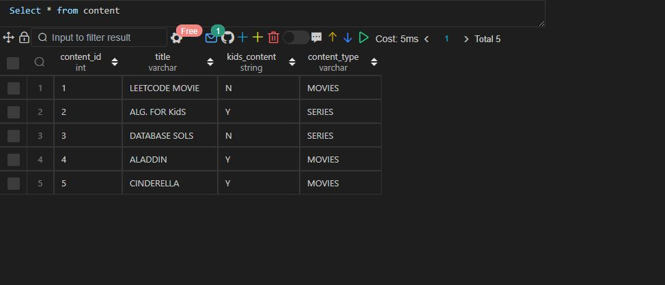

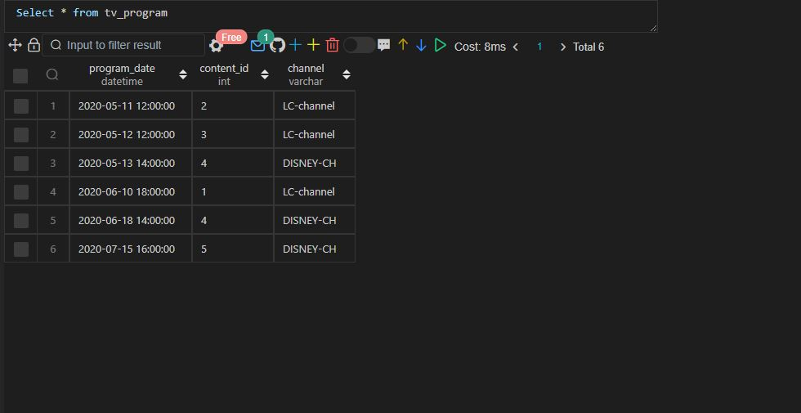

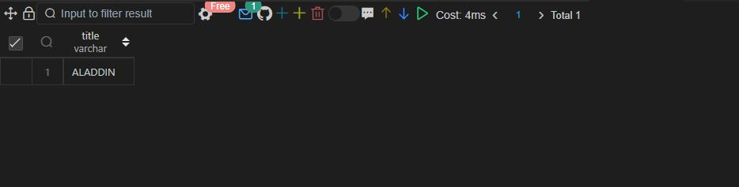

Q30.

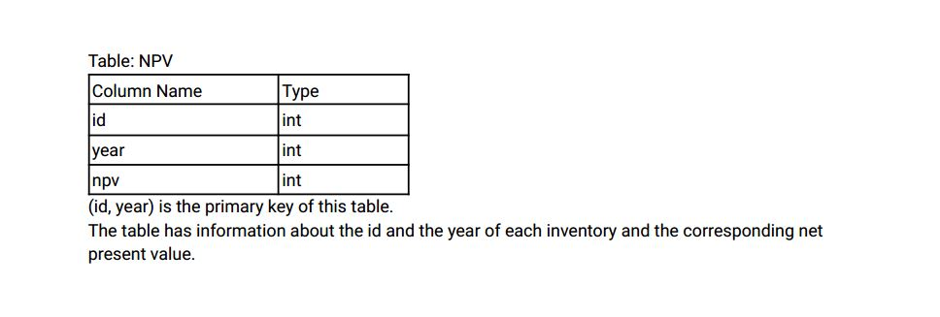

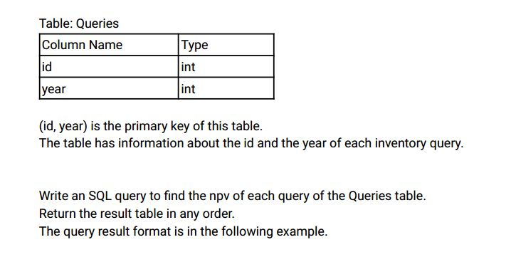

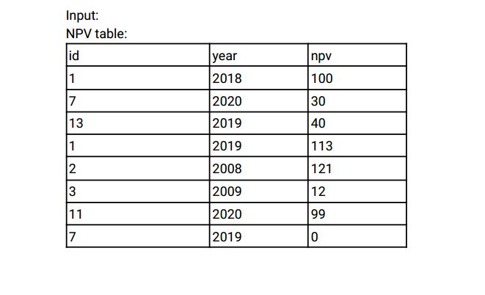

Queries table:

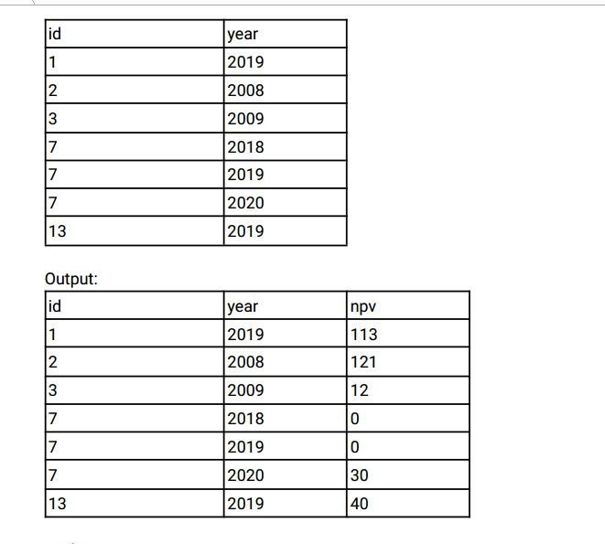

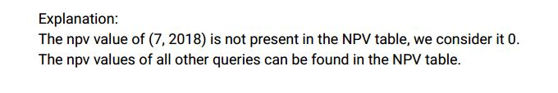

Ans:-

|  |
| --- |
|  |
| CREATE TABLE npv( |
|  | id INT, |
|  | year INT, |
|  | npv INT, |
|  | CONSTRAINT prime_key PRIMARY KEY(id, year) |
|  | ); |
|  |  |
|  |  |
|  | CREATE TABLE queries( |
|  | id INT, |
|  | year INT, |
|  | CONSTRAINT prime_key PRIMARY KEY(id, year) |
|  | ); |
|  |  |
|  |  |
|  | INSERT INTO npv VALUES |
|  | (1,2018,100), |
|  | (7,2020,30), |
|  | (13,2019,40), |
|  | (1,2019,113), |
|  | (2,2008,121), |
|  | (3,2009,12), |
|  | (11,2020,99), |
|  | (7,2019,0); |
|  |  |
|  |  |
|  | INSERT INTO queries VALUES |
|  | (1,2019), |
|  | (2,2008), |
|  | (3,2009), |
|  | (7,2018), |
|  | (7,2019), |
|  | (7,2020), |
|  | (13,2019); |
|  |  |
|  |  |
|  |  |
|  | SELECT |
|  | DISTINCT n.id, |
|  | n.year, |
|  | n.npv |
|  | FROM |
|  | queries q |
|  | INNER JOIN |
|  | npv n |
|  | ON |
|  | n.id = q.id |
|  | AND |
|  | n.year = q.year; |
|  |  |
|  |  |
|  |  |

Select * from npv;

Select * from queries;

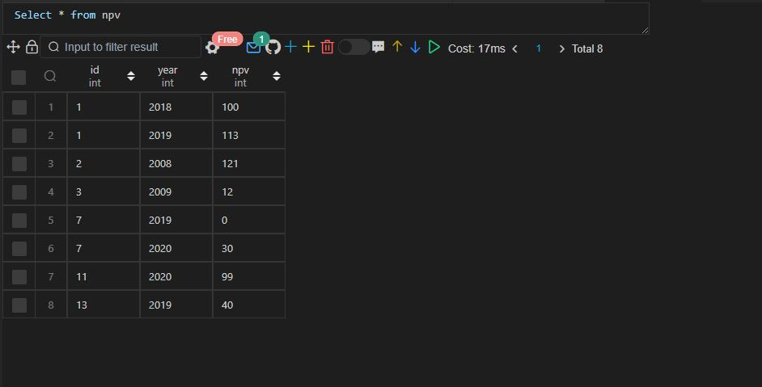

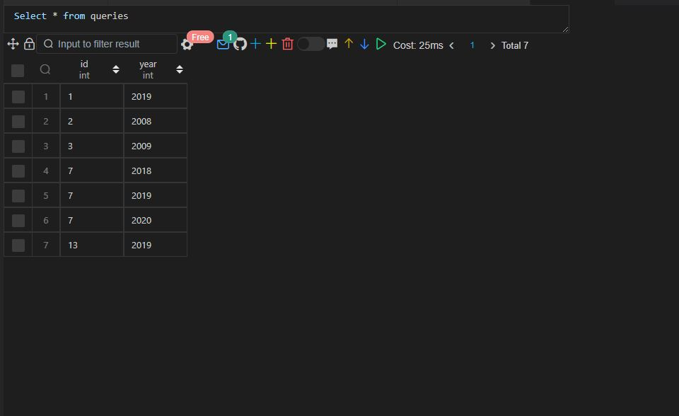

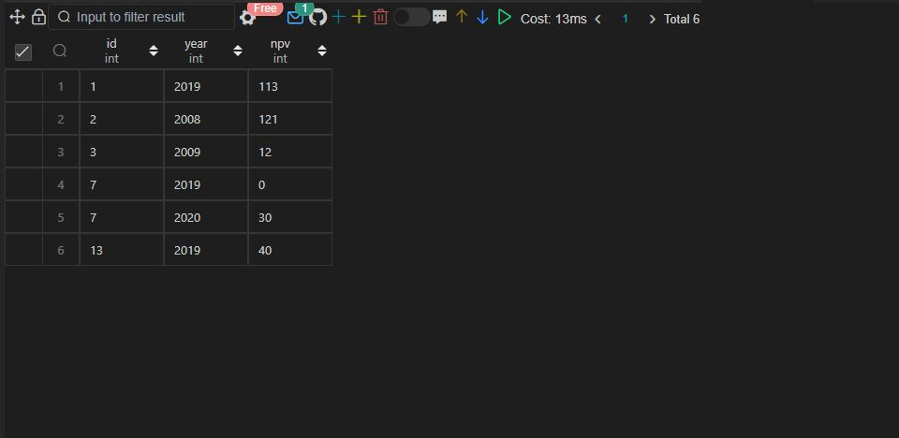

**Q.31 SAME AS 30**

Q32.

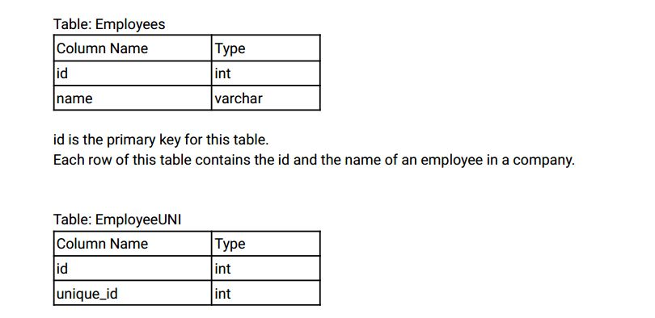

(id, unique_id) is the primary key for this table.

Each row of this table contains the id and the corresponding unique id of an employee in the

company .

Write an SQL query to show the unique ID of each user , If a user does not have a unique ID replace just

show null.

Return the result table in any order .

The query result format is in the following example.

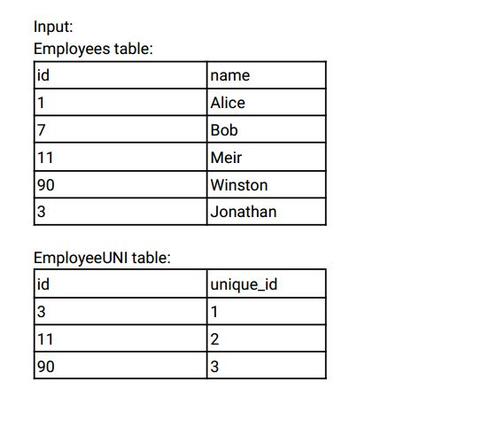

Output:

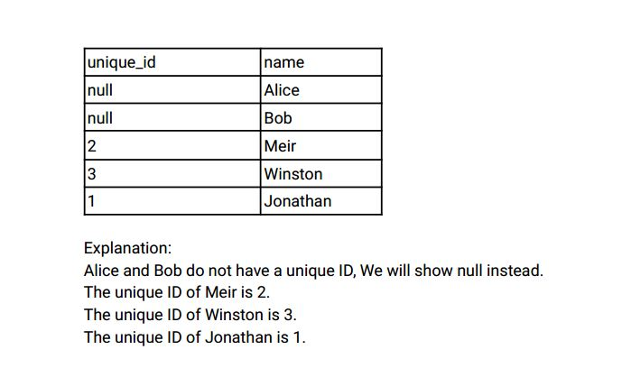

Ans:-

|  |
| --- |
|  |
| CREATE TABLE employees( |
|  | id INT, |
|  | name VARCHAR(20), |
|  | CONSTRAINT prime_key PRIMARY KEY(id) |
|  | ); |
|  |  |
|  |  |
|  | CREATE TABLE employees_uni( |
|  | id INT, |
|  | unique_id INT, |
|  | CONSTRAINT prime_key PRIMARY KEY(id, unique_id) |
|  | ); |
|  |  |
|  |  |
|  | INSERT INTO employees VALUES |
|  | (1,'ALICE'), |
|  | (7,'BOB'), |
|  | (11,'MEIR'), |
|  | (90,'WINSTON'), |
|  | (3,'JONATHAN'); |
|  |  |
|  |  |
|  | INSERT INTO employees_uni VALUES |
|  | (3,1), |
|  | (11,2), |
|  | (90,3); |
|  |  |
|  |  |
|  |  |
|  | SELECT |
|  | eu.unique_id, |
|  | e.name |
|  | FROM |
|  | employees e |
|  | LEFT JOIN |
|  | employees_uni eu |
|  | ON |
|  | e.id = eu.id |
|  | ORDER BY |
|  | e.name; |
|  |  |
|  |  |
|  |  |

Select * from employees;

                Select * from employees_uni;

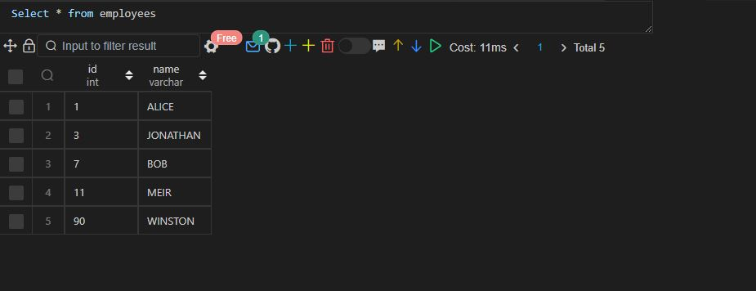

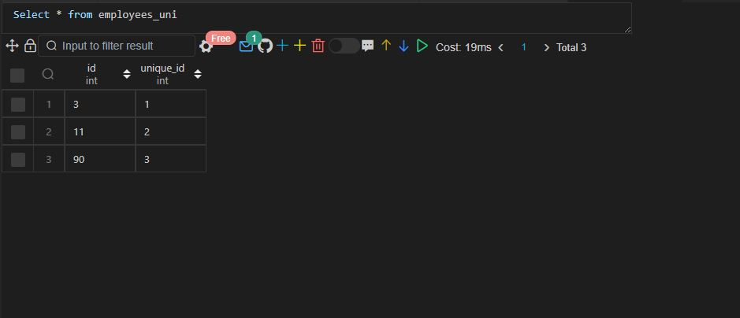

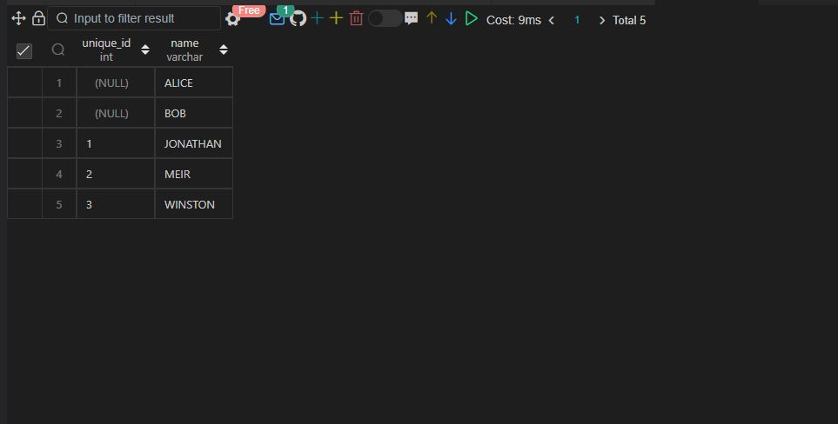

Q33.

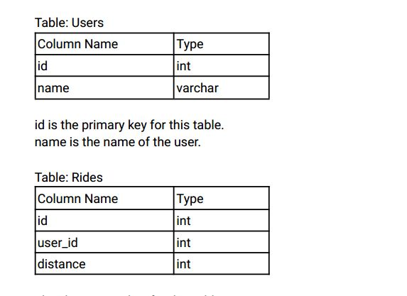

id is the primary key for this table.

user_id is the id of the user who travelled the distance "distance".

Write an SQL query to report the distance travelled by each user .

Return the result table ordered by travelled_distance in descending order , if two or more users

travelled the same distance, order them by their name in ascending order .

The query result format is in the following example.

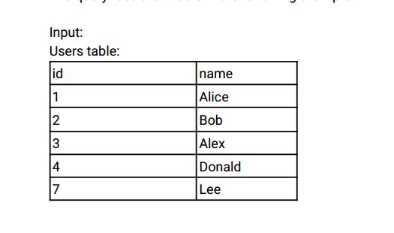

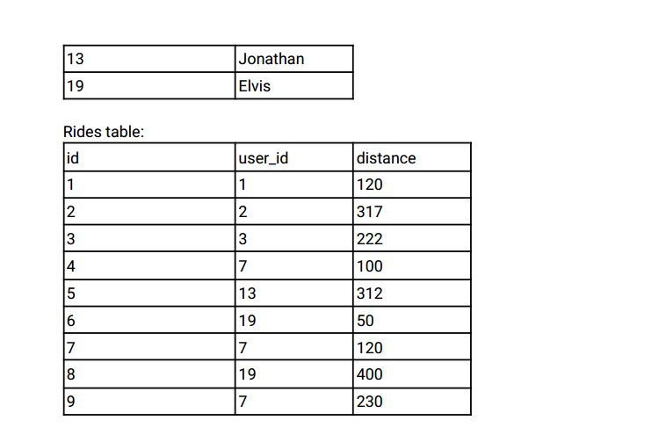

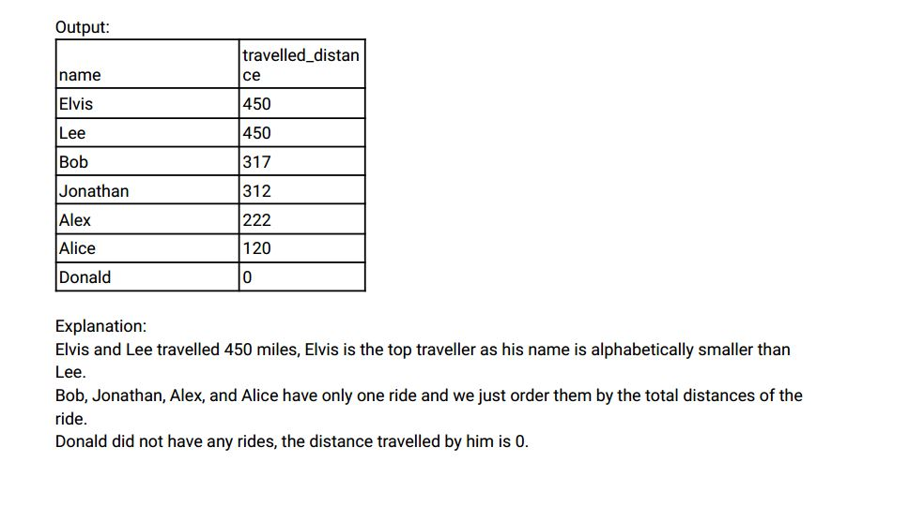

Ans:-

|  |
| --- |
|  |
| CREATE TABLE users( |
|  | id INT, |
|  | name VARCHAR(20), |
|  | CONSTRAINT prime_key PRIMARY KEY(id) |
|  | ); |
|  |  |
|  |  |
|  | INSERT INTO users VALUES |
|  | (1,'ALICE'), |
|  | (2,'BOB'), |
|  | (3,'ALEX'), |
|  | (4,'DONALD'), |
|  | (7,'LEE'), |
|  | (13,'JONATHON'), |
|  | (19,'ELVIS'); |
|  |  |
|  |  |
|  | CREATE TABLE rides( |
|  | id INT, |
|  | user_id INT, |
|  | distance INT, |
|  | CONSTRAINT prime_key PRIMARY KEY(id) |
|  | ); |
|  |  |
|  |  |
|  | INSERT INTO rides VALUES |
|  | (1,1,120), |
|  | (2,2,317), |
|  | (3,3,222), |
|  | (4,7,100), |
|  | (5,13,312), |
|  | (6,19,50), |
|  | (7,7,120), |
|  | (8,19,400), |
|  | (9,7,230); |
|  |  |
|  |  |
|  |  |
|  | SELECT |
|  | u.name AS riders, |
|  | COALESCE(SUM(r.distance), 0) AS distance_travelled |
|  | FROM |
|  | users u |
|  | LEFT JOIN |
|  | rides r |
|  | ON |
|  | u.id = r.user_id |
|  | GROUP BY |
|  | u.name |
|  | ORDER BY |
|  | distance_travelled DESC, |
|  | riders; |
|  |  |
|  |  |
|  |  |

Select * from users;

Select * from rides;

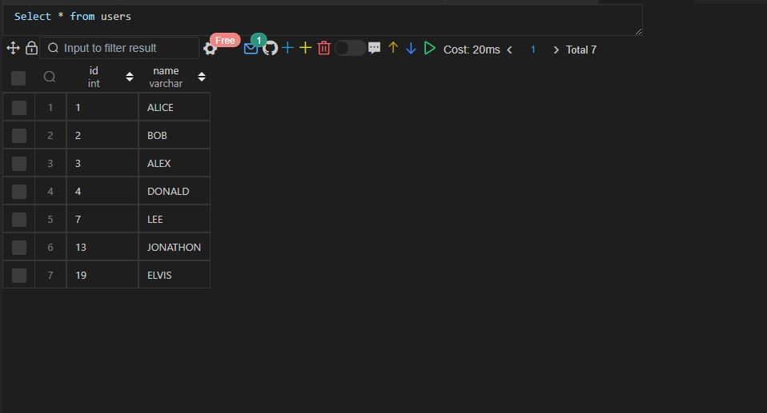

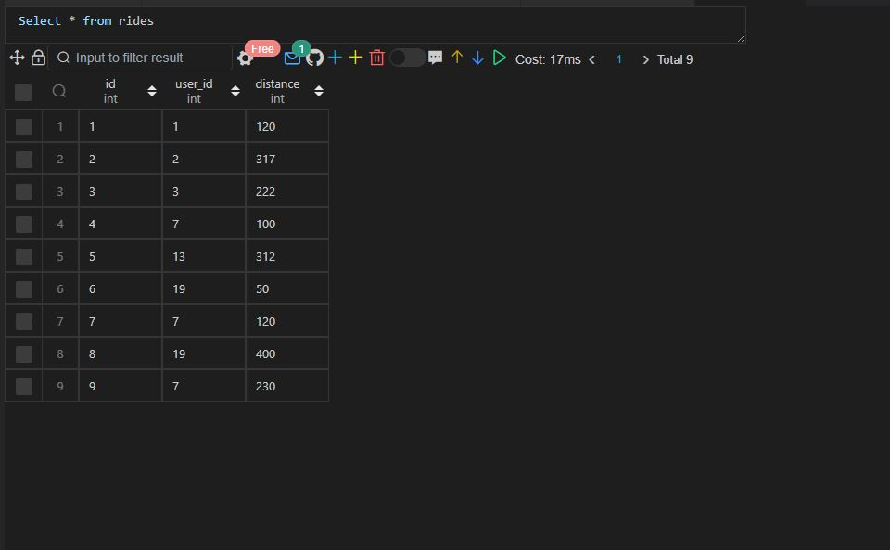

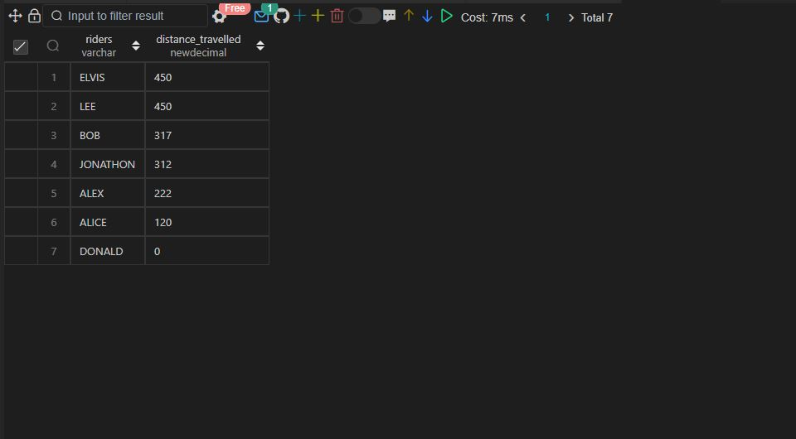

**Q.34 SAME AS 26**

Q35.

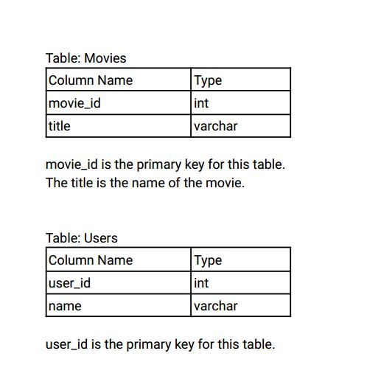

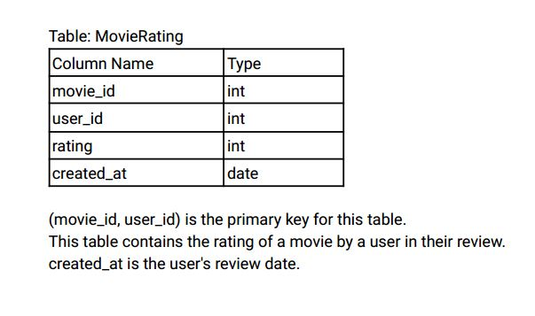

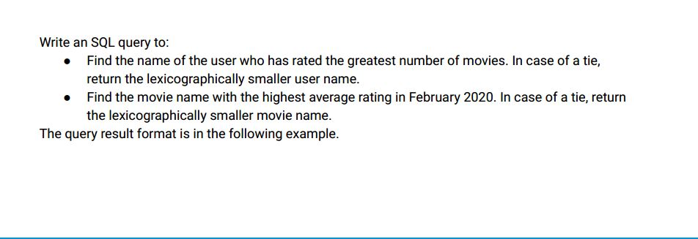

Input:

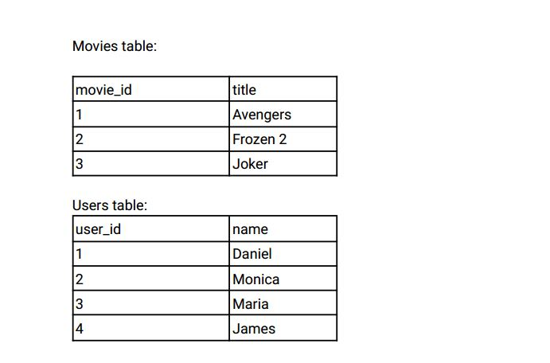

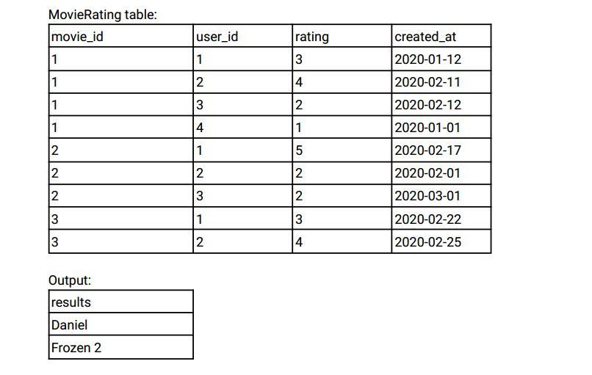

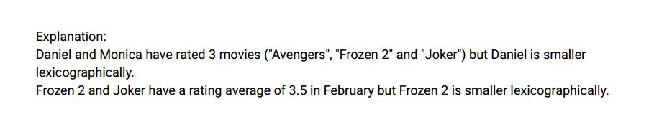

Ans:-

|  |
| --- |
|  |
| CREATE TABLE users( |
|  | user_id INT, |
|  | name VARCHAR(20), |
|  | CONSTRAINT prime_key PRIMARY KEY(user_id) |
|  | ); |
|  |  |
|  |  |
|  | INSERT INTO users VALUES |
|  | (1,'DANIEL'), |
|  | (2,'MONICA'), |
|  | (3,'MARIA'), |
|  | (4,'JAMES'); |
|  |  |
|  |  |
|  | CREATE TABLE movies( |
|  | movie_id INT, |
|  | title VARCHAR(20), |
|  | CONSTRAINT prime_key PRIMARY KEY(movie_id) |
|  | ); |
|  |  |
|  |  |
|  | INSERT INTO movies VALUES |
|  | (1,'AVENGERS'), |
|  | (2,'FROZEN 2'), |
|  | (3,'JOKER'); |
|  |  |
|  |  |
|  | CREATE TABLE movie_rating( |
|  | movie_id INT, |
|  | user_id INT, |
|  | rating INT, |
|  | created_at DATE, |
|  | CONSTRAINT prime_key PRIMARY KEY(movie_id, user_id) |
|  | ); |
|  |  |
|  |  |
|  | INSERT INTO movie_rating VALUES |
|  | (1,1,3,'2020-01-12'), |
|  | (1,2,4,'2020-02-11'), |
|  | (1,3,2,'2020-02-12'), |
|  | (1,4,1,'2020-01-01'), |
|  | (2,1,5,'2020-02-17'), |
|  | (2,2,2,'2020-02-01'), |
|  | (2,3,2,'2020-03-01'), |
|  | (3,1,3,'2020-02-22'), |
|  | (3,2,4,'2020-02-25'); |
|  |  |
|  |  |
|  |  |
|  | -- Find the name of the user who has rated the greatest number of movies |
|  |  |
|  |  |
|  |  |
|  | SELECT |
|  | u.name as user |
|  | FROM |
|  | users u |
|  | INNER JOIN |
|  | movie_rating mr |
|  | ON |
|  | u.user_id = mr.user_id |
|  | GROUP BY |
|  | u.user_id |
|  | ORDER BY |
|  | COUNT(u.name) DESC, |
|  | LENGTH(u.name) |
|  | LIMIT 1; |
|  |  |
|  |  |
|  |  |
|  | -- Find the movie name with the highest average rating in February 2020. |
|  |  |
|  |  |
|  |  |
|  | SELECT |
|  | m.title |
|  | FROM |
|  | movies m |
|  | INNER JOIN |
|  | movie_rating mr |
|  | ON |
|  | m.movie_id = mr.movie_id |
|  | WHERE |
|  | mr.created_at BETWEEN '2020-02-01' AND '2020-02-28' |
|  | GROUP BY |
|  | m.movie_id |
|  | ORDER BY |
|  | AVG(rating) DESC, |
|  | m.title |
|  | LIMIT 1; |
|  |  |
|  |  |
|  |  |

Select * from users;

Select * from movies;

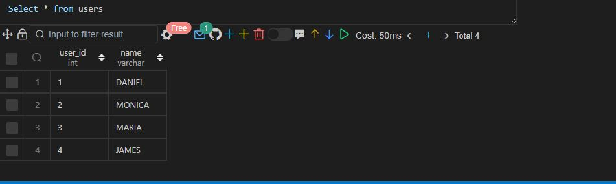

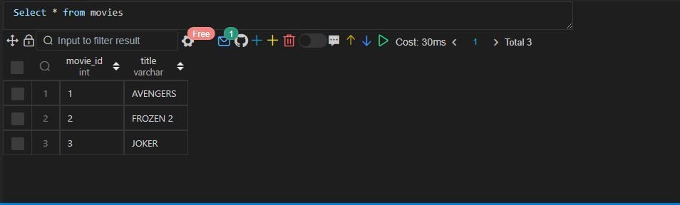

Select * from movie_rating;

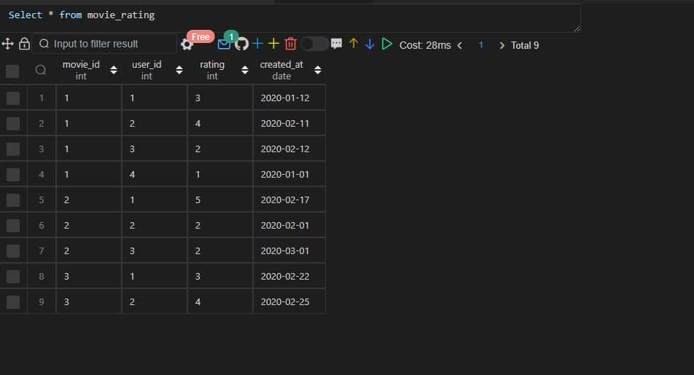

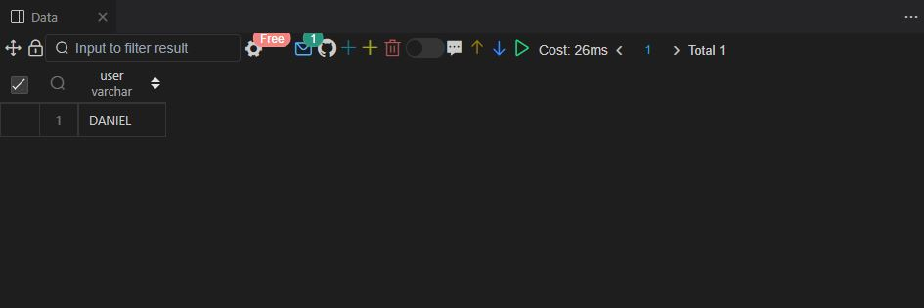

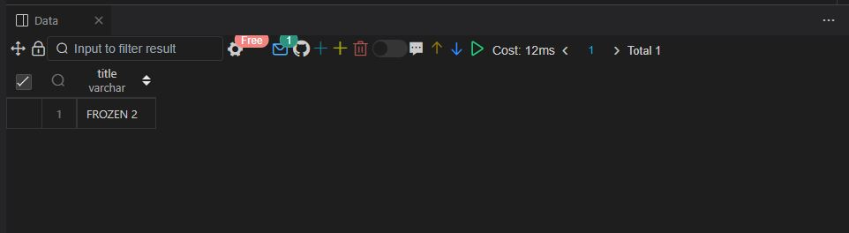

|  |
| --- |
|  |

Q.36 SAME AS 33

Q.37 SAME AS 32

Q38.

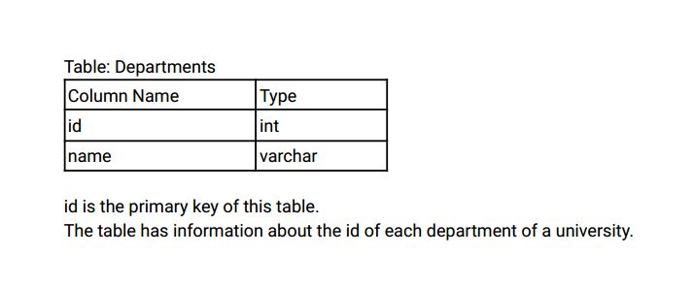

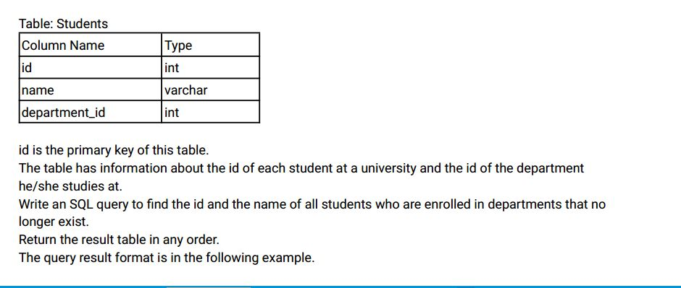

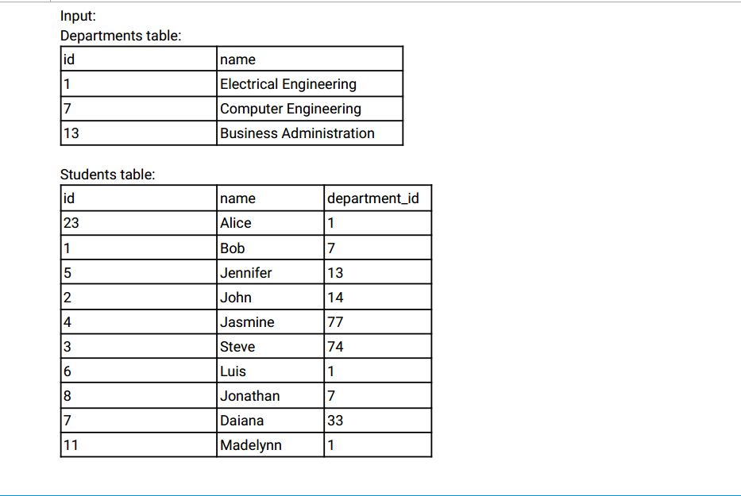

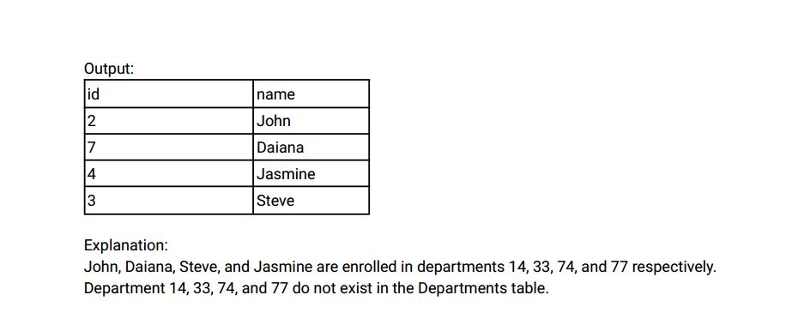

Ans:-

|  |
| --- |
|  |
| CREATE TABLE departments( |
|  | id INT, |
|  | name VARCHAR(25), |
|  | CONSTRAINT prime_key PRIMARY KEY(id) |
|  | ); |
|  |  |
|  |  |
|  | INSERT INTO departments VALUES |
|  | (1,'ELECTRICAL ENGINEERING'), |
|  | (7,'COMPUTER ENGINEERING'), |
|  | (13,'BUSINESS ADMINISTRATION'); |
|  |  |
|  |  |
|  | CREATE TABLE students( |
|  | id INT, |
|  | name VARCHAR(25), |
|  | department_id INT, |
|  | CONSTRAINT prime_key PRIMARY KEY(id) |
|  | ); |
|  |  |
|  |  |
|  | INSERT INTO students VALUES |
|  | (23,'ALICE',1), |
|  | (1,'BOB',7), |
|  | (5,'JENNIFER',13), |
|  | (2,'JOHN',14), |
|  | (4,'JASMINE',77), |
|  | (3,'STEVE',74), |
|  | (6,'LUIS',1), |
|  | (8,'JONATHON',7), |
|  | (7,'DAIANA',33), |
|  | (11,'MADELYNN',1); |
|  |  |
|  |  |
|  |  |
|  | SELECT |
|  | id, |
|  | name |
|  | FROM |
|  | students |
|  | WHERE |
|  | department_id NOT IN ( |
|  | SELECT |
|  | id |
|  | FROM |
|  | departments |
|  | ); |
|  |  |
|  |  |
|  |  |

Select * from departments;

Select * from students;

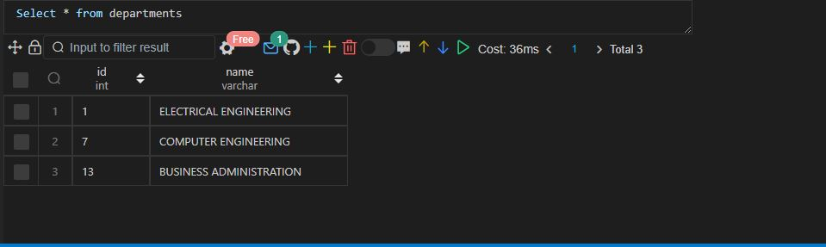

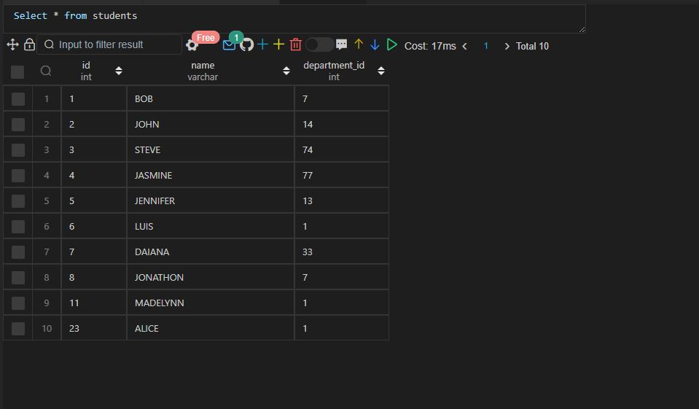

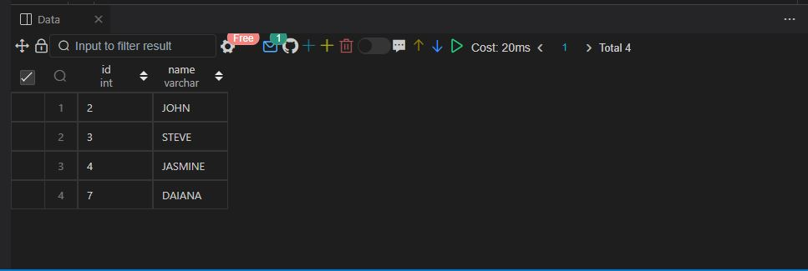

Q39.

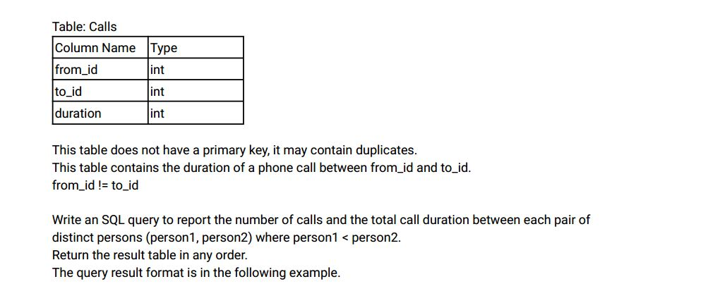

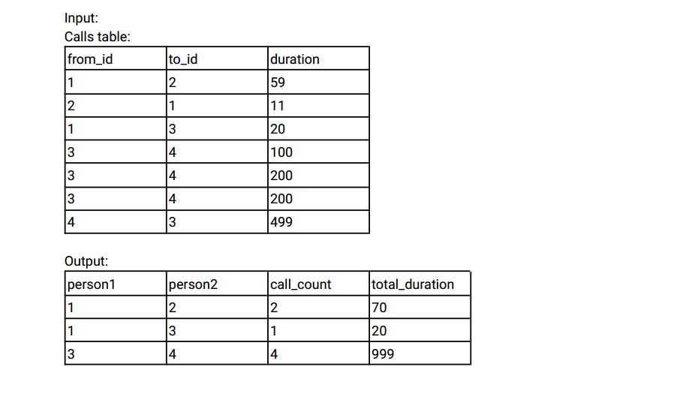

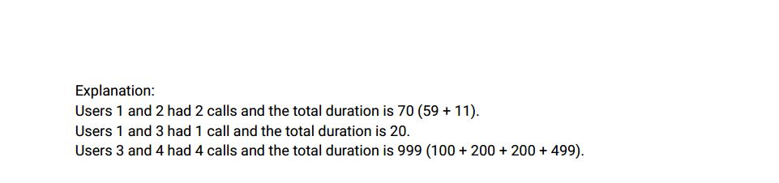

Ans:-

|  |
| --- |
|  |
| CREATE TABLE calls( |
|  | from_id INT, |
|  | to_id INT, |
|  | duration INT |
|  | ); |
|  |  |
|  |  |
|  | INSERT INTO calls VALUES |
|  | (1,2,59), |
|  | (2,1,11), |
|  | (1,3,20), |
|  | (3,4,100), |
|  | (3,4,200), |
|  | (3,4,200), |
|  | (4,3,499); |
|  |  |
|  |  |
|  |  |
|  | -- Approach 1 |
|  |  |
|  |  |
|  |  |
|  | SELECT |
|  | CASE |
|  | WHEN from_id < to_id THEN from_id |
|  | ELSE to_id |
|  | END AS person1, |
|  | CASE |
|  | WHEN from_id < to_id THEN to_id |
|  | ELSE from_id |
|  | END AS person2, |
|  | COUNT(*) AS call_count, |
|  | SUM(duration) AS total_duration |
|  | FROM |
|  | calls |
|  | GROUP BY |
|  | person1, |
|  | person2; |
|  |  |
|  |  |
|  |  |
|  | -- Approach 2 |
|  |  |
|  |  |
|  |  |
|  | SELECT |
|  | least(from_id, to_id) AS person1, |
|  | greatest(from_id,to_id) AS person2, |
|  | COUNT(*) AS call_count, |
|  | SUM(duration) AS total_duration |
|  | FROM |
|  | calls |
|  | GROUP BY |
|  | person1, |
|  | person2; |
|  |  |
|  |  |
|  |  |

Select * from calls;

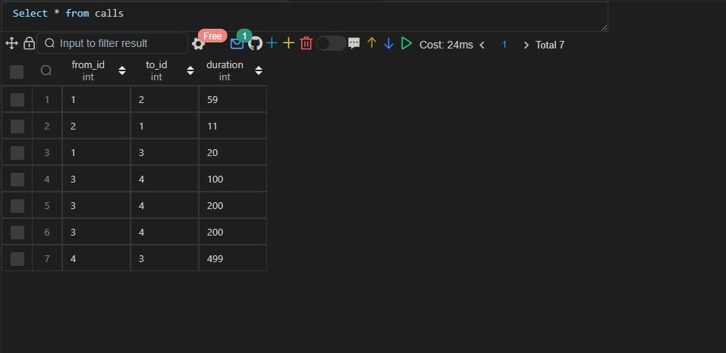

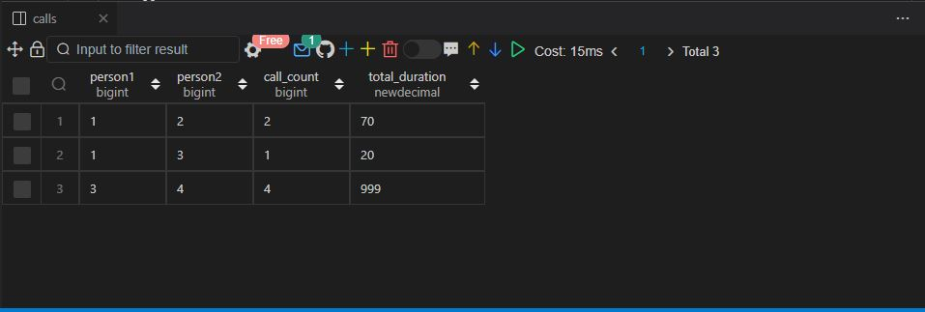

Q.40 SAME AS 23

Q41.

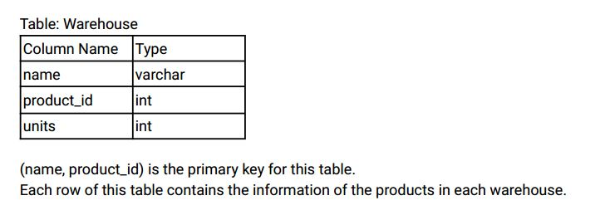

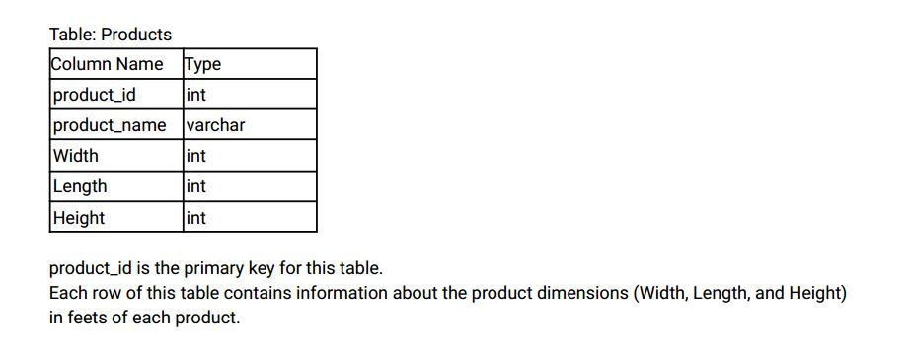

Write an SQL query to report the number of cubic feet of volume the inventory occupies in each

warehouse.

Return the result table in any order .

The query result format is in the following example.

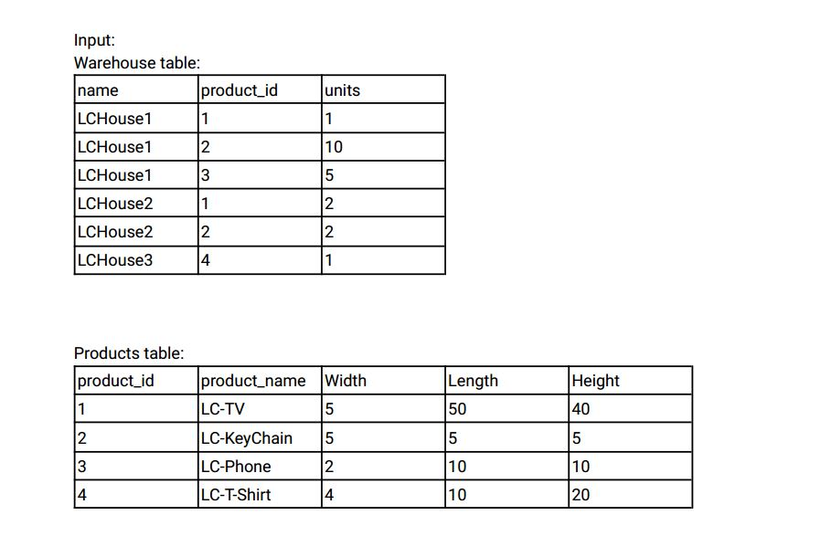

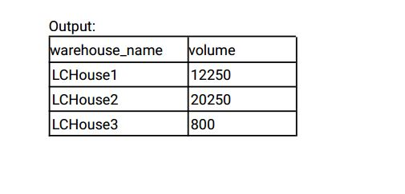

Ans:-

|  |
| --- |
|  |
| CREATE TABLE warehouse( |
|  | name VARCHAR(25), |
|  | product_id INT, |
|  | units INT, |
|  | CONSTRAINT prime_key PRIMARY KEY(name,product_id) |
|  | ); |
|  |  |
|  |  |
|  | INSERT INTO warehouse VALUES |
|  | ('LCHOUSE1',1,1), |
|  | ('LCHOUSE1',2,10), |
|  | ('LCHOUSE1',3,5), |
|  | ('LCHOUSE2',1,2), |
|  | ('LCHOUSE2',2,2), |
|  | ('LCHOUSE3',4,1); |
|  |  |
|  |  |
|  | CREATE TABLE products( |
|  | product_id INT, |
|  | product_name VARCHAR(25), |
|  | width INT, |
|  | length INT, |
|  | height INT, |
|  | CONSTRAINT prime_key PRIMARY KEY(product_id) |
|  | ); |
|  |  |
|  |  |
|  | INSERT INTO products VALUES |
|  | (1,'LC-TV',5,50,40), |
|  | (2,'LC-KEYCHAIN',5,5,5), |
|  | (3,'LC-PHONE',2,10,10), |
|  | (4,'LC-SHIRT',4,10,20); |
|  |  |
|  |  |
|  |  |
|  | SELECT |
|  | w.name AS warehouse_name, |
|  | SUM(p.length * p.width * p.height * w.units) AS volume |
|  | FROM |
|  | warehouse w |
|  | INNER JOIN |
|  | products p |
|  | ON |
|  | w.product_id = p.product_id |
|  | GROUP BY |
|  | w.name; |
|  |  |
|  |  |
|  |  |

Select * from warehouse;

Select * from products;

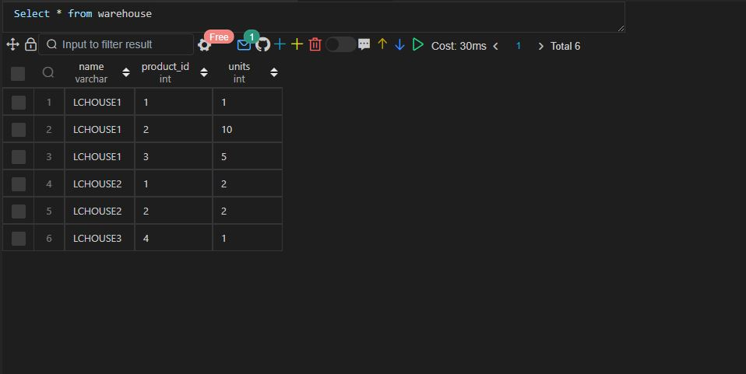

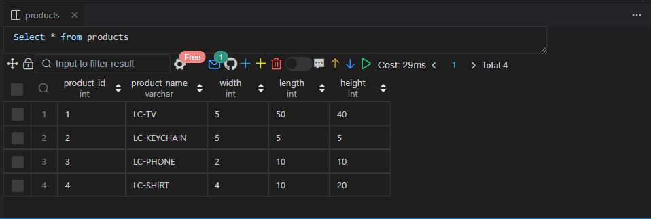

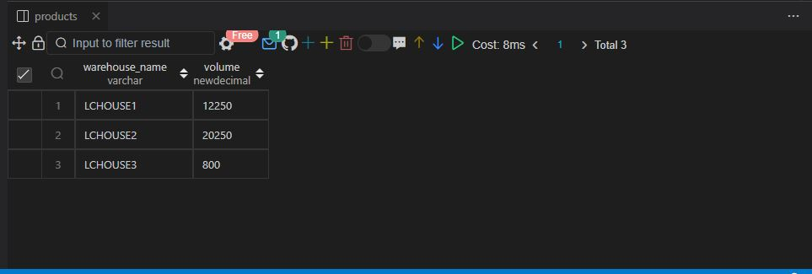

Q42.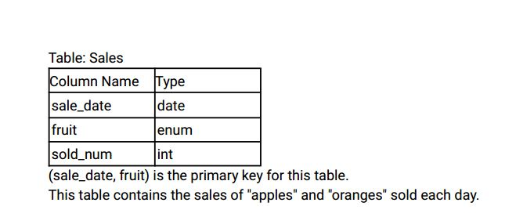

Write an SQL query to report the difference between the number of apples and oranges sold each day .

Return the result table ordered by sale_date.

The query result format is in the following example.

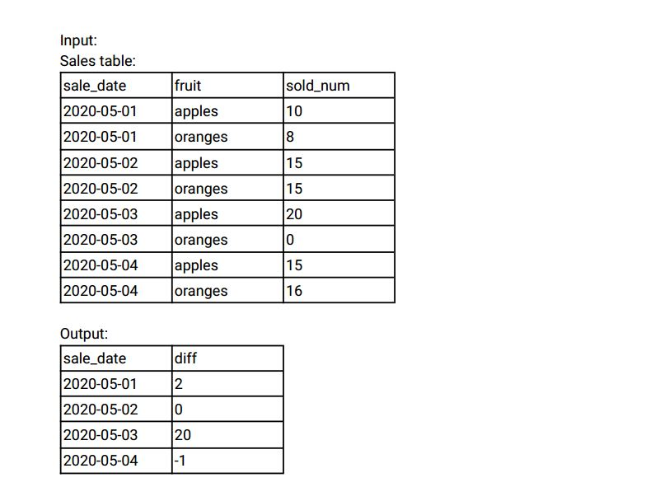

Explanation:

Day 2020-05-01, 10 apples and 8 oranges were sold (Difference 10 - 8 = 2).

Day 2020-05-02, 15 apples and 15 oranges were sold (Difference 15 - 15 = 0).

Day 2020-05-03, 20 apples and 0 oranges were sold (Difference 20 - 0 = 20).

Day 2020-05-04, 15 apples and 16 oranges were sold (Difference 15 - 16 = -1).

Ans:-

|  |
| --- |
|  |
| CREATE TABLE sales( |
|  | sale_date DATE, |
|  | fruit ENUM('APPLES','ORANGES'), |
|  | sold_num INT, |
|  | CONSTRAINT prime_key PRIMARY KEY(sale_date,fruit) |
|  | ); |
|  |  |
|  |  |
|  | INSERT INTO sales VALUES |
|  | ('2020-05-01','APPLES',10), |
|  | ('2020-05-01','ORANGES',8), |
|  | ('2020-05-02','APPLES',15), |
|  | ('2020-05-02','ORANGES',15), |
|  | ('2020-05-03','APPLES',20), |
|  | ('2020-05-03','ORANGES',0), |
|  | ('2020-05-04','APPLES',15), |
|  | ('2020-05-04','ORANGES',16); |
|  |  |
|  |  |
|  |  |
|  | -- Approach 1 |
|  |  |
|  |  |
|  |  |
|  | SELECT |
|  | sale_date, |
|  | difference |
|  | FROM |
|  | ( |
|  | SELECT |
|  | sale_date, |
|  | sold_num - LEAD(sold_num, 1) OVER(PARTITION BY sale_date) AS difference |
|  | FROM |
|  | sales |
|  | ) temp_sales |
|  | WHERE |
|  | difference IS NOT NULL |
|  | ORDER BY |
|  | sale_date; |
|  |  |
|  |  |
|  |  |
|  | -- Approach 2 |
|  |  |
|  |  |
|  |  |
|  | SELECT |
|  | sale_date, |
|  | SUM( |
|  | CASE |
|  | WHEN fruit = 'APPLES' THEN sold_num |
|  | WHEN fruit = 'ORANGES' THEN -sold_num |
|  | END |
|  | ) AS difference |
|  | FROM |
|  | sales |
|  | GROUP BY |
|  | sale_date |
|  | ORDER BY |
|  | sale_date; |
|  |  |
|  |  |
|  |  |
|  | -- Approach 3 |
|  |  |
|  |  |
|  |  |
|  | SELECT |
|  | s.sale_date, |
|  | s.sold_num - ss.sold_num AS difference |
|  | FROM |
|  | sales s |
|  | INNER JOIN |
|  | sales ss |
|  | ON |
|  | s.sale_date = ss.sale_date |
|  | WHERE |
|  | s.fruit = 'APPLES' AND ss.fruit = 'ORANGES' |
|  | ORDER BY |
|  | sale_date; |
|  |  |
|  |  |
|  |  |
|  | -- Approach 4 |
|  |  |
|  |  |
|  |  |
|  | SELECT |
|  | sale_date, |
|  | SUM(IF(fruit = 'APPLES', sold_num, -sold_num)) AS difference |
|  | FROM |
|  | sales |
|  | GROUP BY |
|  | sale_date |
|  | ORDER BY |
|  | sale_date; |
|  |  |
|  |  |
|  |  |
|  | -- Approach 5 |
|  |  |
|  |  |
|  |  |
|  | SELECT |
|  | sale_date, |
|  | SUM( |
|  | CASE |
|  | WHEN fruit = 'APPLES' THEN sold_num |
|  | ELSE -sold_num |
|  | END |
|  | ) AS difference |
|  | FROM |
|  | sales |
|  | GROUP BY |
|  | sale_date |
|  | ORDER BY |
|  | sale_date; |
|  |  |
|  |  |
|  |  |

Select * from sales;

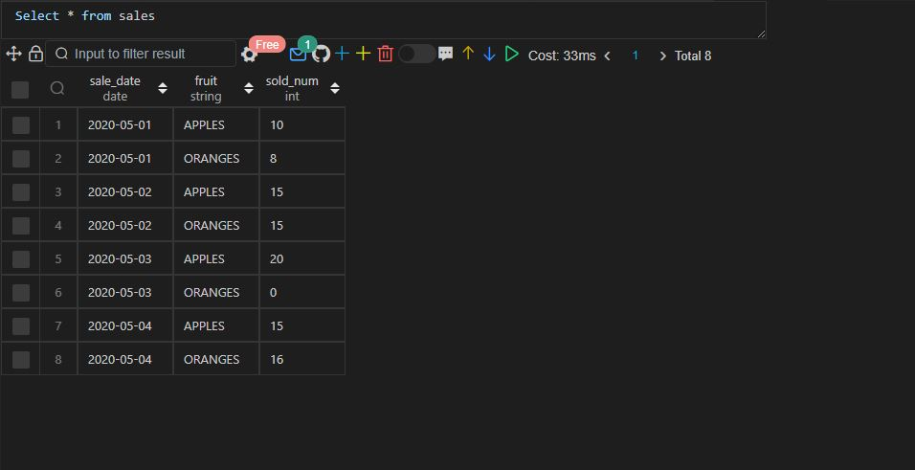

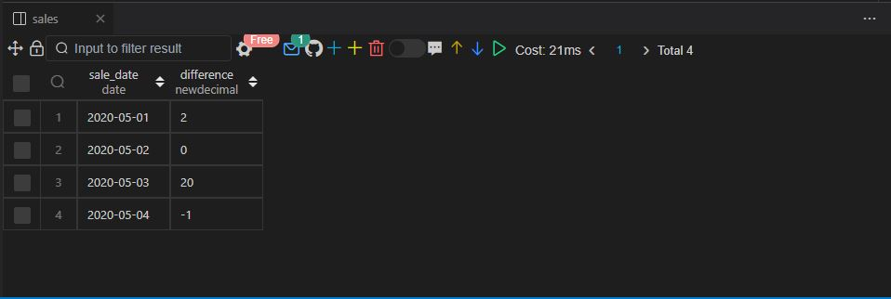

Q43.

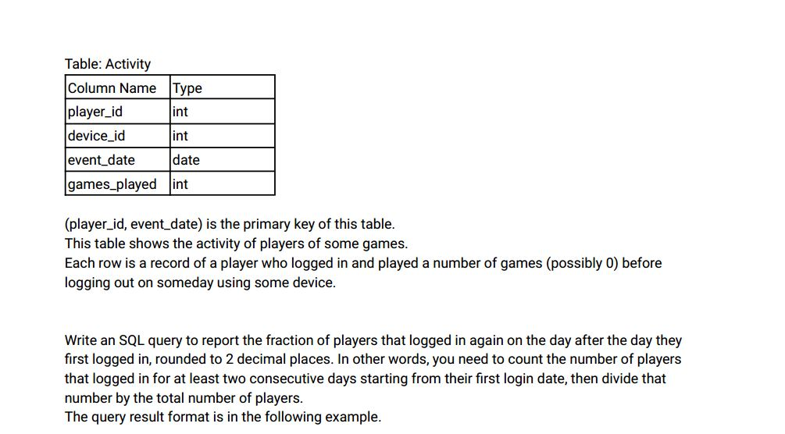

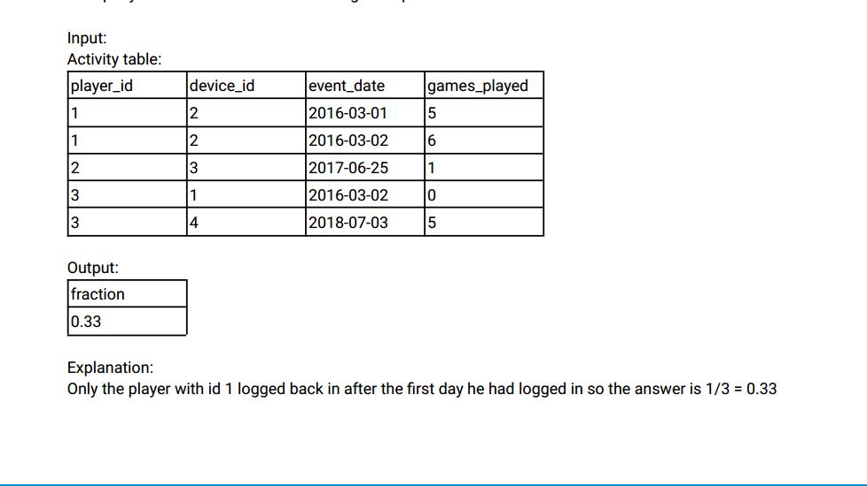

Ans:- CREATE TABLE Activity( player_id int, device_id int, event_date date, games_played int, CONSTRAINT PK PRIMARY KEY(player_id, event_date) );

INSERT INTO Activity VALUES(1,2,'2016-03-01',5), (1,2,'2016-03-02',6), (2,3,'2017-06-25',1), (3,1,'2016-03-02',0), (3,4,'2018-07-03',5);

|  |
| --- |
|  |
| -- Approach 1 |
|  |  |
|  |  |
|  |  |
|  | WITH temp_activity AS ( |
|  | SELECT |
|  | player_id, |
|  | LEAD(event_date, 1) OVER(PARTITION BY player_id ORDER BY event_date) - event_date AS difference |
|  | FROM |
|  | activity |
|  | ), |
|  |  |
|  | temp_activity2 AS ( |
|  | SELECT |
|  | COUNT(DISTINCT player_id) AS players_count |
|  | FROM |
|  | temp_activity |
|  | WHERE |
|  | difference = 1 |
|  | GROUP BY |
|  | player_id |
|  | ) |
|  |  |
|  | SELECT |
|  | ROUND(COUNT(*) / (SELECT COUNT(DISTINCT player_id) FROM activity), 2) AS fraction |
|  | FROM |
|  | temp_activity2; |
|  |  |
|  |  |
|  |  |
|  | -- Approach 2 |
|  |  |
|  |  |
|  |  |
|  | WITH temp_activity AS ( |
|  | SELECT |
|  | player_id, |
|  | event_date, |
|  | DATEDIFF(event_date,lag(event_date) OVER(PARTITION BY player_id ORDER BY event_date)) AS difference |
|  | FROM |
|  | Activity |
|  | ), |
|  |  |
|  | temp_activity2 AS ( |
|  | SELECT |
|  | COUNT(DISTINCT player_id) AS players_count |
|  | FROM |
|  | temp_activity |
|  | WHERE |
|  | difference = 1 |
|  | GROUP BY |
|  | player_id |
|  | ) |
|  |  |
|  |  |
|  | SELECT |
|  | ROUND(COUNT(*) / (SELECT COUNT(DISTINCT player_id) FROM activity), 2) AS fraction |
|  | FROM |
|  | temp_activity2; |
|  |  |
|  |  |
|  |  |

Select * from Activity;

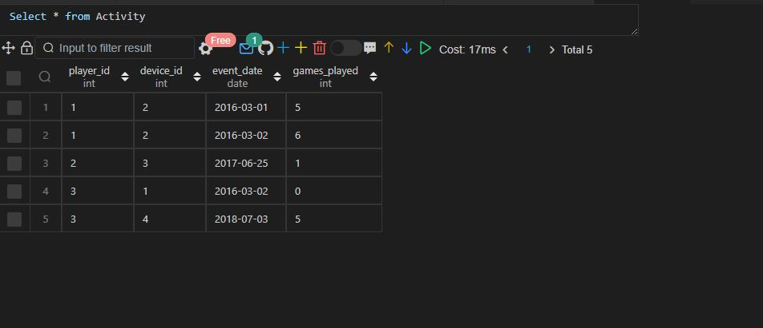

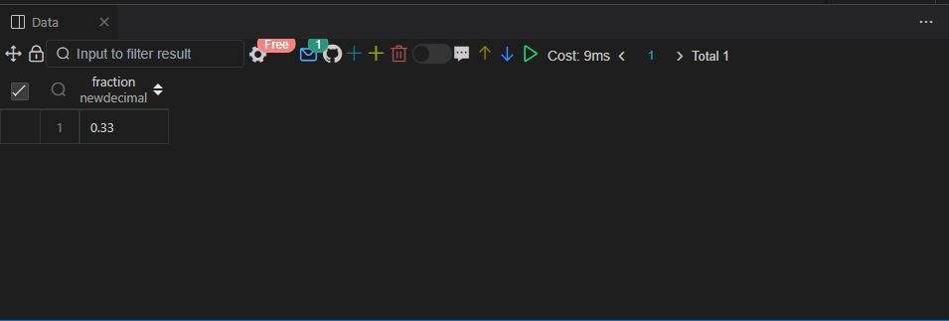

Q44.

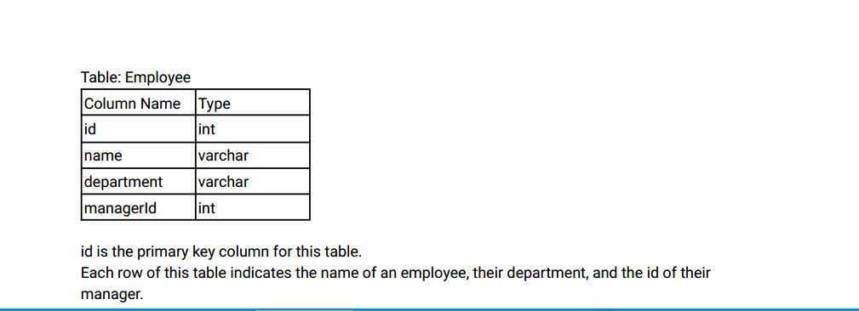

If managerId is null, then the employee does not have a manager .

No employee will be the manager of themself.

Write an SQL query to report the managers with at least five direct reports.

Return the result table in any order .

The query result format is in the following example.

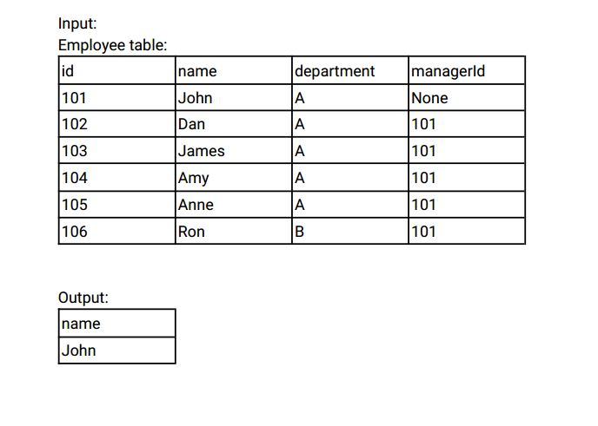

Ans:-

|  |
| --- |
|  |
| CREATE TABLE employee( |
|  | id INT, |
|  | name VARCHAR(20), |
|  | department VARCHAR(20), |
|  | manager_id INT, |
|  | CONSTRAINT prime_key PRIMARY KEY(id) |
|  | ); |
|  |  |
|  |  |
|  | INSERT INTO employee VALUES |
|  | (101,'JOHN','A',NULL), |
|  | (102,'DAN','A',101), |
|  | (103,'JAMES','A',101), |
|  | (104,'AMY','A',101), |
|  | (105,'ANNE','A',101), |
|  | (106,'RON','A',101), |
|  | (107,'BUTTLER','A',111), |
|  | (108,'JIMMY','A',121), |
|  | (111,'ROOT','A',NULL), |
|  | (121,'POPE','A',NULL); |
|  |  |
|  |  |
|  |  |
|  | -- Approach 1 |
|  |  |
|  |  |
|  |  |
|  | SELECT |
|  | name |
|  | FROM |
|  | employee |
|  | WHERE |
|  | id = ( |
|  | SELECT |
|  | e.manager_id |
|  | FROM |
|  | employee e |
|  | INNER JOIN |
|  | employee ee |
|  | ON |
|  | e.manager_id = ee.id |
|  | GROUP BY |
|  | e.manager_id |
|  | HAVING |
|  | COUNT(e.manager_id) >= 5 |
|  | ); |
|  |  |
|  |  |
|  |  |
|  | -- Approach 2 |
|  |  |
|  |  |
|  |  |
|  | SELECT |
|  | name |
|  | FROM |
|  | employee |
|  | WHERE |
|  | id = ( |
|  | SELECT |
|  | manager_id |
|  | FROM |
|  | employee |
|  | GROUP BY |
|  | manager_id |
|  | HAVING |
|  | COUNT(manager_id) >= 5 |
|  | ); |
|  |  |
|  |  |
|  |  |

Select* from employee;

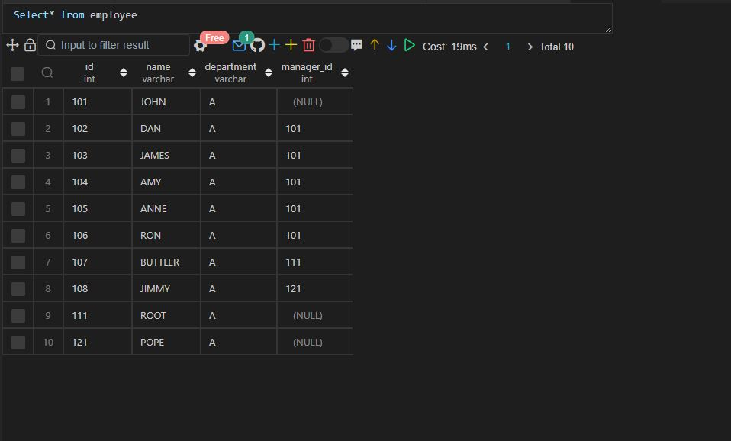

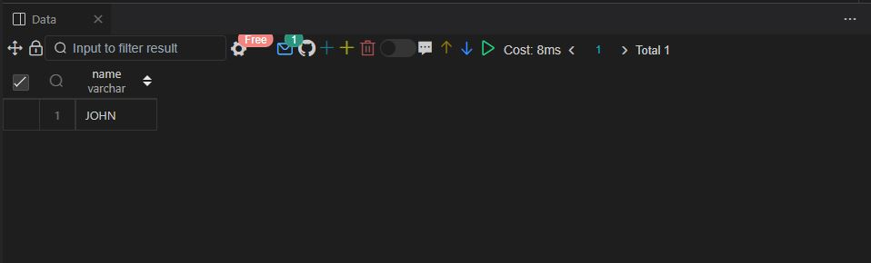

Q45.

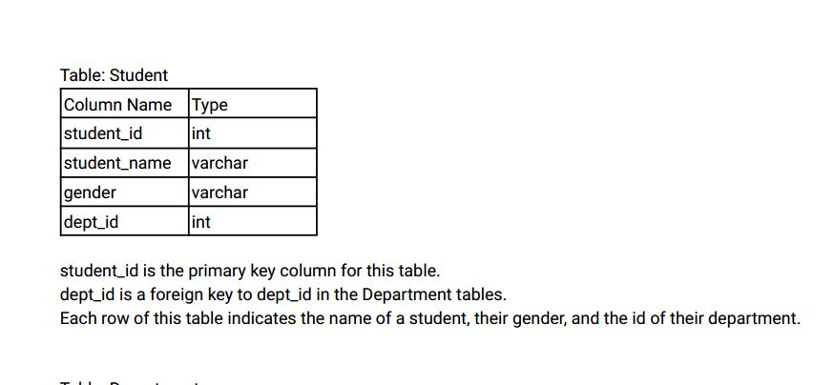

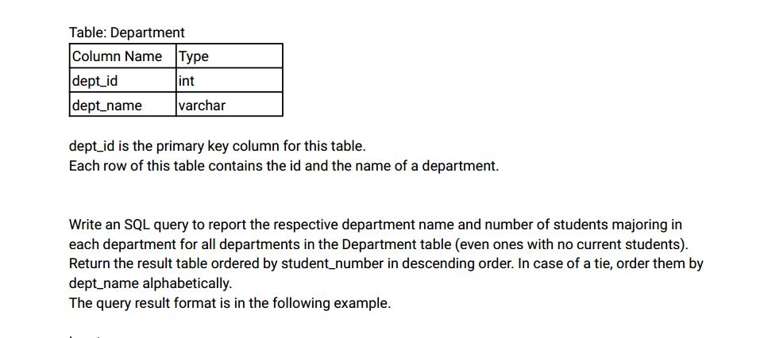

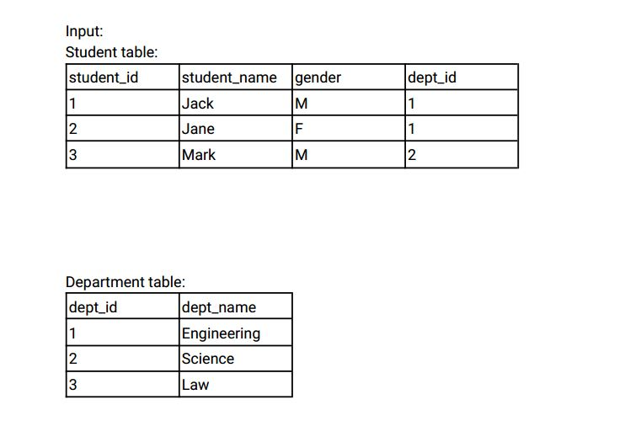

Output:

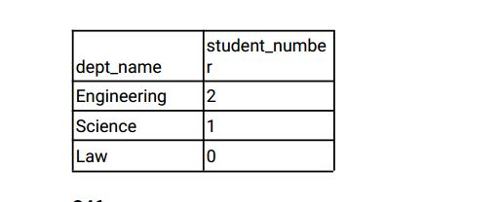

Ans:-

|  |
| --- |
|  |
| CREATE TABLE department( |
|  | dept_id INT, |
|  | department_name VARCHAR(20), |
|  | CONSTRAINT prime_key PRIMARY KEY(dept_id) |
|  | ); |
|  |  |
|  |  |
|  | CREATE TABLE student( |
|  | student_id INT, |
|  | student_name VARCHAR(20), |
|  | gender VARCHAR(6), |
|  | dept_id INT, |
|  | CONSTRAINT prime_key PRIMARY KEY(student_id), |
|  | CONSTRAINT foriegn_key FOREIGN KEY(dept_id) REFERENCES department(dept_id) |
|  | ); |
|  |  |
|  |  |
|  | INSERT INTO department VALUES |
|  | (1,'ENGINEERING'), |
|  | (2,'SCIENCE'), |
|  | (3,'LAW'); |
|  |  |
|  |  |
|  | INSERT INTO student VALUES |
|  | (1,'JACK','M',1), |
|  | (2,'JANE','F',1), |
|  | (3,'MARK','M',2); |
|  |  |
|  |  |
|  |  |
|  | SELECT |
|  | d.department_name, |
|  | COUNT(s.student_id) AS number_of_students |
|  | FROM |
|  | department d |
|  | LEFT JOIN |
|  | student s |
|  | ON |
|  | d.dept_id = s.dept_id |
|  | GROUP BY |
|  | d.department_name |
|  | ORDER BY |
|  | number_of_students DESC, |
|  | department_name; |
|  |  |
|  |  |
|  |  |

Select * from department;

Select * from student;

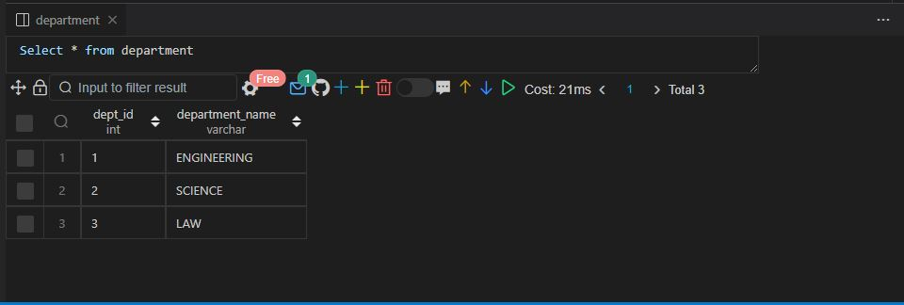

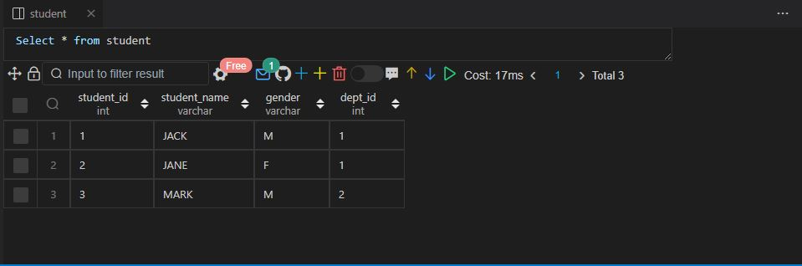

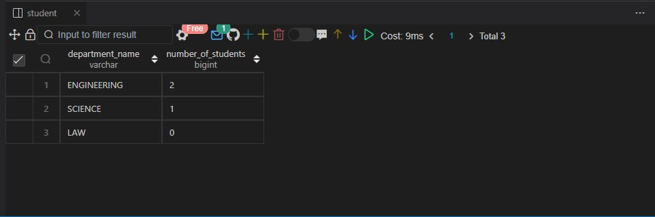

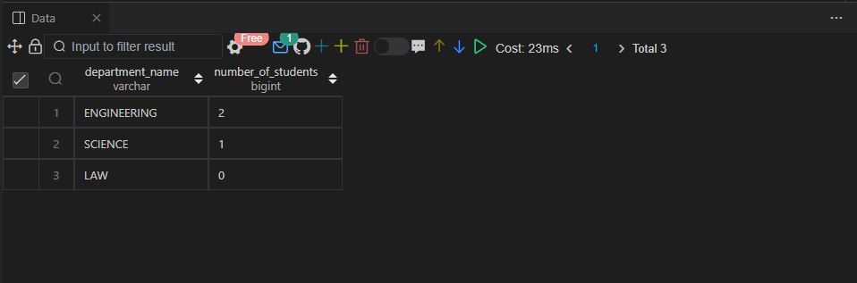

Q46.

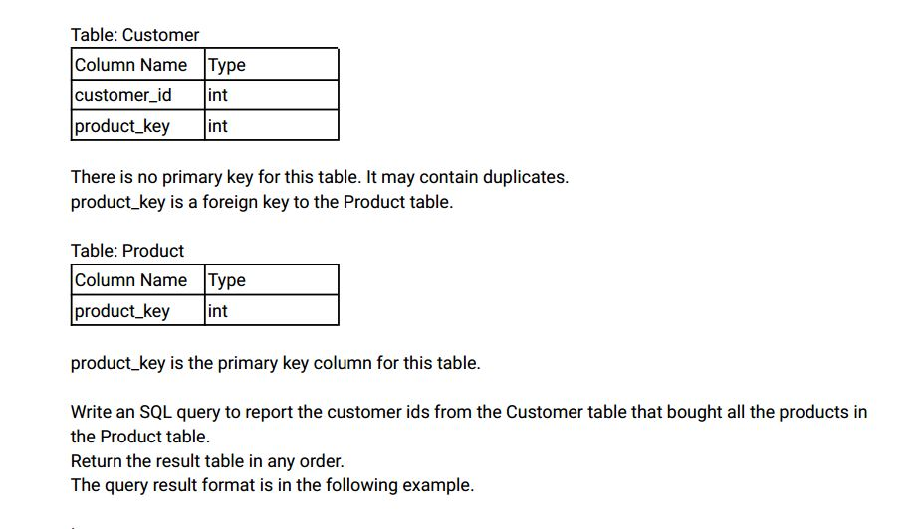

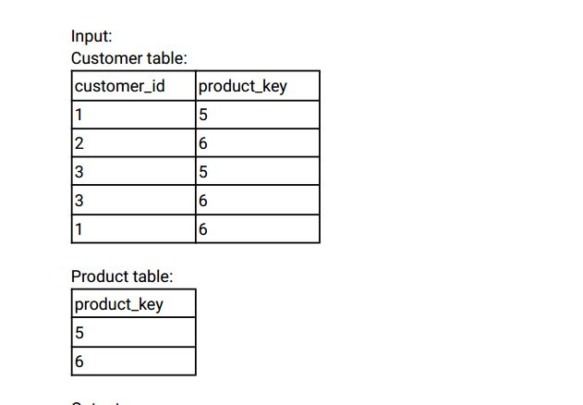

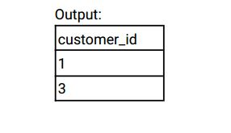

Explanation:

The customers who bought all the products (5 and 6) are customers with IDs 1 and 3.\

Ans:-

|  |
| --- |
|  |
| CREATE TABLE customer( |
|  | customer_id INT, |
|  | product_key INT |
|  | ); |
|  |  |
|  |  |
|  | INSERT INTO customer VALUES |
|  | (1,5), |
|  | (2,6), |
|  | (3,5), |
|  | (3,6), |
|  | (1,6); |
|  |  |
|  |  |
|  | CREATE TABLE product( |
|  | product_key INT, |
|  | CONSTRAINT prime_key PRIMARY KEY(product_key) |
|  | ); |
|  |  |
|  |  |
|  | INSERT INTO product VALUES |
|  | (5), |
|  | (6); |
|  |  |
|  |  |
|  |  |
|  | SELECT |
|  | customer_id |
|  | FROM |
|  | customer |
|  | GROUP BY |
|  | customer_id |
|  | HAVING |
|  | COUNT(DISTINCT product_key) = ( |
|  | SELECT |
|  | COUNT(DISTINCT product_key) |
|  | FROM |
|  | product |
|  | ); |
|  |  |
|  |  |
|  |  |

Select * from customer;

Select * from product;

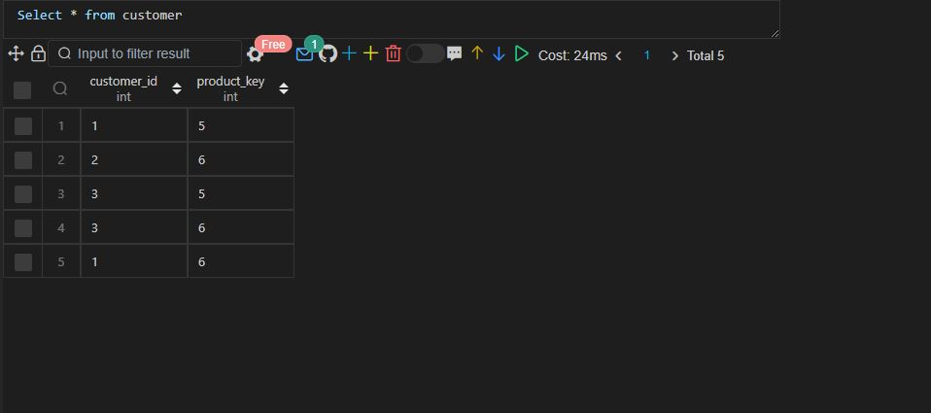

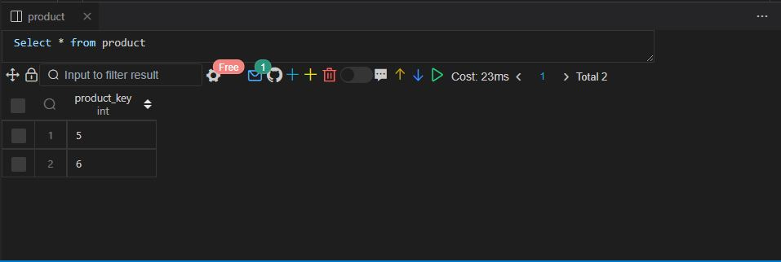

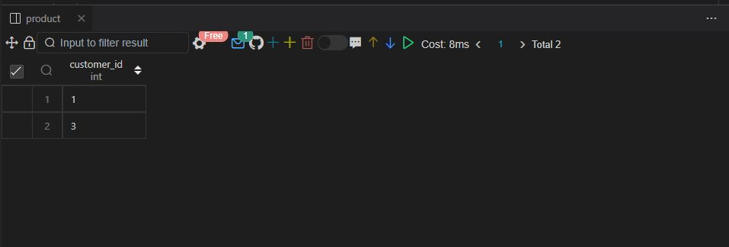

Q47. 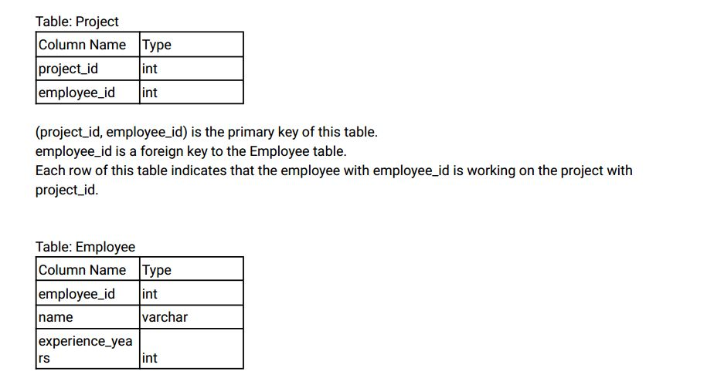

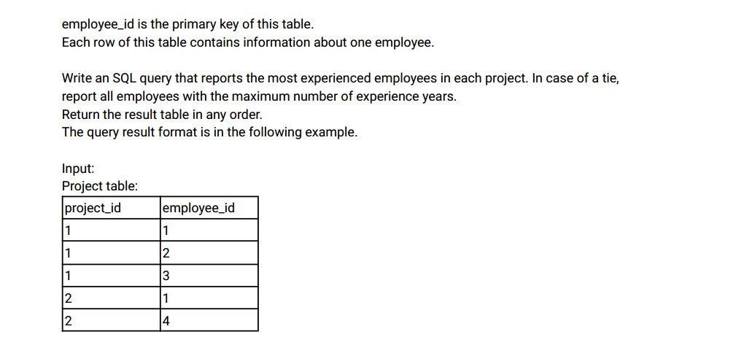

Employee table: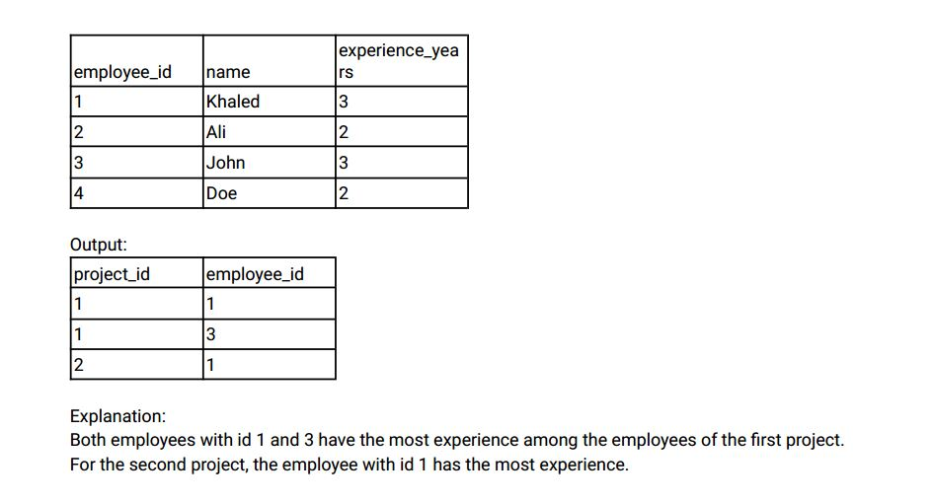

Ans:-

|  |
| --- |
|  |
| CREATE TABLE employee( |
|  | employee_id INT, |
|  | name VARCHAR(20), |
|  | experience_years INT, |
|  | CONSTRAINT prime_key PRIMARY KEY(employee_id) |
|  | ); |
|  |  |
|  |  |
|  | CREATE TABLE project( |
|  | project_id INT, |
|  | employee_id INT, |
|  | CONSTRAINT prime_key PRIMARY KEY(project_id, employee_id) |
|  | ); |
|  |  |
|  |  |
|  | INSERT INTO employee VALUES |
|  | (1,'KHALED',3), |
|  | (2,'ALI',2), |
|  | (3,'JOHN',3), |
|  | (4,'DOE',2); |
|  |  |
|  |  |
|  | INSERT INTO project VALUES |
|  | (1,1), |
|  | (1,2), |
|  | (1,3), |
|  | (2,1), |
|  | (2,4); |
|  |  |
|  |  |
|  |  |
|  | -- Approach 1 |
|  |  |
|  |  |
|  |  |
|  | SELECT |
|  | project_id, |
|  | employee_id |
|  | FROM |
|  | ( |
|  | SELECT |
|  | p.project_id, |
|  | e.employee_id, |
|  | DENSE_RANK() OVER(PARTITION BY p.project_id ORDER BY e.experience_years DESC) AS ranking |
|  | FROM |
|  | employee e |
|  | INNER JOIN |
|  | project p |
|  | ON |
|  | e.employee_id = p.employee_id |
|  | ) temp_employee |
|  | WHERE |
|  | ranking = 1; |
|  |  |
|  |  |
|  |  |
|  | -- Approach 2 |
|  |  |
|  |  |
|  |  |
|  | SELECT |
|  | p.project_id, |
|  | e.employee_id |
|  | FROM |
|  | employee e |
|  | INNER JOIN |
|  | project p |
|  | ON |
|  | e.employee_id = p.employee_id |
|  | WHERE |
|  | e.experience_years = |
|  | ( |
|  | SELECT |
|  | MAX(experience_years) |
|  | FROM |
|  | employee |
|  | ); |
|  |  |
|  |  |
|  |  |

Select * from employee;

Select * from project;

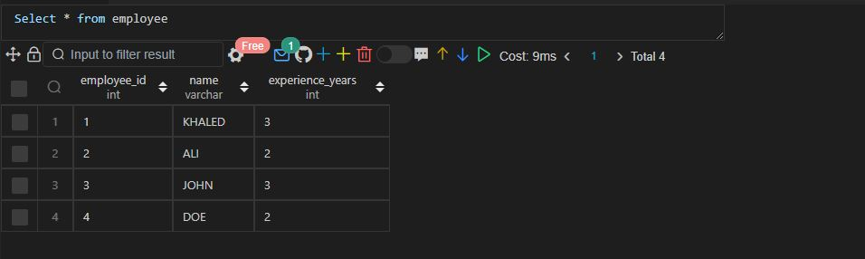

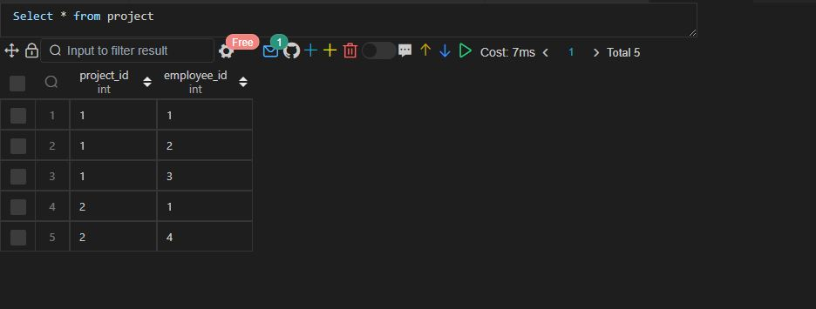

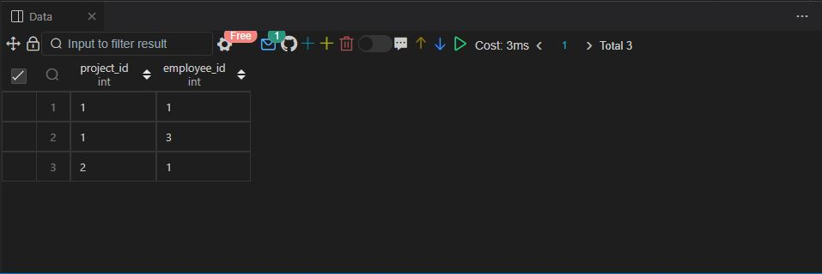

Q48.

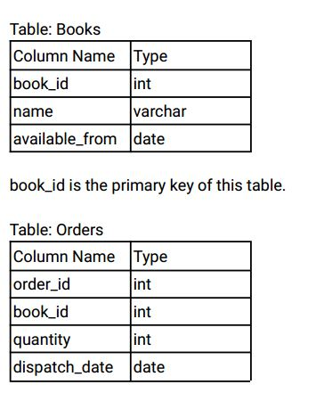

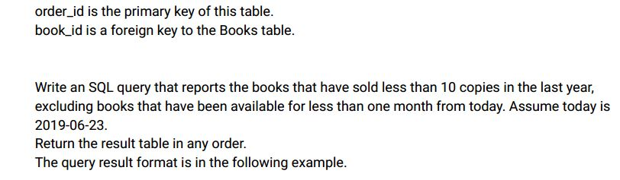

Input:

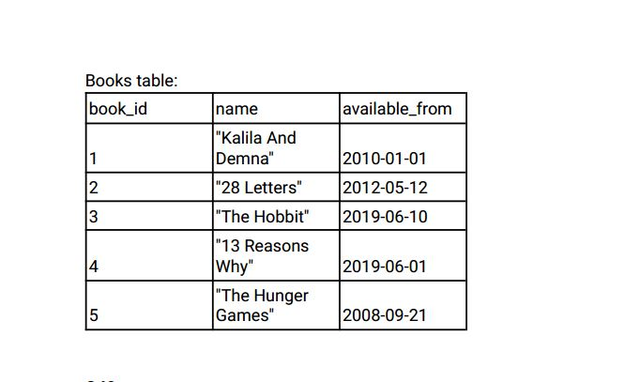

Ans:-

|  |
| --- |
|  |
| CREATE TABLE books( |
|  | book_id INT, |
|  | name VARCHAR(20), |
|  | available_from DATE, |
|  | CONSTRAINT prime_key PRIMARY KEY(book_id) |
|  | ); |
|  |  |
|  |  |
|  | CREATE TABLE orders( |
|  | order_id INT, |
|  | book_id INT, |
|  | quantity INT, |
|  | dispatch_date DATE, |
|  | CONSTRAINT prime_key PRIMARY KEY(order_id), |
|  | CONSTRAINT foriegn_key FOREIGN KEY(book_id) REFERENCES books(book_id) |
|  | ); |
|  |  |
|  |  |
|  | INSERT INTO books VALUES |
|  | (1,"Kalila And Demna",'2010-01-01'), |
|  | (2,"28 Letters",'2012-05-12'), |
|  | (3,"The Hobbit",'2019-06-10'), |
|  | (4,"13 Reasons Why",'2019-06-01'), |
|  | (5,"The Hunger Games",'2008-09-21'); |
|  |  |
|  |  |
|  | INSERT INTO orders VALUES |
|  | (1,1,2,'2018-07-26'), |
|  | (2,1,1,'2018-11-05'), |
|  | (3,3,8,'2019-06-11'), |
|  | (4,4,6,'2019-06-05'), |
|  | (5,4,5,'2019-06-20'), |
|  | (6,5,9,'2009-02-02'), |
|  | (7,5,8,'2010-04-13'); |
|  |  |
|  |  |
|  |  |
|  | SELECT |
|  | b.book_id, b.name |
|  | FROM |
|  | books b |
|  | LEFT JOIN |
|  | orders o |
|  | ON |
|  | b.book_id = o.book_id |
|  | WHERE |
|  | available_from < '2019-05-23' |
|  | AND |
|  | (o.dispatch_date BETWEEN '2018-06-23' AND '2019-06-23') |
|  | OR |
|  | dispatch_date IS NULL |
|  | GROUP BY |
|  | b.book_id, |
|  | b.name |
|  | HAVING |
|  | COALESCE(SUM(o.quantity), 0) < 10; |
|  |  |
|  |  |
|  |  |

Select * from books;

Select * from orders;

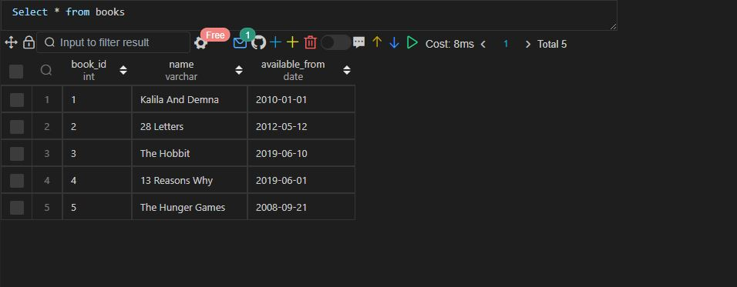

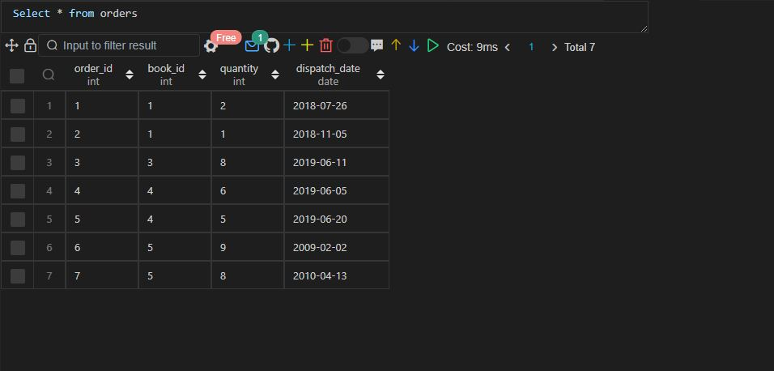

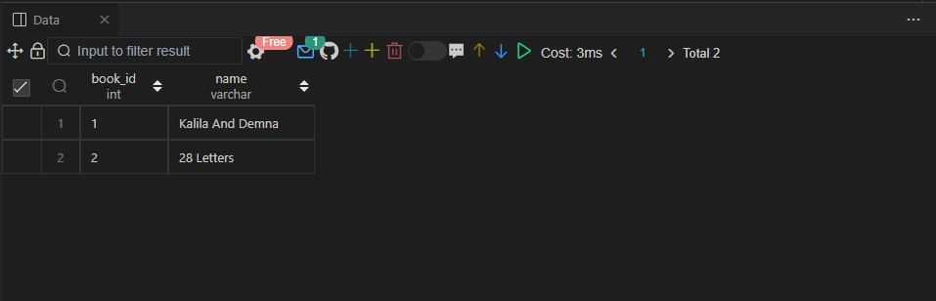

Q49.

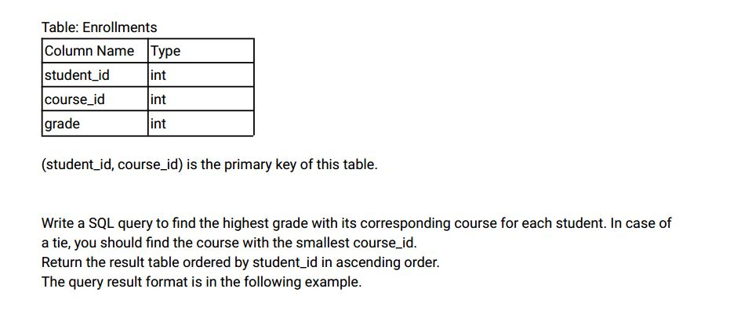

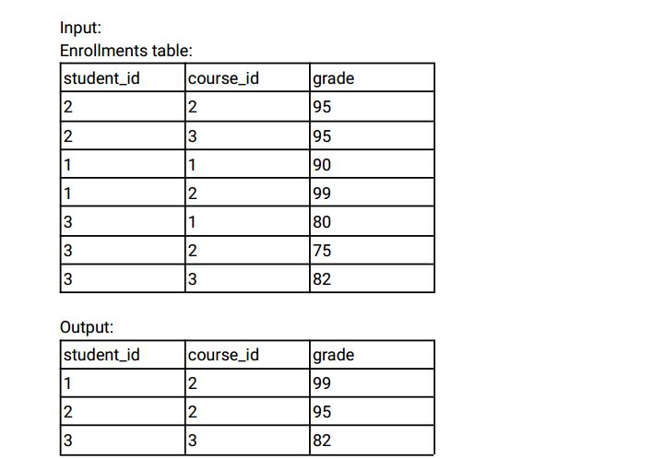

Ans:-

|  |
| --- |
|  |
| CREATE TABLE enrollments( |
|  | student_id INT, |
|  | course_id INT, |
|  | grade INT, |
|  | CONSTRAINT prime_key PRIMARY KEY(student_id,course_id) |
|  | ); |
|  |  |
|  |  |
|  | INSERT INTO enrollments VALUES |
|  | (2,2,95), |
|  | (2,3,95), |
|  | (1,1,90), |
|  | (1,2,99), |
|  | (3,1,80), |
|  | (3,2,75), |
|  | (3,3,82); |
|  |  |
|  |  |
|  |  |
|  | -- Approach 1 |
|  |  |
|  |  |
|  |  |
|  | SELECT |
|  | student_id, |
|  | course_id, |
|  | grade |
|  | FROM |
|  | ( |
|  | SELECT |
|  | student_id, |
|  | course_id, |
|  | grade, |
|  | ROW_NUMBER() OVER(PARTITION BY student_id ORDER BY grade DESC) AS ranking |
|  | FROM |
|  | enrollments |
|  | ) temp_enrollments |
|  | WHERE |
|  | ranking = 1 |
|  | order by |
|  | student_id; |
|  |  |
|  |  |
|  |  |
|  | -- Approach 2 |
|  |  |
|  |  |
|  |  |
|  | WITH temp_enrollments AS |
|  | ( |
|  | SELECT |
|  | student_id, |
|  | course_id, |
|  | grade, |
|  | ROW_NUMBER() OVER(PARTITION BY student_id ORDER BY grade DESC) AS ranking |
|  | FROM |
|  | enrollments |
|  | ) |
|  |  |
|  | SELECT |
|  | student_id, |
|  | course_id, |
|  | grade |
|  | FROM |
|  | temp_enrollments |
|  | WHERE |
|  | ranking = 1 |
|  | order by |
|  | student_id; |
|  |  |
|  |  |
|  |  |
|  |  |

Select * from enrollments;

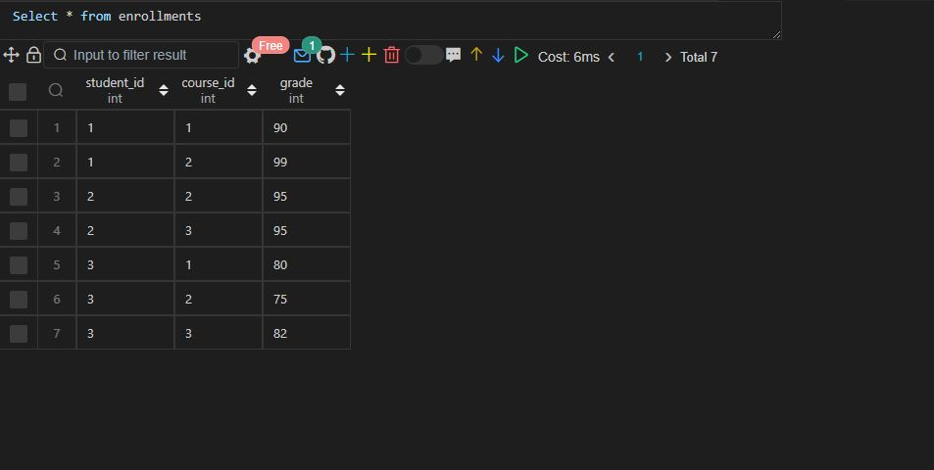

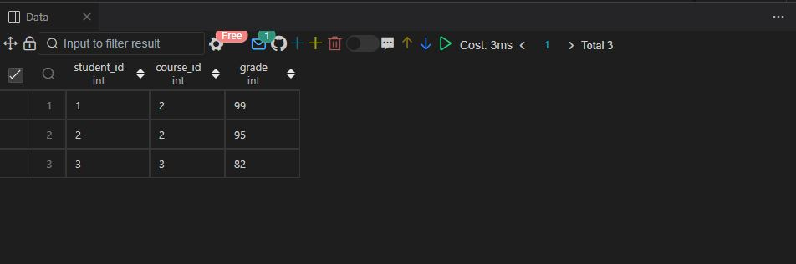

Q50.

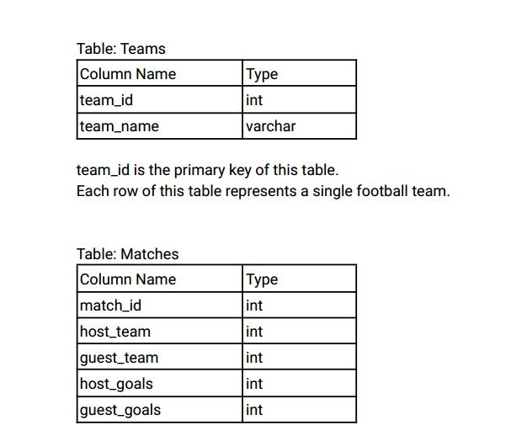

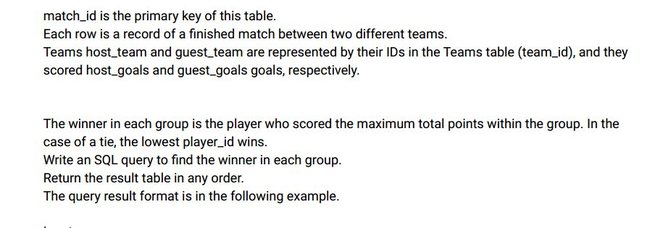

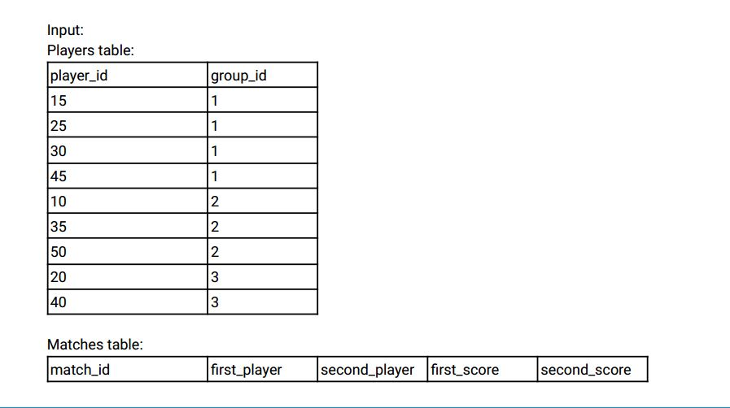

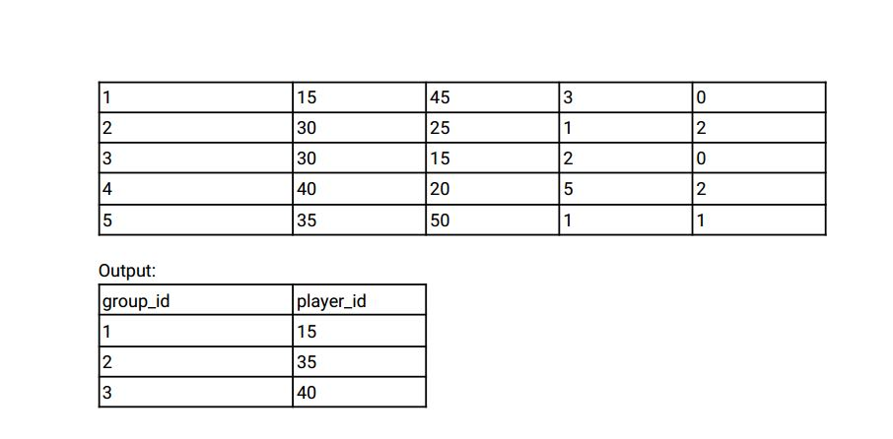

Ans:-

|  |
| --- |
|  |
| CREATE TABLE matches( |
|  | match_id INT, |
|  | first_player INT, |
|  | second_player INT, |
|  | first_player_goals INT, |
|  | second_player_goals INT, |
|  | CONSTRAINT prime_key PRIMARY KEY(match_id) |
|  | ); |
|  |  |
|  |  |
|  | CREATE TABLE teams( |
|  | player_id INT, |
|  | team_id INT, |
|  | CONSTRAINT prime_key PRIMARY KEY(player_id) |
|  | ); |
|  |  |
|  |  |
|  | INSERT INTO matches VALUES |
|  | (1,15,45,3,0), |
|  | (2,30,25,1,2), |
|  | (3,30,15,2,0), |
|  | (4,40,20,5,2), |
|  | (5,35,50,1,1); |
|  |  |
|  |  |
|  | INSERT INTO teams VALUES |
|  | (15,1), |
|  | (25,1), |
|  | (30,1), |
|  | (45,1), |
|  | (10,2), |
|  | (35,2), |
|  | (50,2), |
|  | (20,3), |
|  | (40,3); |
|  |  |
|  |  |
|  |  |
|  | SELECT |
|  | team_id, |
|  | players as player_id |
|  | FROM ( |
|  | SELECT |
|  | t.team_id, |
|  | CASE |
|  | WHEN first_player_goals > second_player_goals THEN first_player |
|  | WHEN first_player_goals < second_player_goals THEN second_player |
|  | WHEN first_player_goals = second_player_goals THEN IF(first_player < second_player, first_player, second_player) |
|  | END AS players, |
|  | MAX(IF(first_player_goals > second_player_goals, first_player_goals, second_player_goals)) AS goals, |
|  | ROW_NUMBER() OVER(PARTITION BY team_id ORDER BY MAX(IF(first_player_goals > second_player_goals, first_player_goals, second_player_goals)) DESC) AS ranking |
|  | FROM |
|  | teams t |
|  | INNER JOIN |
|  | matches m |
|  | ON |
|  | m.first_player = t.player_id |
|  | OR |
|  | m.second_player = t.player_id |
|  | GROUP BY |
|  | t.team_id, |
|  | players |
|  | ) temp_matches |
|  | WHERE |
|  | ranking = 1; |
|  |  |
|  |  |
|  |  |
|  |  |

Select * from matches;

Select * from teams;

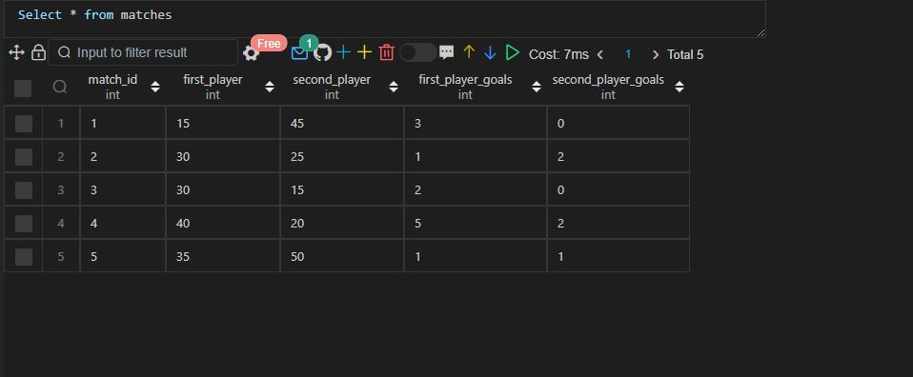

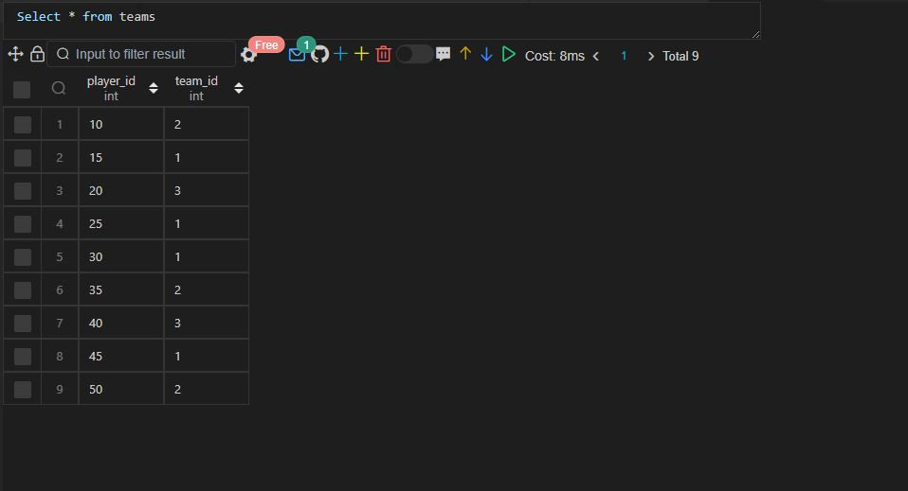

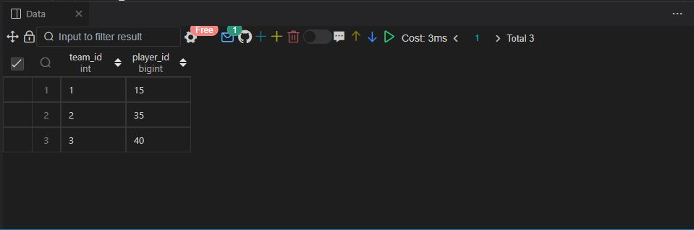

Q51.

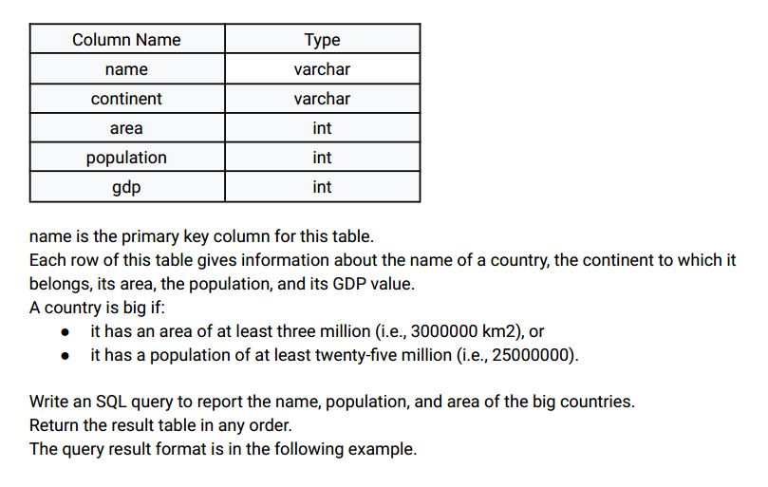

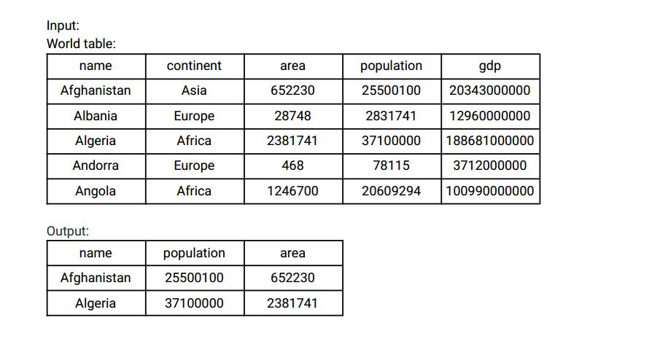

Ans:-

|  |
| --- |
|  |
| CREATE TABLE world( |
|  | name VARCHAR(20) NOT NULL, |
|  | continent VARCHAR(15) NOT NULL, |
|  | area INT NOT NULL, |
|  | population BIGINT NOT NULL, |
|  | gdp BIGINT NOT NULL, |
|  | CONSTRAINT prime_key PRIMARY KEY(name) |
|  | ); |
|  |  |
|  |  |
|  | INSERT INTO world VALUES |
|  | ('Afghanistan', 'Asia', 652230, 25500100, 203430000000), |
|  | ('Albania', 'Europe', 28748, 2831741, 12960000000), |
|  | ('Algeria', 'Africa', 2381741, 37100000, 188681000000), |
|  | ('Andorra', 'Europe', 468, 78115, 3712000000), |
|  | ('Angola', 'Africa', 1246700, 20609294, 100990000000), |
|  | ('Dominican Republic', 'Caribbean', 48671, 9445281, 58898000000), |
|  | ('China', 'Asia', 652230, 1365370000, 8358400000000), |
|  | ('Colombia', 'South America', 1141748, 47662000, 369813000000), |
|  | ('Comoros', 'Africa', 1862, 743798, 616000000), |
|  | ('Denmark', 'Europe', 43094, 5634437, 314889000000), |
|  | ('Djibouti', 'Africa', 23200, 886000, 1361000000), |
|  | ('Dominica', 'Caribbean', 751, 71293, 499000000), |
|  | ('SriLanka', 'Asia', 652230, 25500100, 203430000000); |
|  |  |
|  |  |
|  |  |
|  | SELECT |
|  | name, |
|  | population, |
|  | area |
|  | FROM |
|  | world |
|  | WHERE |
|  | area > 3000000 |
|  | OR |
|  | population > 25000000; |
|  |  |
|  |  |
|  |  |

 Select * from world;

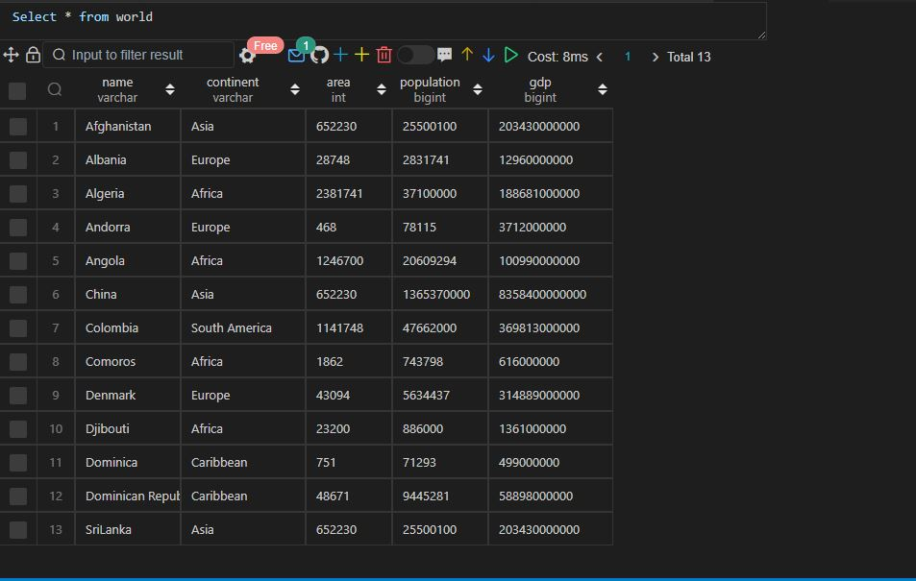

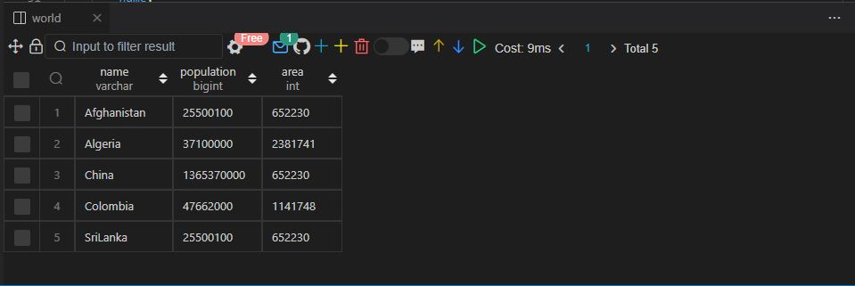

Q52.

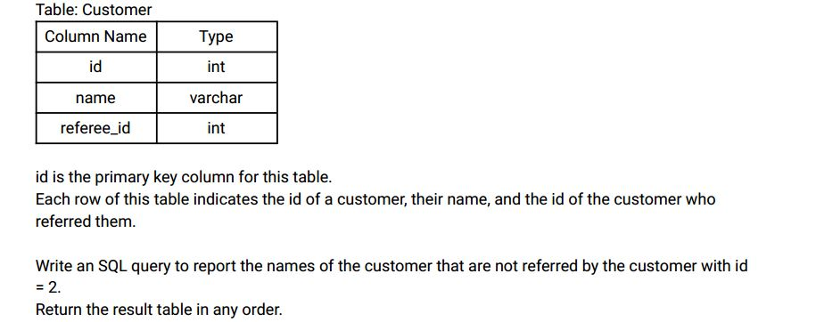

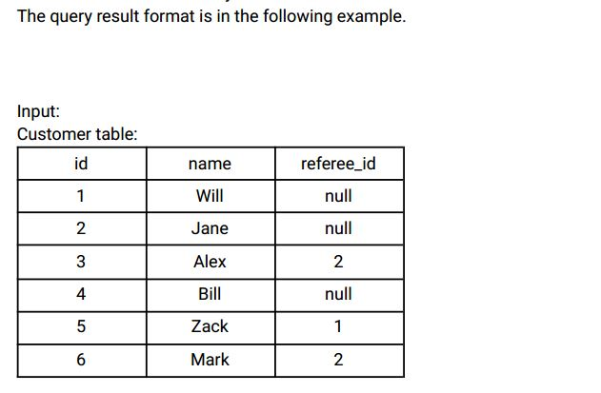

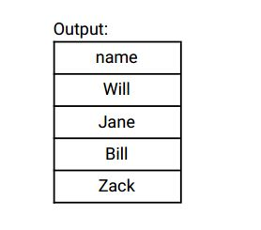

Ans:-

|  |
| --- |
|  |
| CREATE TABLE customer( |
|  | id INT, |
|  | name VARCHAR(10), |
|  | refree_id INT, |
|  | CONSTRAINT prime_key PRIMARY KEY(id) |
|  | ); |
|  |  |
|  |  |
|  | INSERT INTO customer VALUES |
|  | (1,'Will',NULL), |
|  | (2,'Jane',NULL), |
|  | (3,'Alex',2), |
|  | (4,'Bill',NULL), |
|  | (5,'Zack',1), |
|  | (6,'Mark',2); |
|  |  |
|  |  |
|  |  |
|  | SELECT |
|  | name |
|  | FROM |
|  | customer |
|  | WHERE |
|  | refree_id <> 2 |
|  | OR |
|  | refree_id IS NULL; |
|  |  |
|  |  |
|  |  |

Select * from customer;

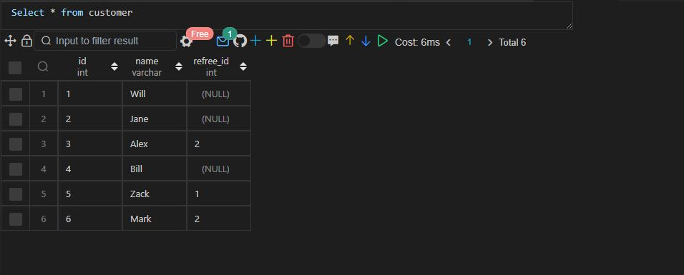

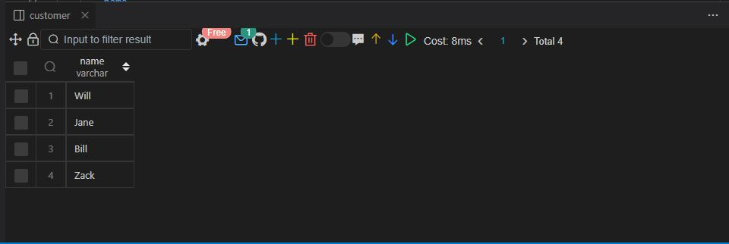

Q53.

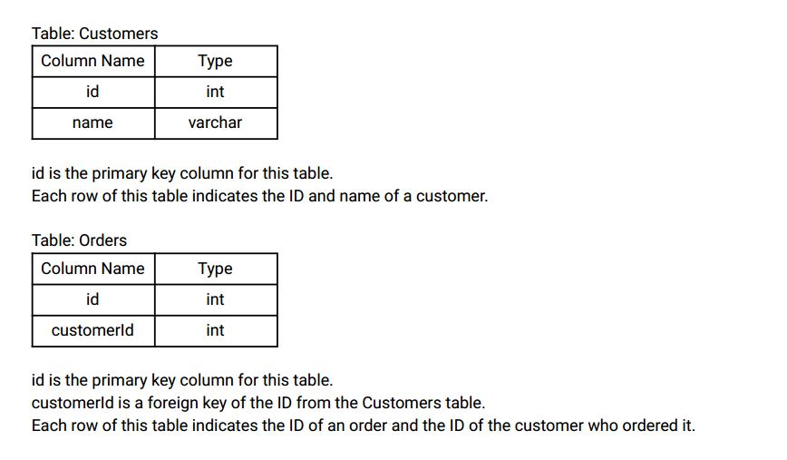

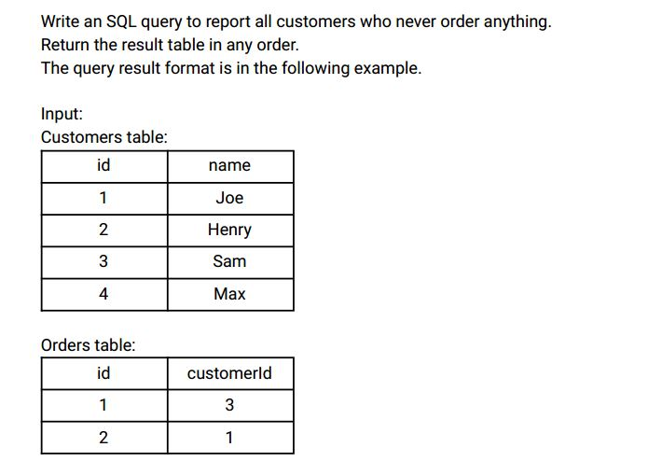

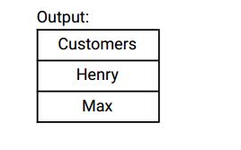

Ans:-

|  |
| --- |
|  |
| CREATE TABLE orders( |
|  | id INT, |
|  | customer_id INT, |
|  | CONSTRAINT prime_key PRIMARY KEY(id) |
|  | ); |
|  |  |
|  |  |
|  | INSERT INTO orders VALUES |
|  | (1,3), |
|  | (2,1); |
|  |  |
|  |  |
|  | CREATE TABLE customers( |
|  | id INT, |
|  | name VARCHAR(20), |
|  | CONSTRAINT prime_key PRIMARY KEY(id) |
|  | ); |
|  |  |
|  |  |
|  | INSERT INTO customers VALUES |
|  | (1,'JOE'), |
|  | (2,'HENRY'), |
|  | (3,'SAM'), |
|  | (4,'MAX'); |
|  |  |
|  |  |
|  |  |
|  | SELECT |
|  | name AS customers |
|  | FROM |
|  | customers |
|  | WHERE |
|  | id NOT IN ( |
|  | SELECT |
|  | customer_id |
|  | FROM |
|  | orders |
|  | ); |
|  |  |
|  |  |
|  |  |

Select * from orders;

Select * from customers;

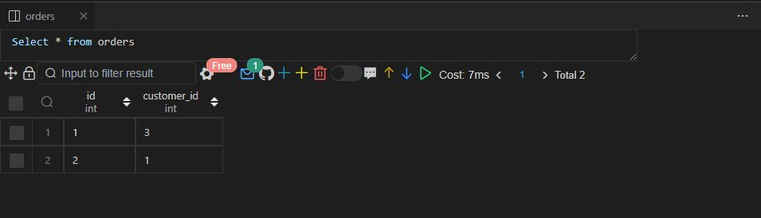

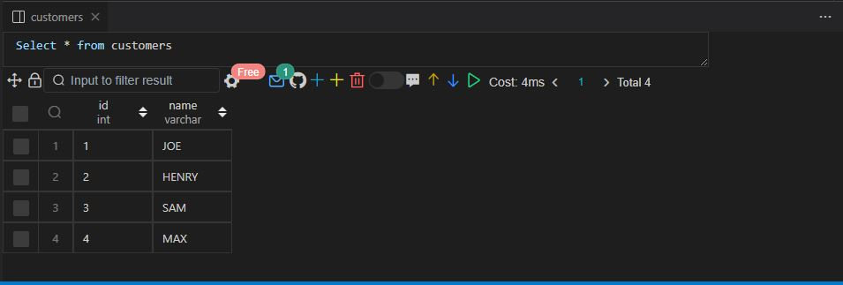

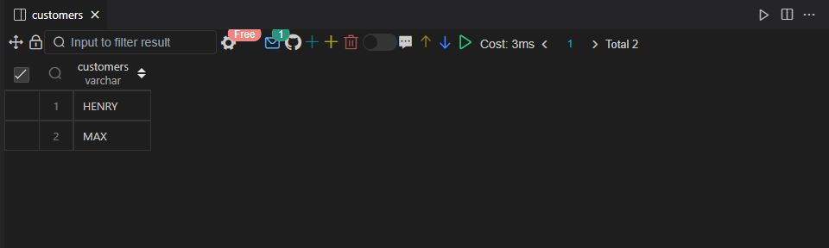

Q54.

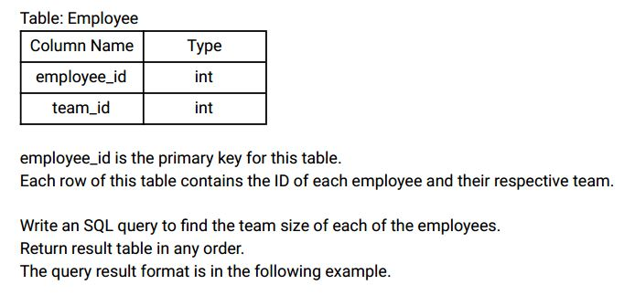

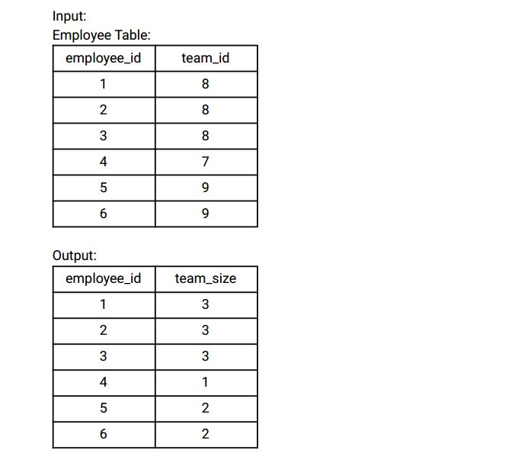

Explanation:

Employees with Id 1,2,3 are part of a team with team_id = 8.

Employee with Id 4 is part of a team with team_id = 7.

Employees with Id 5,6 are part of a team with team_id = 9.

Ans:-

|  |
| --- |
|  |
| CREATE TABLE employee( |
|  | employee_id INT, |
|  | team_id INT, |
|  | CONSTRAINT prime_key PRIMARY KEY(employee_id) |
|  | ); |
|  |  |
|  |  |
|  | INSERT INTO employee VALUES |
|  | (1,8), |
|  | (2,8), |
|  | (3,8), |
|  | (4,7), |
|  | (5,9), |
|  | (6,9); |
|  |  |
|  |  |
|  |  |
|  | SELECT |
|  | employee_id, |
|  | COUNT(employee_id) OVER(PARTITION BY team_id ORDER BY employee_id |
|  | ROWS BETWEEN UNBOUNDED PRECEDING AND UNBOUNDED FOLLOWING) AS team_size |
|  | FROM |
|  | employee |
|  | ORDER BY |
|  | employee_id; |
|  |  |
|  |  |
|  |  |

Select * from employee;

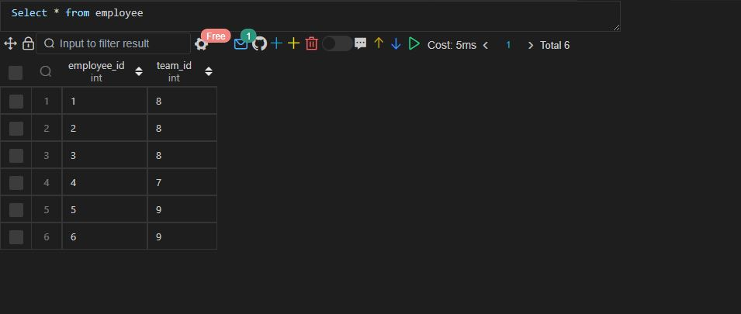

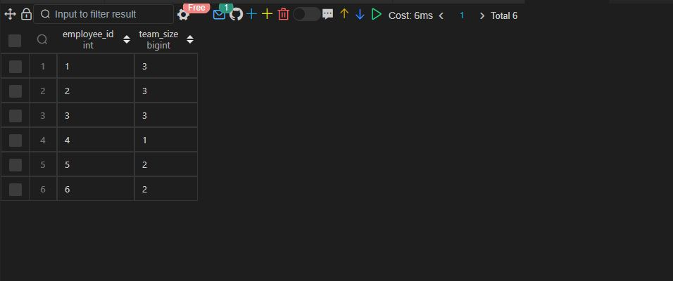

Q55

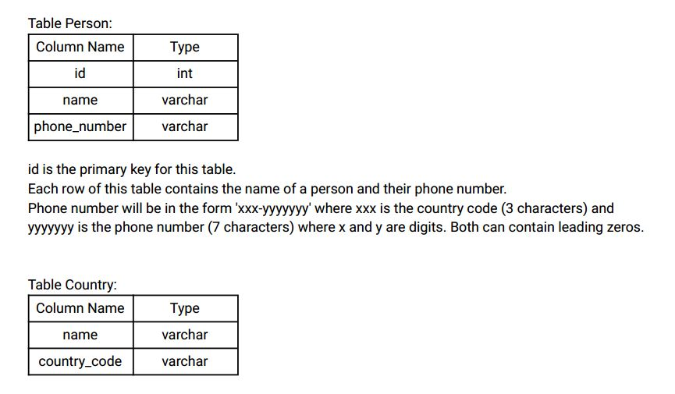

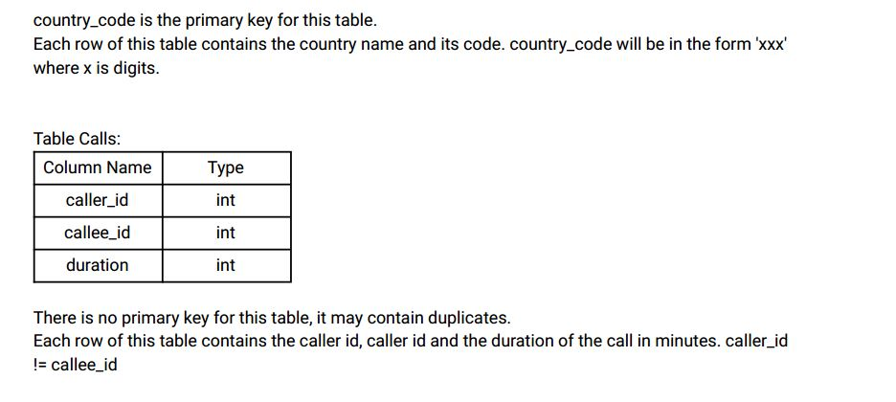

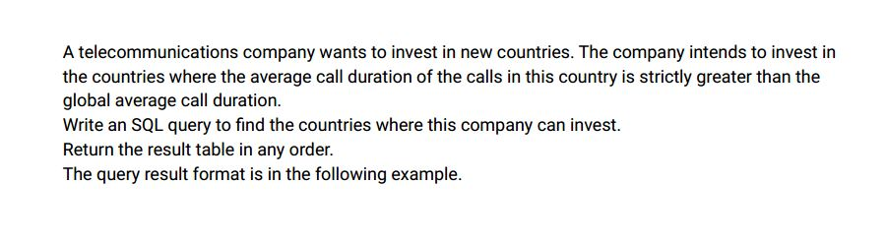

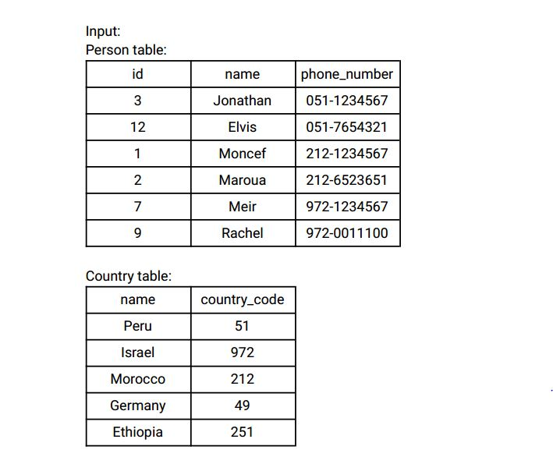

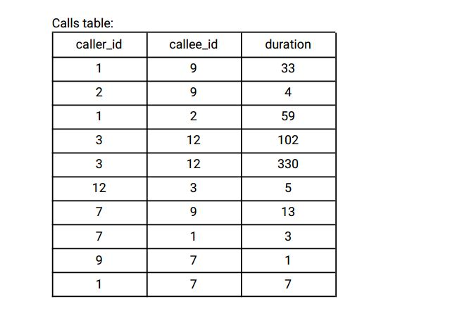

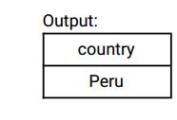

Explanation:

The average call duration for Peru is (102 + 102 + 330 + 330 + 5 + 5) / 6 = 145.666667

The average call duration for Israel is (33 + 4 + 13 + 13 + 3 + 1 + 1 + 7) / 8 = 9.37500

The average call duration for Morocco is (33 + 4 + 59 + 59 + 3 + 7) / 6 = 27.5000

Global call duration average = (2 * (33 + 4 + 59 + 102 + 330 + 5 + 13 + 3 + 1 + 7)) / 20 = 55.70000

Since Peru is the only country where the average call duration is greater than the global average, it is

the only recommended country .

Ans:-

|  |
| --- |
|  |
| CREATE TABLE person( |
|  | id INT, |
|  | name VARCHAR(20), |
|  | phone_number VARCHAR(20), |
|  | CONSTRAINT prime_key PRIMARY KEY(id) |
|  | ); |
|  |  |
|  |  |
|  | CREATE TABLE country( |
|  | name VARCHAR(20), |
|  | country_code VARCHAR(20), |
|  | CONSTRAINT prime_key PRIMARY KEY(country_code) |
|  | ); |
|  |  |
|  |  |
|  | CREATE TABLE calls( |
|  | caller_id INT, |
|  | callee_id INT, |
|  | duration INT |
|  | ); |
|  |  |
|  |  |
|  | INSERT INTO person VALUES |
|  | (3,'JONATHON','051-1234567'), |
|  | (21,'ELVIS','051-7654321'), |
|  | (1,'MONCEF','212-1234567'), |
|  | (2,'MAROUA','212-6523651'), |
|  | (7,'MEIR','972-1234567'), |
|  | (9,'RACHEL','972-0011100'); |
|  |  |
|  |  |
|  | INSERT INTO calls VALUES |
|  | (1,9,33), |
|  | (1,2,59), |
|  | (3,12,102), |
|  | (3,12,330), |
|  | (12,3,5), |
|  | (7,9,13), |
|  | (7,1,3), |
|  | (9,7,1), |
|  | (1,7,7), |
|  | (2,9,4); |
|  |  |
|  |  |
|  | INSERT INTO country VALUES |
|  | ('PERU','51'), |
|  | ('ISRAEL','972'), |
|  | ('MOROCCO','212'), |
|  | ('GERMANY','49'), |
|  | ('ETHIOPIA','251'); |
|  |  |
|  |  |
|  | -- Approach 1 |
|  |  |
|  |  |
|  | SELECT |
|  | name AS country |
|  | FROM ( |
|  | SELECT |
|  | c.name, |
|  | SUM(ca.duration) AS call_duration, |
|  | COUNT(c.country_code) AS number_of_calls |
|  | FROM ( |
|  | SELECT |
|  | id, |
|  | name, |
|  | CASE |
|  | WHEN LEFT(SUBSTR(phone_number, 1,3),1) = '0' THEN RIGHT(SUBSTR(phone_number, 1,3), (LENGTH(SUBSTR(phone_number, 1,3))-1)) |
|  | ELSE SUBSTR(phone_number, 1,3) END AS country_code |
|  | FROM |
|  | person |
|  | ) temp_person |
|  | JOIN |
|  | country c |
|  | ON |
|  | temp_person.country_code = c.country_code |
|  | JOIN |
|  | calls ca |
|  | ON |
|  | temp_person.id = caller_id |
|  | GROUP BY |
|  | c.name |
|  |  |
|  | UNION ALL |
|  |  |
|  | SELECT |
|  | c.name, |
|  | SUM(ca.duration) AS call_duration, |
|  | COUNT(c.country_code) AS number_of_calls |
|  | FROM ( |
|  | SELECT |
|  | id, |
|  | name, |
|  | CASE |
|  | WHEN LEFT(SUBSTR(phone_number, 1,3),1) = '0' THEN RIGHT(SUBSTR(phone_number, 1,3), (length(SUBSTR(phone_number, 1,3))-1)) |
|  | ELSE SUBSTR(phone_number, 1,3) END AS country_code |
|  | FROM |
|  | person |
|  | ) temp_person |
|  | JOIN |
|  | country c |
|  | ON |
|  | temp_person.country_code = c.country_code |
|  | JOIN |
|  | calls ca |
|  | ON |
|  | temp_person.id = ca.callee_id |
|  | GROUP BY |
|  | c.name |
|  |  |
|  | ) temp |
|  | GROUP BY |
|  | name |
|  | HAVING |
|  | SUM(call_duration)/SUM(number_of_calls) > (SELECT AVG(duration) FROM calls); |
|  |  |
|  |  |
|  |  |
|  | -- Approach 2 |
|  |  |
|  |  |
|  | WITH temp_person AS ( |
|  | SELECT |
|  | id, |
|  | name, |
|  | CASE |
|  | WHEN LEFT(SUBSTR(phone_number, 1,3),1) = '0' THEN RIGHT(SUBSTR(phone_number, 1,3), (LENGTH(SUBSTR(phone_number, 1,3))-1)) |
|  | ELSE SUBSTR(phone_number, 1,3) END AS country_code |
|  | FROM |
|  | person |
|  | ) |
|  |  |
|  |  |
|  | SELECT |
|  | name AS country |
|  | FROM ( |
|  | SELECT |
|  | c.name, |
|  | SUM(ca.duration) AS call_duration, |
|  | COUNT(c.country_code) AS number_of_calls |
|  | FROM |
|  | temp_person |
|  | JOIN |
|  | country c |
|  | ON |
|  | temp_person.country_code = c.country_code |
|  | JOIN |
|  | calls ca |
|  | ON |
|  | temp_person.id = ca.caller_id |
|  | GROUP BY |
|  | c.name |
|  |  |
|  | UNION ALL |
|  |  |
|  | SELECT |
|  | c.name, |
|  | SUM(ca.duration) AS call_duration, |
|  | COUNT(c.country_code) AS number_of_calls |
|  | FROM |
|  | temp_person |
|  | JOIN |
|  | country c |
|  | ON |
|  | temp_person.country_code = c.country_code |
|  | JOIN |
|  | calls ca |
|  | ON |
|  | temp_person.id = ca.callee_id |
|  | GROUP BY |
|  | c.name |
|  |  |
|  | )temp |
|  | GROUP BY |
|  | name |
|  | HAVING |
|  | SUM(call_duration)/SUM(number_of_calls) > (SELECT AVG(duration) FROM calls); |
|  |  |
|  |  |
|  |  |

Select * from person;

Select * from calls;

Select * from country;

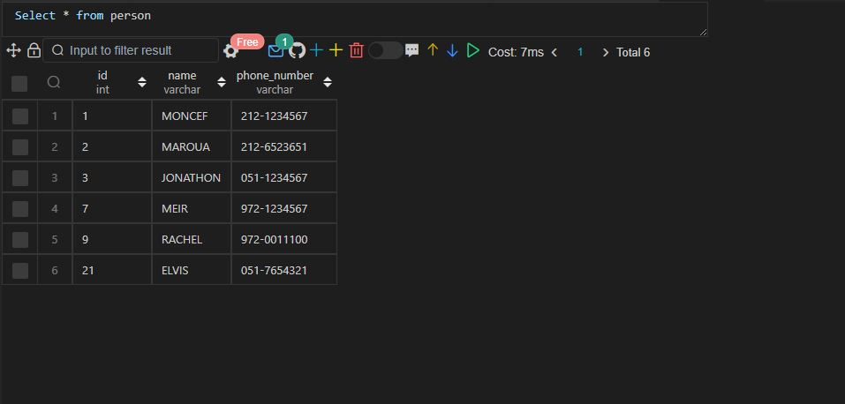

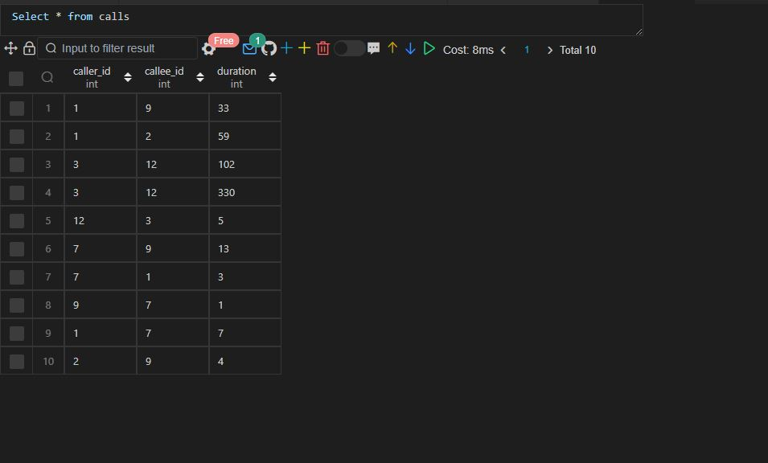

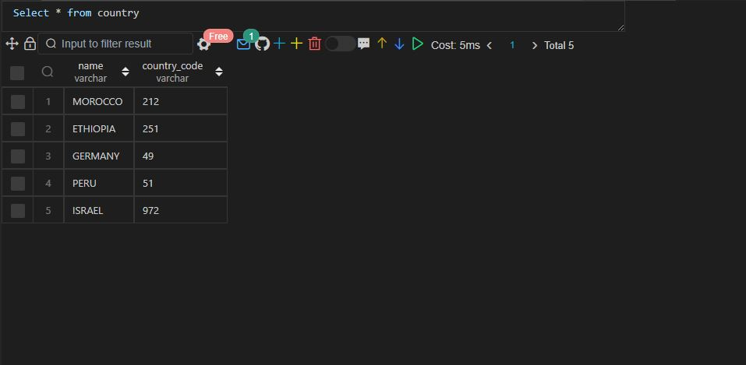

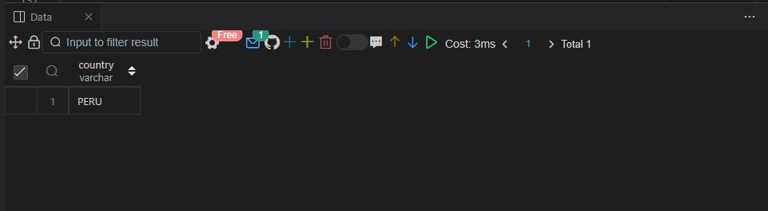

Q56.

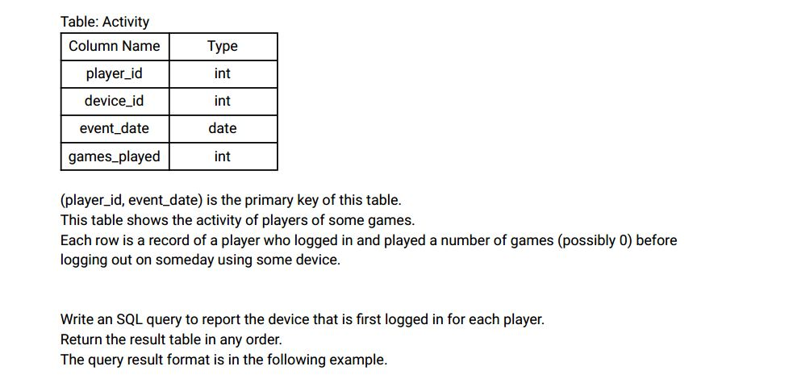

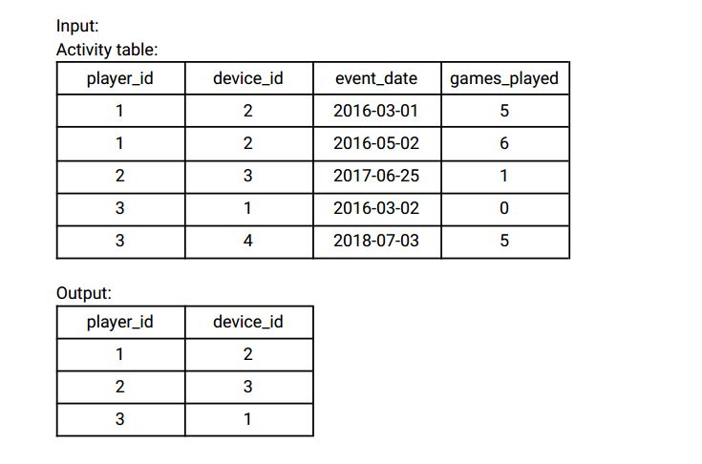

Ans:-

|  |
| --- |
|  |
| CREATE TABLE activity( |
|  | player_id INT, |
|  | device_id INT, |
|  | event_date DATE, |
|  | games_played INT, |
|  | CONSTRAINT prime_key PRIMARY KEY(player_id, event_date) |
|  | ); |
|  |  |
|  |  |
|  | INSERT INTO activity VALUES |
|  | (1,2,'2016-03-01',5), |
|  | (1,2,'2016-03-02',6), |
|  | (2,3,'2017-06-25',1), |
|  | (3,1,'2016-03-02',0), |
|  | (3,4,'2018-07-03',5); |
|  |  |
|  |  |
|  |  |
|  | SELECT |
|  | player_id, |
|  | device_id |
|  | FROM |
|  | ( |
|  | SELECT |
|  | player_id, |
|  | device_id, |
|  | event_date, |
|  | ROW_number() OVER(PARTITION BY player_id ORDER BY event_date) ranking |
|  | FROM |
|  | activity |
|  | ) temp_activity |
|  | WHERE |
|  | ranking = 1; |
|  |  |
|  |  |

Select * from activity;

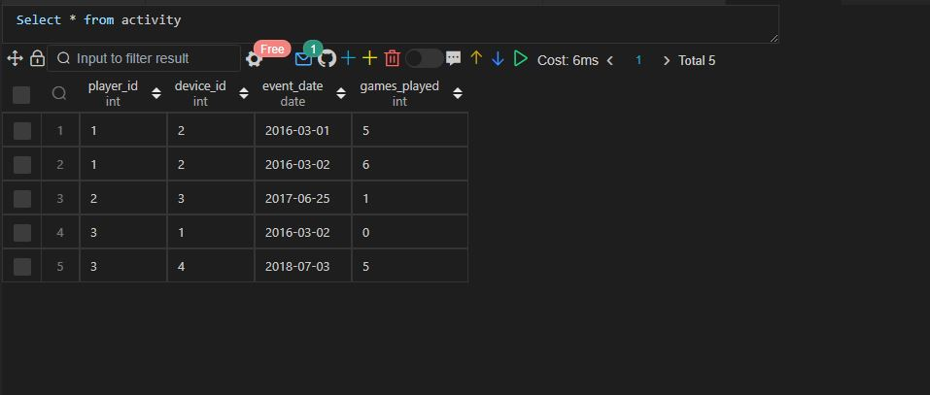

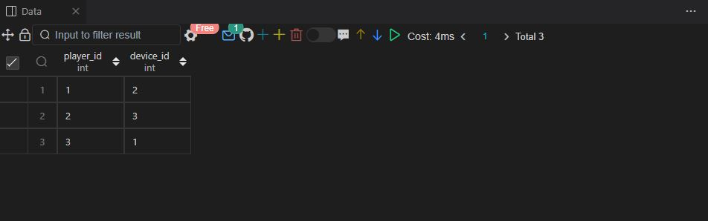

Q57.

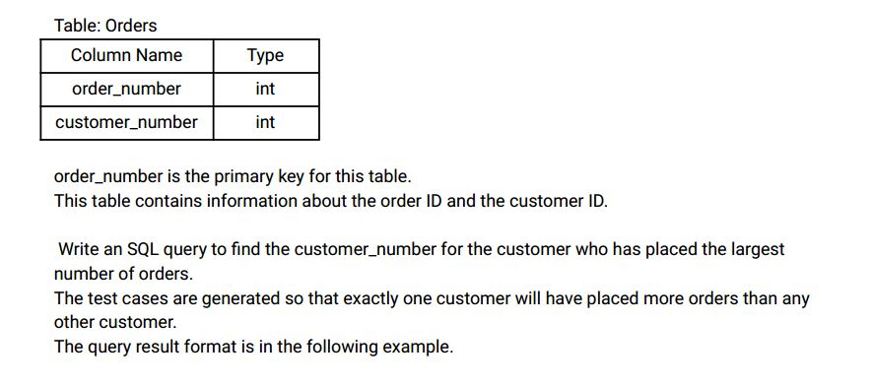

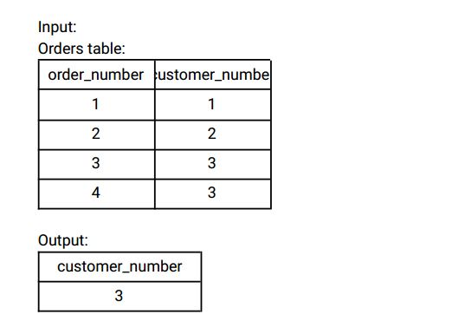

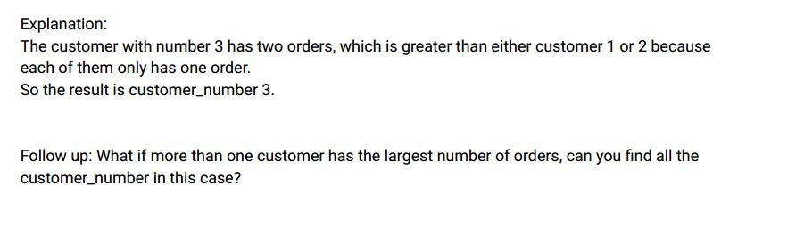

Ans:-

|  |
| --- |
|  |
| CREATE TABLE orders( |
|  | order_number INT, |
|  | customer_number INT, |
|  | CONSTRAINT prime_key PRIMARY KEY(order_number) |
|  | ); |
|  |  |
|  |  |
|  | INSERT INTO orders VALUES |
|  | (1,1), |
|  | (2,2), |
|  | (3,3), |
|  | (4,3); |
|  |  |
|  |  |
|  |  |
|  | WITH temp_orders AS ( |
|  | SELECT |
|  | DISTINCT customer_number, |
|  | DENSE_RANK() OVER(ORDER BY total_orders DESC) AS ranking |
|  | FROM ( |
|  | SELECT |
|  | customer_number, |
|  | COUNT(order_number) OVER(PARTITION BY customer_number) total_orders |
|  | FROM |
|  | orders |
|  | ) temp_cust_details |
|  | ) |
|  |  |
|  | SELECT |
|  | customer_number |
|  | FROM |
|  | temp_orders |
|  | WHERE |
|  | ranking = 1; |
|  |  |
|  |  |
|  |  |

Select * from orders;

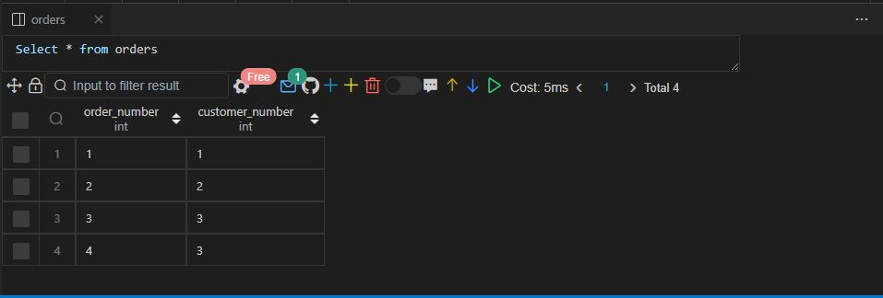

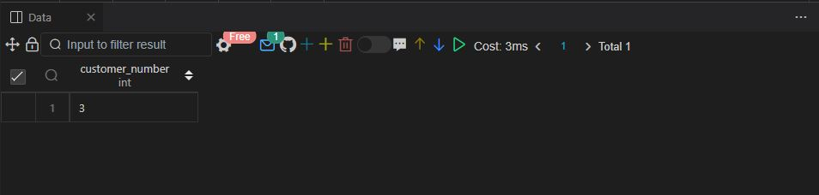

Q58.

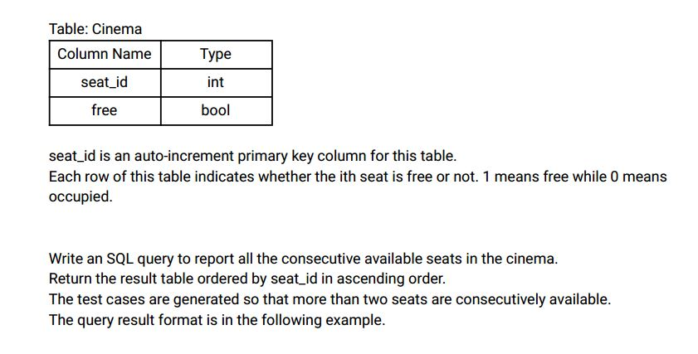

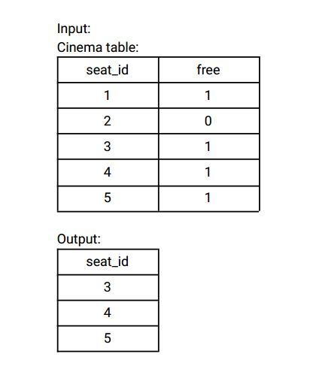

Ans:-

|  |
| --- |
|  |
| CREATE TABLE cinema( |
|  | seat_id INT AUTO_INCREMENT, |
|  | free BOOLEAN, |
|  | CONSTRAINT prime_key PRIMARY KEY(seat_id) |
|  | ); |
|  |  |
|  |  |
|  | INSERT INTO cinema (free) VALUES |
|  | (1),(0),(1),(1),(1),(1),(0),(1), |
|  | (1),(0),(1),(1),(1),(0),(1),(1); |
|  |  |
|  |  |
|  |  |
|  | SELECT |
|  | DISTINCT c1.seat_id |
|  | FROM |
|  | cinema c1 |
|  | INNER JOIN |
|  | cinema c2 |
|  | ON |
|  | ABS(c1.seat_id - c2.seat_id) = 1 |
|  | AND |
|  | (c1.free = 1 AND c2.free = 1) |
|  | ORDER BY |
|  | c1.seat_id; |
|  |  |
|  |  |
|  |  |

Select * from cinema;

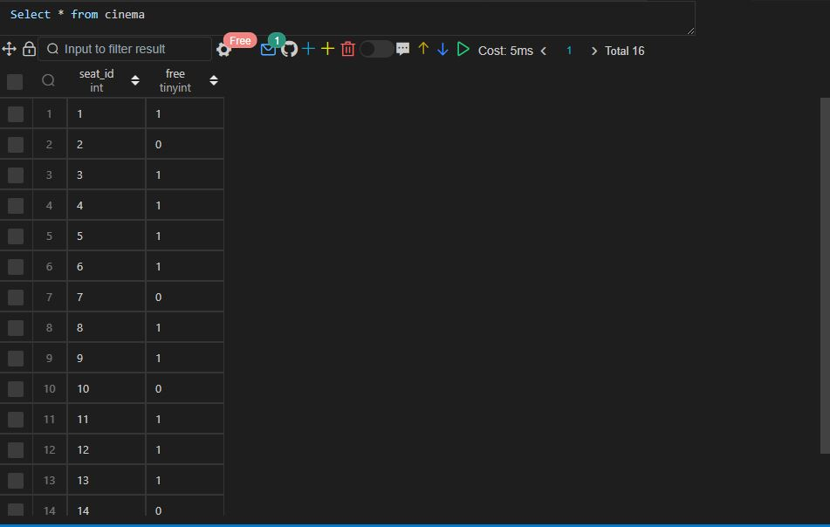

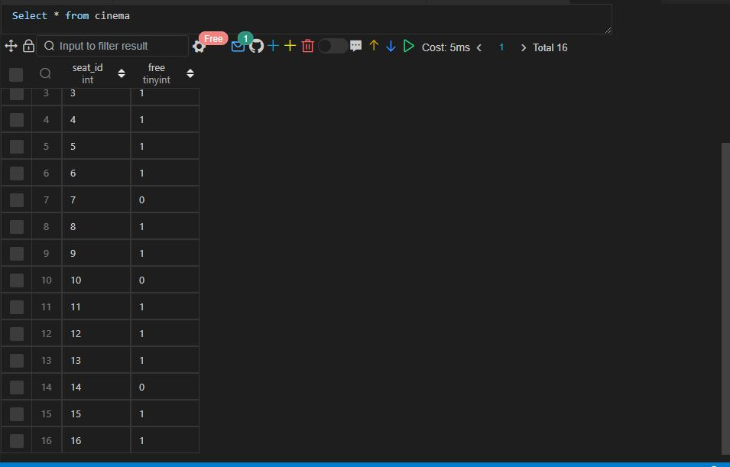

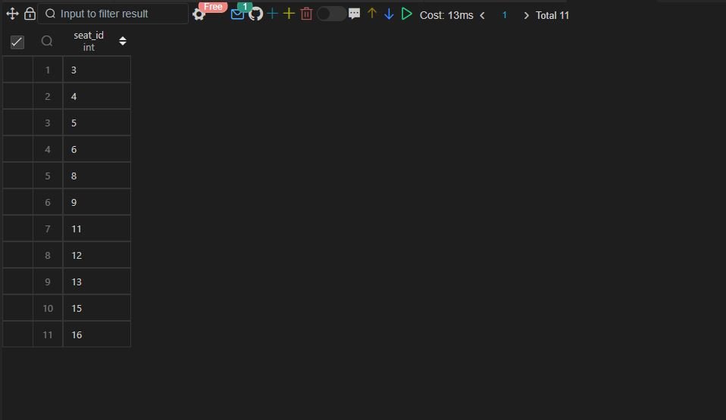

Q59.

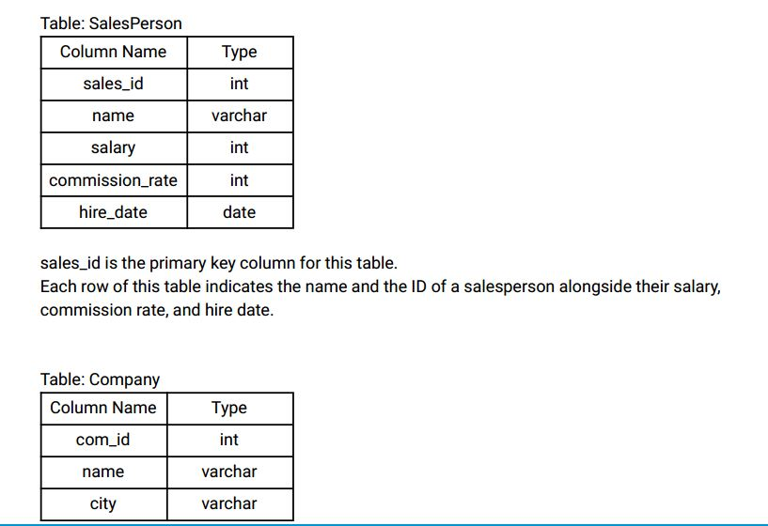

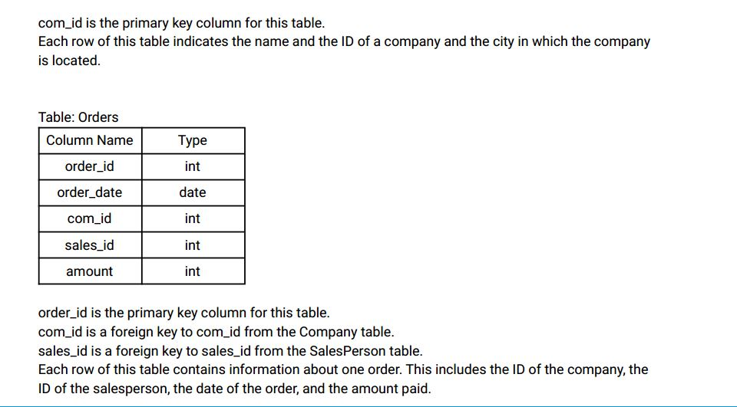

Write an SQL query to report the names of all the salespersons who did not have any orders related to

the company with the name "RED".

Return the result table in any order .

The query result format is in the following example.

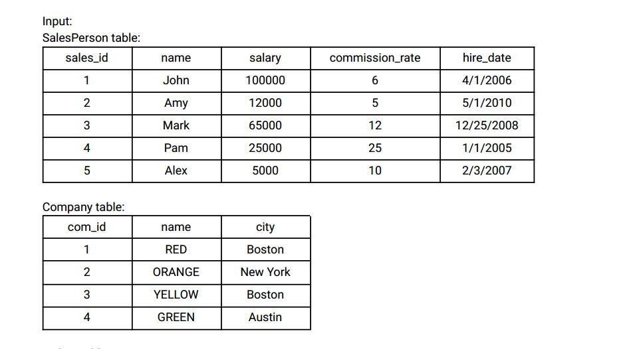

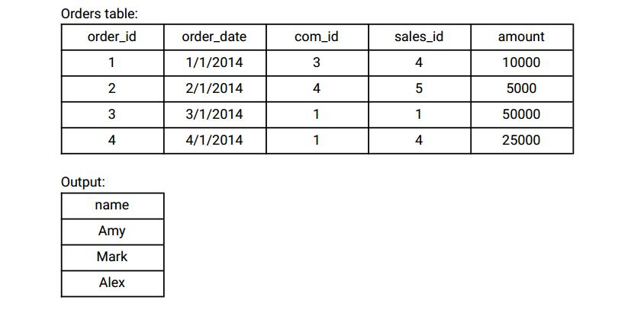

Explanation:

According to orders 3 and 4 in the Orders table, it is easy to tell that only salesperson John and Pam

have sales to company RED, so we report all the other names in the table salesperson.

Ans:-

|  |
| --- |
|  |
| CREATE TABLE sales_person( |
|  | sales_id INT, |
|  | name VARCHAR(20), |
|  | salary INT, |
|  | commission_rate INT, |
|  | hire_date VARCHAR(25), |
|  | CONSTRAINT prime_key PRIMARY KEY(sales_id) |
|  | ); |
|  |  |
|  |  |
|  | INSERT INTO sales_person VALUES |
|  | (1,'JOHN',100000,6,'4/1/2006'), |
|  | (2,'AMY',12000,5,'5/1/2010'), |
|  | (3,'MARK',65000,12,'12/25/2008'), |
|  | (4,'PAM',25000,25,'1/1/2005'), |
|  | (5,'ALEX',5000,10,'2/3/2007'); |
|  |  |
|  |  |
|  | CREATE TABLE company( |
|  | company_id INT, |
|  | name VARCHAR(20), |
|  | city VARCHAR(10), |
|  | CONSTRAINT prime_key PRIMARY KEY(company_id) |
|  | ); |
|  |  |
|  |  |
|  | INSERT INTO company VALUES |
|  | (1,'RED','BOSTON'), |
|  | (2,'ORANGE','NEW YORK'), |
|  | (3,'YELLOW','BOSTON'), |
|  | (4,'GREEN','AUSTIN'); |
|  |  |
|  |  |
|  | CREATE TABLE orders( |
|  | order_id INT, |
|  | order_date VARCHAR(30), |
|  | company_id INT, |
|  | sales_id INT, |
|  | amount INT, |
|  | CONSTRAINT prime_key PRIMARY KEY(order_id), |
|  | CONSTRAINT company_foreign_key FOREIGN KEY (company_id) REFERENCES company(company_id), |
|  | CONSTRAINT sales_foreign_key FOREIGN KEY (sales_id) REFERENCES sales_person(sales_id) |
|  | ); |
|  |  |
|  |  |
|  | INSERT INTO orders VALUES |
|  | (1,'1/1/2014',3,4,10000), |
|  | (2,'2/1/2014',4,5,5000), |
|  | (3,'3/1/2014',1,1,50000), |
|  | (4,'4/1/2014',1,4,25000); |
|  |  |
|  |  |
|  |  |
|  | SELECT |
|  | name |
|  | FROM |
|  | sales_person |
|  | WHERE |
|  | sales_id NOT IN ( |
|  | SELECT |
|  | o.sales_id |
|  | FROM |
|  | orders o |
|  | INNER JOIN |
|  | company c |
|  | ON |
|  | c.company_id = o.company_id |
|  | WHERE |
|  | c.name = 'RED' |
|  | ); |
|  |  |
|  |  |
|  |  |

Select * from sales_person;

Select * from company;

Select * from orders;

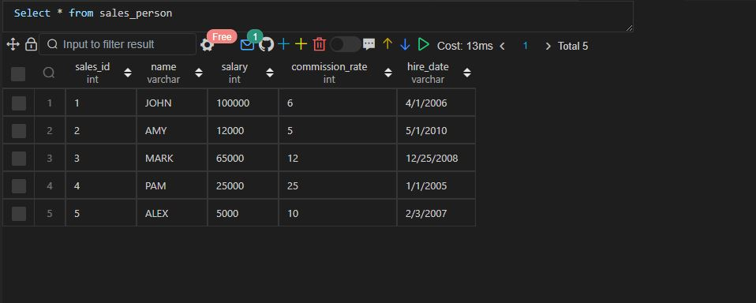

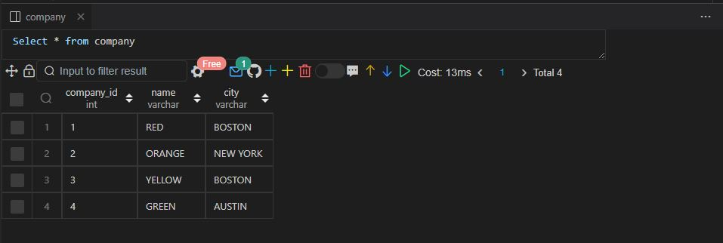

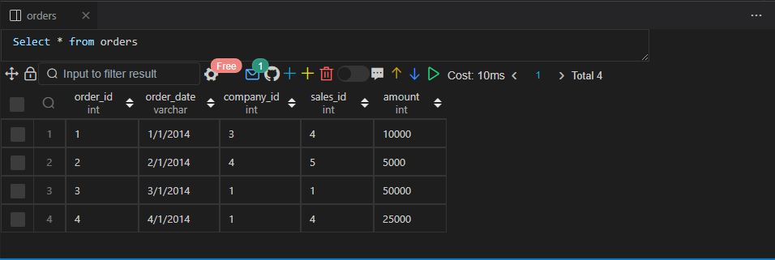

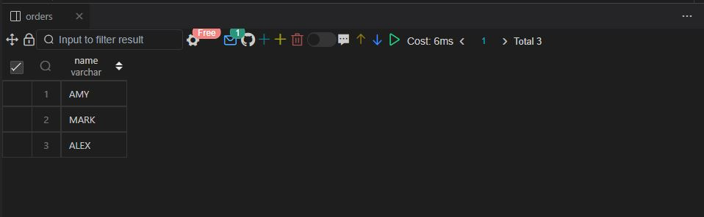

Q60.

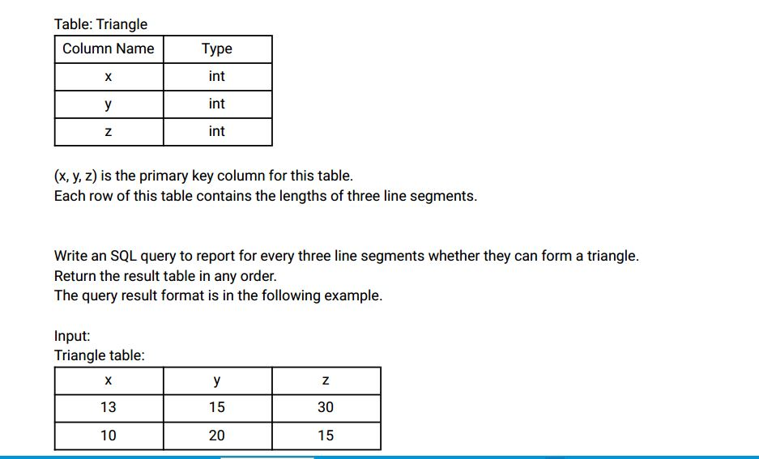

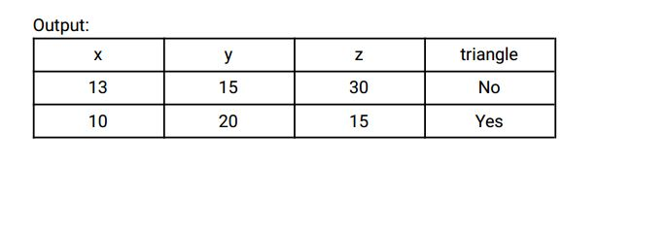

Ans:-

|  |
| --- |
|  |
| CREATE TABLE triangle( |
|  | x INT, |
|  | y INT, |
|  | z INT, |
|  | CONSTRAINT prime_key PRIMARY KEY(x,y,z) |
|  | ); |
|  |  |
|  |  |
|  | INSERT INTO triangle VALUES |
|  | (13,15,30), |
|  | (10,20,15); |
|  |  |
|  |  |
|  |  |
|  | SELECT |
|  | x, |
|  | y, |
|  | z, |
|  | IF(x+y>z AND x+z>y AND y+z>x, 'YES','NO') AS is_triangle |
|  | FROM |
|  | triangle; |
|  |  |
|  |  |
|  |  |

Select * from triangle;

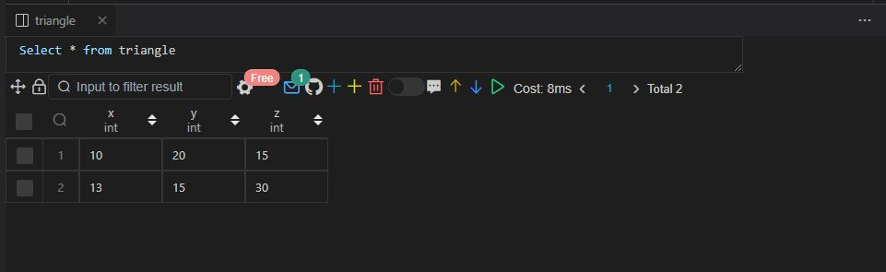

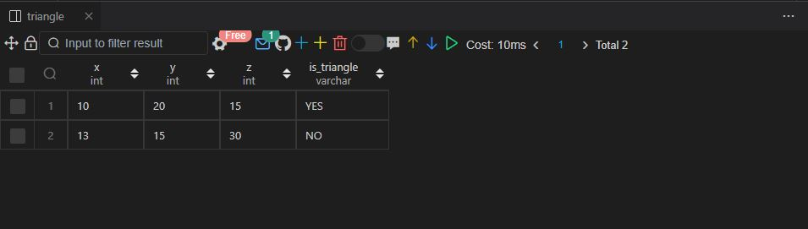

Q61.

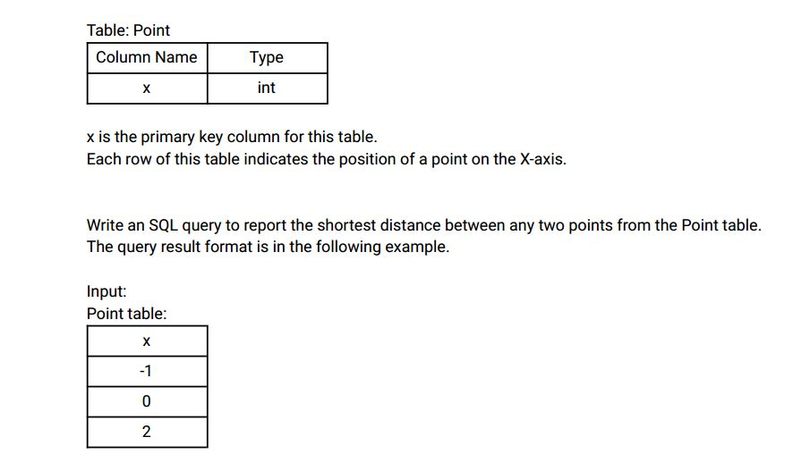

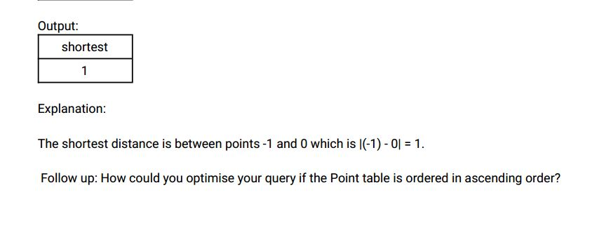

Ans:-

|  |
| --- |
|  |
| CREATE TABLE point( |
|  | x INT, |
|  | CONSTRAINT prime_key PRIMARY KEY(x) |
|  | ); |
|  |  |
|  |  |
|  | INSERT INTO point VALUES |
|  | (-1), |
|  | (0), |
|  | (2); |
|  |  |
|  |  |
|  |  |
|  | SELECT |
|  | MIN(ABS(c1.x - c2.x)) AS shortest_distance |
|  | FROM |
|  | point c1 |
|  | INNER JOIN |
|  | point c2 |
|  | WHERE |
|  | c1.x!=c2.x; |
|  |  |
|  |  |
|  |  |

Select * from point;

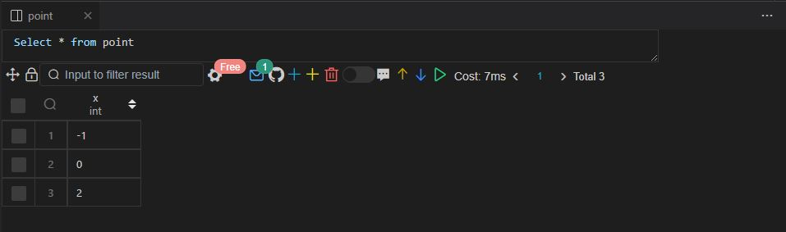

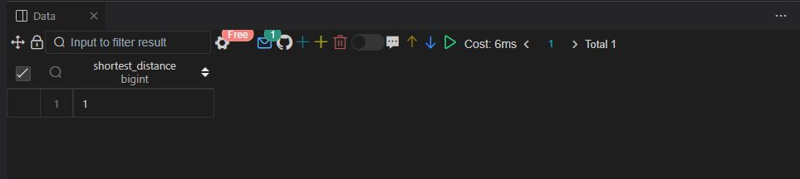

Q62.

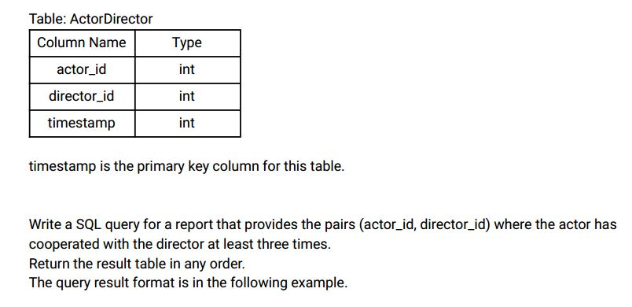

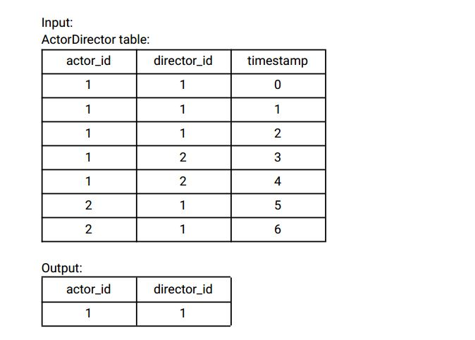

Explanation:

The only pair is (1, 1) where they cooperated exactly 3 times.

Ans:-

|  |
| --- |
|  |
| CREATE TABLE actor_director( |
|  | actor_id INT, |
|  | director_id INT, |
|  | timestamp INT, |
|  | CONSTRAINT prime_key PRIMARY KEY(timestamp) |
|  | ); |
|  |  |
|  |  |
|  | INSERT INTO actor_director VALUES |
|  | (1,1,0), |
|  | (1,1,1), |
|  | (1,1,2), |
|  | (1,2,3), |
|  | (1,2,4), |
|  | (2,1,5), |
|  | (2,1,6); |
|  |  |
|  |  |
|  |  |
|  | WITH temp_actor_director AS ( |
|  | SELECT |
|  | DISTINCT actor_id, |
|  | director_id, |
|  | DENSE_RANK() OVER(ORDER BY total_movies DESC) AS ranking |
|  | FROM ( |
|  | SELECT |
|  | actor_id, |
|  | director_id, |
|  | COUNT(actor_id) OVER(PARTITION BY actor_id, director_id) AS total_movies |
|  | FROM |
|  | actor_director |
|  | ) temp |
|  | ) |
|  |  |
|  | SELECT |
|  | actor_id, |
|  | director_id |
|  | FROM |
|  | temp_actor_director |
|  | WHERE |
|  | ranking = 1; |
|  |  |
|  |  |
|  |  |

Select * from actor_director;

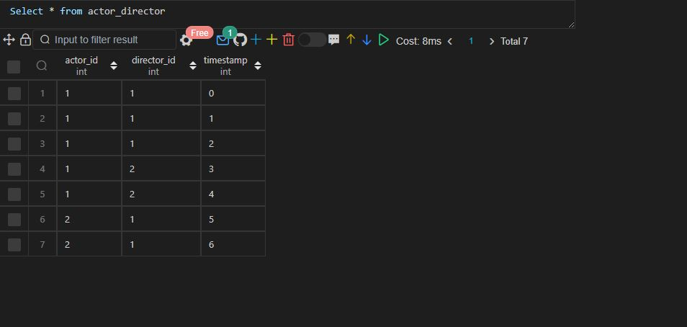

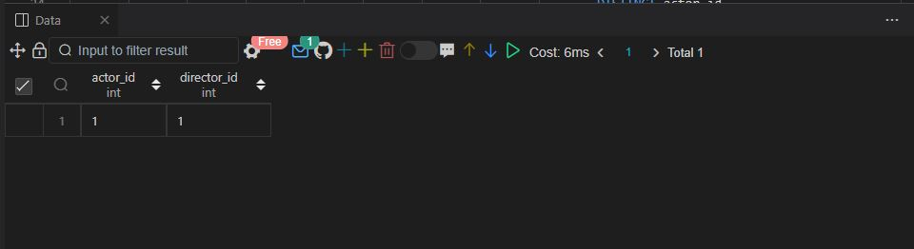

Q63.

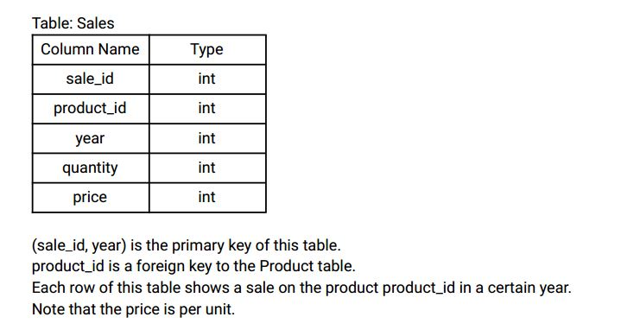

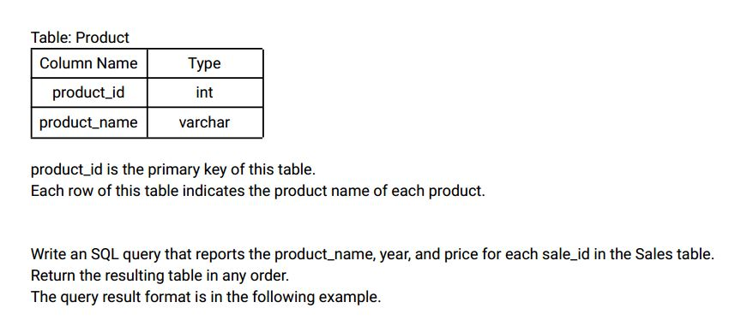

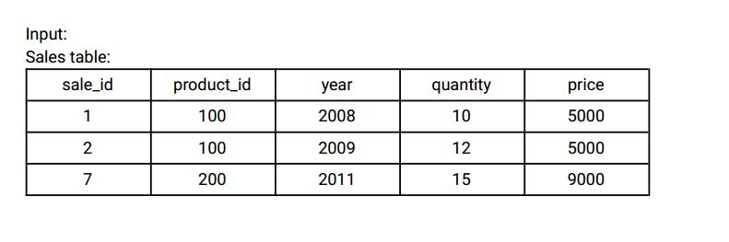

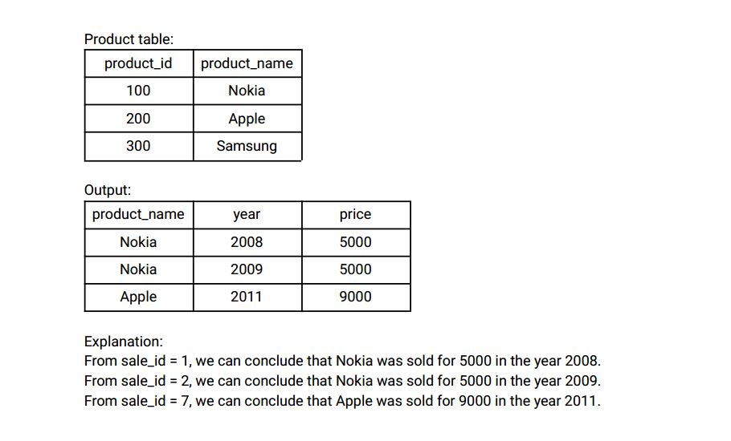

Ans:-

|  |
| --- |
|  |
| CREATE TABLE sales( |
|  | sale_id INT, |
|  | product_id INT, |
|  | year INT, |
|  | Quantity INT, |
|  | price INT, |
|  | CONSTRAINT prime_key PRIMARY KEY(sale_id, year) |
|  | ); |
|  |  |
|  |  |
|  | CREATE TABLE product( |
|  | product_id INT, |
|  | product_name VARCHAR(20), |
|  | CONSTRAINT prime_key PRIMARY KEY(product_id) |
|  | ); |
|  |  |
|  |  |
|  | INSERT INTO sales VALUES |
|  | (1,100,2008,10,5000), |
|  | (2,100,2009,12,5000), |
|  | (7,200,2011,15,9000); |
|  |  |
|  |  |
|  | INSERT INTO product VALUES |
|  | (100,'NOKIA'), |
|  | (200,'APPLE'), |
|  | (300,'SAMSUNG'); |
|  |  |
|  |  |
|  |  |
|  | SELECT |
|  | p.product_name, |
|  | s.year, |
|  | s.price |
|  | FROM |
|  | sales s |
|  | INNER JOIN |
|  | product p |
|  | ON |
|  | p.product_id = s.product_id; |
|  |  |
|  |  |
|  |  |

Select * from sales;

Select * from product;

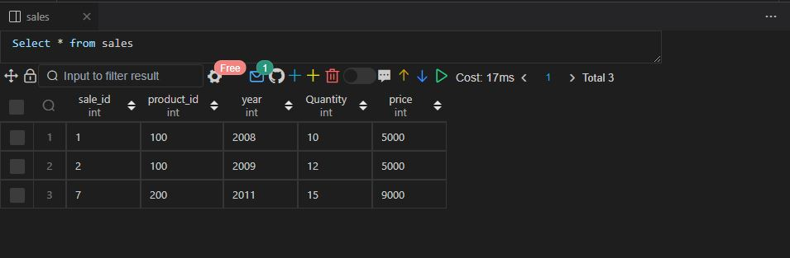

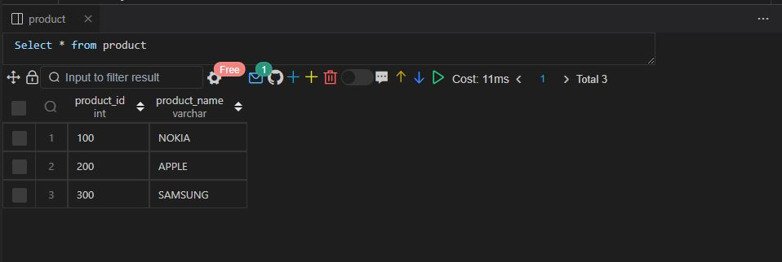

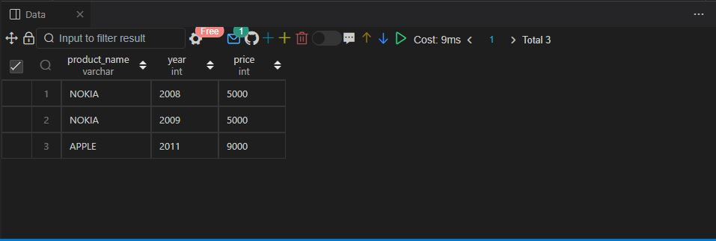

Q64.

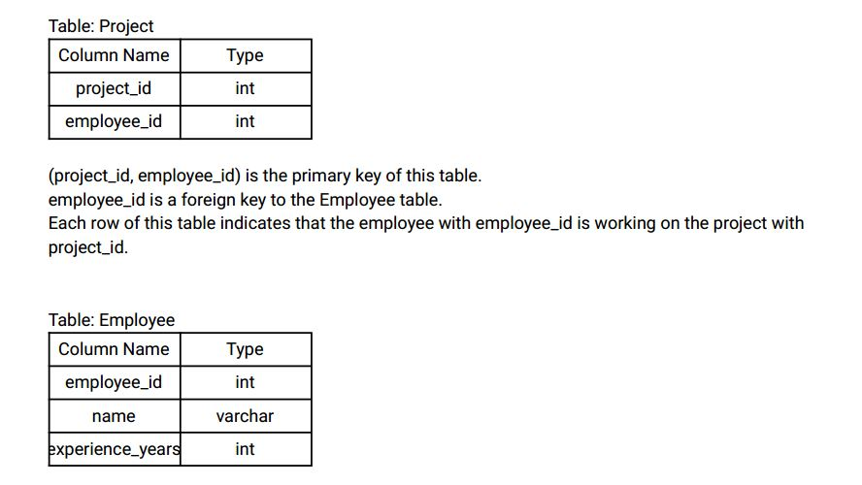

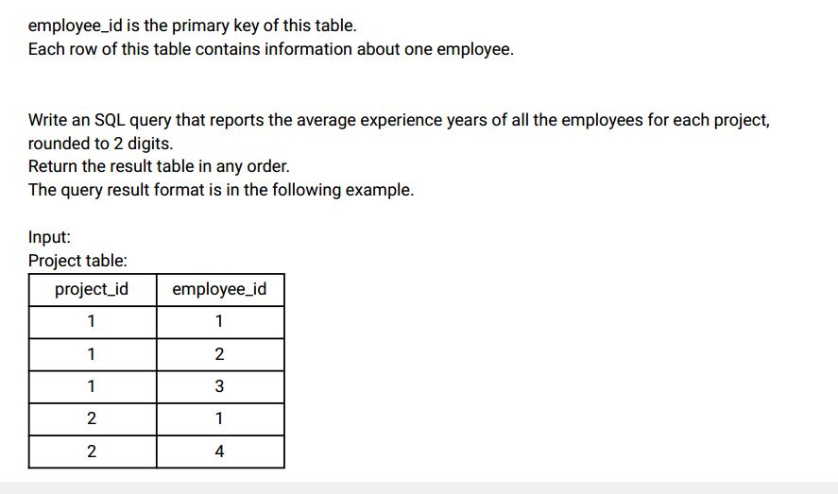

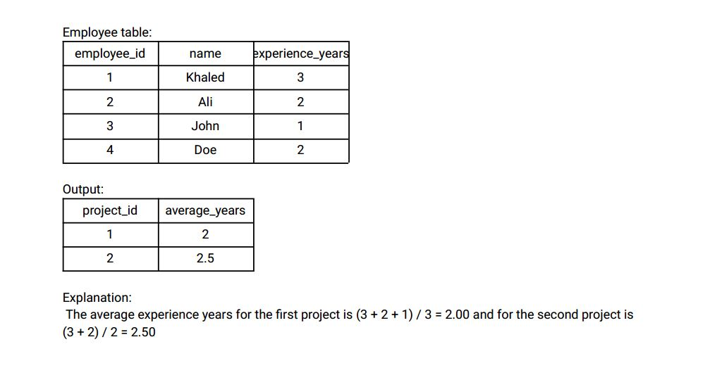

Ans:-

|  |
| --- |
|  |
| CREATE TABLE project( |
|  | project_id INT, |
|  | employee_id INT, |
|  | CONSTRAINT prime_key PRIMARY KEY(project_id, employee_id) |
|  | ); |
|  |  |
|  |  |
|  | INSERT INTO project VALUES |
|  | (1,1), |
|  | (1,2), |
|  | (1,3), |
|  | (2,1), |
|  | (2,4); |
|  |  |
|  |  |
|  | CREATE TABLE employee( |
|  | employee_id INT, |
|  | name VARCHAR(20), |
|  | experience_years INT, |
|  | CONSTRAINT prime_key PRIMARY KEY(employee_id) |
|  | ); |
|  |  |
|  |  |
|  | INSERT INTO employee VALUES |
|  | (1,'KHALED',3), |
|  | (2,'ALI',2), |
|  | (3,'JOHN',1), |
|  | (4,'DOE',2); |
|  |  |
|  |  |
|  | -- Approach 1 |
|  |  |
|  |  |
|  | SELECT |
|  | p.project_id, |
|  | ROUND(AVG(experience_years), 2) AS average_years |
|  | FROM |
|  | employee e |
|  | INNER JOIN |
|  | project p |
|  | ON |
|  | p.employee_id = e.employee_id |
|  | GROUP BY |
|  | project_id; |
|  |  |
|  |  |
|  |  |
|  | -- Approach 2 |
|  |  |
|  |  |
|  | SELECT |
|  | DISTINCT p.project_id, |
|  | ROUND(AVG(experience_years) OVER(PARTITION BY project_id), 2) AS average_years |
|  | FROM |
|  | employee e |
|  | INNER JOIN |
|  | project p |
|  | ON |
|  | p.employee_id = e.employee_id; |
|  |  |
|  |  |
|  |  |

Select * from project;

Select * from employee;

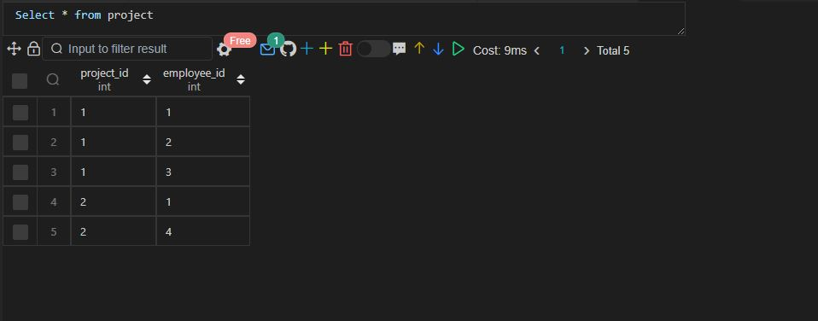

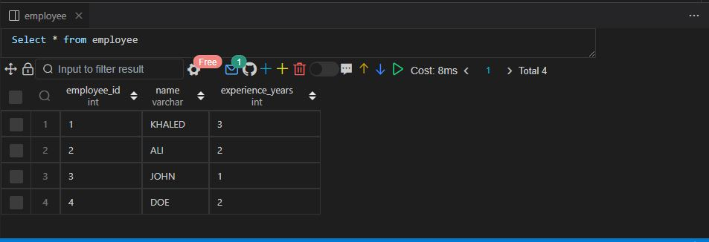

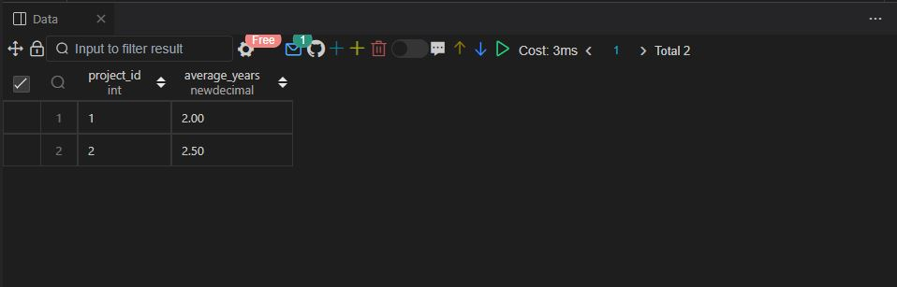

Q65.

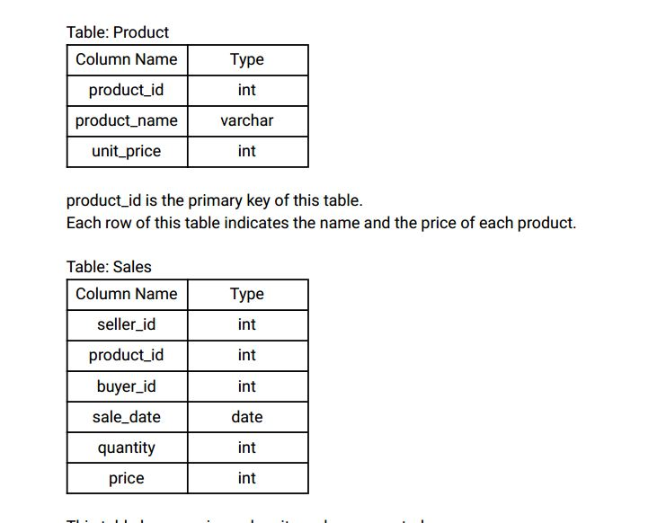

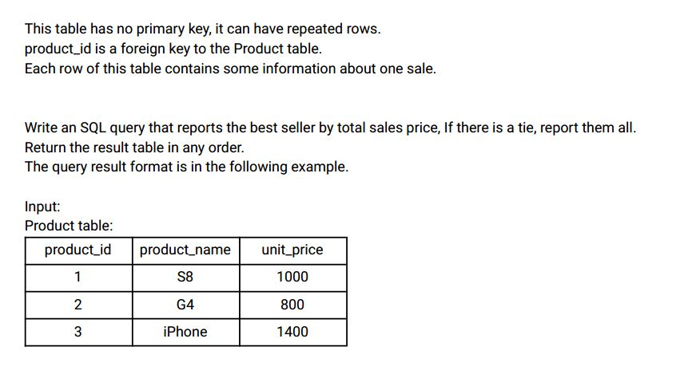

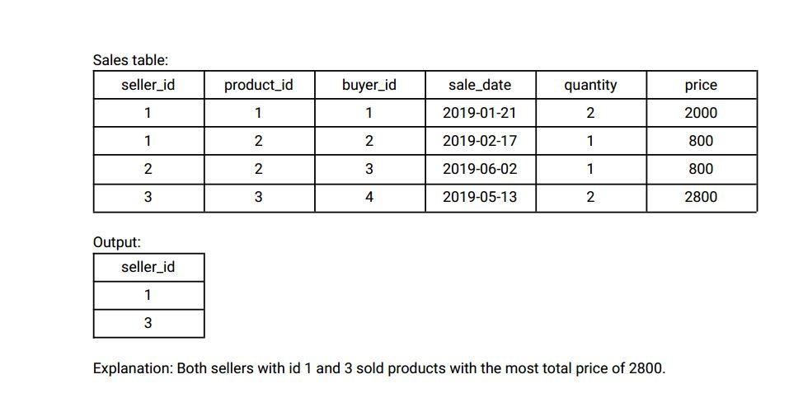

Ans:-

|  |
| --- |
|  |
| CREATE TABLE product( |
|  | product_id INT, |
|  | product_name VARCHAR(20), |
|  | unit_price INT, |
|  | CONSTRAINT prime_key PRIMARY KEY(product_id) |
|  | ); |
|  |  |
|  |  |
|  | INSERT INTO product VALUES |
|  | (1,'S8',1000), |
|  | (2,'G4',800), |
|  | (3,'Iphone',1400); |
|  |  |
|  |  |
|  | CREATE TABLE sales( |
|  | seller_id INT, |
|  | product_id INT, |
|  | buyer_id INT, |
|  | sale_date DATE, |
|  | quantity INT, |
|  | price INT, |
|  | CONSTRAINT FOREIGN_KEY FOREIGN KEY(product_id) REFERENCES product(product_id) |
|  | ); |
|  |  |
|  |  |
|  | INSERT INTO sales VALUES |
|  | (1,1,1,'2019-01-21',2,2000), |
|  | (1,2,2,'2019-01-21',1,800), |
|  | (2,2,3,'2019-01-21',1,800), |
|  | (3,3,4,'2019-01-21',2,2800); |
|  |  |
|  |  |
|  |  |
|  | WITH temp_sales AS ( |
|  | SELECT |
|  | seller_id, |
|  | total_price, |
|  | DENSE_RANK() OVER (ORDER BY total_price DESC) ranking |
|  | FROM |
|  | ( |
|  | SELECT |
|  | s.seller_id, |
|  | SUM(s.quantity*p.unit_price) AS total_price |
|  | FROM |
|  | sales s |
|  | INNER JOIN |
|  | product p |
|  | ON |
|  | p.product_id = s.product_id |
|  | GROUP BY |
|  | seller_id |
|  | ) temp |
|  | ) |
|  |  |
|  |  |
|  | SELECT |
|  | seller_id |
|  | FROM |
|  | temp_sales |
|  | WHERE |
|  | ranking = 1; |
|  |  |
|  |  |
|  |  |

Select * from product;

Select * from sales;

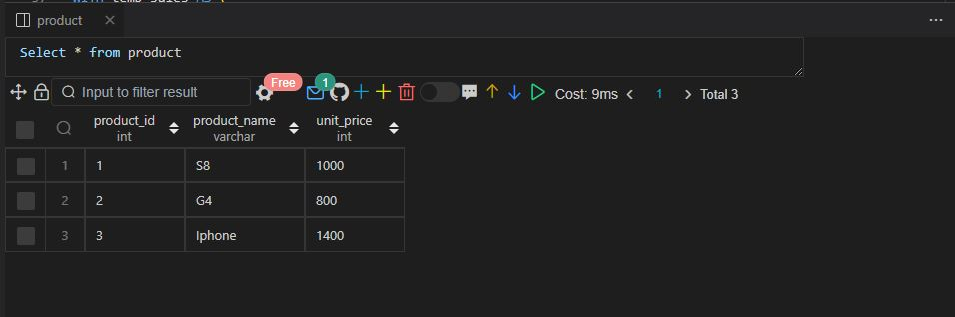

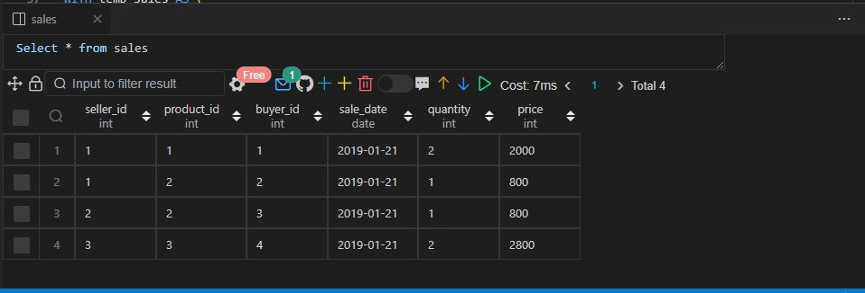

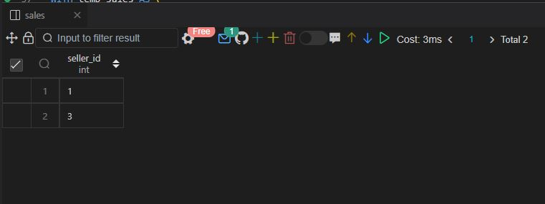

Q66.

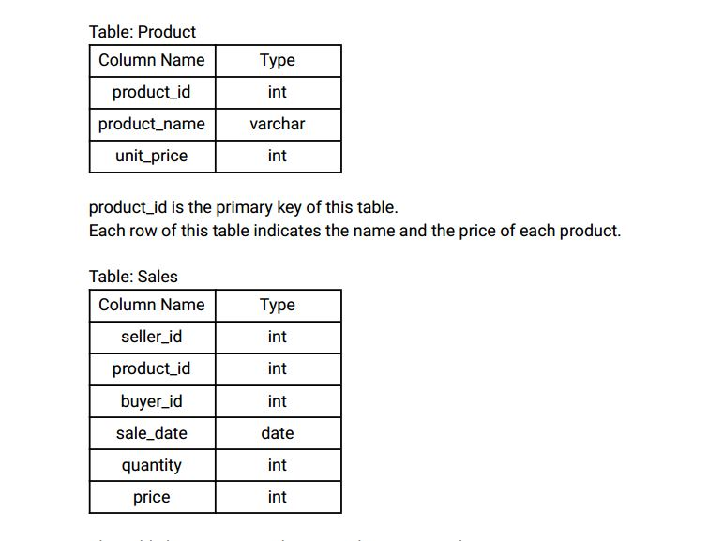

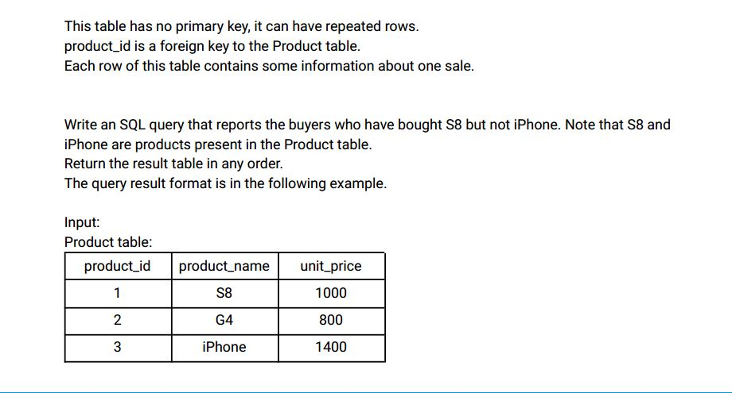

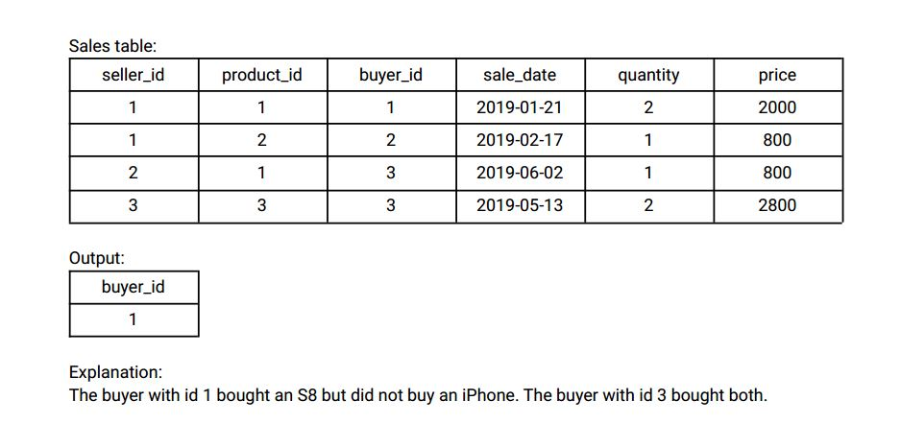

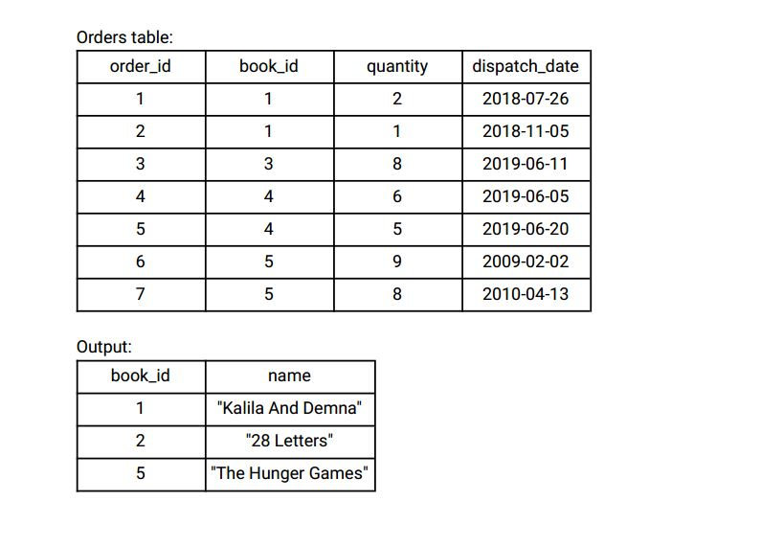

Ans:- Same input table as for previous question i.e. Q65

|  |
| --- |
|  |
|  |
|  |  |
|  |  |
|  |  |
|  | SELECT |
|  | s.buyer_id |
|  | FROM |
|  | sales s |
|  | INNER JOIN |
|  | product p |
|  | ON |
|  | p.product_id = s.product_id |
|  | WHERE |
|  | p.product_name = 'S8' |
|  | AND |
|  | s.buyer_id NOT IN ( |
|  | SELECT |
|  | s.buyer_id |
|  | FROM |
|  | sales S |
|  | INNER JOIN |
|  | product P |
|  | ON |
|  | s.product_id = p.product_id |
|  | WHERE |
|  | p.product_name = 'Iphone' |
|  | ); |
|  |  |
|  |  |
|  |  |

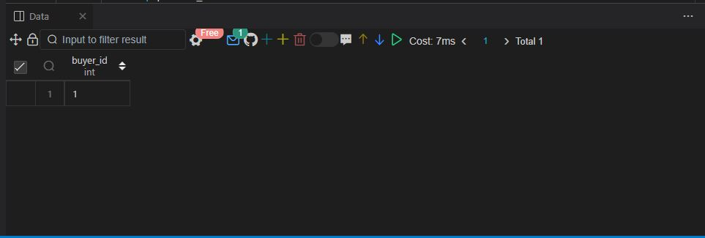

Q67.

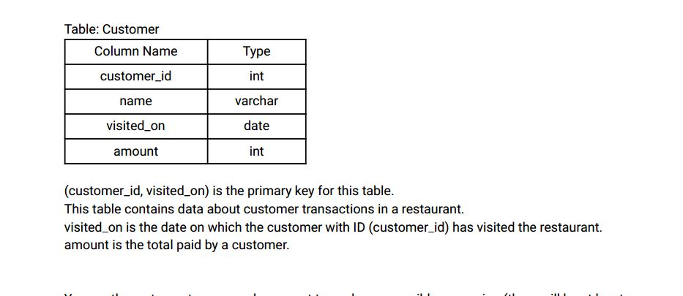

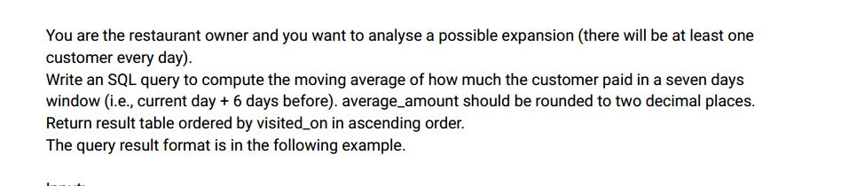

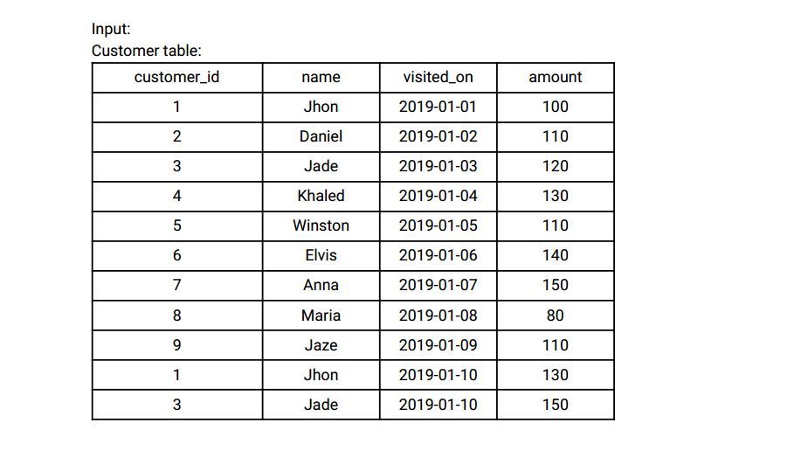

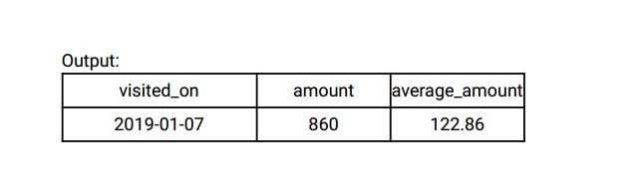

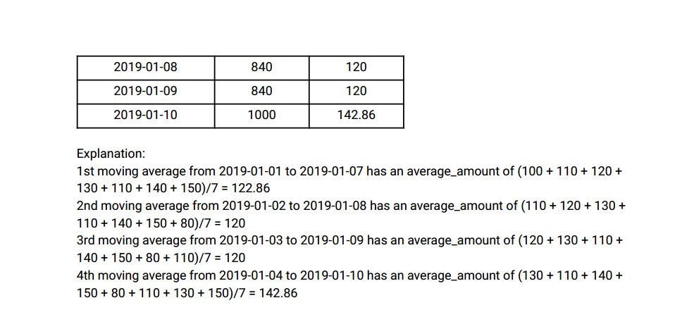

Ans:-

|  |
| --- |
|  |
| CREATE TABLE customer( |
|  | customer_id INT, |
|  | name VARCHAR(20), |
|  | visited_on DATE, |
|  | amount INT, |
|  | CONSTRAINT PRIMARY_KEY PRIMARY KEY(customer_id,visited_on) |
|  | ); |
|  |  |
|  |  |
|  | INSERT INTO customer VALUES |
|  | (1,'JOHN','2019-01-01',100), |
|  | (2,'DANIEL','2019-01-02',110), |
|  | (3,'JADE','2019-01-03',120), |
|  | (4,'KHALED','2019-01-04',130), |
|  | (5,'WINSTON','2019-01-05',110), |
|  | (6,'ELVIS','2019-01-06',140), |
|  | (7,'ANNA','2019-01-07',150), |
|  | (8,'MARIA','2019-01-08',80), |
|  | (9,'JAZE','2019-01-09',110), |
|  | (1,'JOHN','2019-01-10',130), |
|  | (3,'JADE','2019-01-10',150); |
|  |  |
|  |  |
|  |  |
|  | WITH temp_customer AS ( |
|  | SELECT |
|  | visited_on, |
|  | SUM(amount) AS amount |
|  | FROM |
|  | customer |
|  | GROUP BY |
|  | visited_on |
|  | ), |
|  |  |
|  | temp_customer2 AS ( |
|  | SELECT |
|  | visited_on, |
|  | sum(amount) OVER(ORDER BY visited_on ROWS BETWEEN 6 PRECEDING AND CURRENT ROW) AS weekly_amount, |
|  | ROUND(AVG(amount) OVER(ORDER BY visited_on ROWS BETWEEN 6 PRECEDING AND CURRENT ROW), 2) AS average_amount, |
|  | DENSE_RANK() OVER(ORDER BY visited_on) as ranking |
|  | FROM |
|  | temp_customer |
|  | ) |
|  |  |
|  | SELECT |
|  | visited_on, |
|  | weekly_amount, |
|  | average_amount |
|  | FROM |
|  | temp_customer2 |
|  | WHERE |
|  | ranking > 6; |
|  |  |
|  |  |
|  |  |

Select * from customer;

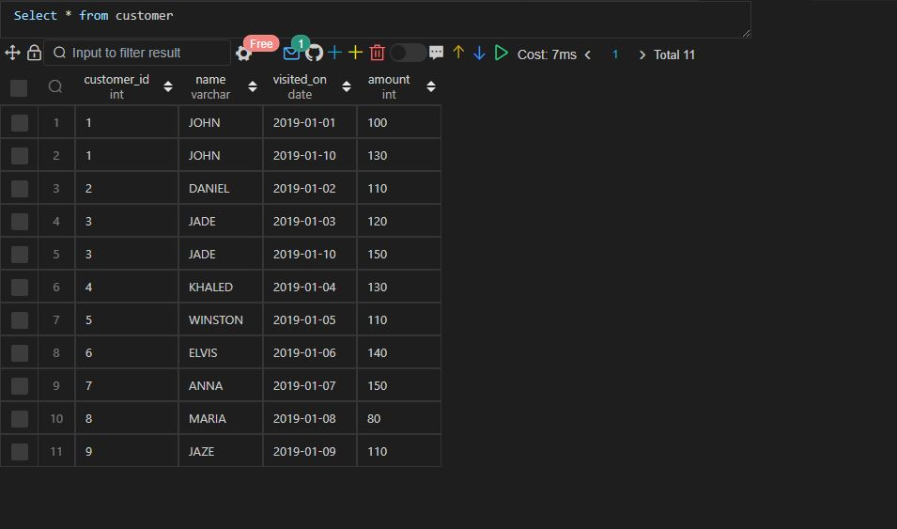

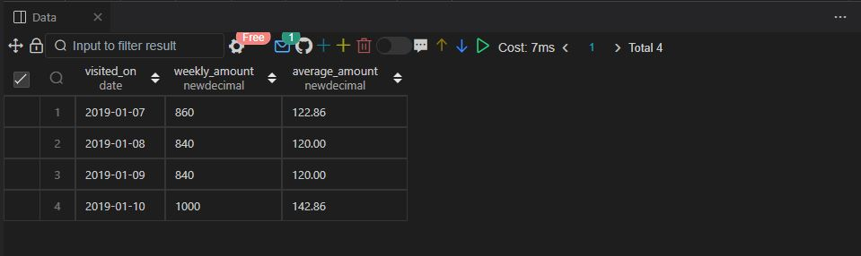

Q68.

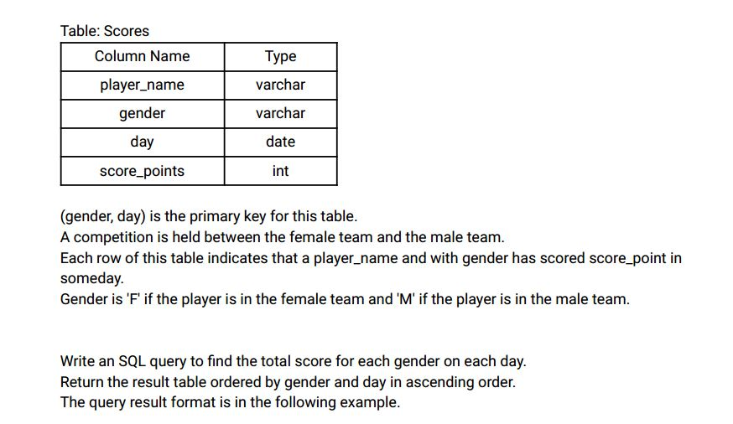

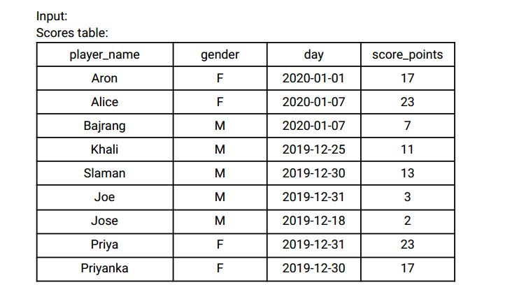

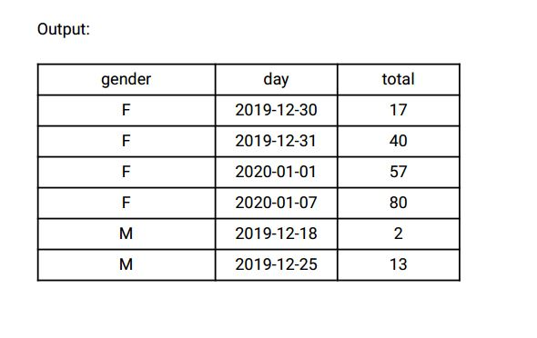

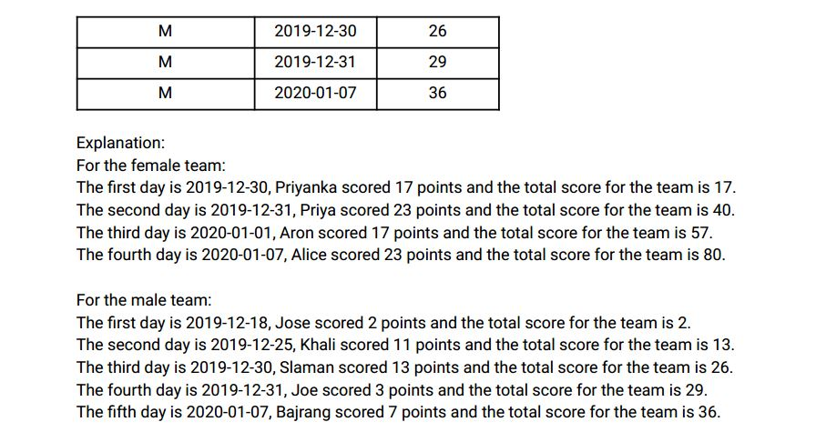

Ans:-

|  |
| --- |
|  |
| CREATE TABLE scores( |
|  | player_name VARCHAR(20), |
|  | gender VARCHAR(20), |
|  | day DATE, |
|  | score_points INT, |
|  | CONSTRAINT prime_key PRIMARY KEY(gender,day) |
|  | ); |
|  |  |
|  |  |
|  | INSERT INTO scores VALUES |
|  | ('ARON','F','2020-01-01',17), |
|  | ('ALICE','F','2020-01-07',23), |
|  | ('BAJRANG','M','2020-01-07',7), |
|  | ('KHALI','M','2019-12-25',11), |
|  | ('SLAMAN','M','2019-12-30',13), |
|  | ('JOE','M','2019-12-31',3), |
|  | ('JOSE','M','2019-12-18',2), |
|  | ('PRIYA','F','2019-12-31',23), |
|  | ('PRIYANKA','F','2019-12-30',17); |
|  |  |
|  |  |
|  |  |
|  | SELECT |
|  | gender, |
|  | day, |
|  | SUM(score_points) OVER(PARTITION BY gender ORDER BY day |
|  | ROWS BETWEEN UNBOUNDED PRECEDING AND CURRENT ROW) AS total_points |
|  | FROM |
|  | scores |
|  | order by |
|  | gender, |
|  | day; |
|  |  |
|  |  |
|  |  |

Select * from scores;

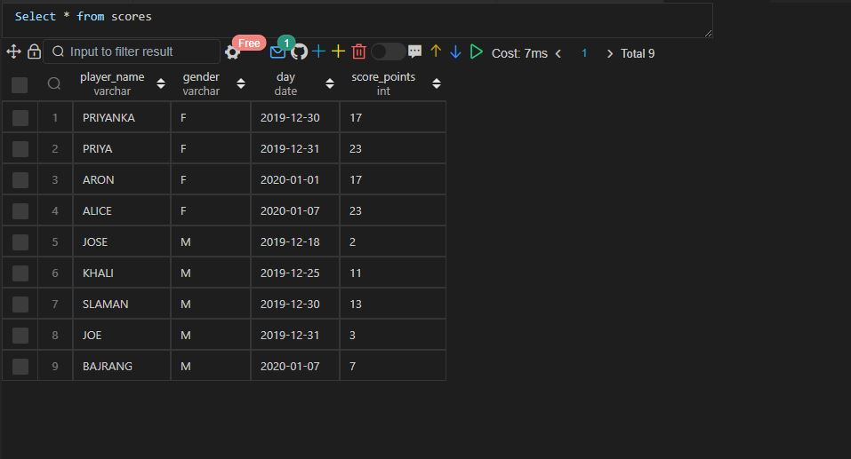

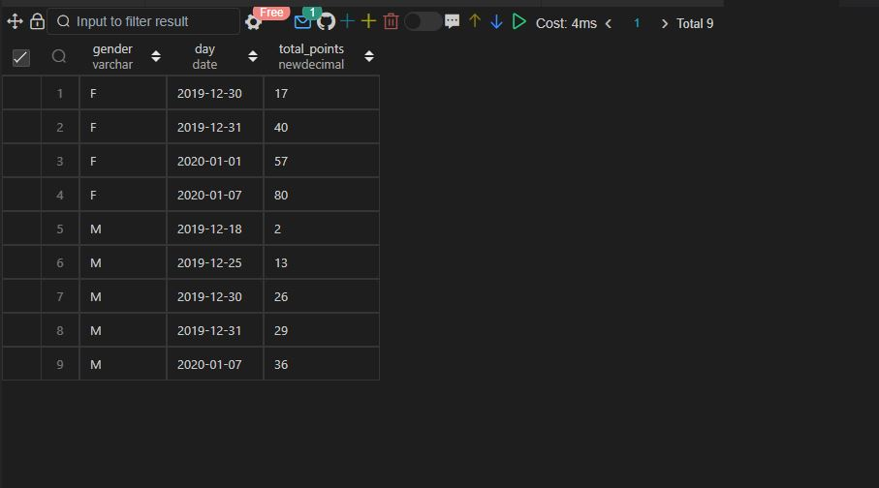

Q69.

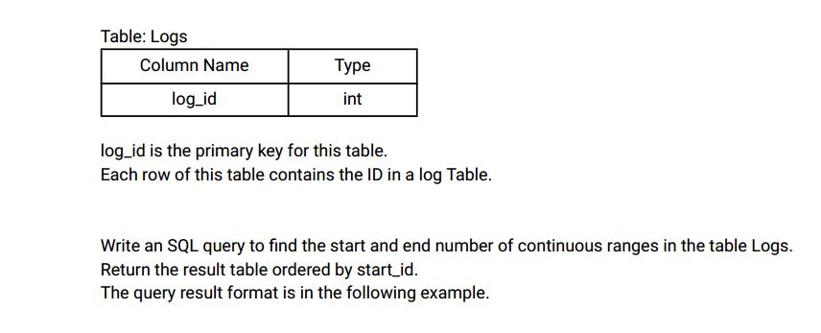

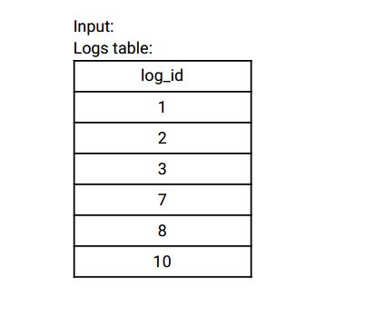

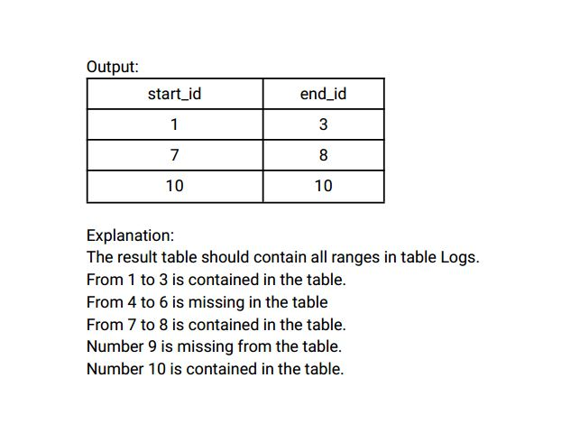

Ans:-

|  |
| --- |
|  |
| CREATE TABLE logs( |
|  | log_id INT, |
|  | CONSTRAINT prime_key PRIMARY KEY(log_id) |
|  | ); |
|  |  |
|  |  |
|  | INSERT INTO logs VALUES |
|  | (1), |
|  | (2), |
|  | (3), |
|  | (7), |
|  | (8), |
|  | (10); |
|  |  |
|  |  |
|  |  |
|  | SELECT |
|  | MIN(log_id) AS start_id, |
|  | MAX(log_id) AS end_id |
|  | FROM |
|  | ( |
|  | SELECT |
|  | log_id, |
|  | DENSE_RANK() OVER(ORDER BY log_id - RN) AS ranking |
|  | FROM |
|  | ( |
|  | SELECT |
|  | log_id, |
|  | ROW_number() OVER(ORDER BY log_id) AS RN |
|  | FROM |
|  | logs |
|  | ) temp_log |
|  | ) temp_log2 |
|  | GROUP BY |
|  | ranking |
|  | ORDER BY |
|  | start_id; |
|  |  |
|  |  |
|  |  |

Select * from logs;

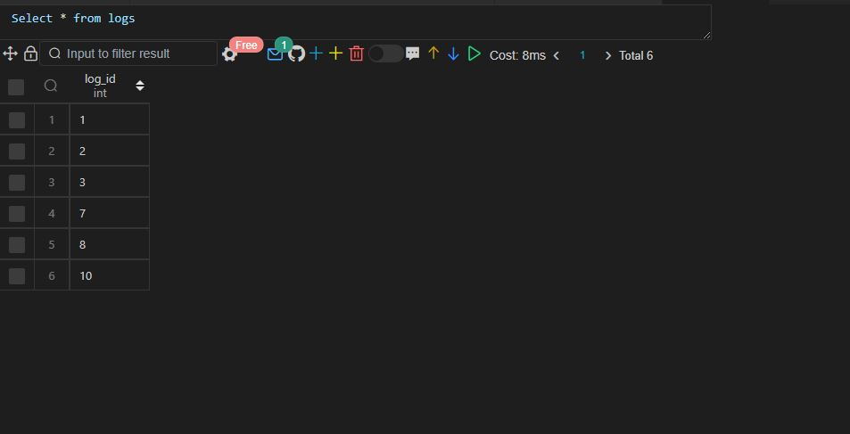

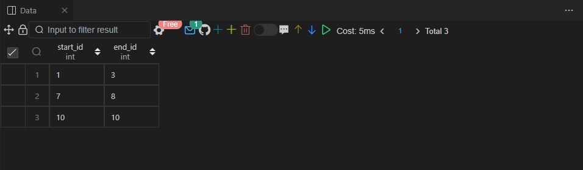

Q70.

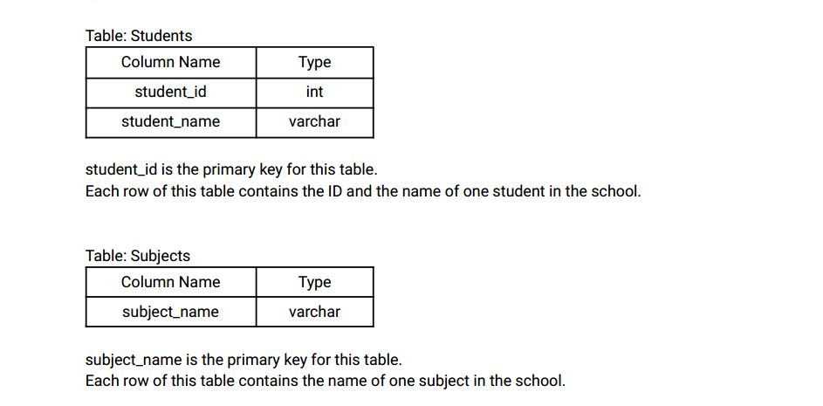

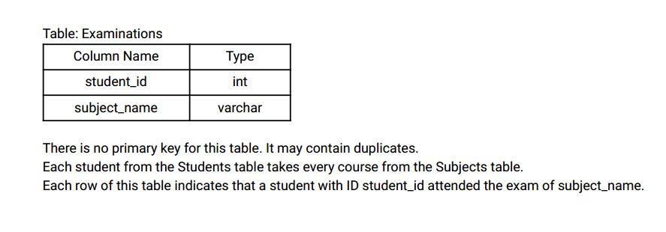

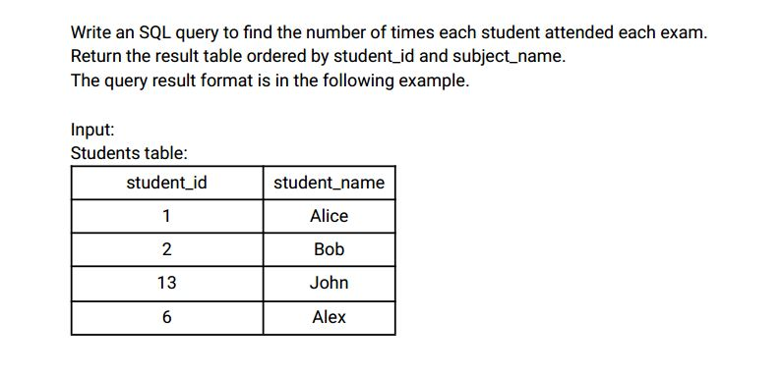

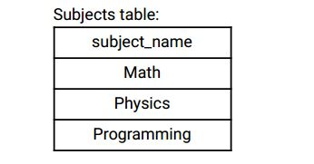

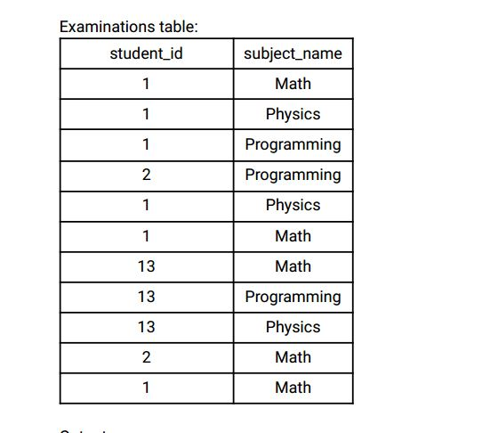

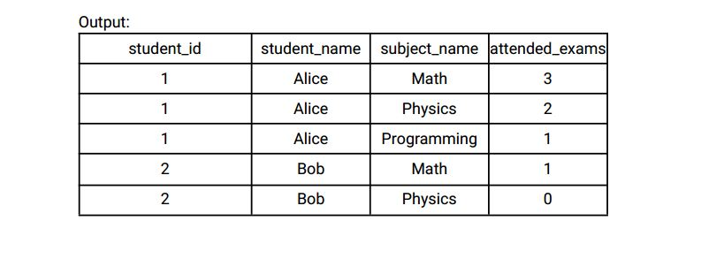

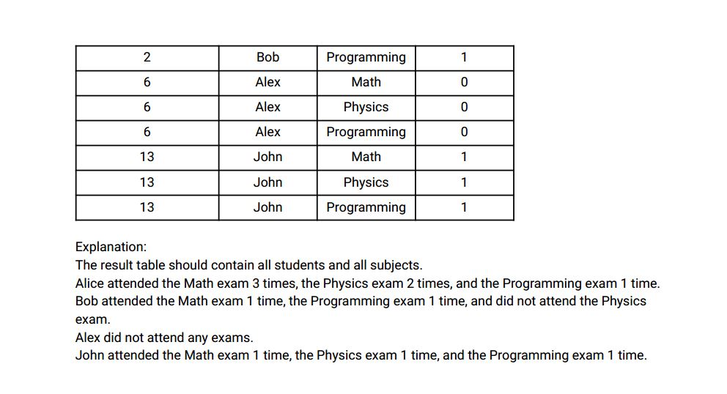

Ans:-

|  |
| --- |
|  |
| CREATE TABLE students( |
|  | student_id INT, |
|  | student_name VARCHAR(20), |
|  | CONSTRAINT prime_key PRIMARY KEY(student_id) |
|  | ); |
|  |  |
|  |  |
|  | CREATE TABLE subjects( |
|  | subject_name VARCHAR(20), |
|  | CONSTRAINT prime_key PRIMARY KEY(subject_name) |
|  | ); |
|  |  |
|  |  |
|  | CREATE TABLE exams( |
|  | student_id INT, |
|  | subject_name VARCHAR(20) |
|  | ); |
|  |  |
|  |  |
|  | INSERT INTO students VALUES |
|  | (1,'ALICE'), |
|  | (2,'BOB'), |
|  | (13,'JOHN'), |
|  | (6,'ALEX'); |
|  |  |
|  |  |
|  | INSERT INTO subjects VALUES |
|  | ('MATHS'), |
|  | ('PHYSICS'), |
|  | ('PROGRAMMING'); |
|  |  |
|  |  |
|  | INSERT INTO exams VALUES |
|  | (1,'MATHS'), |
|  | (1,'PHYSICS'), |
|  | (1,'PROGRAMMING'), |
|  | (2,'PROGRAMMING'), |
|  | (1,'PHYSICS'), |
|  | (1,'MATHS'), |
|  | (13,'MATHS'), |
|  | (13,'PROGRAMMING'), |
|  | (13,'PHYSICS'), |
|  | (2,'MATHS'), |
|  | (1,'MATHS'); |
|  |  |
|  |  |
|  |  |
|  | WITH temp_student AS ( |
|  | SELECT |
|  | student_id, |
|  | student_name, |
|  | subject_name |
|  | FROM |
|  | students, |
|  | subjects |
|  | ), |
|  |  |
|  | temp_student2 AS ( |
|  | SELECT |
|  | student_id, |
|  | subject_name, |
|  | COUNT(*) AS times_attended_each_exam |
|  | FROM |
|  | exams |
|  | GROUP BY |
|  | student_id, |
|  | subject_name |
|  | ) |
|  |  |
|  | SELECT |
|  | t.student_id, |
|  | t.student_name, |
|  | t.subject_name, |
|  | COALESCE(times_attended_each_exam,0) AS attended_exams |
|  | FROM |
|  | temp_student t |
|  | LEFT JOIN |
|  | temp_student2 t2 |
|  | ON |
|  | t.student_id = t2.student_id |
|  | AND |
|  | t.subject_name = t2.subject_name |
|  | ORDER BY |
|  | t.student_id, |
|  | t.subject_name; |
|  |  |
|  |  |
|  |  |

Select * from student;

Select * from subject;

Select * from exams;

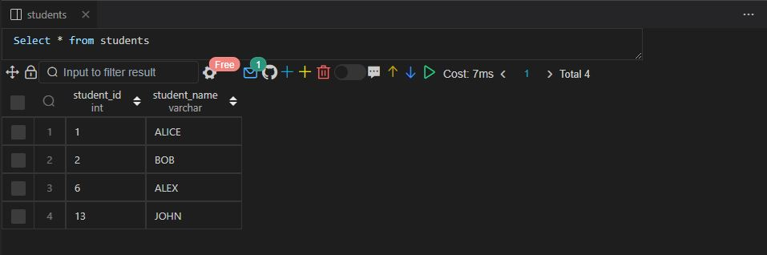

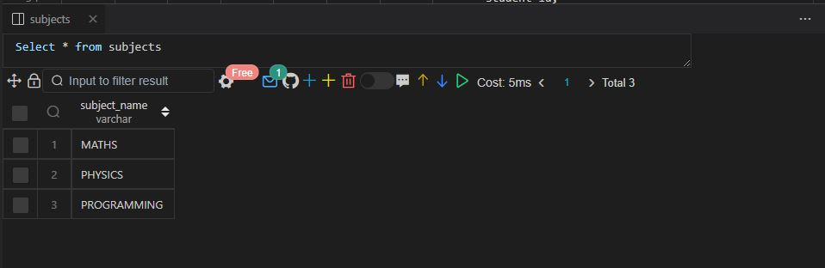

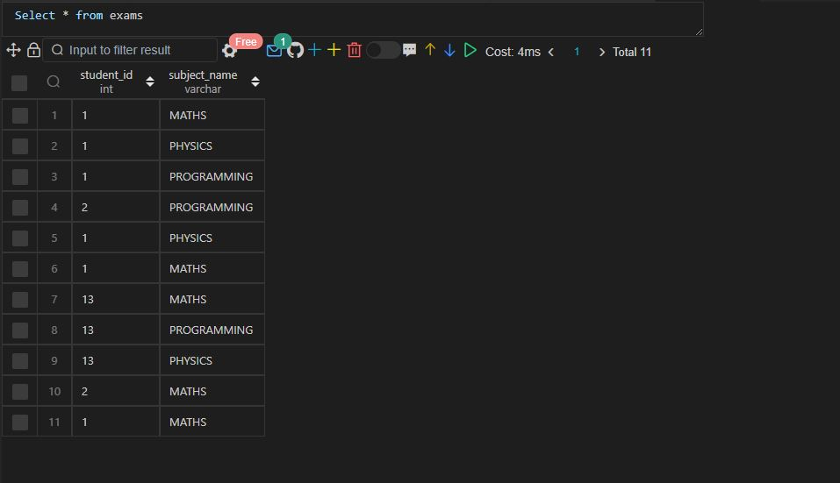

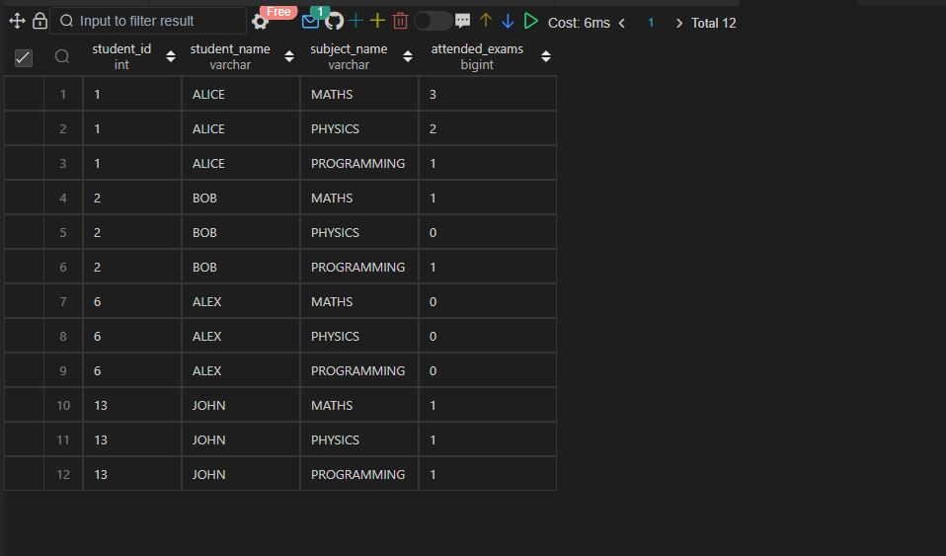

Q71.

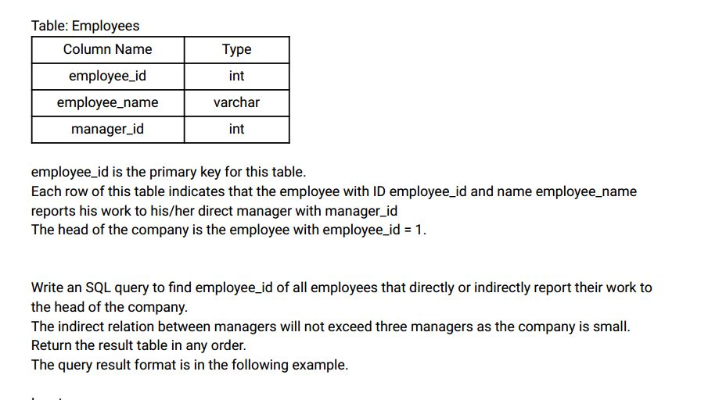

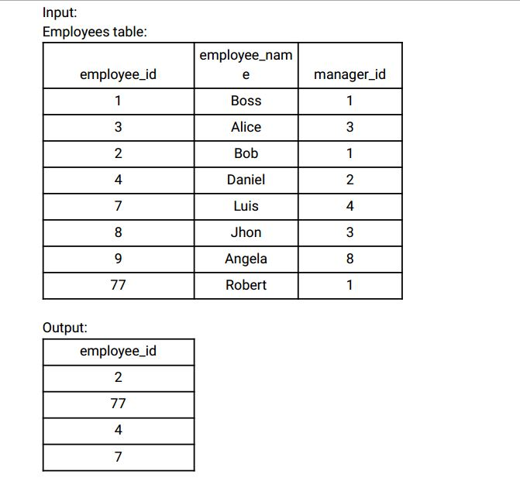

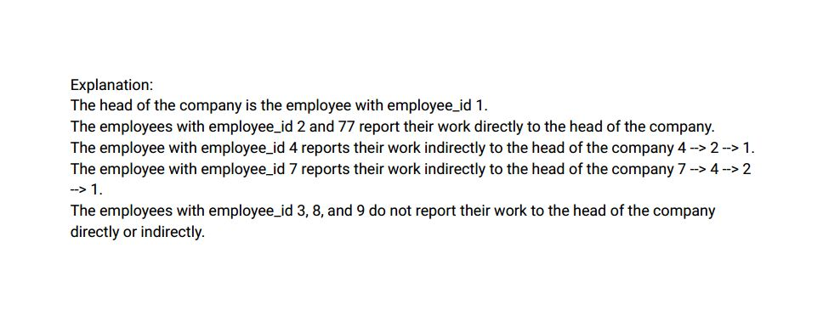

Ans:-

|  |
| --- |
|  |
| CREATE TABLE employees( |
|  | employee_id INT, |
|  | employee_name VARCHAR(20), |
|  | manager_id INT, |
|  | CONSTRAINT prime_key PRIMARY KEY(employee_id) |
|  | ); |
|  |  |
|  |  |
|  | INSERT INTO employees VALUES |
|  | (1,'BOSS',1), |
|  | (3,'ALICE',3), |
|  | (2,'BOB',1), |
|  | (4,'DANIEL',2), |
|  | (7,'LUIS',4), |
|  | (8,'JHON',3), |
|  | (9,'ANGELA',8), |
|  | (77,'ROBERT',1); |
|  |  |
|  |  |
|  |  |
|  | with recursive managers as ( |
|  | SELECT |
|  | employee_id, |
|  | manager_id |
|  | FROM |
|  | employees |
|  | WHERE |
|  | employee_id = 1 |
|  |  |
|  | UNION |
|  |  |
|  | SELECT |
|  | e.employee_id, |
|  | m.manager_id |
|  | FROM |
|  | managers m |
|  | INNER JOIN |
|  | employees e |
|  | ON |
|  | e.manager_id = m.employee_id |
|  | ) |
|  |  |
|  | SELECT |
|  | employee_id |
|  | FROM |
|  | managers |
|  | WHERE |
|  | employee_id <> manager_id; |
|  |  |
|  |  |
|  |  |

Select * from employees;

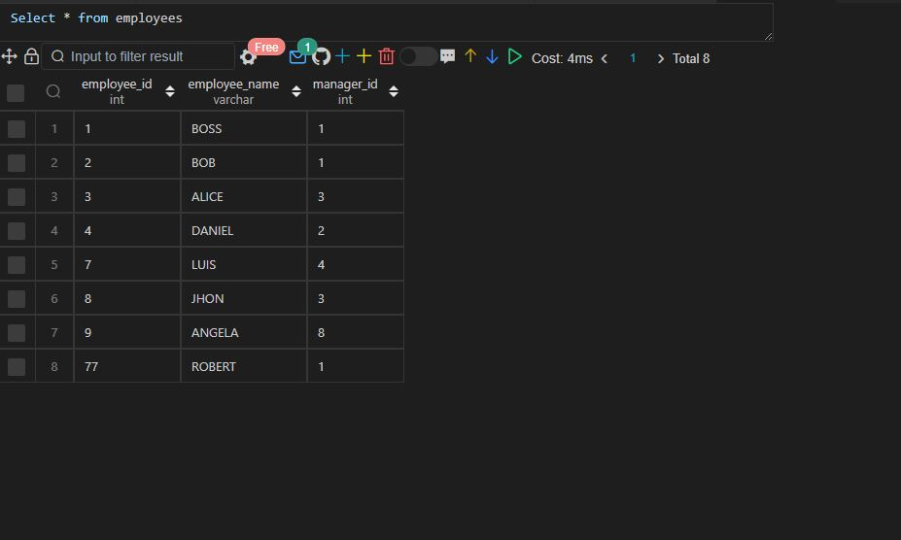

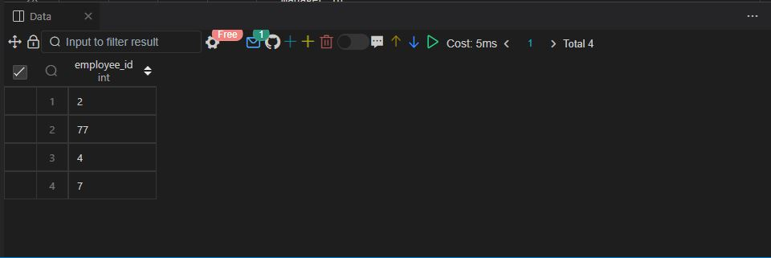

Q72.

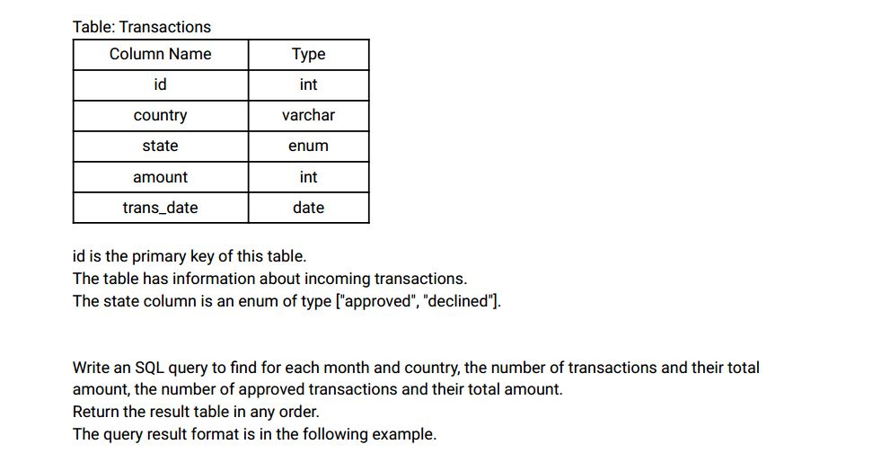

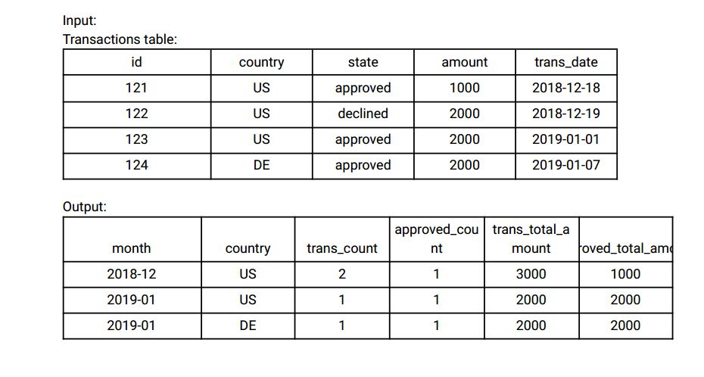

Ans:-

|  |
| --- |
|  |
| CREATE TABLE transactions( |
|  | id INT, |
|  | country VARCHAR(20), |
|  | state ENUM ('APPROVED','DECLINED'), |
|  | amount INT, |
|  | trans_date DATE, |
|  | CONSTRAINT prime_key PRIMARY KEY(id) |
|  | ); |
|  |  |
|  |  |
|  | INSERT INTO transactions VALUES |
|  | (121,'US','APPROVED',1000,'2018-12-18'), |
|  | (122,'US','DECLINED',2000,'2018-12-19'), |
|  | (123,'US','APPROVED',2000,'2019-01-01'), |
|  | (124,'DE','APPROVED',2000,'2019-01-07'); |
|  |  |
|  |  |
|  |  |
|  | WITH temp_transactions AS ( |
|  | SELECT |
|  | concat(YEAR(trans_date), '-',MONTH(trans_date)) AS transaction_date, |
|  | country, |
|  | state, |
|  | count(*) OVER (PARTITION BY concat(YEAR(trans_date), '-',MONTH(trans_date)), country) AS total_transactions, |
|  | sum(amount) OVER (PARTITION BY concat(YEAR(trans_date), '-',MONTH(trans_date)), country) AS total_transactions_amount, |
|  | sum(amount) OVER (PARTITION BY concat(YEAR(trans_date), '-',MONTH(trans_date)), country, state) AS amount |
|  |  |
|  | FROM |
|  | transactions |
|  | ) |
|  |  |
|  | SELECT |
|  | transaction_date, |
|  | country, |
|  | total_transactions, |
|  | count(*) OVER(PARTITION BY transaction_date, country, state) AS approved_transactions, |
|  | total_transactions_amount, |
|  | amount AS approved_amount |
|  |  |
|  | FROM |
|  | temp_transactions |
|  | WHERE |
|  | state = 'Approved'; |
|  |  |
|  |  |
|  |  |

Select * from transactions;

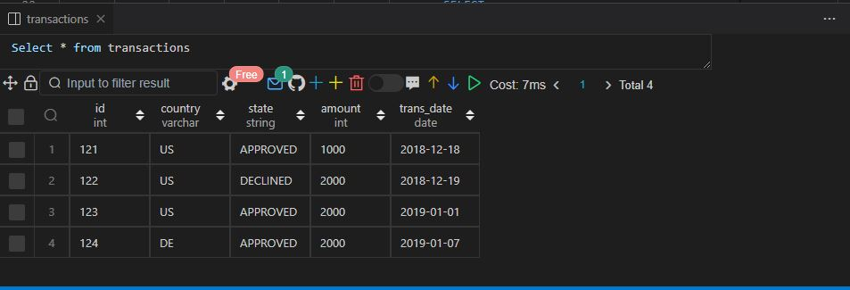

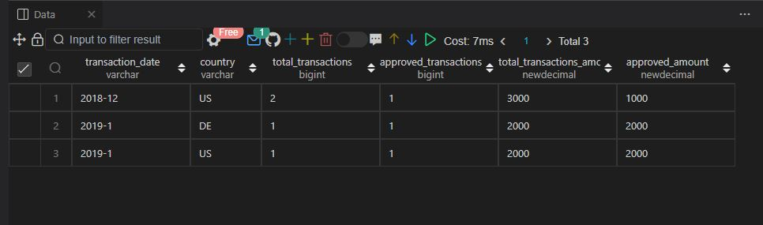

Q73.

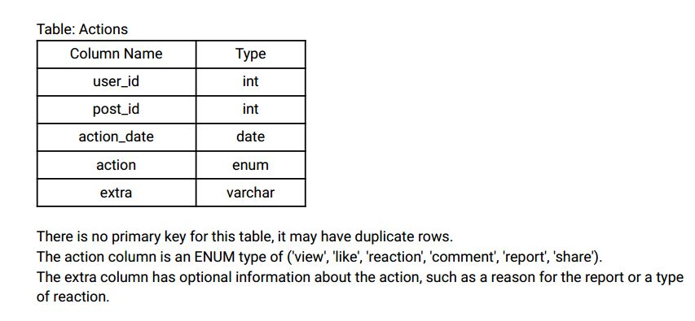

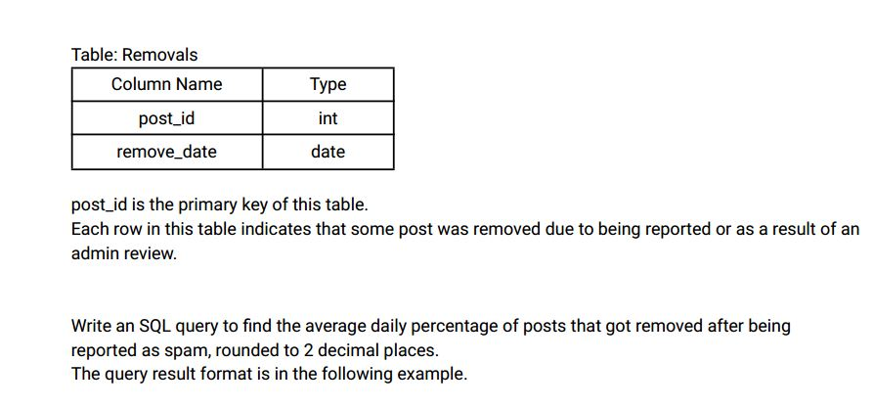

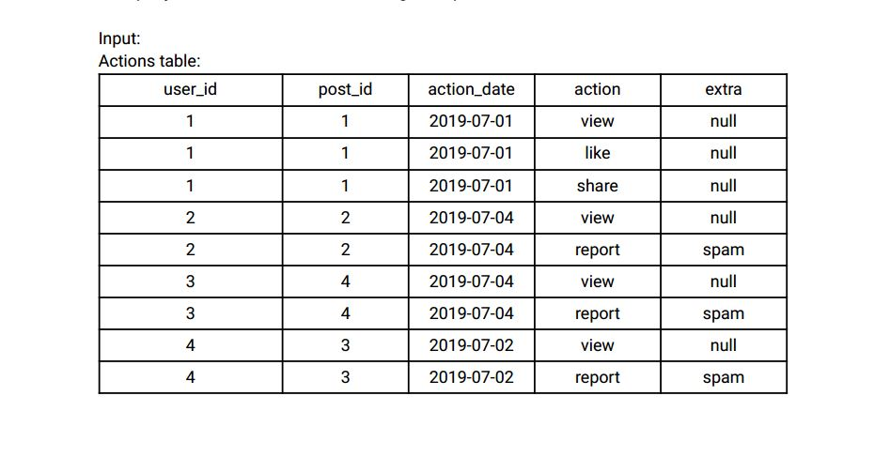

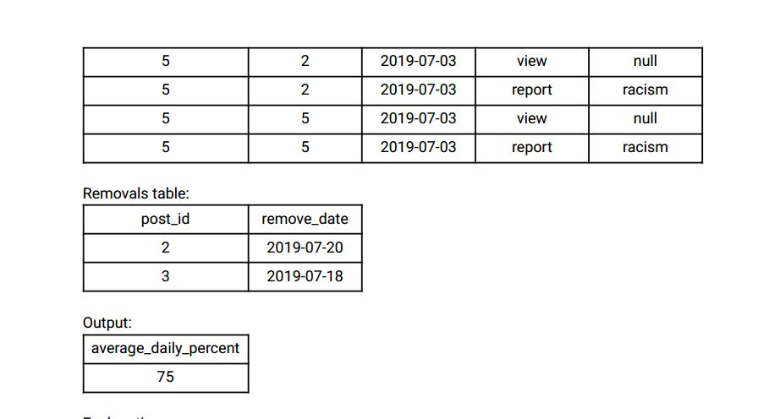

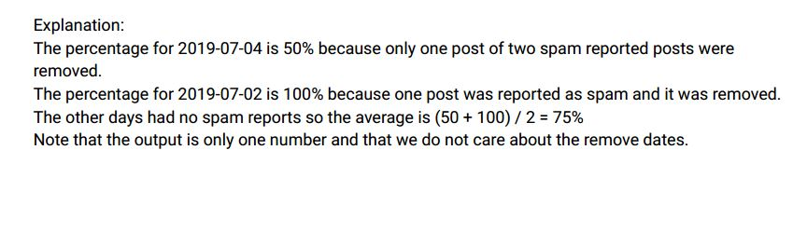

Ans:-

|  |
| --- |
|  |
| CREATE TABLE actions( |
|  | user_id INT, |
|  | post_id INT, |
|  | action_date DATE, |
|  | action ENUM ('VIEW','LIKE','REACTION','COMMENT','REPORT','SHARE'), |
|  | extra VARCHAR(20) |
|  | ); |
|  |  |
|  |  |
|  | CREATE TABLE removals( |
|  | post_id INT, |
|  | remove_date DATE, |
|  | CONSTRAINT prime_key PRIMARY KEY(post_id) |
|  | ); |
|  |  |
|  |  |
|  | INSERT INTO actions VALUES |
|  | (1,1,'2019-07-01','VIEW','NULL'), |
|  | (1,1,'2019-07-01','LIKE','NULL'), |
|  | (1,1,'2019-07-01','SHARE','NULL'), |
|  | (2,2,'2019-07-04','VIEW','NULL'), |
|  | (2,2,'2019-07-04','REPORT','SPAM'), |
|  | (3,4,'2019-07-04','VIEW','NULL'), |
|  | (3,4,'2019-07-04','REPORT','SPAM'), |
|  | (4,3,'2019-07-02','VIEW','NULL'), |
|  | (4,3,'2019-07-02','REPORT','SPAM'), |
|  | (5,2,'2019-07-03','VIEW','NULL'), |
|  | (5,2,'2019-07-03','REPORT','RACISM'), |
|  | (5,5,'2019-07-03','VIEW','NULL'), |
|  | (5,5,'2019-07-03','REPORT','RACISM'); |
|  |  |
|  |  |
|  | INSERT INTO removals VALUES |
|  | (2,'2019-07-20'), |
|  | (3,'2019-07-18'); |
|  |  |
|  |  |
|  |  |
|  | WITH temp_action AS ( |
|  | SELECT |
|  | action_date, |
|  | post_id, |
|  | COUNT(EXTRA) OVER(PARTITION BY action_date) num_post_reported_spam |
|  | FROM |
|  | actions |
|  | WHERE |
|  | extra = 'SPAM' |
|  | ) |
|  |  |
|  | SELECT |
|  | ROUND(AVG(percentage), 2) AS avg_daily_percent |
|  | FROM |
|  | ( |
|  | SELECT |
|  | action_date, |
|  | ROUND((COUNT(post_id)/num_post_reported_spam) * 100, 2) AS percentage |
|  | FROM |
|  | temp_action |
|  | WHERE |
|  | post_id IN ( |
|  | SELECT |
|  | post_id |
|  | FROM |
|  | removals |
|  | ) |
|  | GROUP BY |
|  | action_date |
|  | ) temp; |
|  |  |
|  |  |
|  |  |

Select * from actions;

Select * from removals;

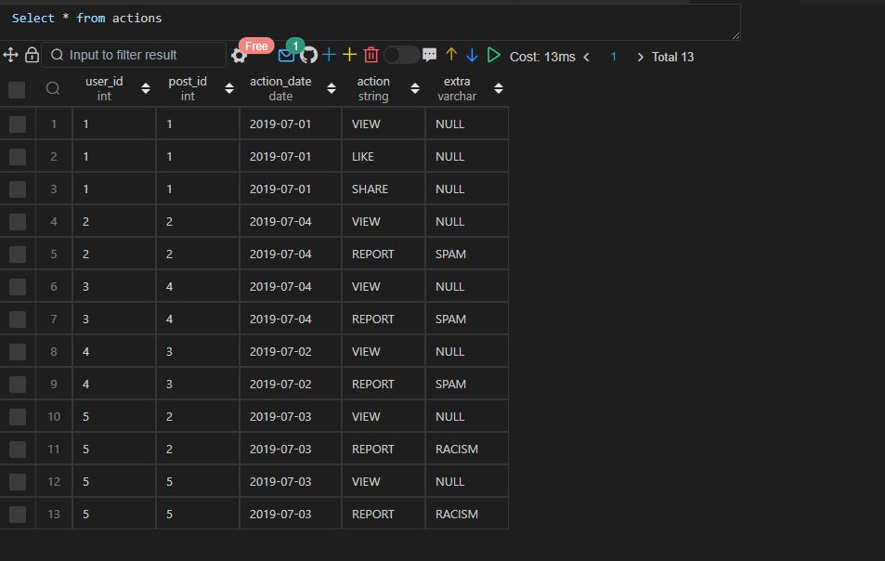

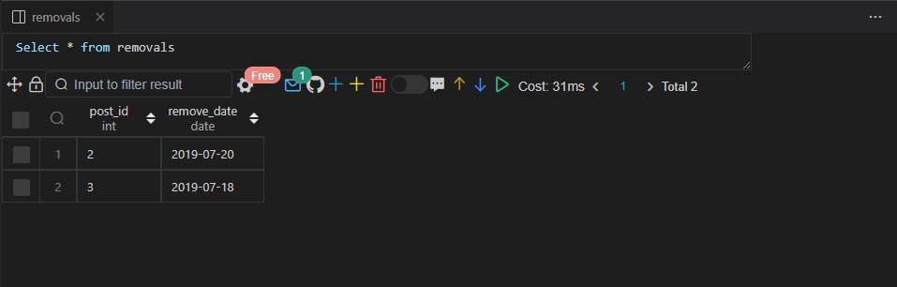

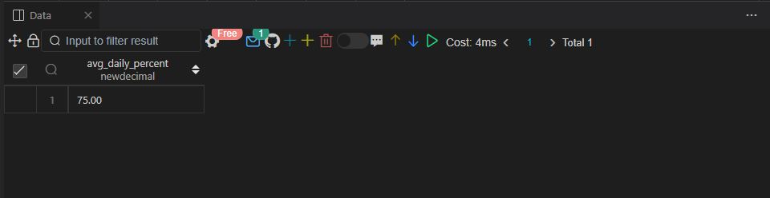

Q74.

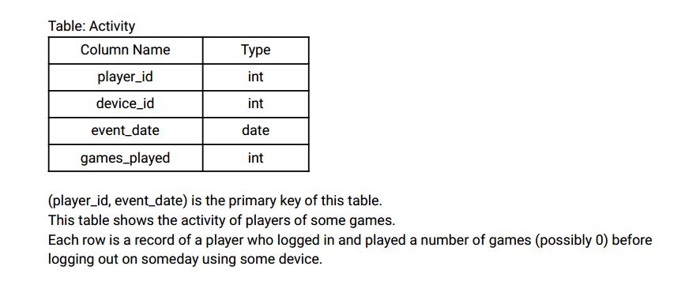

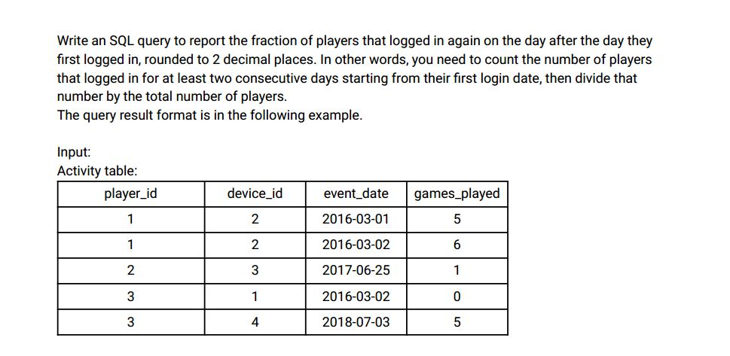

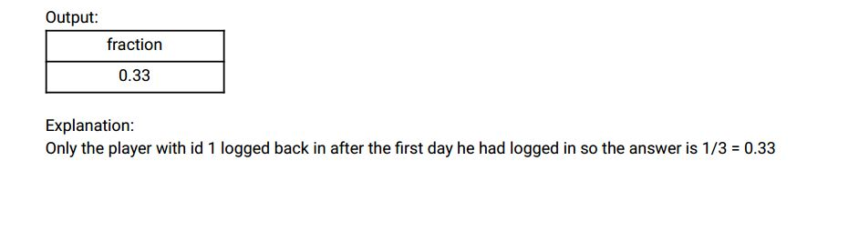

Ans:- Q.74 SAME AS Q.43

Q.75 SAME AS Q.43

Q76.

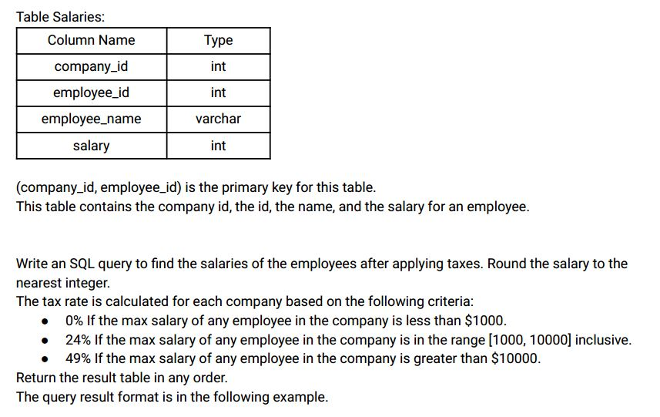

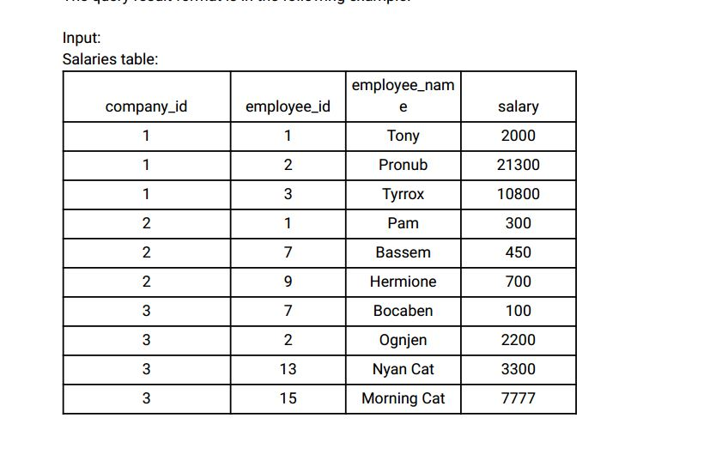

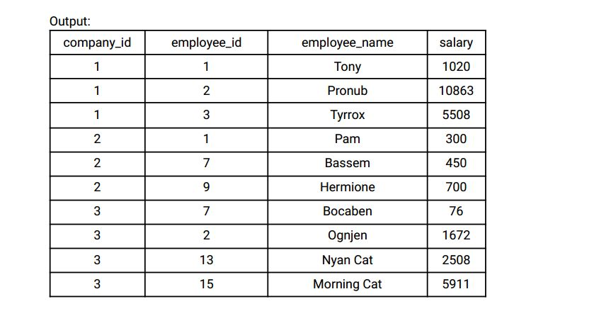

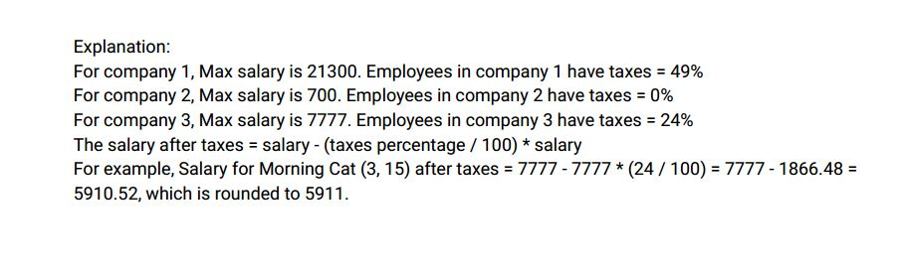

Ans:-

|  |
| --- |
|  |
| CREATE TABLE salaries( |
|  | company_id INT, |
|  | employee_id INT, |
|  | employee_name VARCHAR(20), |
|  | salary INT, |
|  | CONSTRAINT prime_key PRIMARY KEY(company_id, employee_id) |
|  | ); |
|  |  |
|  |  |
|  | INSERT INTO salaries VALUES |
|  | (1,1,'TONY',2000), |
|  | (1,2,'PRONUB',21300), |
|  | (1,3,'TYRROX',10800), |
|  | (2,1,'PAM',300), |
|  | (2,7,'BASSEM',450), |
|  | (2,9,'HERMIONE',700), |
|  | (3,7,'BOCABEN',100), |
|  | (3,2,'OGNJEN',2200), |
|  | (3,13,'NYAN CAT',3300), |
|  | (3,15,'MORNING CAT',7777); |
|  |  |
|  |  |
|  |  |
|  | WITH temp_salaries AS ( |
|  | SELECT |
|  | company_id, |
|  | employee_id, |
|  | employee_name, |
|  | salary, |
|  | MAX(salary) OVER(PARTITION BY company_id) max_sal_per_company |
|  | FROM |
|  | salaries |
|  | ) |
|  |  |
|  | SELECT |
|  | company_id, |
|  | employee_id, |
|  | employee_name, |
|  | salary, |
|  | ROUND( |
|  | CASE |
|  | WHEN max_sal_per_company > 10000 THEN salary - (salary * 0.49) |
|  | WHEN max_sal_per_company BETWEEN 1000 AND 10000 THEN salary - (salary * 0.24) |
|  | ELSE salary |
|  | END, 0) AS sal_after_tax_deduction |
|  | FROM |
|  | temp_salaries; |
|  |  |
|  |  |

Select * from salaries;

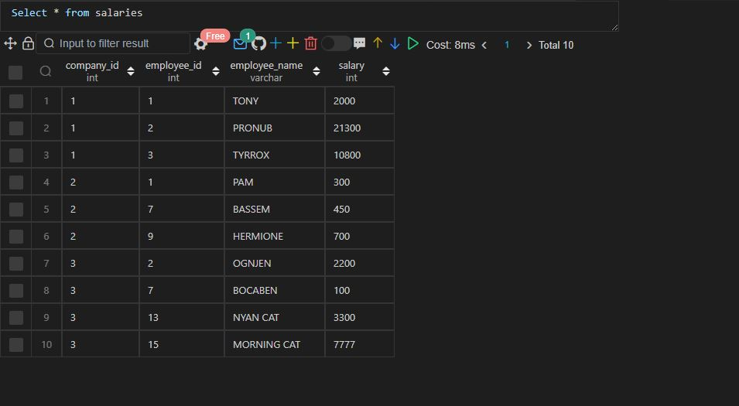

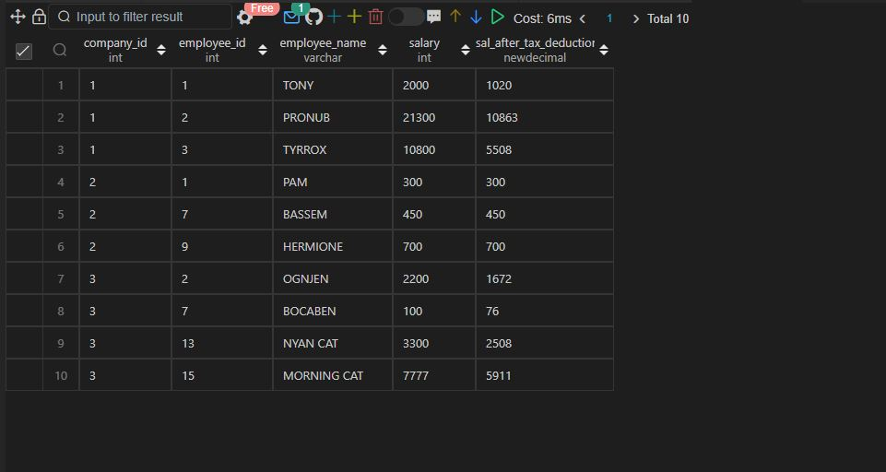

Q77.

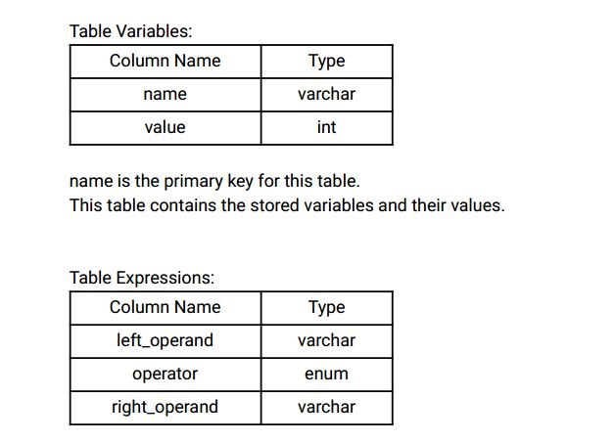

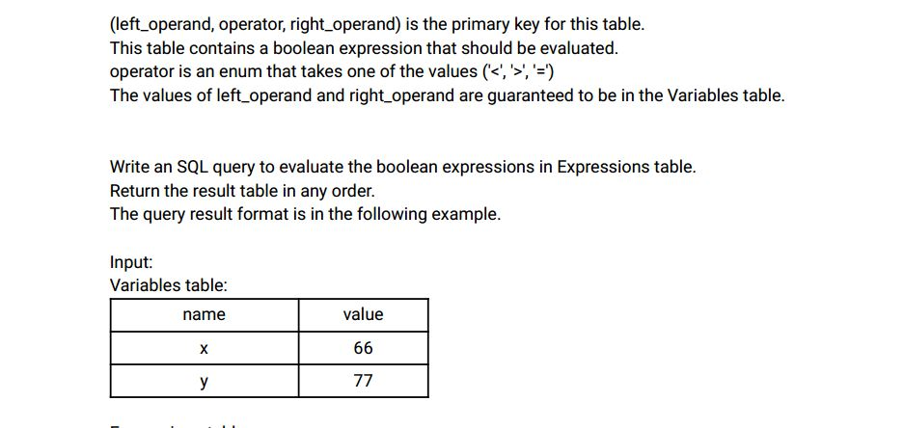

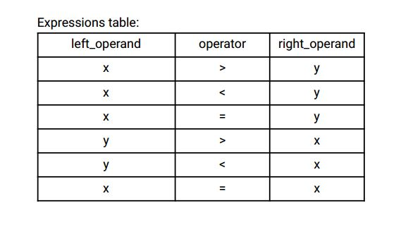

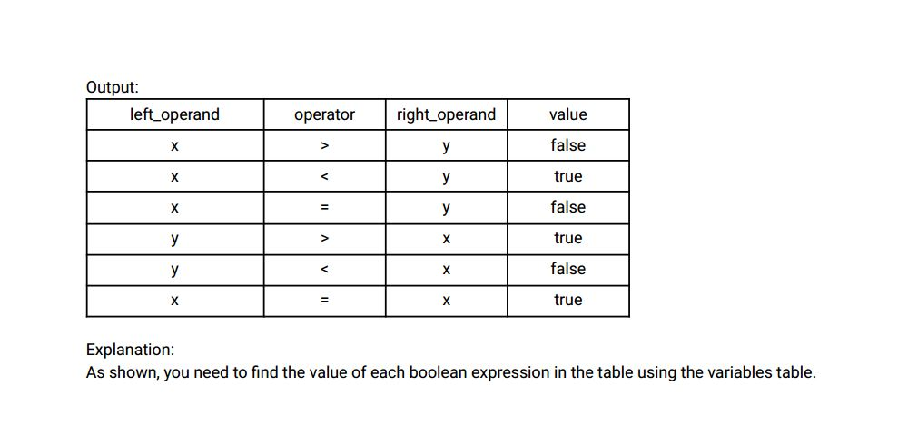

Ans:-

|  |
| --- |
|  |
| CREATE TABLE variables( |
|  | name VARCHAR(2), |
|  | value INT, |
|  | CONSTRAINT prime_key PRIMARY KEY(name) |
|  | ); |
|  |  |
|  |  |
|  | INSERT INTO variables VALUES |
|  | ('x',66), |
|  | ('y',77); |
|  |  |
|  |  |
|  | CREATE TABLE expressions( |
|  | left_operand VARCHAR(2), |
|  | operator ENUM('<','=','>'), |
|  | right_operand VARCHAR(2), |
|  | CONSTRAINT prime_key PRIMARY KEY(left_operand, operator, right_operand) |
|  | ); |
|  |  |
|  |  |
|  | INSERT INTO expressions VALUES |
|  | ('x','>','y'), |
|  | ('x','<','y'), |
|  | ('x','=','y'), |
|  | ('y','>','x'), |
|  | ('y','<','x'), |
|  | ('x','=','x'); |
|  |  |
|  |  |
|  |  |
|  | SELECT |
|  | e.left_operand, |
|  | e.operator, |
|  | e.right_operand, |
|  | CASE |
|  | WHEN e.operator = '<' THEN IF(l.value < r.value, 'TRUE', 'FALSE') |
|  | WHEN e.operator = '>' THEN IF(l.value > r.value, 'TRUE', 'FALSE') |
|  | ELSE IF(l.value = r.value, 'TRUE', 'FALSE') |
|  | END AS result |
|  | FROM |
|  | expressions e |
|  | JOIN |
|  | variables l |
|  | ON |
|  | e.left_operand = l.name |
|  | JOIN |
|  | variables r |
|  | ON |
|  | e.right_operand = r.name; |
|  |  |
|  |  |
|  |  |

Select * from variables;

Select * from expressions;

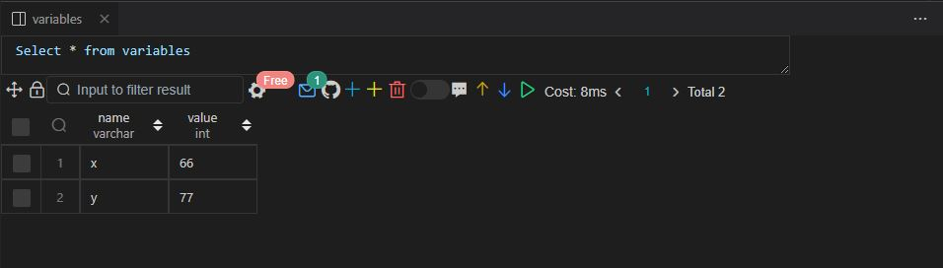

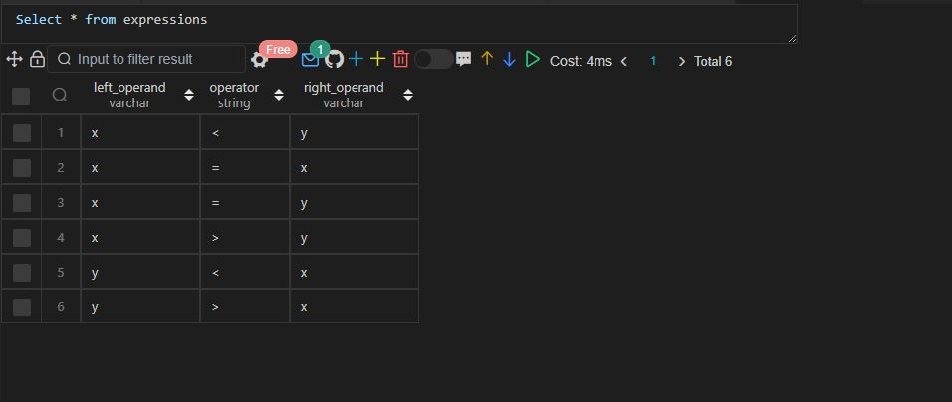

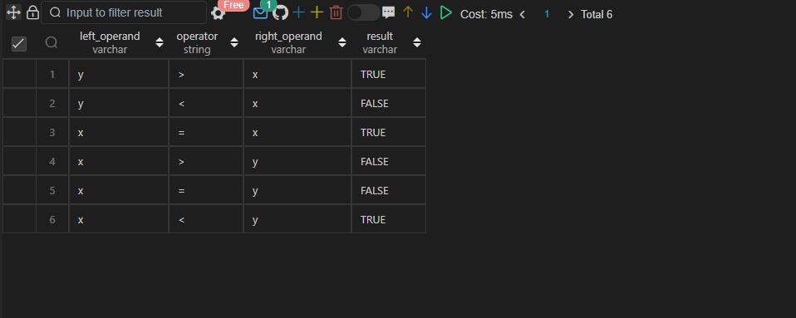

Q.78 SAME AS Q.55

Q79.

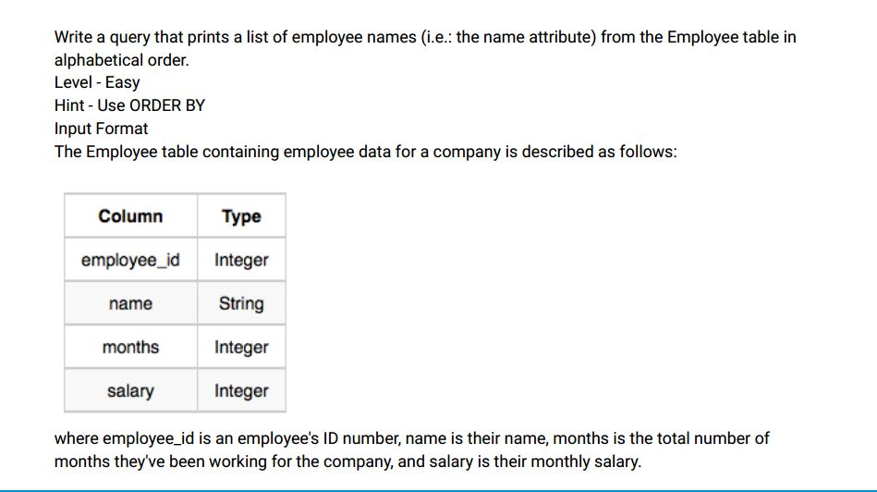

Sample Input

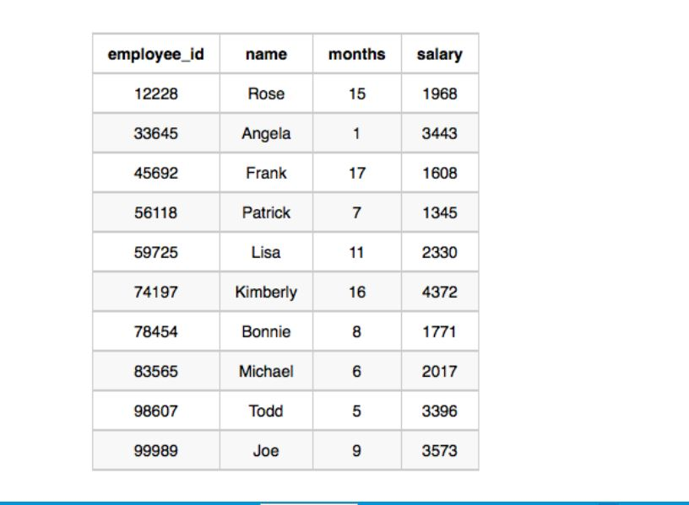

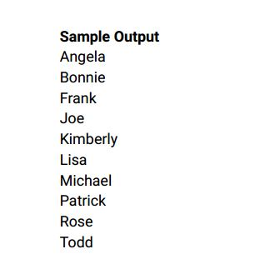

Ans:-

|  |
| --- |
|  |
| CREATE TABLE employee( |
|  | employee_id INT, |
|  | name VARCHAR(20), |
|  | months INT, |
|  | salary INT |
|  | ); |
|  |  |
|  |  |
|  | INSERT INTO employee VALUES |
|  | (12228,'ROSE',15,1968), |
|  | (33645,'ANGELA',1,3443), |
|  | (45692,'FRANK',17,1608), |
|  | (56118,'PATRIK',7,1345), |
|  | (74197,'KINBERLY',16,4372), |
|  | (78454,'BONNIE',8,1771), |
|  | (83565,'MICHAEL',6,2017), |
|  | (98607,'TODD',5,3396), |
|  | (99989,'JOE',9,3573); |
|  |  |
|  |  |
|  | SELECT |
|  | name |
|  | FROM |
|  | employee |
|  | ORDER BY |
|  | name; |
|  |  |
|  |  |
|  |  |
|  |  |
|  |  |

Select * from employee;

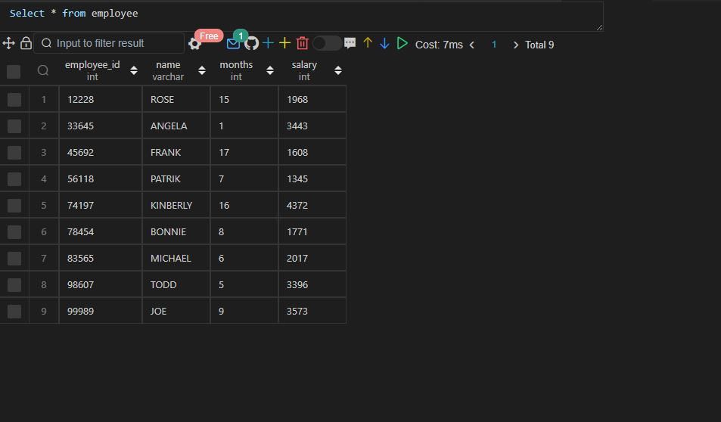

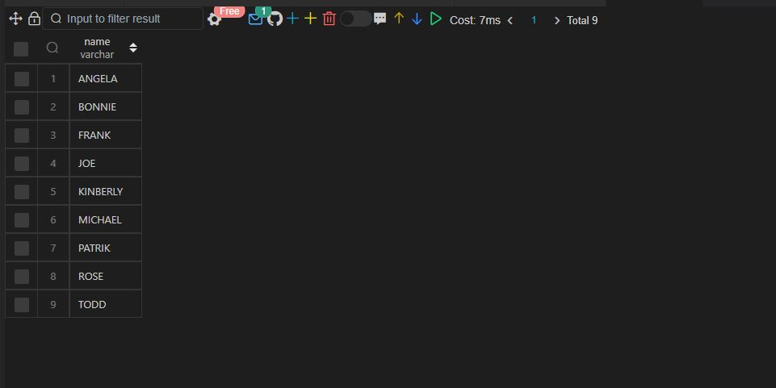

Q80

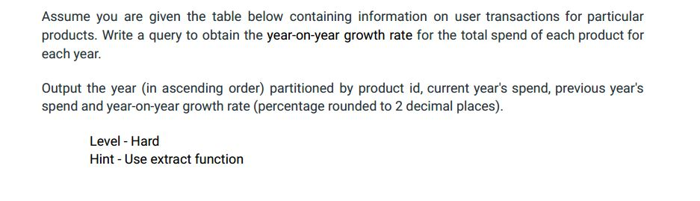

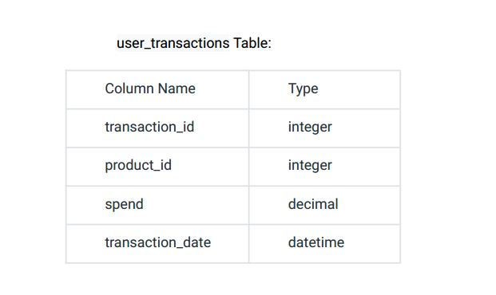

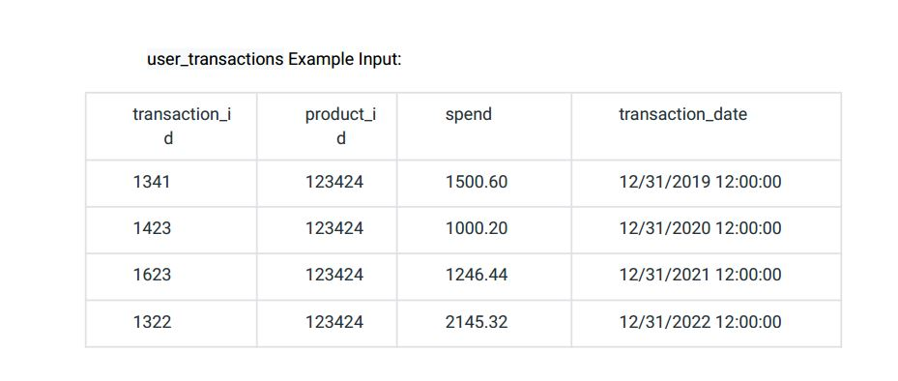

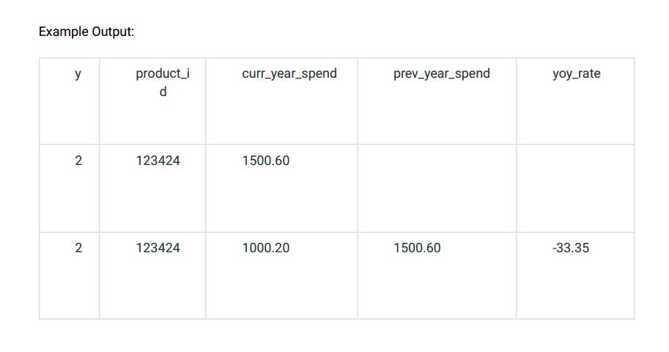

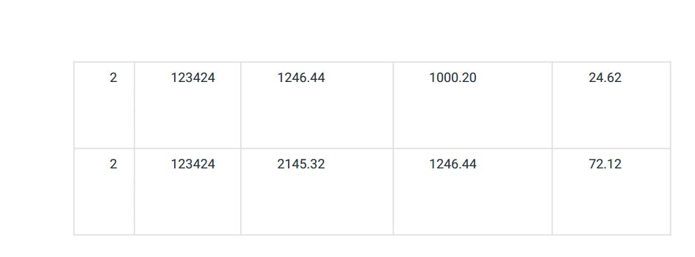

Ans:-

|  |
| --- |
|  |
| CREATE TABLE user_transactions( |
|  | transaction_id INT, |
|  | product_id INT, |
|  | spend FLOAT, |
|  | transaction_date VARCHAR(30) |
|  | ); |
|  |  |
|  |  |
|  | INSERT INTO user_transactions VALUES |
|  | (1341,123424,1500.60,'12/31/2019 12:00:00'), |
|  | (1423,123424,1000.20,'12/31/2020 12:00:00'), |
|  | (1623,123424,1246.44,'12/31/2021 12:00:00'), |
|  | (1322,123424,2145.32,'12/31/2022 12:00:00'); |
|  |  |
|  |  |
|  | -- Approach 1 |
|  |  |
|  |  |
|  | WITH temp_transactions AS ( |
|  | SELECT |
|  | product_id, |
|  | transaction_date, |
|  | spend AS curr_year_spend, |
|  | LAG(spend,1,0) OVER w AS prev_year_spend, |
|  | IFNULL(spend - LAG(spend,1) OVER w, 0) AS prev_curr_spend_diff |
|  | FROM |
|  | user_transactions |
|  | WINDOW |
|  | w AS (PARTITION BY product_id ORDER BY EXTRACT(YEAR FROM transaction_date)) |
|  | ) |
|  |  |
|  | SELECT |
|  | product_id, |
|  | curr_year_spend, |
|  | ROUND(prev_year_spend, 2), |
|  | IFNULL(ROUND((prev_curr_spend_diff * 100)/prev_year_spend,2),0) AS YOY |
|  | FROM |
|  | temp_transactions; |
|  |  |
|  |  |
|  |  |
|  | -- Approach 2 |
|  |  |
|  |  |
|  | WITH temp_transactions AS ( |
|  | SELECT |
|  | YEAR(STR_TO_date(transaction_date, '%m/%d/%Y')) AS YEAR_id, |
|  | product_id, |
|  | transaction_date, |
|  | spend AS curr_year_spend, |
|  | LAG(spend,1) OVER w AS prev_year_spend, |
|  | spend - LAG(spend,1) OVER w AS prev_curr_spend_diff |
|  | FROM |
|  | user_transactions |
|  | WINDOW |
|  | w AS (PARTITION BY product_id ORDER BY EXTRACT(YEAR FROM transaction_date)) |
|  | ) |
|  |  |
|  | SELECT |
|  | year_id, |
|  | product_id, |
|  | curr_year_spend, |
|  | ROUND(prev_year_spend, 2), |
|  | ROUND((prev_curr_spend_diff * 100)/prev_year_spend,2) AS YOY |
|  | FROM |
|  | temp_transactions; |
|  |  |
|  |  |
|  | -- Approach 3 |
|  |  |
|  |  |
|  | SELECT |
|  | product_id, |
|  | YEAR(STR_TO_date(transaction_date, '%m/%d/%Y')) AS YEAR_id, |
|  | spend AS curr_year_spend, |
|  | ROUND(LAG(spend,1,0) OVER w ,2) AS prev_year_spend, |
|  | ROUND((spend - LAG(spend,1) OVER w ) * 100 / |
|  | LAG(spend,1) OVER w, 2) AS YOY |
|  | FROM |
|  | user_transactions |
|  | WINDOW |
|  | w AS (PARTITION BY product_id ORDER BY EXTRACT(YEAR FROM transaction_date)); |
|  |  |
|  |  |
|  |  |

Select * from user_transactions;

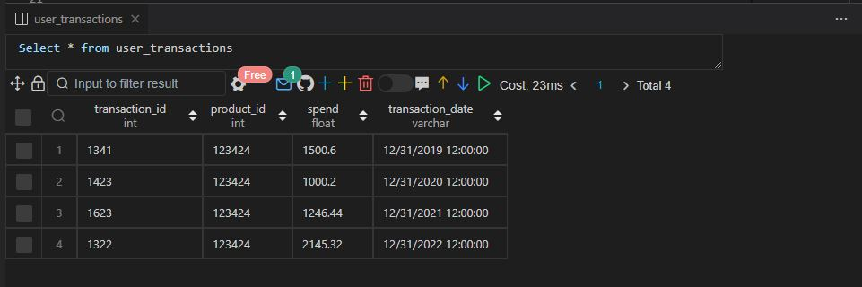

Approach 1

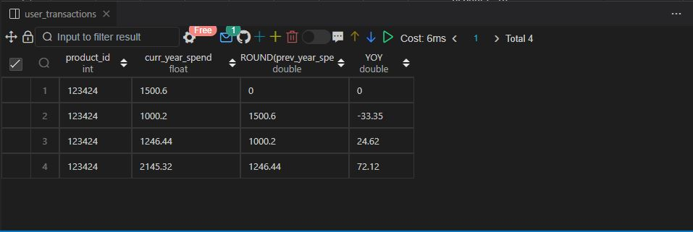

Approach 2

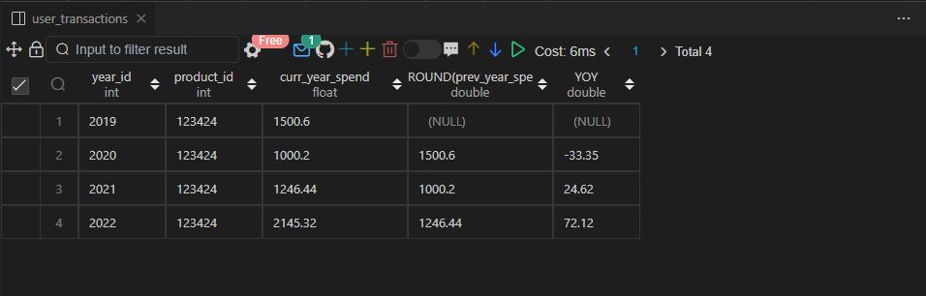

Approach 3

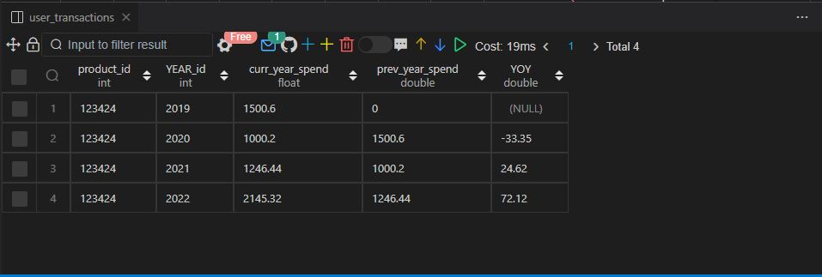

Q81.

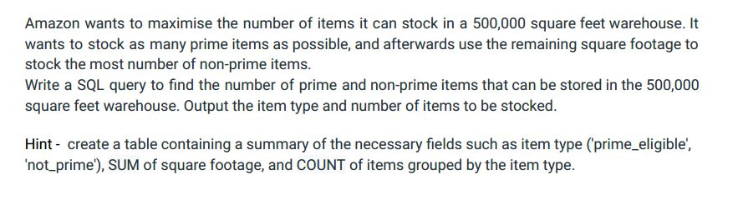

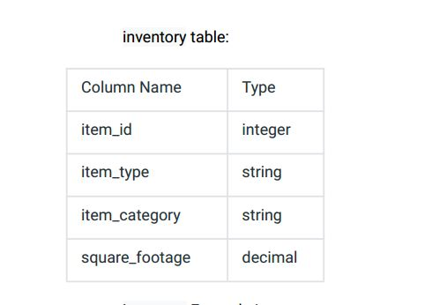

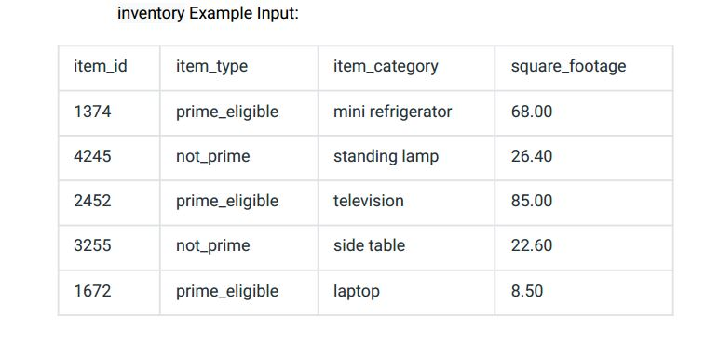

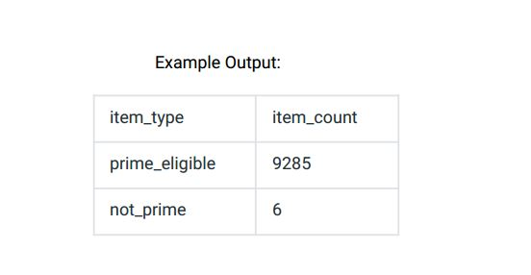

Ans:-

|  |
| --- |
|  |
| CREATE TABLE inventory( |
|  | item_id INT, |
|  | item_type VARCHAR(20), |
|  | item_category VARCHAR(20), |
|  | square_foot FLOAT |
|  | ); |
|  |  |
|  |  |
|  | INSERT INTO inventory VALUES |
|  | (1374,'PRIME_ELIGIBLE','MINI FRidGE',68.00), |
|  | (4245,'NOT_PRIME','STANDING LAMP',26.40), |
|  | (2452,'PRIME_ELIGIBLE','TELEVISION',85.00), |
|  | (3255,'NOT_PRIME','SidE TABLE',22.60), |
|  | (1672,'PRIME_ELIGIBLE','LAPTOP',8.50); |
|  |  |
|  |  |
|  |  |
|  | -- Approach 1 |
|  |  |
|  | WITH temp_inventory AS ( |
|  | SELECT |
|  | item_type, |
|  | SUM(square_foot) AS square_foot_per_category, |
|  | COUNT(*) AS count_of_items |
|  | FROM |
|  | inventory |
|  | GROUP BY |
|  | item_type |
|  | ), |
|  |  |
|  | temp_inventory2 AS ( |
|  | SELECT |
|  | (500000 - SUM(square_foot_per_category)*FLOOR(500000/SUM(square_foot_per_category))) AS area_left |
|  | FROM |
|  | temp_inventory |
|  | WHERE |
|  | item_type = 'PRIME_ELIGIBLE' |
|  | ), |
|  |  |
|  | temp_inventory3 AS ( |
|  | SELECT |
|  | item_type, |
|  | CASE |
|  | WHEN item_type = 'PRIME_ELIGIBLE' |
|  | THEN FLOOR(500000/square_foot_per_category) * count_of_items |
|  |  |
|  | WHEN item_type = 'NOT_PRIME' |
|  | THEN FLOOR((SELECT area_left FROM temp_inventory2) / square_foot_per_category) * count_of_items |
|  |  |
|  | END AS item_count |
|  | FROM |
|  | temp_inventory |
|  | ) |
|  |  |
|  | SELECT |
|  | item_type, |
|  | item_count |
|  | FROM |
|  | temp_inventory3; |
|  |  |
|  |  |
|  |  |
|  | -- Approach 2 |
|  |  |
|  |  |
|  | WITH temp_inventory AS ( |
|  | SELECT |
|  | item_type, |
|  | SUM(square_foot) AS square_foot_per_category, |
|  | COUNT(*) AS count_of_items, |
|  | CASE |
|  | WHEN item_type = 'PRIME_ELIGIBLE' THEN FLOOR(500000/SUM(square_foot)) * COUNT(*) |
|  | END AS prime_items_count |
|  | FROM |
|  | inventory |
|  | GROUP BY |
|  | item_type |
|  | ), |
|  |  |
|  | temp_inventory2 AS ( |
|  | SELECT |
|  | (500000 - SUM(square_foot_per_category)*FLOOR(500000/SUM(square_foot_per_category))) AS area_left |
|  | FROM |
|  | temp_inventory |
|  | WHERE |
|  | item_type = 'PRIME_ELIGIBLE' |
|  | ), |
|  |  |
|  | temp_inventory3 AS ( |
|  | SELECT |
|  | item_type, |
|  | CASE |
|  | WHEN item_type = 'PRIME_ELIGIBLE' THEN prime_items_count |
|  | WHEN item_type = 'NOT_PRIME' THEN FLOOR((SELECT area_left FROM temp_inventory2) / square_foot_per_category) * count_of_items |
|  | END AS item_count |
|  | FROM |
|  | temp_inventory |
|  | ) |
|  |  |
|  | SELECT |
|  | item_type, |
|  | item_count |
|  | FROM |
|  | temp_inventory3; |
|  |  |
|  |  |
|  |  |
|  | -- Approach 3 |
|  |  |
|  |  |
|  | WITH temp_inventory AS ( |
|  | SELECT |
|  | item_type, |
|  | SUM(square_foot) AS square_foot_per_category, |
|  | COUNT(*) AS count_of_items, |
|  | CASE |
|  | WHEN item_type = 'PRIME_ELIGIBLE' THEN FLOOR(500000/SUM(square_foot)) * COUNT(*) |
|  | END AS prime_items_count |
|  | FROM |
|  | inventory |
|  | GROUP BY |
|  | item_type |
|  | ), |
|  |  |
|  | temp_inventory2 AS ( |
|  | SELECT |
|  | item_type, |
|  | CASE |
|  | WHEN item_type = 'PRIME_ELIGIBLE' THEN prime_items_count |
|  | WHEN item_type = 'NOT_PRIME' THEN FLOOR((500000 - (SELECT |
|  | SUM(square_foot_per_category) |
|  | FROM |
|  | temp_inventory |
|  | WHERE |
|  | item_type = 'PRIME_ELIGIBLE') * FLOOR(500000 / |
|  | (SELECT |
|  | SUM(square_foot_per_category) |
|  | FROM |
|  | temp_inventory |
|  | WHERE |
|  | item_type = 'PRIME_ELIGIBLE' |
|  | ))) / square_foot_per_category) * count_of_items |
|  | END AS item_count |
|  | FROM |
|  | temp_inventory |
|  | ) |
|  |  |
|  | SELECT |
|  | item_type, |
|  | item_count |
|  | FROM |
|  | temp_inventory2; |
|  |  |
|  |  |
|  |  |

Select * from inventory;

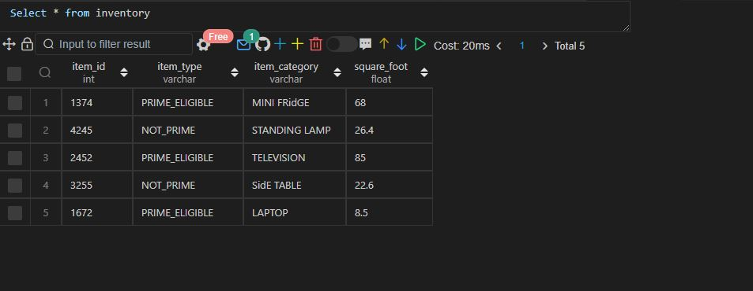

Approach 1, Approach2, Approach 3

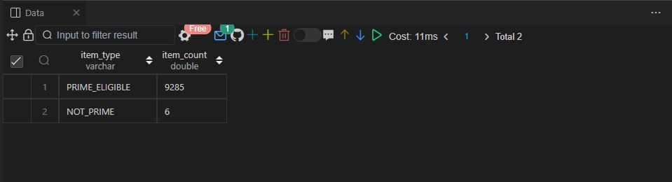

Q82.

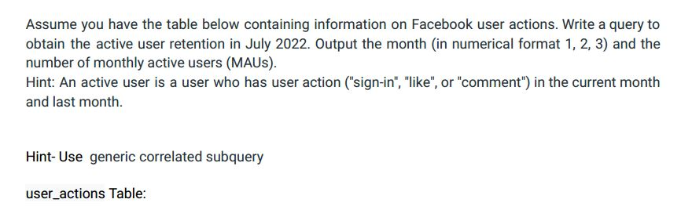

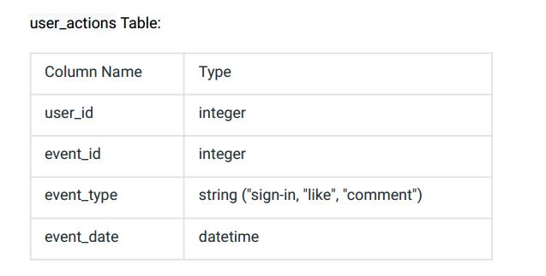

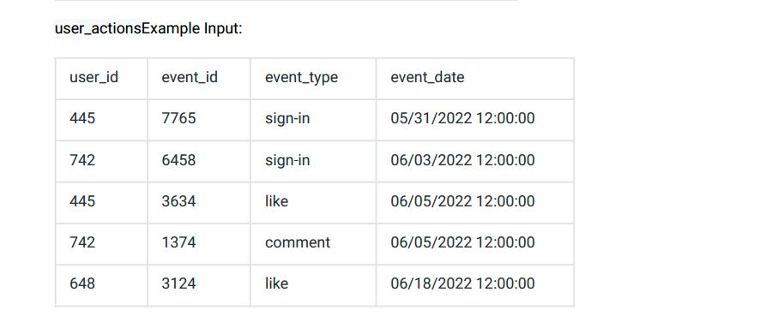

Example Output for June 2022:

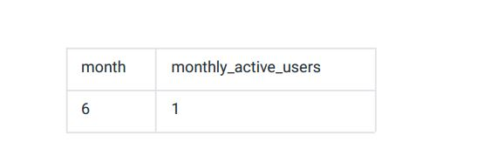

Ans:-

|  |
| --- |
|  |
| CREATE TABLE user_actions( |
|  | user_id INT, |
|  | event_id INT, |
|  | event_type ENUM('SIGN-IN','LIKE','COMMENT'), |
|  | event_date DATETIME |
|  | ); |
|  |  |
|  |  |
|  | INSERT INTO user_actions VALUES |
|  | (445,7765,'SIGN-IN','2022-05-31 12:00:00'), |
|  | (742,6458,'SIGN-IN','2022-06-03 12:00:00'), |
|  | (445,3634,'LIKE','2022-06-05 12:00:00'), |
|  | (742,1374,'COMMENT','2022-06-05 12:00:00'), |
|  | (648,3124,'LIKE','2022-06-18 12:00:00'); |
|  |  |
|  |  |
|  | -- Approach 1 |
|  |  |
|  |  |
|  | WITH temp_actions AS ( |
|  | SELECT |
|  | user_id, |
|  | event_date, |
|  | event_type, |
|  | SUBSTR(event_date, 6, 2) - lag(SUBSTR(event_date, 6, 2)) OVER w AS difference |
|  | FROM |
|  | user_actions |
|  | WINDOW |
|  | w as (PARTITION BY user_id ORDER BY event_date) |
|  | ), |
|  |  |
|  | temp_actions2 AS ( |
|  | SELECT |
|  | SUBSTR(event_date, 6, 2) AS months, |
|  | COUNT(user_id) AS monthly_active_users |
|  | FROM |
|  | temp_actions |
|  | WHERE |
|  | difference = 1 AND event_type IN ('LIKE', 'COMMENT', 'SIGN-IN') |
|  | GROUP BY |
|  | months |
|  | ) |
|  |  |
|  | SELECT |
|  | months, |
|  | monthly_active_users |
|  | FROM |
|  | temp_actions2; |
|  |  |
|  |  |
|  |  |
|  | -- Approach 2 |
|  |  |
|  |  |
|  | WITH temp_actions AS ( |
|  | SELECT |
|  | user_id, |
|  | event_date, |
|  | event_type, |
|  | SUBSTR(event_date, 6, 2) - lag(SUBSTR(event_date, 6, 2)) OVER w AS difference |
|  | FROM |
|  | user_actions |
|  | WINDOW |
|  | w as (PARTITION BY user_id ORDER BY event_date) |
|  | ) |
|  |  |
|  |  |
|  | SELECT |
|  | SUBSTR(event_date, 6, 2) AS months, |
|  | COUNT(DISTINCT user_id) AS active_users |
|  | FROM |
|  | temp_actions |
|  | WHERE |
|  | difference = 1 |
|  | AND |
|  | event_type IN ('LIKE', 'COMMENT', 'SIGN-IN') |
|  | GROUP BY |
|  | months; |
|  |  |
|  |  |
|  |  |

Select * from user_actions;

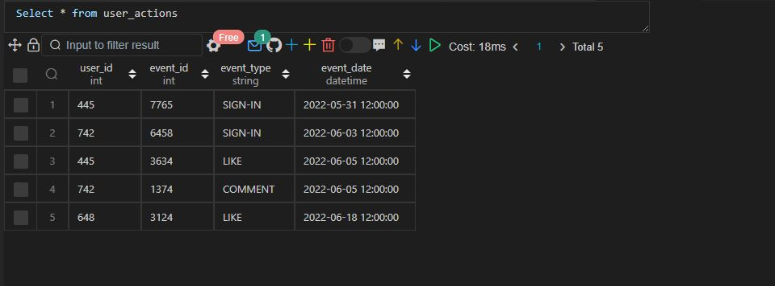

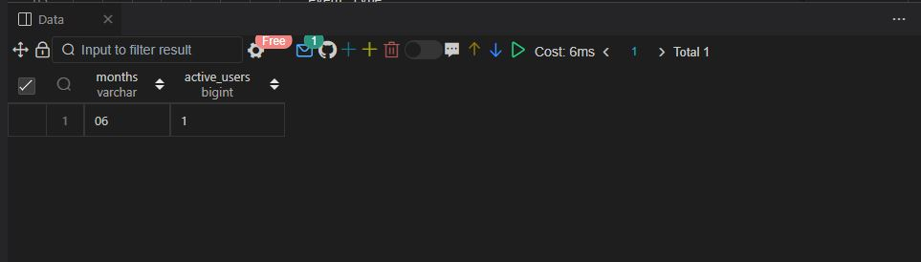

Q83.

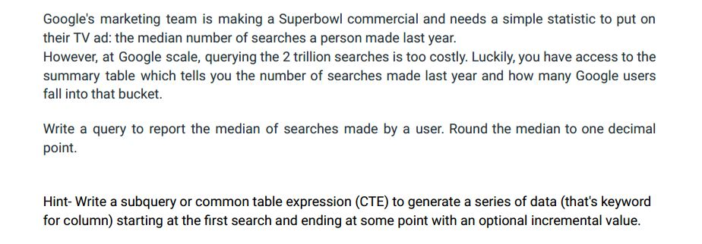

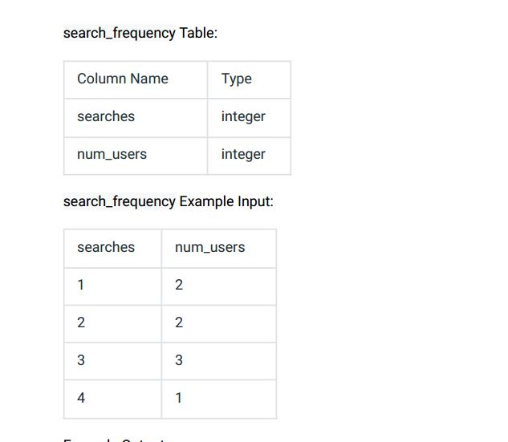

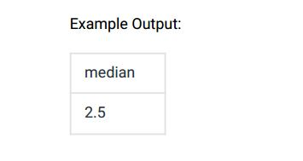

Ans:-

|  |
| --- |
|  |
| CREATE TABLE search_frequency( |
|  | searches INT, |
|  | num_users INT |
|  | ); |
|  |  |
|  |  |
|  | INSERT INTO search_frequency VALUES |
|  | (1,2), |
|  | (2,2), |
|  | (3,3), |
|  | (4,1); |
|  |  |
|  |  |
|  | WITH temp_search_freq AS ( |
|  | SELECT |
|  | searches, |
|  | num_users, |
|  | ROW_NUMBER() OVER(ORDER BY searches) row_num, |
|  | COUNT(*) OVER(ORDER BY searches ROWS BETWEEN UNBOUNDED PRECEDING AND UNBOUNDED FOLLOWING) total_records |
|  | FROM |
|  | search_frequency |
|  | ), |
|  |  |
|  | temp_search_freq2 as ( |
|  | SELECT |
|  | searches, |
|  | num_users, |
|  | CASE |
|  | WHEN total_records % 2 <> 0 THEN ( |
|  | SELECT |
|  | DISTINCT ROUND(SUM(searches) OVER w / |
|  | COUNT(*) OVER w,1) |
|  | FROM |
|  | temp_search_freq |
|  | WHERE |
|  | row_num = ROUND((total_records + 1) / 2, 0) |
|  | WINDOW |
|  | w AS (ORDER BY searches ROWS BETWEEN UNBOUNDED PRECEDING AND UNBOUNDED FOLLOWING) |
|  |  |
|  | ) |
|  |  |
|  | WHEN total_records % 2 = 0 THEN ( |
|  | SELECT |
|  | DISTINCT ROUND(SUM(searches) OVER w / |
|  | COUNT(*) OVER w,1) |
|  | FROM |
|  | temp_search_freq |
|  | WHERE |
|  | row_num IN (total_records/2,(total_records/2)+1) |
|  | WINDOW |
|  | w AS (ORDER BY searches ROWS BETWEEN UNBOUNDED PRECEDING AND UNBOUNDED FOLLOWING) |
|  | ) |
|  | END AS median |
|  | FROM |
|  | temp_search_freq |
|  | ) |
|  |  |
|  |  |
|  | SELECT |
|  | DISTINCT median |
|  | FROM |
|  | temp_search_freq2; |
|  |  |
|  |  |
|  |  |

Select * from search_frequency;

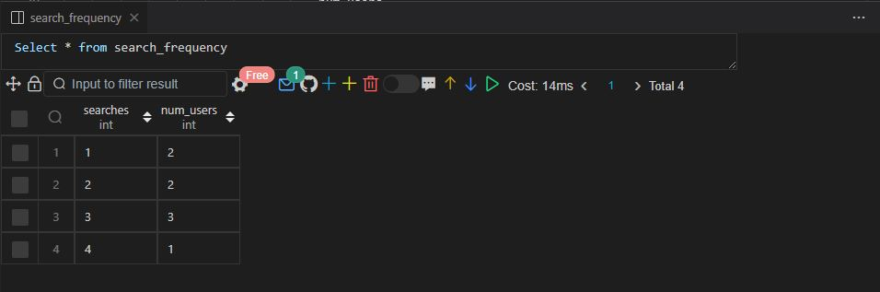

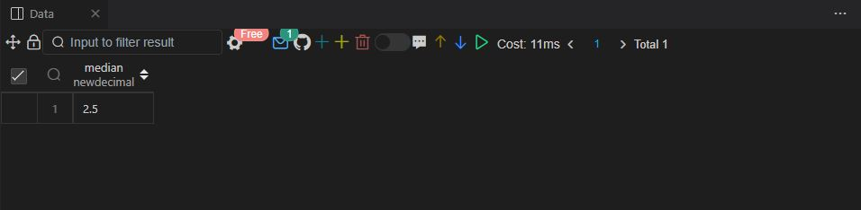

Q84.

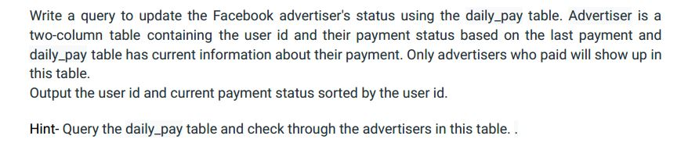

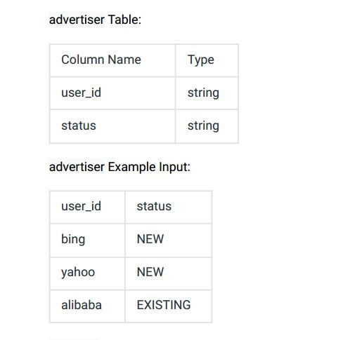

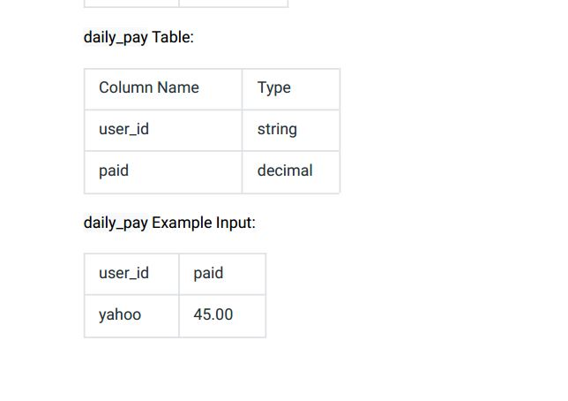

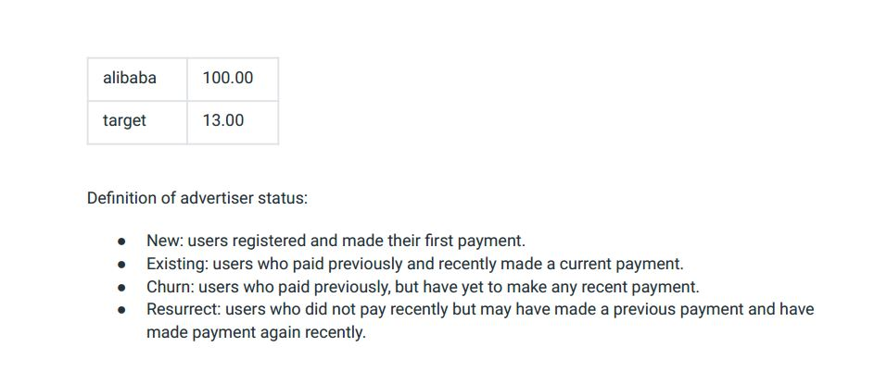

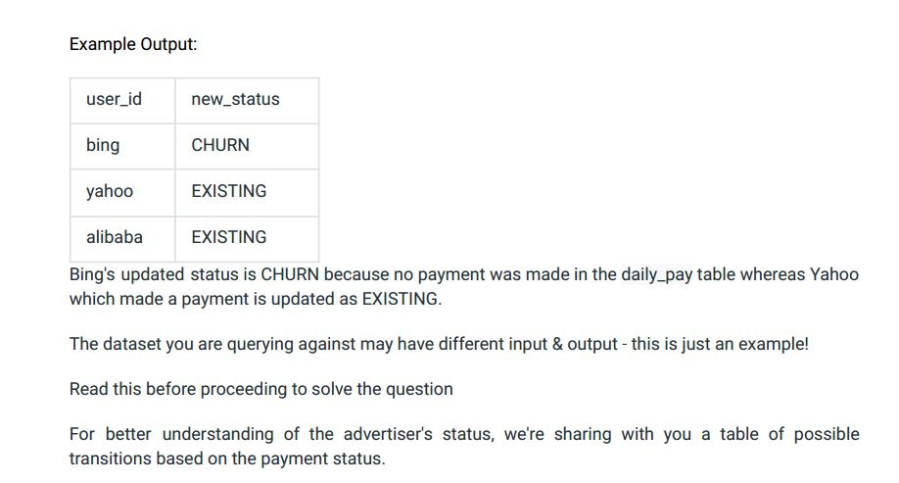

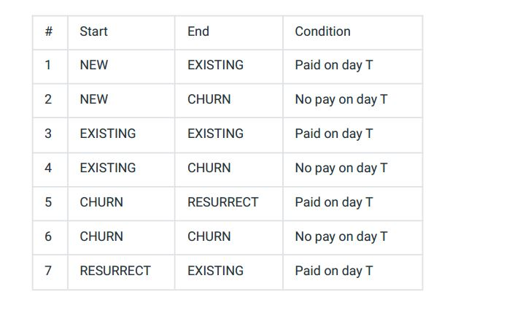

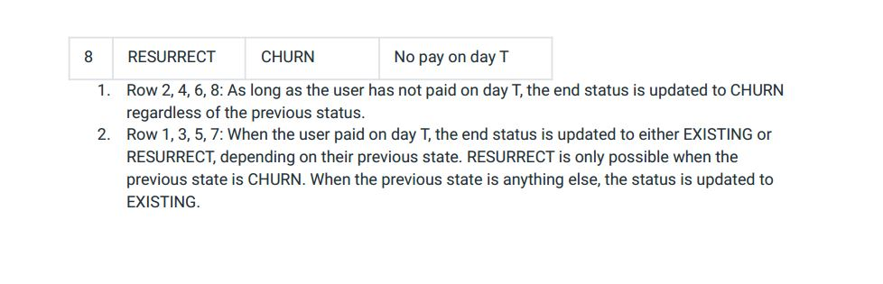

Ans:-

|  |
| --- |
|  |
| CREATE TABLE advertiser( |
|  | user_id VARCHAR(20), |
|  | status ENUM('NEW','EXISTING','CHURN','RESURRECT') |
|  | ); |
|  |  |
|  |  |
|  | CREATE TABLE daily_pay( |
|  | user_id VARCHAR(20), |
|  | paid DECIMAL |
|  | ); |
|  |  |
|  |  |
|  | INSERT INTO advertiser VALUES |
|  | ('BING','NEW'), |
|  | ('YAHOO','NEW'), |
|  | ('ALIBABA','EXISTING'); |
|  |  |
|  |  |
|  | INSERT INTO daily_pay VALUES |
|  | ('YAHOO',45.00), |
|  | ('ALIBABA',100.00), |
|  | ('TARGET',13.00); |
|  |  |
|  |  |
|  |  |
|  | SELECT |
|  | user_id, |
|  | CASE |
|  | WHEN user_id IN (SELECT user_id FROM daily_pay) THEN 'EXISTING' |
|  | ELSE 'CHURN' |
|  | END AS new_status |
|  | FROM |
|  | Advertiser |
|  | ORDER BY |
|  | user_id; |
|  |  |
|  |  |
|  |  |

Select * from advertiser;

Select * from daily_pay;

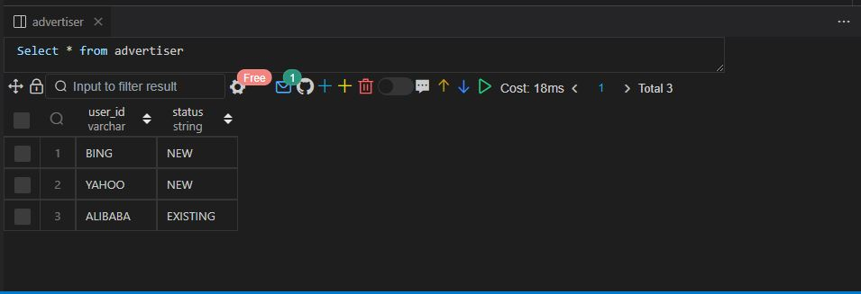

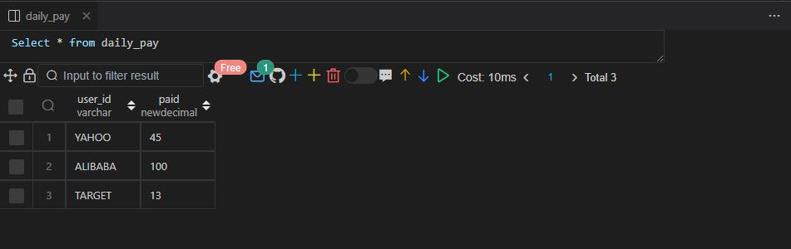

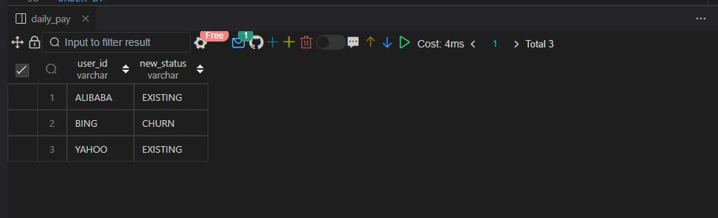

Q85.

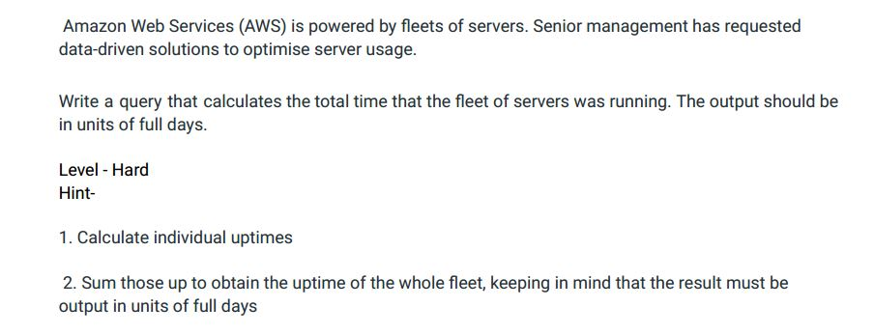

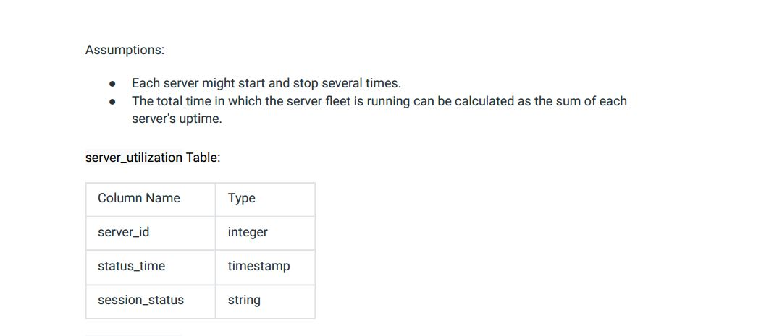

server_utilization Example Input:

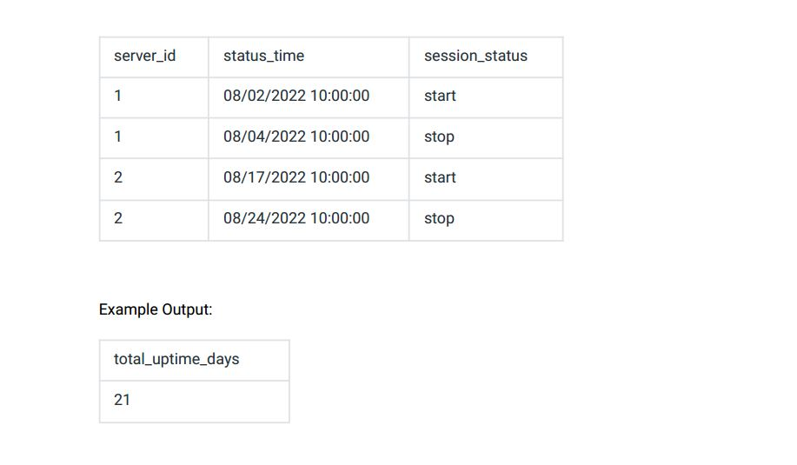

Ans:-

|  |
| --- |
|  |
| CREATE TABLE server_utilization( |
|  | server_id INT, |
|  | session_status VARCHAR(20), |
|  | status_time VARCHAR(25) |
|  | ); |
|  |  |
|  |  |
|  | INSERT INTO server_utilization VALUES |
|  | (1,'start', '08/02/2022 10:00:00'), |
|  | (1, 'stop', '08/04/2022 10:00:00'), |
|  | (2, 'stop', '08/24/2022 10:00:00'), |
|  | (2, 'start','08/17/2022 10:00:00'); |
|  |  |
|  |  |
|  | -- Approach 1 |
|  |  |
|  |  |
|  | SELECT |
|  | stop_time - start_time AS total_up_time |
|  | FROM |
|  | ( |
|  | SELECT |
|  | SUM( |
|  | CASE |
|  | WHEN session_status = 'start' then EXTRACT(DAY from STR_TO_DATE(status_time, '%m/%d/%y')) |
|  | END |
|  | ) AS start_time, |
|  | SUM( |
|  | CASE |
|  | WHEN session_status = 'stop' then EXTRACT(DAY from STR_TO_DATE(status_time, '%m/%d/%y')) |
|  | END |
|  | ) AS stop_time |
|  | FROM |
|  | server_utilization |
|  | ) temp_server_utilization; |
|  |  |
|  |  |
|  |  |
|  |  |
|  | -- Approach 2 (Works only in PostgreSQL) |
|  |  |
|  | WITH temp_server_utilization AS ( |
|  | SELECT |
|  | server_id, |
|  | status_time AS start_time, |
|  | session_status, |
|  | lead(status_time) OVER(ORDER BY server_id,status_time) AS end_time |
|  | FROM |
|  | server_utilization |
|  | ) |
|  |  |
|  | SELECT |
|  | EXTRACT(DAY FROM justify_hours(SUM(end_time - start_time))) as total_time |
|  | FROM |
|  | temp_server_utilization |
|  | WHERE |
|  | session_status = 'start'; |
|  |  |
|  |  |
|  |  |

Select * from server_utilization;

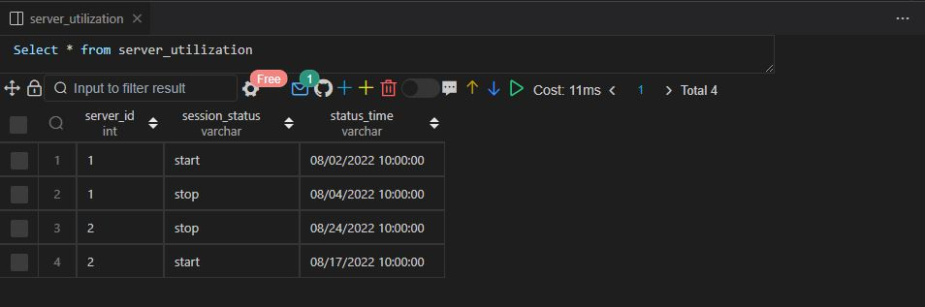

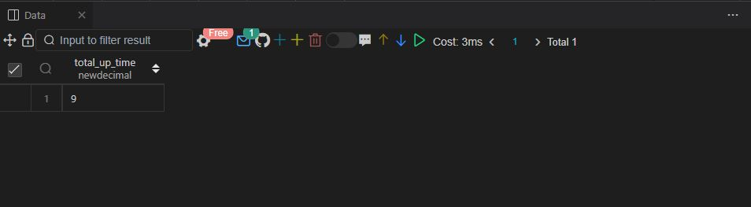

Q86.

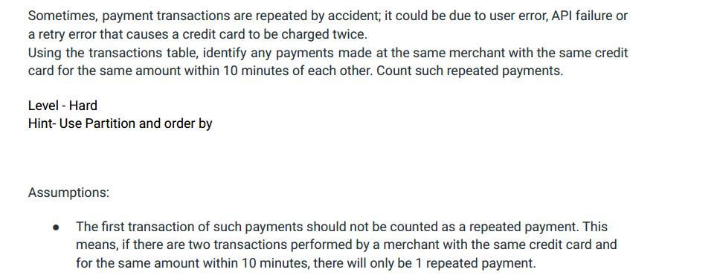

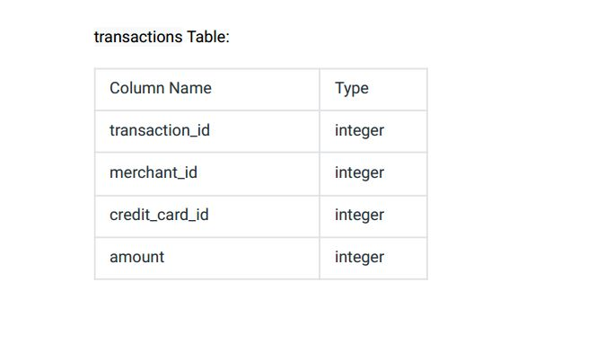

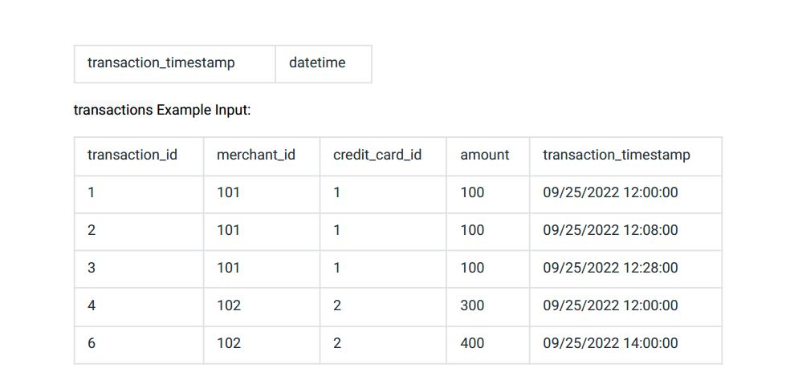

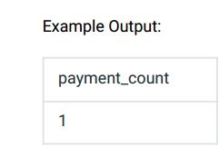

Ans:-

|  |
| --- |
|  |
| CREATE TABLE transactions( |
|  | transaction_id INT, |
|  | merchant_id INT, |
|  | credit_card_id INT, |
|  | amount INT, |
|  | transaction_timestamp DATETIME |
|  | ); |
|  |  |
|  |  |
|  | INSERT INTO transactions VALUES |
|  | (1,101,1,100,'2022-09-25 12:00:00'), |
|  | (2,101,1,100,'2022-09-25 12:08:00'), |
|  | (3,101,1,100,'2022-09-25 12:28:00'), |
|  | (4,102,2,300,'2022-09-25 12:00:00'), |
|  | (5,102,2,400,'2022-09-25 14:00:00'); |
|  |  |
|  |  |
|  |  |
|  | WITH temp_transactions AS ( |
|  | SELECT |
|  | merchant_id, |
|  | credit_card_id, |
|  | amount, |
|  | transaction_timestamp, |
|  | LAG(transaction_timestamp) OVER w AS prev_tran_timestamp, |
|  | timestampdiff(MINUTE,LAG(transaction_timestamp) OVER w, transaction_timestamp) AS difference |
|  | FROM |
|  | transactions |
|  | WINDOW |
|  | w as (PARTITION BY credit_card_id ORDER BY transaction_timestamp) |
|  | ) |
|  |  |
|  | SELECT |
|  | COUNT(DISTINCT merchant_id) AS payment_count |
|  | FROM |
|  | temp_transactions |
|  | WHERE |
|  | difference <= 10; |
|  |  |
|  |  |
|  |  |
|  | -- Approach 2 (Works only in PostgreSQL) |
|  |  |
|  |  |
|  | WITH temp_transactions AS ( |
|  | SELECT |
|  | merchant_id, |
|  | credit_card_id, |
|  | amount, |
|  | transaction_timestamp, |
|  | LAG(transaction_timestamp) OVER w AS prev_tran_timestamp, |
|  | EXTRACT(EPOCH FROM LAG(transaction_timestamp) OVER w - transaction_timestamp) AS difference |
|  | FROM |
|  | transactions |
|  | WINDOW |
|  | w as (PARTITION BY credit_card_id ORDER BY transaction_timestamp) |
|  | ) |
|  |  |
|  | SELECT |
|  | COUNT(DISTINCT merchant_id) AS payment_count |
|  | FROM |
|  | temp_transactions |
|  | WHERE |
|  | difference < 10; |
|  |  |
|  |  |
|  |  |
|  |  |

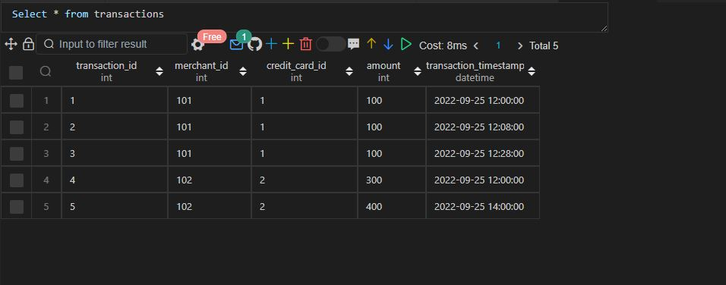

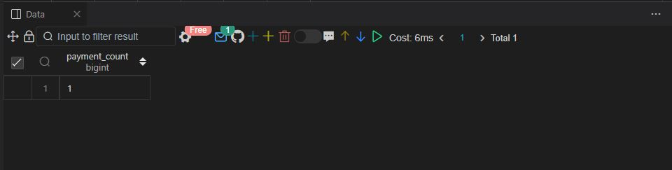

Q87.

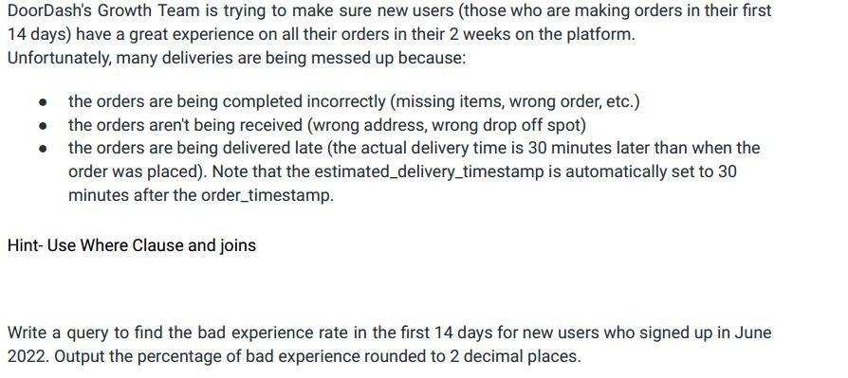

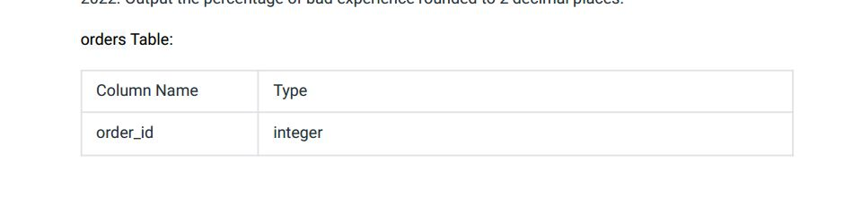

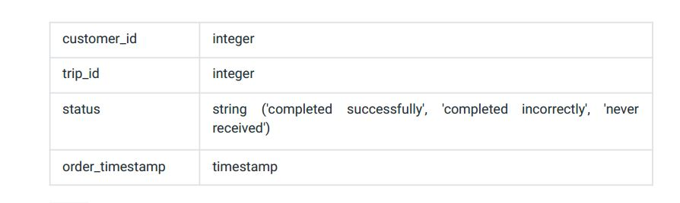

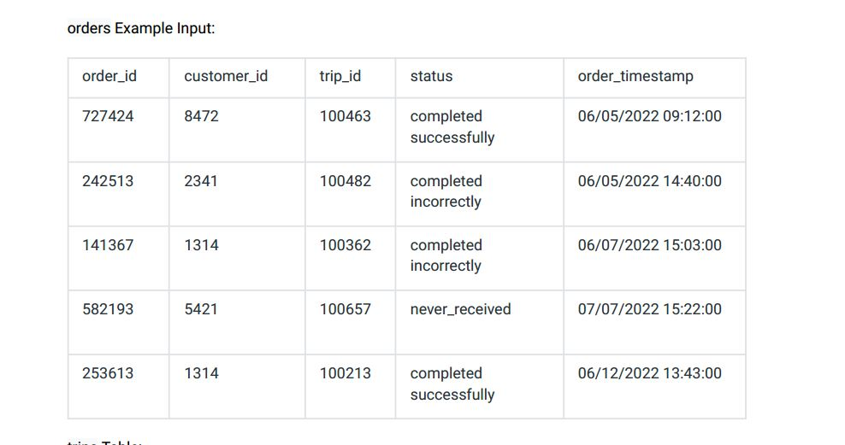

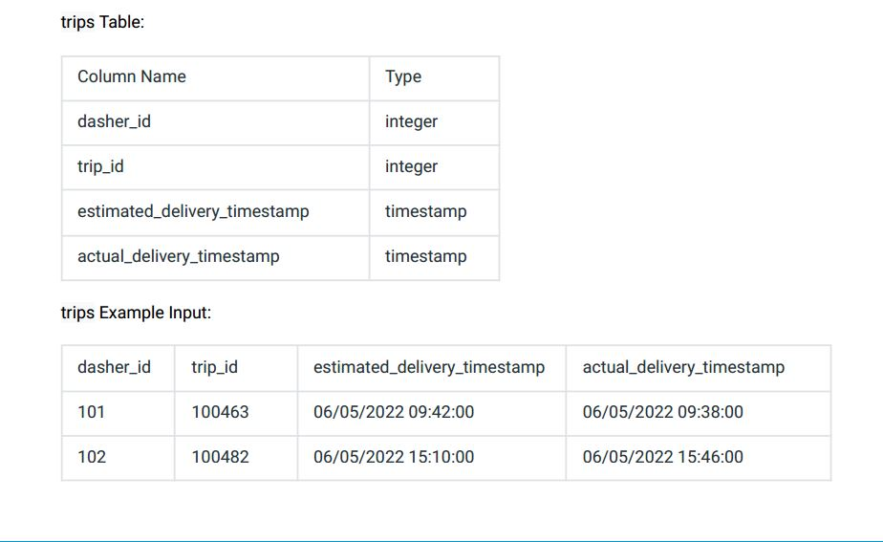

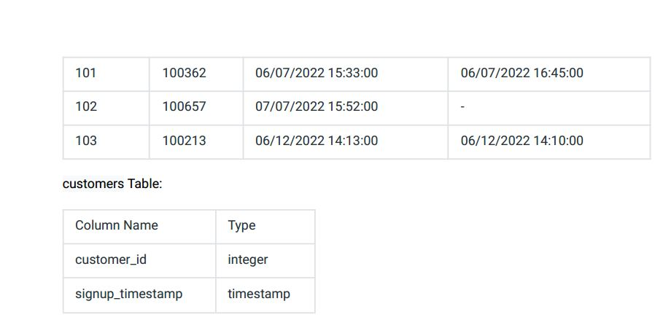

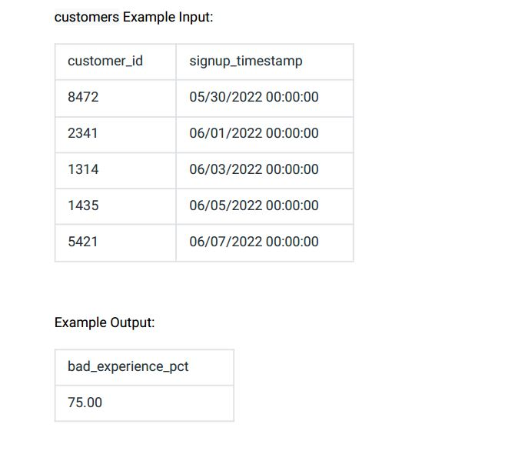

Ans:-

|  |
| --- |
|  |
| CREATE TABLE orders( |
|  | order_id INT, |
|  | customer_id INT, |
|  | trip_id INT, |
|  | status ENUM('COMPLETED SUCCESSFULLY','COMPLETED INCORRECTLY','NEVER_RECEIVED'), |
|  | order_timestamp VARCHAR(30) |
|  | ); |
|  |  |
|  |  |
|  | INSERT INTO orders VALUES |
|  | (727424,8472,100463,'COMPLETED SUCCESSFULLY','06/05/2022 09:12:00'), |
|  | (242513,2341,100482,'COMPLETED INCORRECTLY','06/05/2022 14:40:00'), |
|  | (141367,1314,100362,'COMPLETED INCORRECTLY','06/07/2022 15:03:00'), |
|  | (582193,5421,100657,'NEVER_RECEIVED','07/07/2022 15:22:00'), |
|  | (253613,1314,100213,'COMPLETED SUCCESSFULLY','06/12/2022 13:43:00'); |
|  |  |
|  |  |
|  | CREATE TABLE trips( |
|  | dasher_id INT, |
|  | trip_id INT, |
|  | estimated_delivery_timestamp VARCHAR(25), |
|  | actual_delivery_timestamp VARCHAR(25) |
|  | ); |
|  |  |
|  |  |
|  | INSERT INTO trips VALUES |
|  | (101,100463,'06/05/2022 09:42:00','06/05/2022 09:38:00'), |
|  | (102,100482,'06/05/2022 15:10:00','06/05/2022 15:46:00'), |
|  | (101,100362,'06/07/2022 15:33:00','06/07/2022 16:45:00'), |
|  | (102,100657,'07/07/2022 15:52:00',NULL), |
|  | (103,100213,'06/12/2022 14:13:00','06/12/2022 14:10:00'); |
|  |  |
|  |  |
|  | CREATE TABLE customers( |
|  | customer_id INT, |
|  | signup_timestamp VARCHAR(30) |
|  | ); |
|  |  |
|  |  |
|  | INSERT INTO customers VALUES |
|  | (8472,'05/30/2022 00:00:00'), |
|  | (2341,'06/01/2022 00:00:00'), |
|  | (1314,'06/03/2022 00:00:00'), |
|  | (1435,'06/05/2022 00:00:00'), |
|  | (5421,'06/07/2022 00:00:00'); |
|  |  |
|  |  |
|  |  |
|  | SELECT |
|  | ROUND( |
|  | SUM( |
|  | CASE |
|  | WHEN status !='completed successfully' THEN 1 ELSE 0 |
|  | END |
|  | )*100.0/count(*),2) AS bad_experience_pct |
|  | FROM |
|  | customers c |
|  | INNER JOIN |
|  | orders o |
|  | ON |
|  | o.customer_id = c.customer_id |
|  | WHERE |
|  | o.order_timestamp < date_add(STR_TO_date(signup_timestamp, '%m/%d/%Y'), INTERVAL 14 DAY) |
|  | AND |
|  | MONTH(STR_TO_date(signup_timestamp, '%m/%d/%Y')) = 06 |
|  | AND |
|  | YEAR(STR_TO_date(signup_timestamp, '%m/%d/%Y')) = 2022; |
|  |  |
|  |  |
|  |  |
|  | Select * from orders;  Select * from trips;  Select * from customers;  output10.JPG |
|  |  |

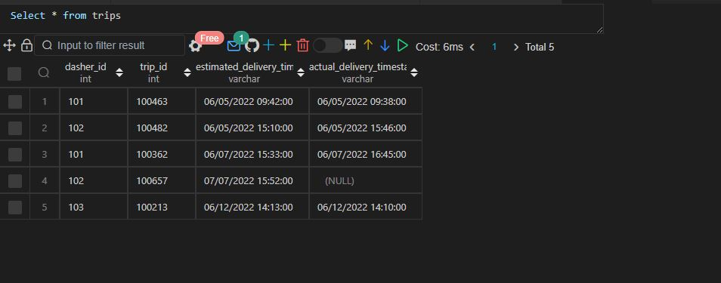

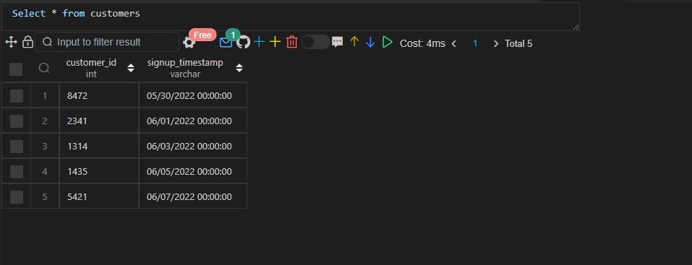

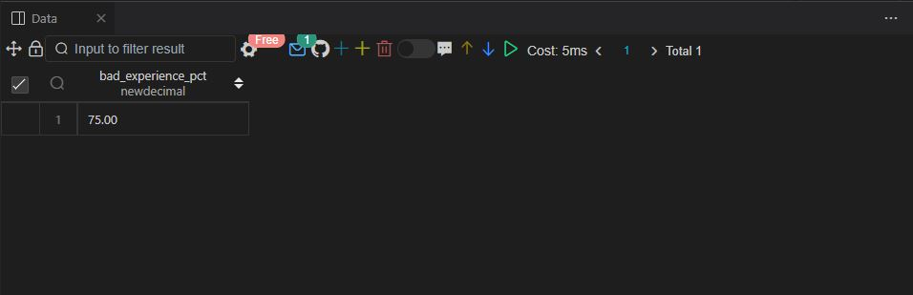

Q.88 SAME AS 68

Q.89 SAME AS 55

Q90.

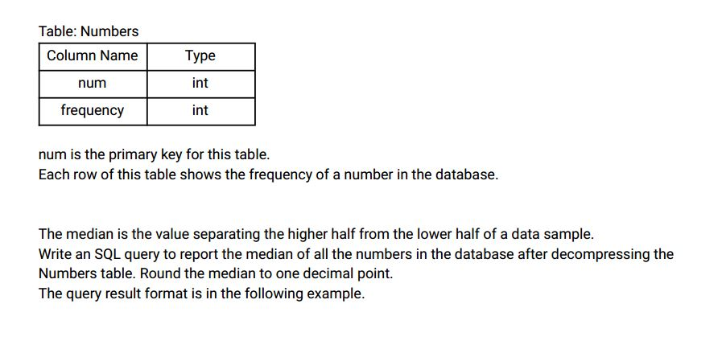

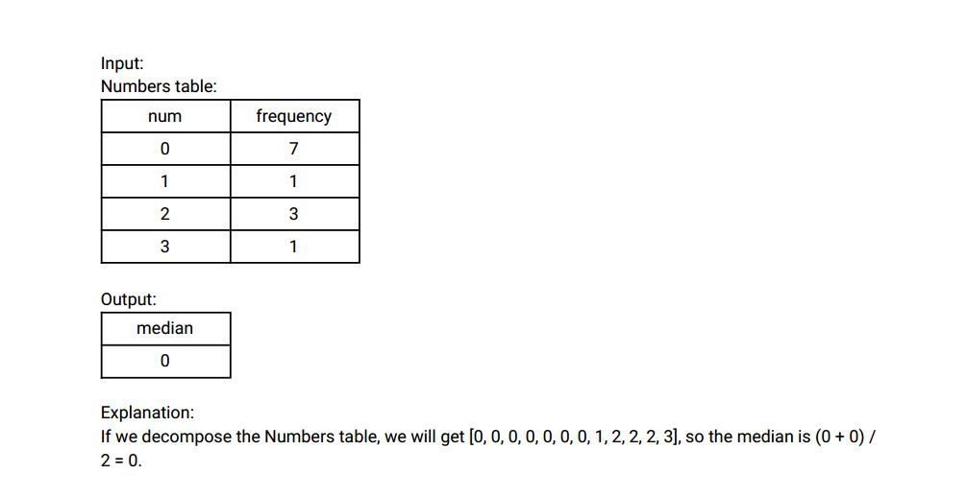

Ans:-

|  |
| --- |
|  |
| CREATE TABLE numbers( |
|  | num INT, |
|  | frequency INT |
|  | ); |
|  |  |
|  |  |
|  | INSERT INTO numbers VALUES |
|  | (0,7), |
|  | (1,1), |
|  | (2,3), |
|  | (3,1); |
|  |  |
|  |  |
|  |  |
|  | WITH RECURSIVE num_frequency (num,frequency, i) AS |
|  | ( |
|  | SELECT num, |
|  | frequency,1 |
|  | FROM |
|  | numbers |
|  | UNION ALL |
|  | SELECT num, |
|  | frequency, |
|  | i+1 |
|  | FROM |
|  | num_frequency |
|  | WHERE |
|  | num_frequency.i < num_frequency.frequency |
|  | ), |
|  |  |
|  | num_frequency2 AS ( |
|  | SELECT |
|  | num, |
|  | frequency, |
|  | row_number() OVER(ORDER BY num, frequency) AS row_num, |
|  | COUNT(*) OVER(ORDER BY num, frequency ROWS BETWEEN UNBOUNDED PRECEDING AND UNBOUNDED FOLLOWING) AS total_records |
|  | FROM |
|  | num_frequency |
|  | ) |
|  |  |
|  |  |
|  | SELECT |
|  | DISTINCT CASE |
|  | WHEN total_records % 2 <> 0 THEN ( |
|  | SELECT |
|  | DISTINCT ROUND(SUM(num) OVER w / |
|  | COUNT(*) OVER w, 1) |
|  | FROM |
|  | num_frequency2 |
|  | WHERE |
|  | row_num = ROUND((total_records + 1) / 2, 0) |
|  | WINDOW |
|  | w as (ORDER BY num, frequency ROWS BETWEEN UNBOUNDED PRECEDING AND UNBOUNDED FOLLOWING)) |
|  |  |
|  | WHEN total_records % 2 = 0 THEN ( |
|  | SELECT |
|  | DISTINCT ROUND(SUM(num) OVER w / |
|  | COUNT(*) OVER w, 1) |
|  | FROM |
|  | num_frequency2 |
|  | WHERE |
|  | row_num IN (total_records/2,(total_records/2)+1) |
|  | WINDOW |
|  | w as (ORDER BY num, frequency ROWS BETWEEN UNBOUNDED PRECEDING AND UNBOUNDED FOLLOWING)) |
|  | END AS median |
|  | FROM |
|  | num_frequency2; |
|  |  |
|  |  |
|  |  |
|  |
|  |
|  |
|  |
|  |
|  |
|  |
|  |
|  |
|  |
|  |
|  |  |
|  |  |

Select * from numbers;

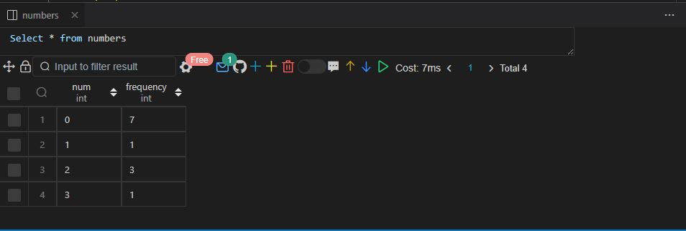

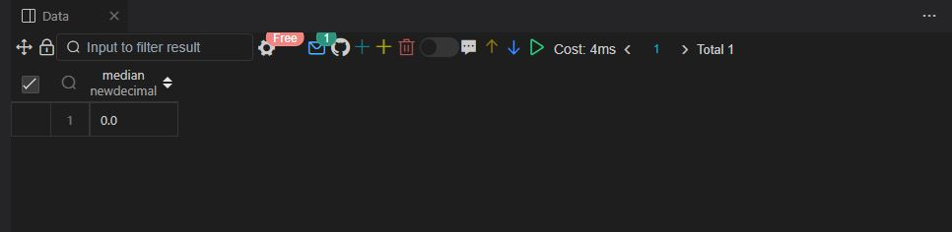

Q91.

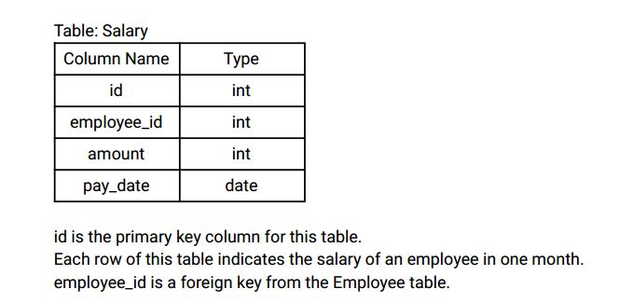

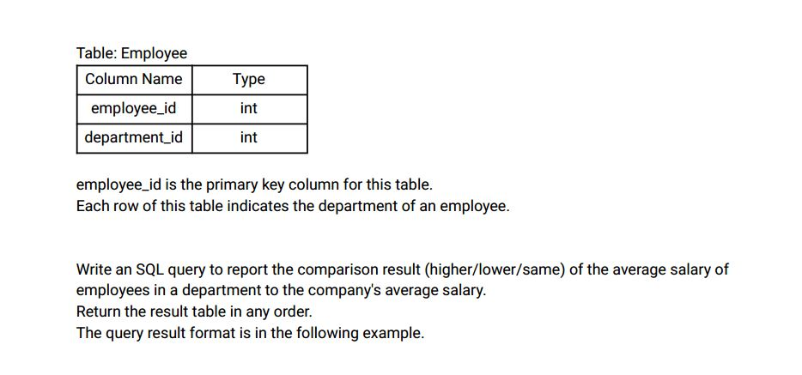

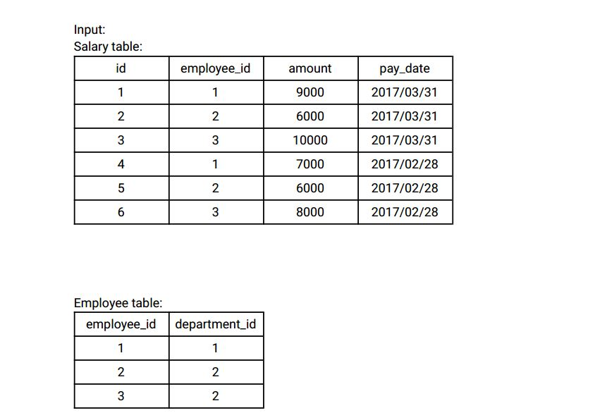

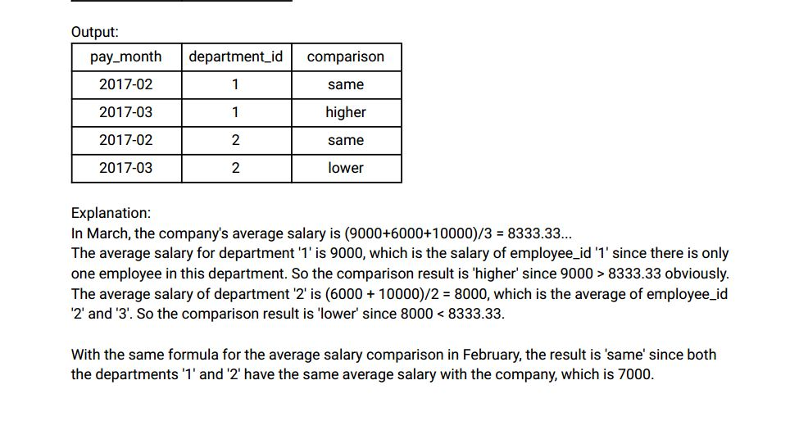

Ans:-

|  |
| --- |
|  |
| CREATE TABLE salary( |
|  | id INT, |
|  | employee_id INT, |
|  | amount INT, |
|  | paydate DATE, |
|  | CONSTRAINT prime_key PRIMARY KEY(id) |
|  | ); |
|  |  |
|  |  |
|  | CREATE TABLE employee( |
|  | employee_id INT, |
|  | department_id INT, |
|  | CONSTRAINT prime_key PRIMARY KEY(employee_id) |
|  | ); |
|  |  |
|  |  |
|  | INSERT INTO salary VALUES |
|  | (1,1,9000,'2017/03/31'), |
|  | (2,2,6000,'2017/03/31'), |
|  | (3,3,10000,'2017/03/31'), |
|  | (4,1,7000,'2017/02/28'), |
|  | (5,2,6000,'2017/02/28'), |
|  | (6,3,8000,'2017/02/28'); |
|  |  |
|  |  |
|  | INSERT INTO employee VALUES |
|  | (1,1), |
|  | (2,2), |
|  | (3,2); |
|  |  |
|  |  |
|  |  |
|  |  |
|  |  |
|  | WITH temp_comparison AS ( |
|  | SELECT |
|  | s.employee_id, |
|  | e.department_id, |
|  | s.amount, |
|  | s.paydate, |
|  | avg(amount) OVER (PARTITION BY MONTH(paydate) ORDER BY month(paydate), employee_id |
|  | ROWS BETWEEN UNBOUNDED PRECEDING AND UNBOUNDED FOLLOWING) company_avg_salary, |
|  | avg(amount) OVER (PARTITION BY MONTH(paydate), department_id order by month(paydate) |
|  | ROWS BETWEEN UNBOUNDED PRECEDING AND UNBOUNDED FOLLOWING) department_avg |
|  | FROM |
|  | salary s |
|  | INNER JOIN |
|  | employee e |
|  | ON |
|  | e.employee_id = s.employee_id |
|  | ) |
|  |  |
|  | SELECT |
|  | DISTINCT DATE_FORMAT(paydate, '%Y-%m') AS pay_month, |
|  | department_id, |
|  | CASE |
|  | WHEN company_avg_salary = department_avg THEN 'same' |
|  | WHEN company_avg_salary > department_avg THEN 'lower' |
|  | WHEN company_avg_salary < department_avg THEN 'higher' |
|  | END AS comparison |
|  | FROM |
|  | temp_comparison; |
|  |  |
|  |  |
|  |  |

Select * from salary;

Select * from employee;

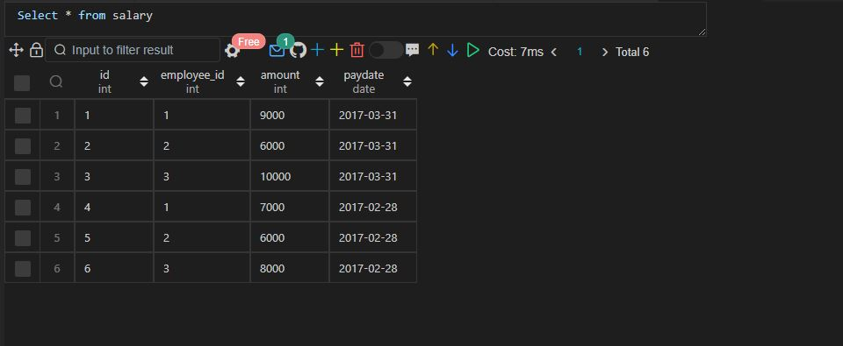

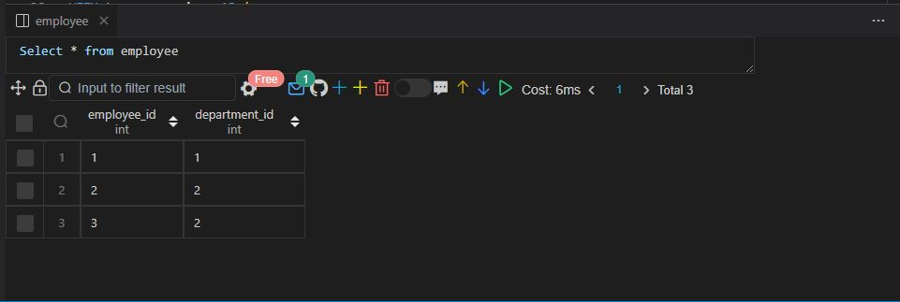

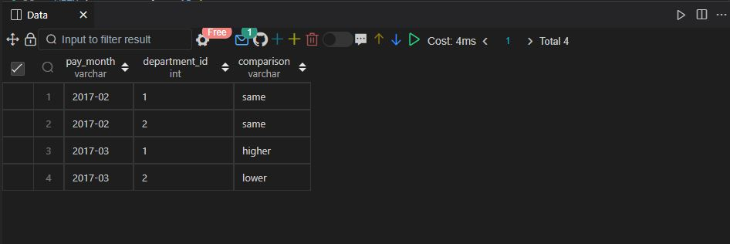

Q92.

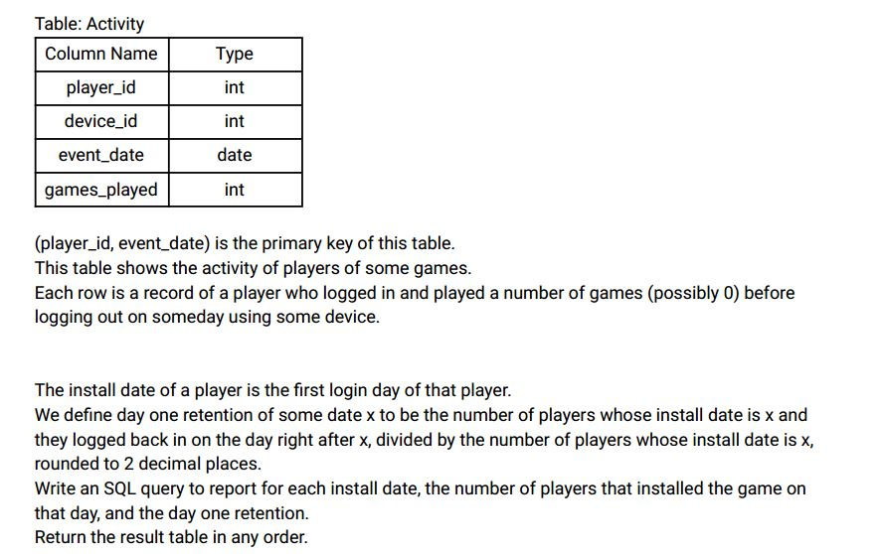

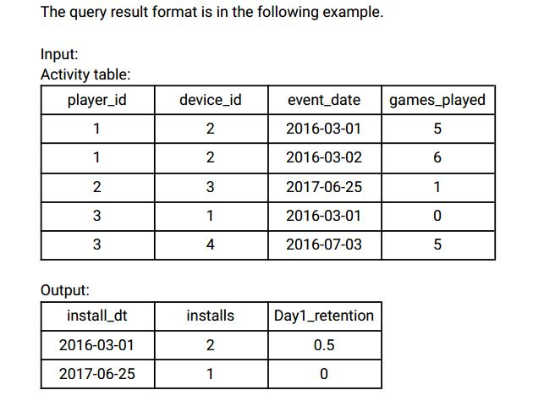

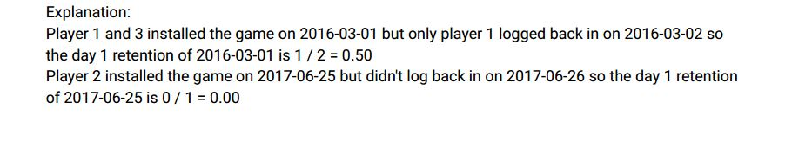

Ans:-

|  |
| --- |
|  |
| CREATE TABLE activity( |
|  | player_id INT, |
|  | device_id INT, |
|  | event_date DATE, |
|  | games_played INT, |
|  | CONSTRAINT prime_key PRIMARY KEY(player_id, event_date) |
|  | ); |
|  |  |
|  |  |
|  | INSERT INTO activity VALUES |
|  | (1,2,'2016-03-01',5), |
|  | (1,2,'2016-03-02',6), |
|  | (2,3,'2017-06-25',1), |
|  | (3,1,'2016-03-01',0), |
|  | (3,4,'2018-07-03',5); |
|  |  |
|  |  |
|  | -- Approach 1 |
|  |  |
|  |  |
|  | SELECT |
|  | a.event_date AS install_date, |
|  | COUNT(a.player_id) AS installs, |
|  | ROUND(COUNT(b.player_id) / COUNT(a.player_id), 2) AS day1_retention |
|  | FROM |
|  | ( |
|  | SELECT |
|  | player_id, |
|  | MIN(event_date) AS event_date |
|  | FROM |
|  | activity |
|  | GROUP BY |
|  | player_id |
|  | ) a |
|  | LEFT JOIN |
|  | activity b |
|  | ON |
|  | a.player_id = b.player_id |
|  | AND |
|  | a.event_date + 1 = b.event_date |
|  | GROUP BY |
|  | a.event_date; |
|  |  |
|  |  |
|  | -- Approach 2 |
|  |  |
|  |  |
|  | SELECT |
|  | a1.event_date AS install_dt, |
|  | COUNT(a1.player_id) AS installs, |
|  | ROUND(COUNT(a3.player_id) / COUNT(a1.player_id), 2) AS day1_retention |
|  | FROM |
|  | activity a1 |
|  | LEFT JOIN |
|  | activity a2 |
|  | ON |
|  | a1.player_id = a2.player_id |
|  | AND |
|  | a1.event_date > a2.event_date |
|  | LEFT JOIN |
|  | activity a3 |
|  | ON |
|  | a1.player_id = a3.player_id |
|  | AND |
|  | DATEDIFF(a3.event_date, a1.event_date) = 1 |
|  | WHERE |
|  | a2.event_date IS NULL |
|  | GROUP BY |
|  | a1.event_date; |
|  |  |
|  |  |
|  |  |

Select * from activity;

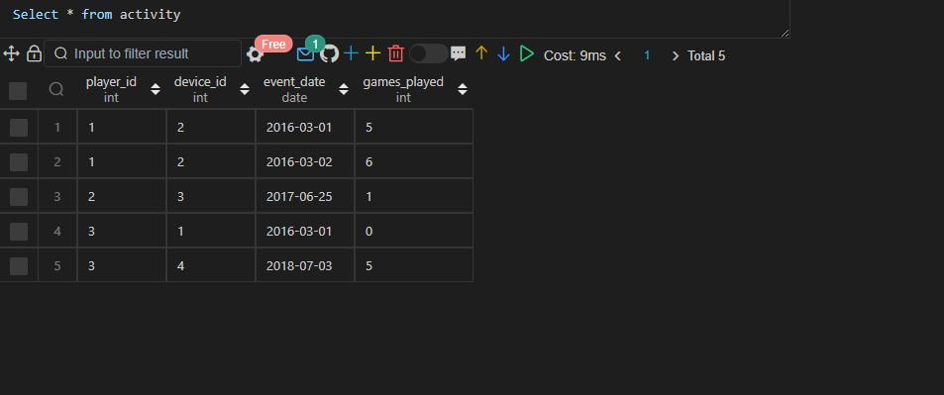

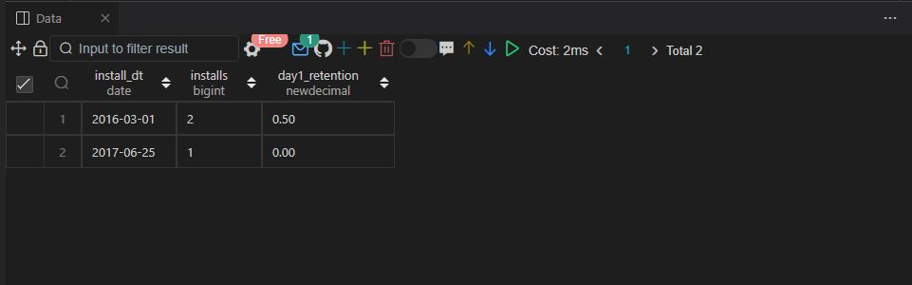

Q.93 SAME AS 50

Q94.

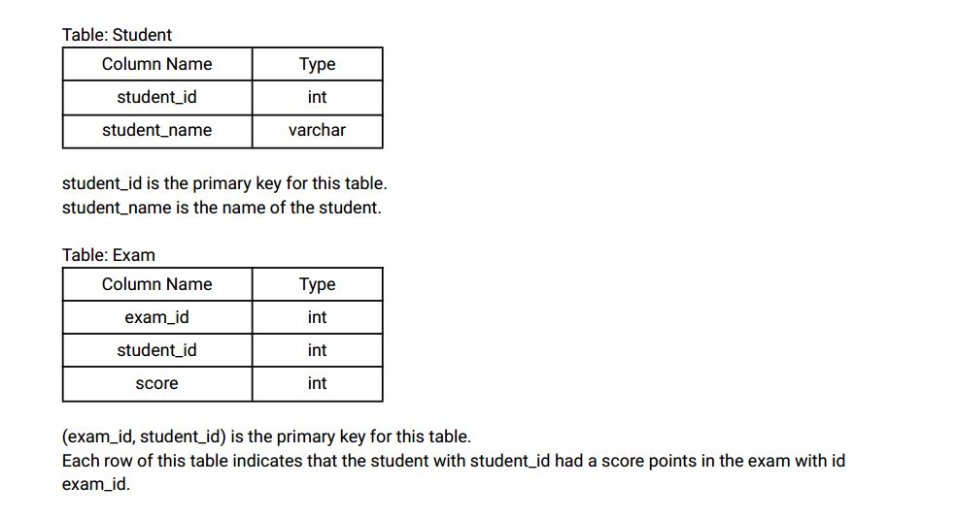



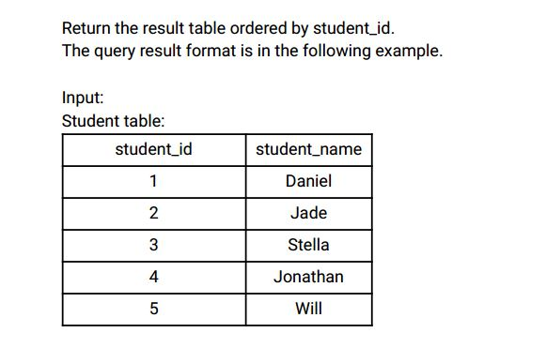

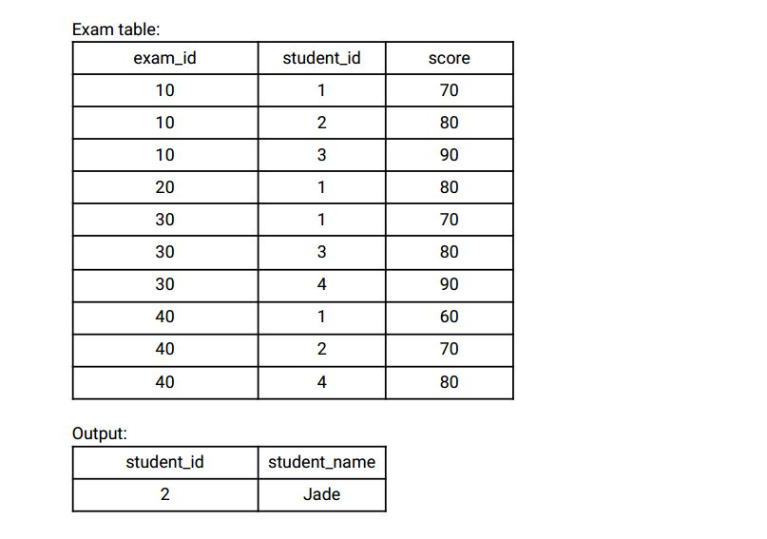

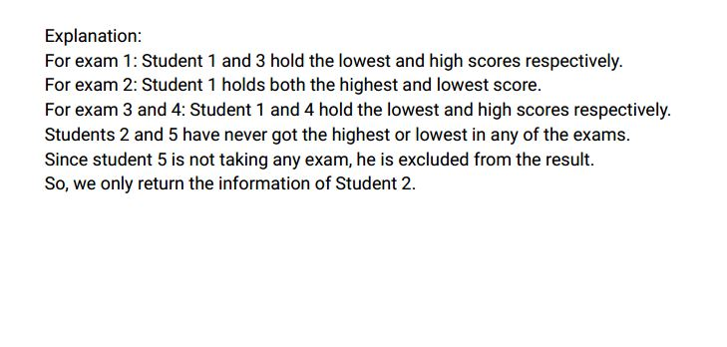

Ans:-

|  |
| --- |
|  |
| CREATE TABLE student( |
|  | student_id INT, |
|  | student_name VARCHAR(20), |
|  | CONSTRAINT prime_key PRIMARY KEY(student_id) |
|  | ); |
|  |  |
|  |  |
|  | CREATE TABLE exam( |
|  | exam_id INT, |
|  | student_id INT, |
|  | score INT, |
|  | CONSTRAINT prime_key PRIMARY KEY(exam_id,student_id) |
|  | ); |
|  |  |
|  |  |
|  | INSERT INTO student VALUES |
|  | (1,'DANIEL'), |
|  | (2,'JADE'), |
|  | (3,'STELLA'), |
|  | (4,'JONATHAN'), |
|  | (5,'WILL'); |
|  |  |
|  |  |
|  | INSERT INTO exam VALUES |
|  | (10,1,70), |
|  | (10,2,80), |
|  | (10,3,90), |
|  | (20,1,80), |
|  | (30,1,70), |
|  | (30,3,80), |
|  | (30,4,90), |
|  | (40,1,60), |
|  | (40,2,70), |
|  | (40,4,80); |
|  |  |
|  |  |
|  | -- Approach 1 |
|  |  |
|  | WITH temp_examination AS ( |
|  | SELECT |
|  | exam_id, |
|  | student_id, |
|  | score, |
|  | max(score) OVER w AS highest, |
|  | min(score) OVER w AS lowest |
|  | FROM |
|  | exam |
|  | WINDOW w AS (PARTITION BY exam_id) |
|  | ), |
|  |  |
|  | temp_examination1 AS ( |
|  | SELECT |
|  | DISTINCT student_id |
|  | FROM |
|  | temp_examination |
|  | WHERE |
|  | score IN (lowest, highest) |
|  | ) |
|  |  |
|  | SELECT |
|  | DISTINCT s.student_id, |
|  | s.student_name |
|  | FROM |
|  | temp_examination |
|  | INNER JOIN |
|  | student s |
|  | ON |
|  | s.student_id = temp_examination.student_id |
|  | WHERE |
|  | s.student_id NOT IN (SELECT student_id FROM temp_examination1); |
|  |  |
|  |  |
|  |  |
|  | -- Approach 2 |
|  |  |
|  |  |
|  | WITH temp_examination AS ( |
|  | SELECT |
|  | student_id, |
|  | CASE |
|  | WHEN score < max(score) OVER(PARTITION BY exam_id) AND score >min(score) OVER(PARTITION BY exam_id) THEN 0 |
|  | ELSE 1 |
|  | END AS category |
|  | FROM |
|  | exam |
|  | ORDER BY |
|  | student_id |
|  | ), |
|  |  |
|  | temp_examination1 AS ( |
|  | SELECT |
|  | student_id, |
|  | SUM(category) AS high_low_count |
|  | FROM |
|  | temp_examination |
|  | GROUP BY |
|  | student_id |
|  | ) |
|  |  |
|  |  |
|  |  |
|  | SELECT |
|  | s.student_id, |
|  | s.student_name |
|  | FROM |
|  | student s |
|  | INNER JOIN |
|  | temp_examination1 |
|  | ON |
|  | s.student_id = temp_examination1.student_id |
|  | WHERE |
|  | high_low_count = 0 |
|  | ORDER BY |
|  | temp_examination1.student_id; |
|  |  |
|  |  |
|  |  |

Select * from student;

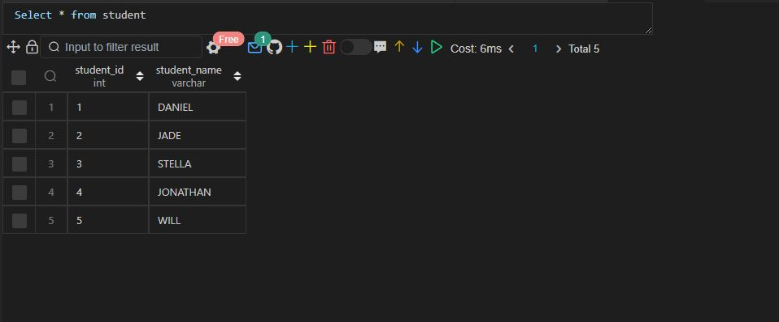

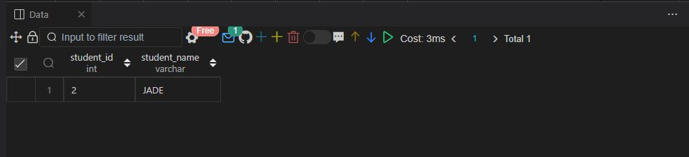

Q.95 SAME AS 94

Q96.

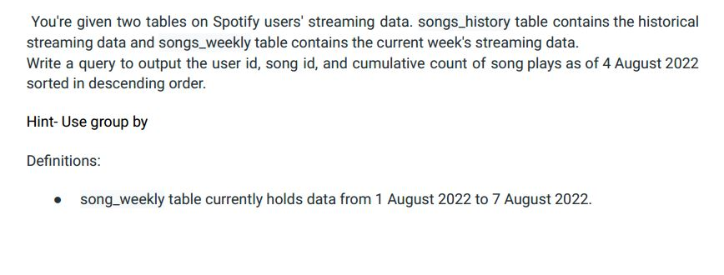

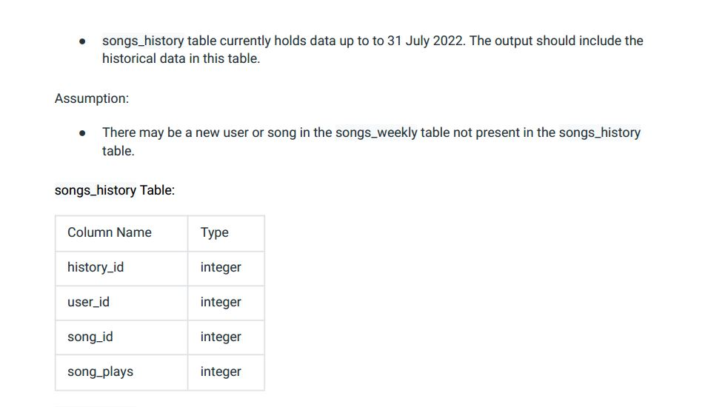

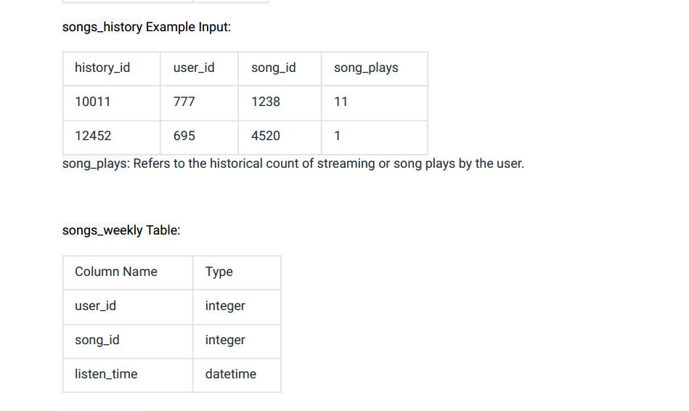

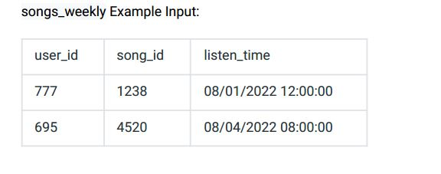

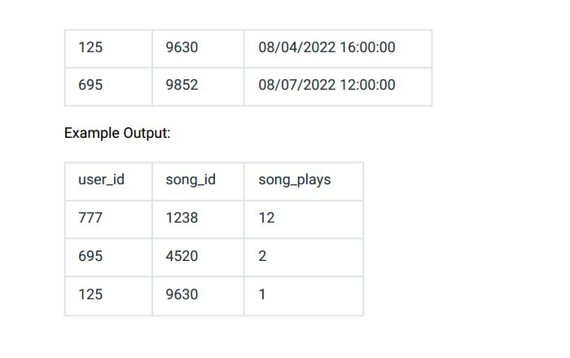

Ans:-

|  |
| --- |
|  |
| CREATE TABLE songs_history( |
|  | history_id INT, |
|  | user_id INT, |
|  | song_id INT, |
|  | song_plays INT |
|  | ); |
|  |  |
|  |  |
|  | INSERT INTO songs_history VALUES |
|  | (10011,777,1238,11), |
|  | (12452,695,4520,1); |
|  |  |
|  |  |
|  | CREATE TABLE songs_weekly( |
|  | user_id INT, |
|  | song_id INT, |
|  | listen_time VARCHAR(25) |
|  | ); |
|  |  |
|  |  |
|  | INSERT INTO songs_weekly VALUES |
|  | (777,1238,'08/01/2022 12:00:00'), |
|  | (695,4520,'08/04/2022 08:00:00'), |
|  | (125,9630,'08/04/2022 16:00:00'), |
|  | (695,9852,'08/07/2022 12:00:00'); |
|  |  |
|  |  |
|  |  |
|  | WITH streaming AS ( |
|  | SELECT |
|  | user_id, |
|  | song_id, |
|  | song_plays |
|  | FROM |
|  | songs_history |
|  |  |
|  | UNION ALL |
|  |  |
|  | SELECT |
|  | user_id, |
|  | song_id, |
|  | count(*) AS song_plays |
|  | FROM |
|  | songs_weekly |
|  | WHERE |
|  | listen_time <= '08/04/2022 23:59:59' |
|  | GROUP by |
|  | user_id, |
|  | song_id |
|  | ) |
|  |  |
|  | SELECT |
|  | user_id, |
|  | song_id, |
|  | SUM(song_plays) as song_plays |
|  | FROM |
|  | streaming |
|  | GROUP BY |
|  | user_id, |
|  | song_id |
|  | ORDER BY |
|  | song_plays DESC; |
|  |  |
|  |  |
|  |  |

Select * from songs_history;

Select * from songs_weekly;

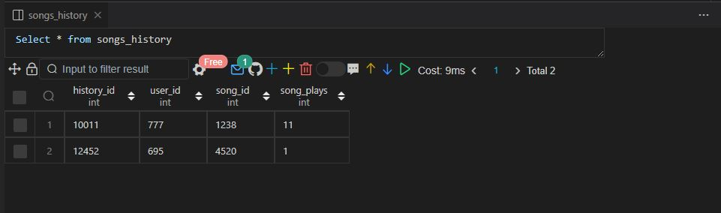

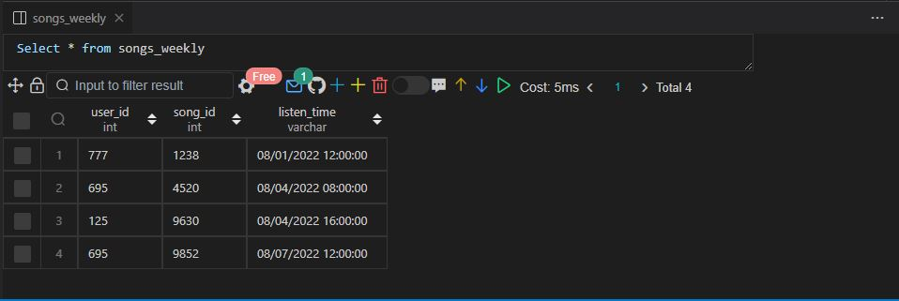

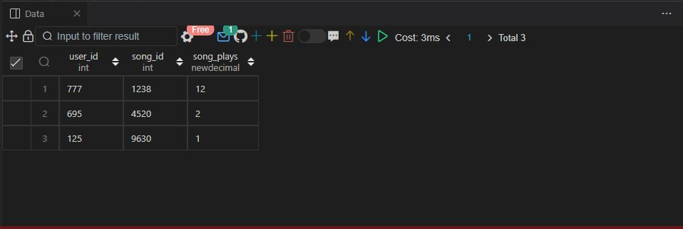

Q97.

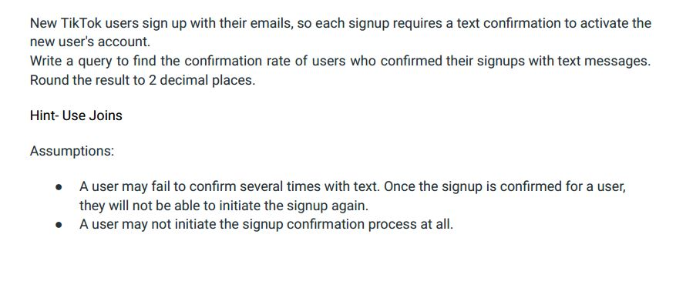

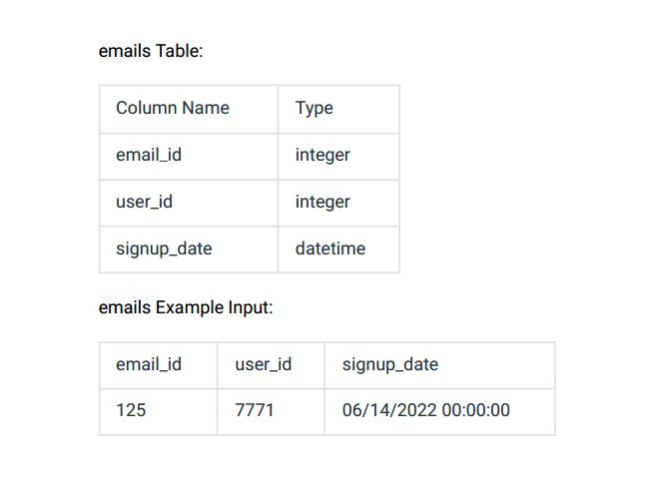

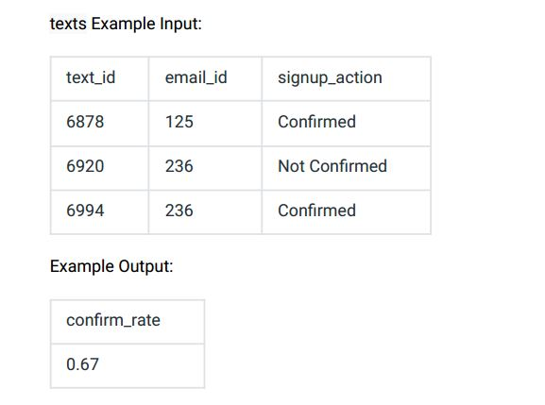

Ans:-

|  |
| --- |
|  |
| CREATE TABLE emails( |
|  | email_id INT, |
|  | user_id INT, |
|  | signup_date DATETIME |
|  | ); |
|  |  |
|  |  |
|  | INSERT INTO emails VALUES |
|  | (125,7771,'2022-06-14 00:00:00'), |
|  | (236,6950,'2022-07-01 00:00:00'), |
|  | (433,1052,'2022-07-09 00:00:00'); |
|  |  |
|  |  |
|  | CREATE TABLE texts( |
|  | text_id INT, |
|  | email_id INT, |
|  | signup_action VARCHAR(20) |
|  | ); |
|  |  |
|  |  |
|  | INSERT INTO texts VALUES |
|  | (6878,125,'CONFIRMED'), |
|  | (6920,236,'NOT CONFIRMED'), |
|  | (6994,236,'CONFIRMED'); |
|  |  |
|  |  |
|  |  |
|  | WITH temp_confirmation AS ( |
|  | SELECT |
|  | e.email_id, |
|  | CASE |
|  | WHEN signup_action = 'Confirmed' THEN 1 |
|  | END |
|  | AS confirmed_users |
|  | FROM |
|  | emails e |
|  | LEFT JOIN |
|  | texts t |
|  | ON |
|  | e.email_id = t.email_id |
|  | AND |
|  | t.signup_action = 'Confirmed' |
|  | ) |
|  |  |
|  |  |
|  | SELECT |
|  | ROUND(SUM(confirmed_users)/COUNT(email_id),2) AS confirm_rate |
|  | FROM |
|  | temp_confirmation; |
|  |  |
|  |  |
|  |  |

Select * from emails;

Select * from texts;

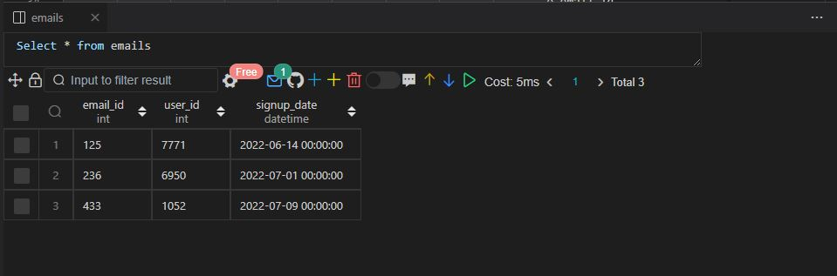

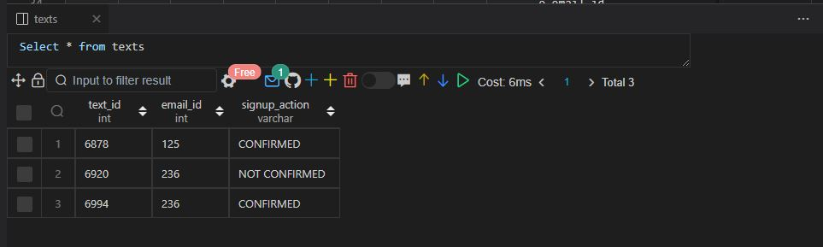

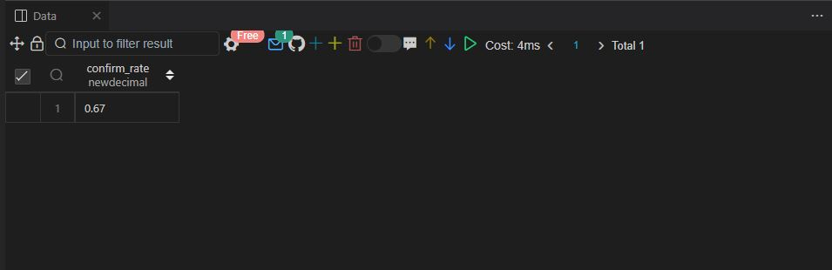

Q98.

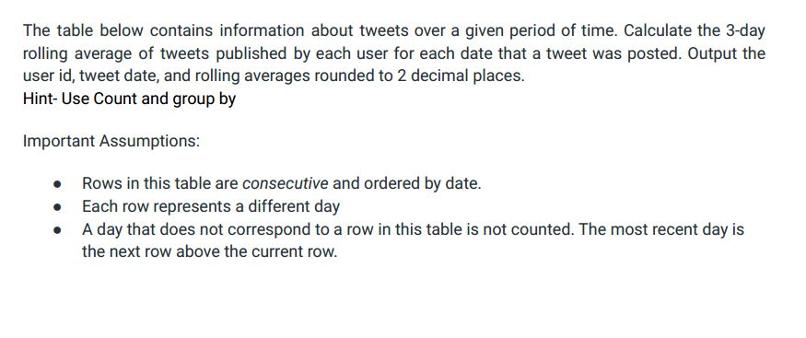

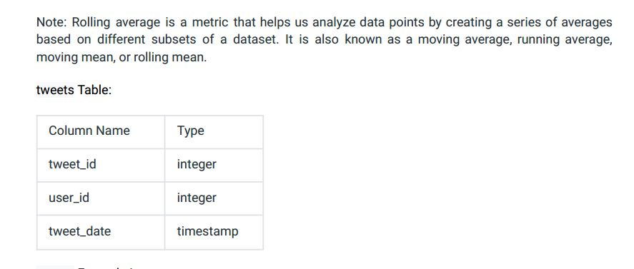

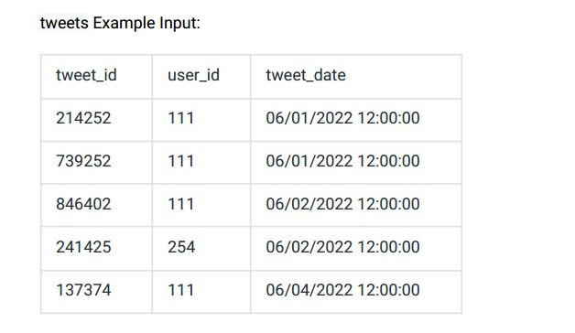

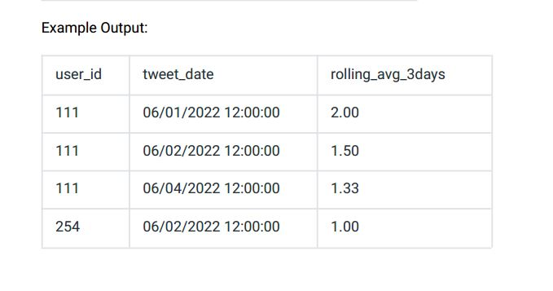

Ans:-

|  |
| --- |
|  |
| CREATE TABLE tweets( |
|  | tweet_id INT, |
|  | user_id INT, |
|  | tweet_date DATETIME |
|  | ); |
|  |  |
|  |  |
|  | INSERT INTO tweets VALUES |
|  | (214252,111,'2022-06-01 12:00:00'), |
|  | (739252,111,'2022-06-01 12:00:00'), |
|  | (846402,111,'2022-06-02 12:00:00'), |
|  | (241425,254,'2022-06-02 12:00:00'), |
|  | (137374,111,'2022-06-04 12:00:00'); |
|  |  |
|  |  |
|  | WITH temp_tweets AS ( |
|  | SELECT |
|  | user_id, |
|  | tweet_date, |
|  | COUNT(tweet_id) AS tweets_count |
|  | FROM |
|  | tweets |
|  | GROUP BY |
|  | user_id, |
|  | tweet_date |
|  | ORDER BY |
|  | user_id, |
|  | tweet_date |
|  | ) |
|  |  |
|  | SELECT |
|  | user_id, |
|  | tweet_date, |
|  | ROUND(avg(tweets_count) |
|  | OVER(PARTITION BY user_id ORDER BY tweet_date |
|  | ROWS BETWEEN 2 PRECEDING AND CURRENT ROW),2) AS rolling_avg_3days |
|  | FROM |
|  | temp_tweets; |
|  |  |
|  |  |
|  | Select * from tweets;  output.JPG  output2.JPG  Q99.  question.JPG  question2.JPG  question4.JPG  question5.JPG  question7.JPG  age_breakdown Example Input:  question9.JPG  Ans:-   |  | | --- | |  | | CREATE TABLE activities( | |  | activity_id INT, | |  | user_id INT, | |  | activity_type ENUM('SEND','OPEN','CHAT'), | |  | time_spent FLOAT, | |  | activity_date varchar(25) | |  | ); | |  |  | |  |  | |  | INSERT INTO activities VALUES | |  | (7274,123,'OPEN',4.50,'06/22/2022 12:00:00'), | |  | (2425,123,'SEND',3.50,'06/22/2022 12:00:00'), | |  | (1413,456,'SEND',5.67,'06/23/2022 12:00:00'), | |  | (1414,789,'CHAT',11.00,'06/25/2022 12:00:00'), | |  | (2536,456,'OPEN',3.00,'06/25/2022 12:00:00'); | |  |  | |  |  | |  | CREATE TABLE age_breakdown( | |  | user_id INT, | |  | age_bucket ENUM('21-25','26-30','31-35') | |  | ); | |  |  | |  |  | |  | INSERT INTO age_breakdown VALUES | |  | (123,'31-35'), | |  | (456,'26-30'), | |  | (789,'21-25'); | |  |  | |  |  | |  |  | |  | WITH temp_activities AS ( | |  | SELECT | |  | user_id, | |  | activity_type, | |  | sum(time_spent) time_spent, | |  | CASE | |  | WHEN activity_type = 'open' THEN sum(time_spent) | |  | ELSE 0 | |  | END opening_snap, | |  | CASE | |  | WHEN activity_type = 'send' THEN sum(time_spent) | |  | ELSE 0 | |  | END sending_snap | |  | FROM | |  | activities | |  | WHERE | |  | activity_type in ('open','send') | |  | GROUP BY | |  | user_id, | |  | activity_type | |  | ORDER BY | |  | user_id | |  | ), | |  |  | |  | temp_activities2 AS ( | |  | SELECT | |  | user_id, | |  | SUM(opening_snap) time_sending, | |  | SUM(sending_snap) time_opening | |  | FROM | |  | temp_activities | |  | GROUP BY | |  | user_id | |  | ) | |  |  | |  | SELECT | |  | ab.age_bucket, | |  | ROUND(time_opening * 100.0 /(time_sending+time_opening), 2) AS send_perc, | |  | ROUND(time_sending * 100.0 /(time_sending+time_opening), 2) AS open_perc | |  | FROM | |  | temp_activities2 | |  | INNER JOIN | |  | age_breakdown ab | |  | ON | |  | ab.user_id = temp_activities2.user_id | |  | ORDER BY | |  | ab.age_bucket; | |  |  | |  |  | |  |  |   Select * from activities;  Select * from age_breakdown;  output4.JPG  output7.JPG  output9.JPG  Q100 .  question10.JPG  question14.JPG  personal_profiles Example Input:  question15.JPG  question17.JPG  question19.JPG  question20.JPG  question22.JPG  question24.JPG  Ans:-   |  | | --- | |  | | CREATE TABLE personal_profiles( | |  | profile_id INT, | |  | name VARCHAR(20), | |  | followers INT | |  | ); | |  |  | |  |  | |  | INSERT INTO personal_profiles VALUES | |  | (1,'NICK SINGH',92000), | |  | (2,'ZACH WILSON',199000), | |  | (3,'DALIANA LIU',171000), | |  | (4,'RAVIT JAIN',107000), | |  | (5,'VIN VASHISHTA',139000), | |  | (6,'SUSAN WOJCICKI',39000); | |  |  | |  |  | |  | CREATE TABLE employee_company( | |  | personal_profile_id INT, | |  | company_id INT | |  | ); | |  |  | |  |  | |  | INSERT INTO employee_company VALUES | |  | (1,4), | |  | (1,9), | |  | (2,2), | |  | (3,1), | |  | (4,3), | |  | (5,6), | |  | (6,5); | |  |  | |  |  | |  | CREATE TABLE company_pages( | |  | company_id INT, | |  | name VARCHAR(30), | |  | followers INT | |  | ); | |  |  | |  |  | |  | INSERT INTO company_pages VALUES | |  | (1,'THE DATA SCIENCE PODCAST',8000), | |  | (2,'AIRBNB',700000), | |  | (3,'THE RAVIT SHOW',6000), | |  | (4,'DATA LEMUR',200), | |  | (5,'YOUTUBE',16000000), | |  | (6,'DATASCIENCE.VIN',4500), | |  | (9,'ACE THE DATA SCIENCE INTERVIEW',4479); | |  |  | |  |  | |  |  | |  | SELECT | |  | DISTINCT p.profile_id | |  | FROM | |  | personal_profiles p | |  | INNER JOIN | |  | employee_company ec | |  | ON | |  | p.profile_id = ec.personal_profile_id | |  | INNER JOIN | |  | company_pages c | |  | ON | |  | ec.company_id = c.company_id | |  | WHERE | |  | p.followers > c.followers | |  | ORDER BY | |  | p.profile_id; | |  |  | |  |  | |  |  |   Select * from personal_profiles;  Select * from employee_company;  Select * from company_pages;  output10.JPG  output14.JPG  output20.JPG  output22.JPG  Q 101.  question25.JPG |

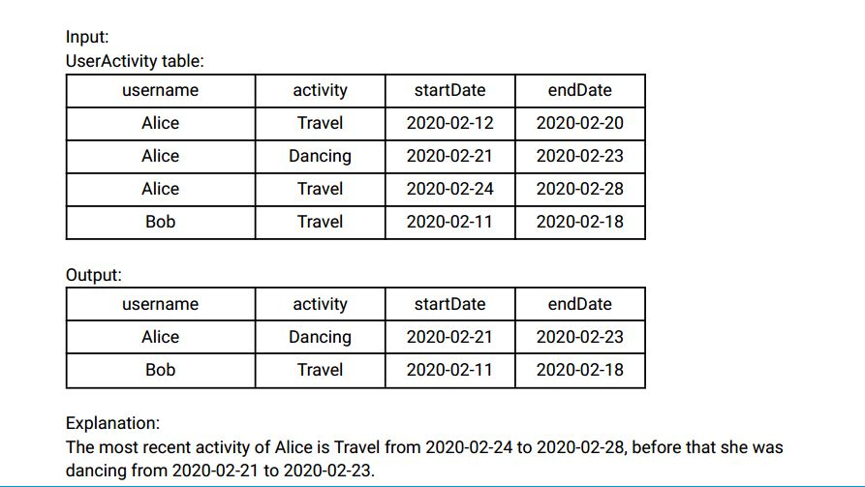

Bob only has one record, we just take that one.

Ans:-

|  |
| --- |
|  |
| CREATE TABLE user_activity( |
|  | username VARCHAR(20), |
|  | activity VARCHAR(20), |
|  | start_date DATE, |
|  | end_date DATE |
|  | ); |
|  |  |
|  |  |
|  | INSERT INTO user_activity VALUES |
|  | ('ALICE','TRAVEL','2020-02-12','2020-02-20'), |
|  | ('ALICE','DANCING','2020-02-21','2020-02-23'), |
|  | ('ALICE','TRAVEL','2020-02-24','2020-02-28'), |
|  | ('BOB','TRAVEL','2020-02-11','2020-02-18'); |
|  |  |
|  |  |
|  |  |
|  | WITH temp_activity AS ( |
|  | SELECT |
|  | username, |
|  | activity, |
|  | start_date, |
|  | end_date, |
|  | ROW_NUMBER() OVER(PARTITION BY username ORDER BY start_date, end_date) row_num, |
|  | COUNT(*) OVER(PARTITION BY username ORDER BY start_date, end_date |
|  | rows between unbounded preceding and unbounded following) total_activities |
|  | FROM |
|  | user_activity |
|  | ), |
|  | temp_activity2 AS ( |
|  | SELECT |
|  | username, |
|  | activity, |
|  | start_date, |
|  | end_date, |
|  | IF(total_activities = 1 and row_num = 1, 2, row_num) AS ranking |
|  | FROM |
|  | temp_activity |
|  | ) |
|  |  |
|  | SELECT |
|  | username, |
|  | activity, |
|  | start_date, |
|  | end_date |
|  | FROM |
|  | temp_activity2 |
|  | WHERE |
|  | ranking = 2; |
|  |  |
|  |  |
|  |  |

Select * from user_activity;

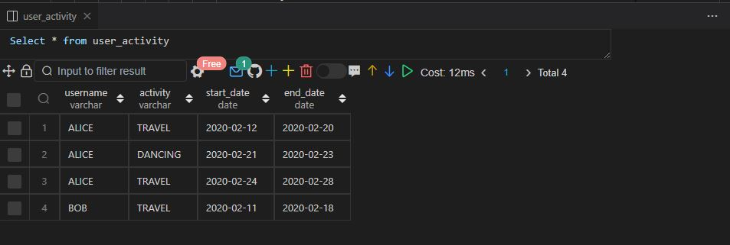

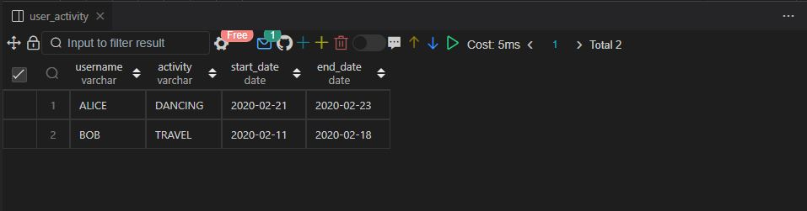

Q102.

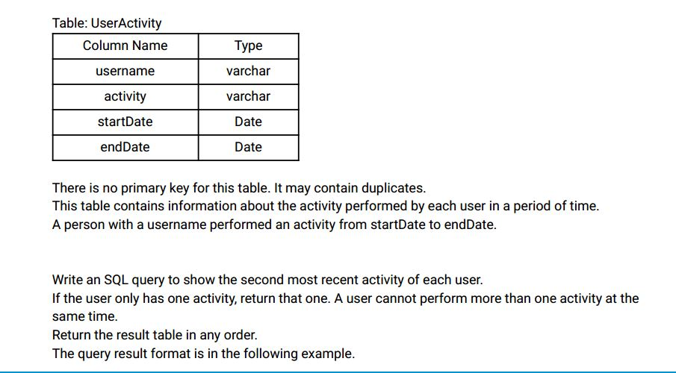

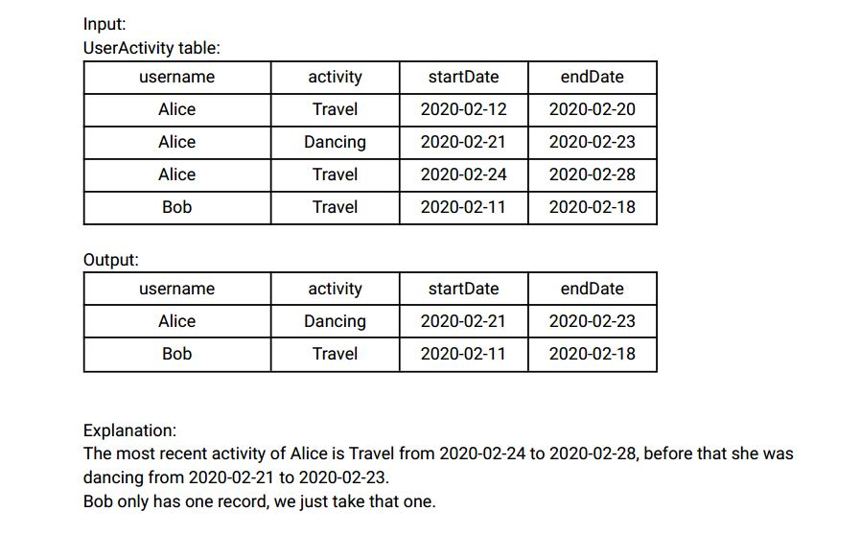

Ans:- Q.102 SAME AS 101

Q103.

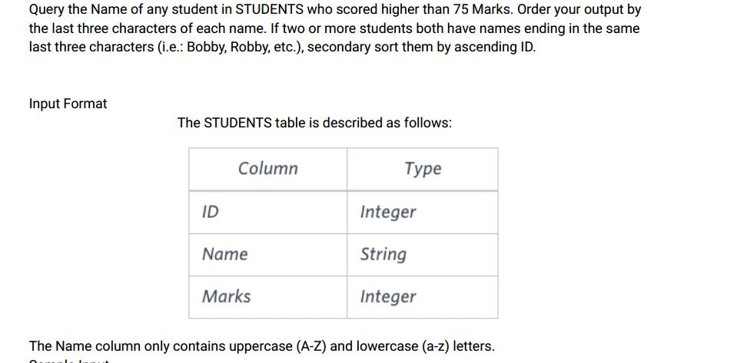

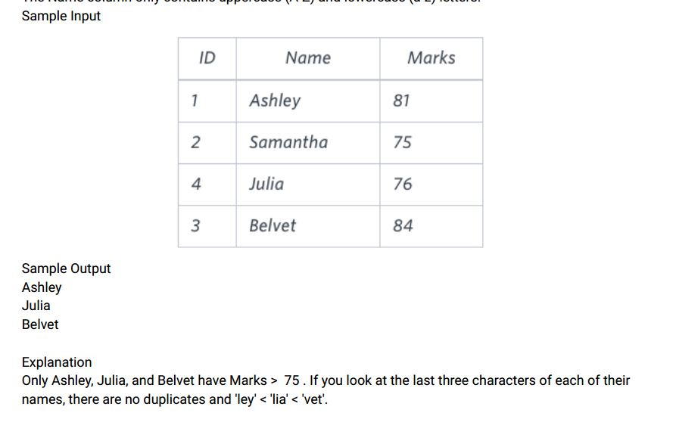

Ans:-

|  |
| --- |
|  |
| CREATE TABLE students( |
|  | id INT, |
|  | name VARCHAR(20), |
|  | marks INT |
|  | ); |
|  |  |
|  |  |
|  | INSERT INTO students VALUES |
|  | (1,'ASHLEY',81), |
|  | (2,'SAMANTHA',75), |
|  | (3,'JULIA',76), |
|  | (4,'BELVET',84); |
|  |  |
|  |  |
|  |  |
|  | SELECT |
|  | name |
|  | FROM |
|  | students |
|  | WHERE |
|  | marks > 75 |
|  | ORDER BY |
|  | RIGHT(name,3), |
|  | id; |
|  |  |
|  |  |

Select * from students;

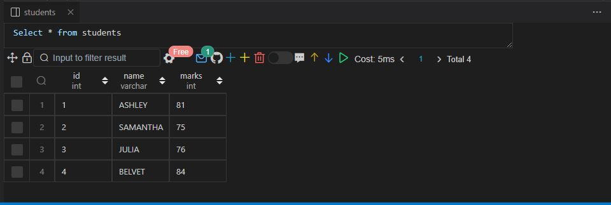

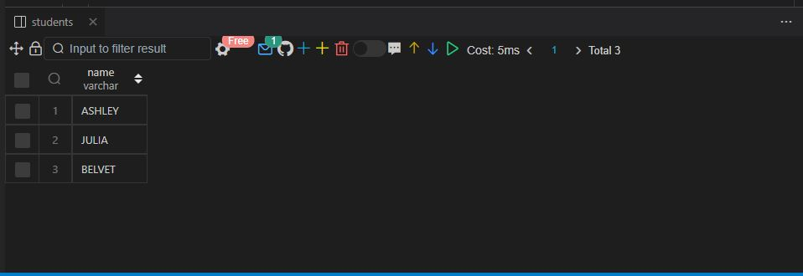

Q104.

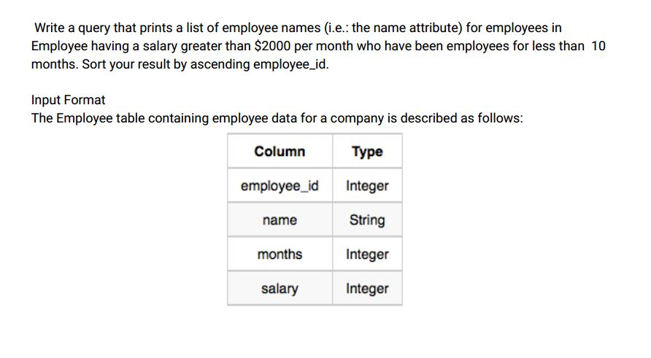

where employee_id is an employee' s ID number , name is their name, months is the total number of

months they've been working for the company , and salary is the their monthly salary .

Sample Input

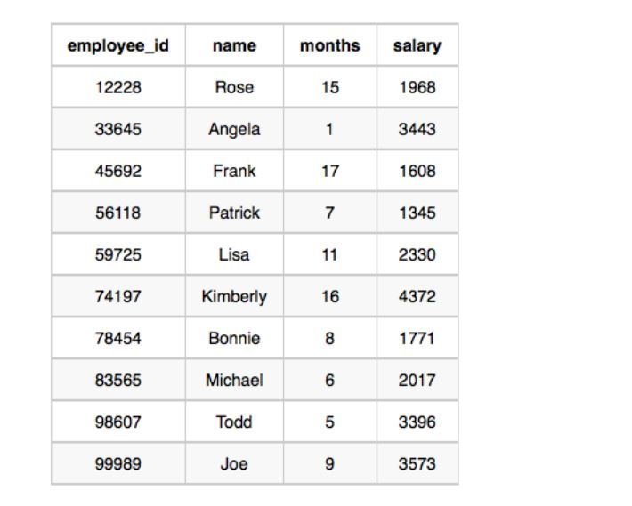

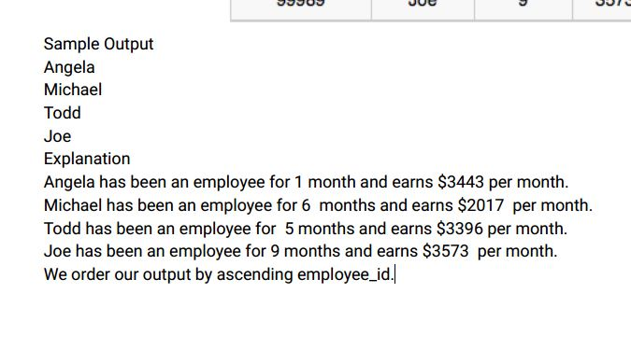

Ans:-

|  |
| --- |
|  |
| CREATE TABLE employee( |
|  | employee_id INT, |
|  | name VARCHAR(20), |
|  | month INT, |
|  | salary INT |
|  | ); |
|  |  |
|  |  |
|  | INSERT INTO employee VALUES |
|  | (12228,'ROSE',15,1968), |
|  | (33645,'ANGELA',1,3443), |
|  | (45692,'FRANK',17,1608), |
|  | (56118,'PATRICK',7,1345), |
|  | (59725,'LISA',11,2330), |
|  | (74197,'KIMBERLY',16,4372), |
|  | (78454,'BONNIE',8,1771), |
|  | (83565,'MICHAEL',6,2017), |
|  | (98607,"TODD",5,3396), |
|  | (99989,'JOE',9,3573); |
|  |  |
|  |  |
|  |  |
|  | SELECT |
|  | name |
|  | FROM |
|  | employee |
|  | WHERE |
|  | salary > 2000 |
|  | AND |
|  | month < 10 |
|  | ORDER BY |
|  | employee_id; |
|  |  |
|  |  |
|  |  |

Select * from employee;

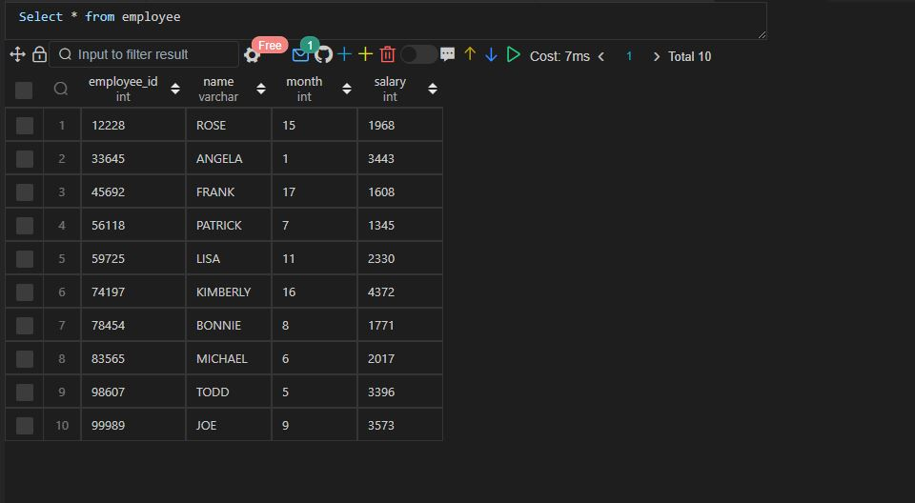

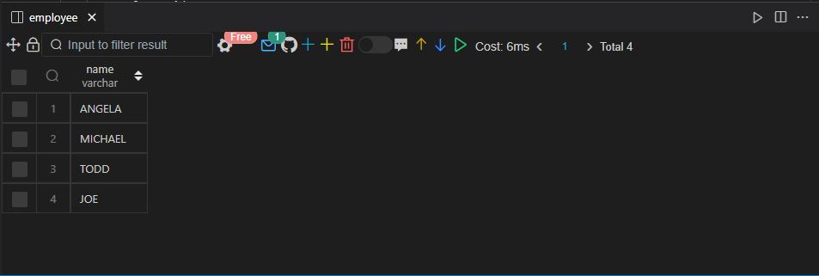

Q105

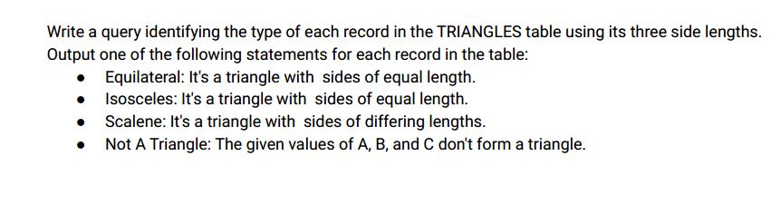

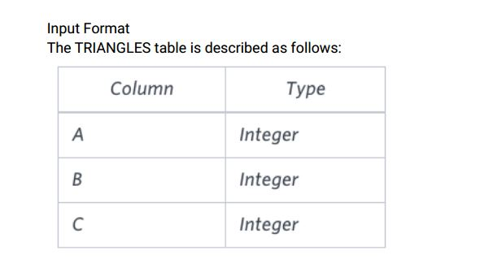

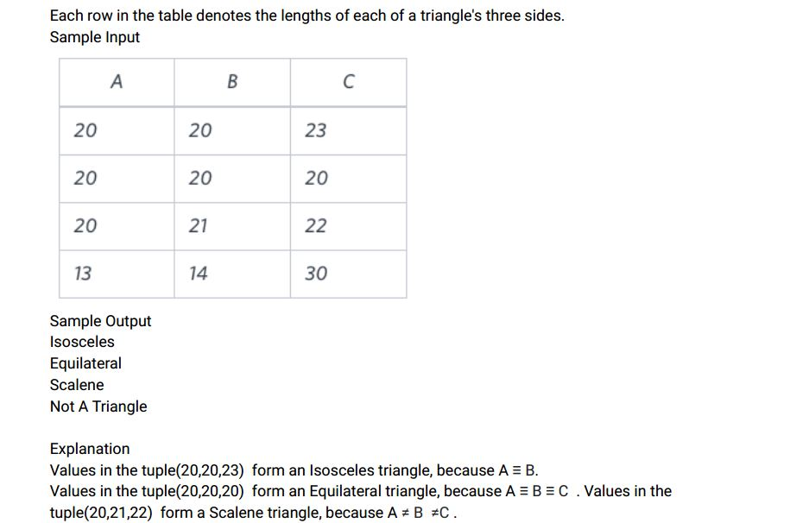

Values in the tuple (13,14,30) cannot form a triangle because the combined value of sides A and B is

not larger than that of side C .

Ans:-

|  |
| --- |
|  |
| CREATE TABLE triangles( |
|  | a INT, |
|  | b INT, |
|  | c INT |
|  | ); |
|  |  |
|  |  |
|  | INSERT INTO triangles VALUES |
|  | (20,20,23), |
|  | (20,20,20), |
|  | (20,21,22), |
|  | (13,14,30); |
|  |  |
|  |  |
|  |  |
|  | SELECT |
|  | a, |
|  | b, |
|  | c, |
|  | CASE |
|  | WHEN a + b <= c OR b + c <= a OR a + c <= b THEN 'NOT A TRIANGLE' |
|  | WHEN a = b AND b = c THEN 'EQUILATERAL' |
|  | WHEN a = b OR b = c OR c = a THEN 'ISSOCELES' |
|  | WHEN a <> b AND b <> c THEN 'SCALEAN' |
|  | END AS type_of_triangle |
|  | FROM |
|  | triangles; |
|  |  |
|  |  |
|  |  |

Select * from triangles;

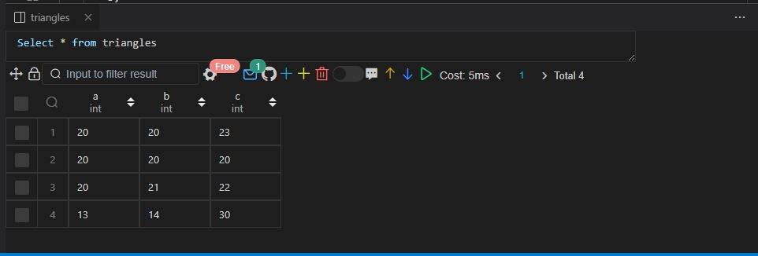

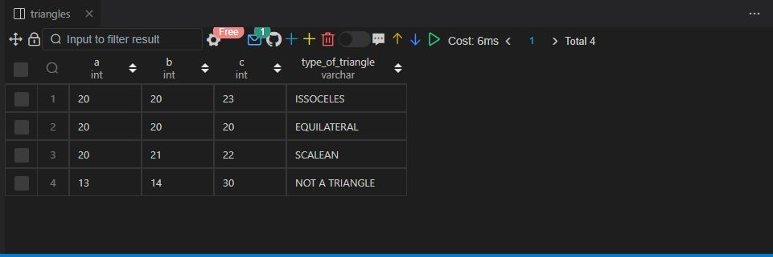

Q106.

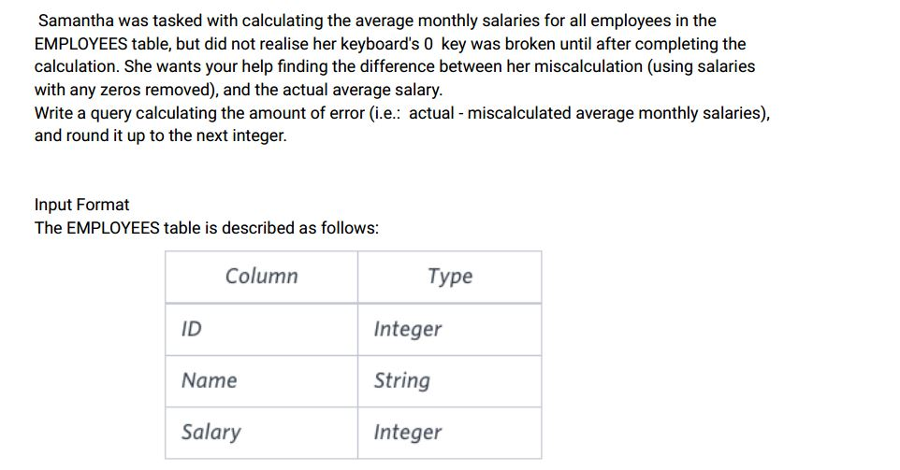

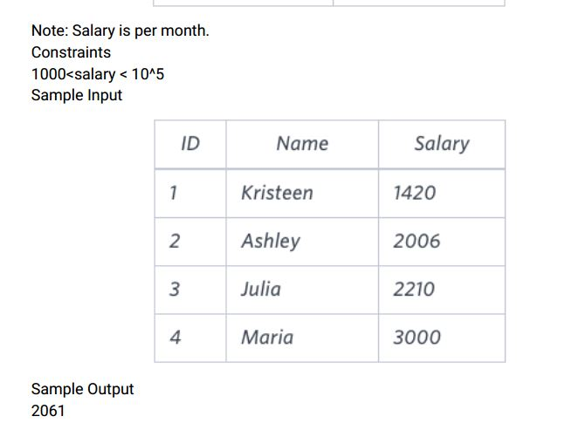

Explanation

The table below shows the salaries without zeros as they were entered by Samantha:

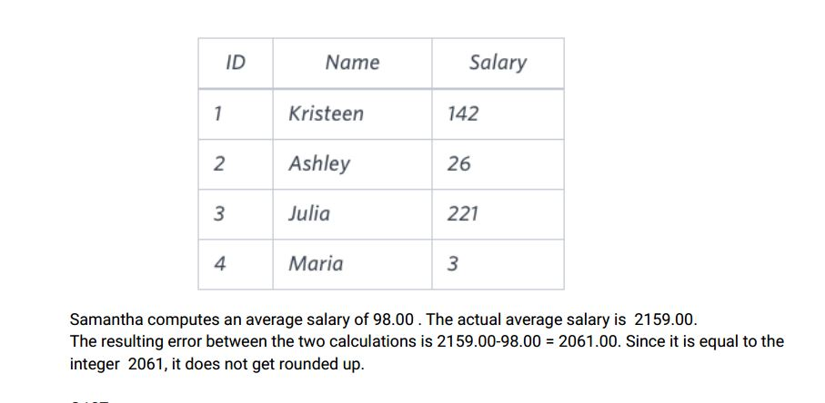

Ans:-

|  |
| --- |
|  |
| CREATE TABLE employees( |
|  | id INT, |
|  | name VARCHAR(20), |
|  | salary INT |
|  | ); |
|  |  |
|  | INSERT INTO employees VALUES |
|  | (1,'KRISTEEN',1420), |
|  | (2,'ASHLEY',2006), |
|  | (3,'JULIA',2210), |
|  | (4,'MARIA',3000); |
|  |  |
|  |  |
|  | SELECT |
|  | ceil(avg(salary) - avg(replace(salary, '0', ''))) AS error |
|  | FROM |
|  | employees; |
|  |  |
|  |  |

Select * from employees;

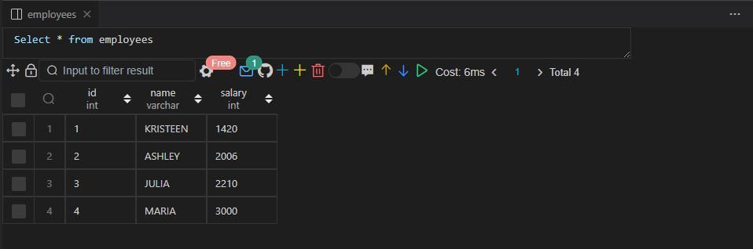

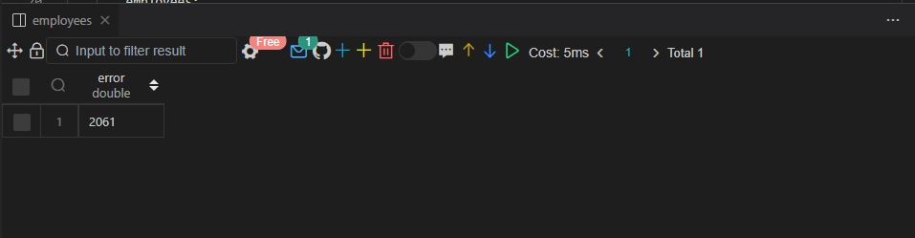

Q107.

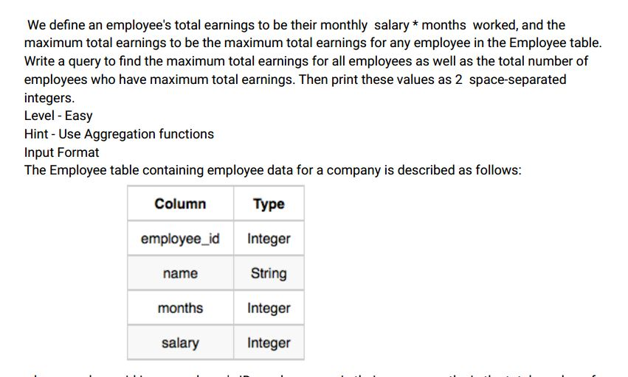

where employee_id is an employee' s ID number , name is their name, months is the total number of

months they've been working for the company , and salary is the their monthly salary .

Sample Input

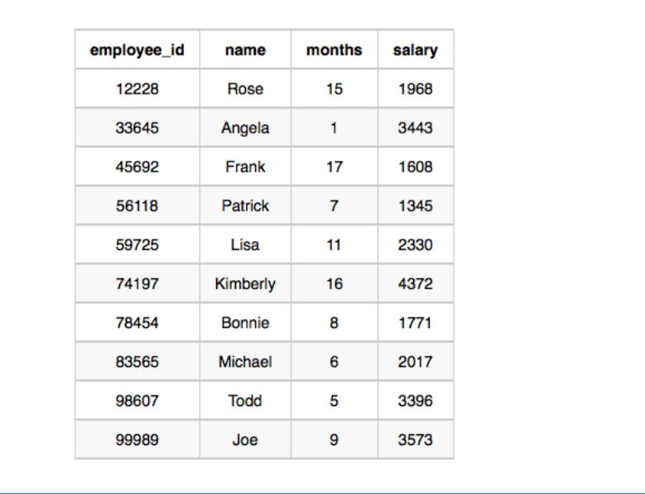

Sample Output

69952 1

Explanation:

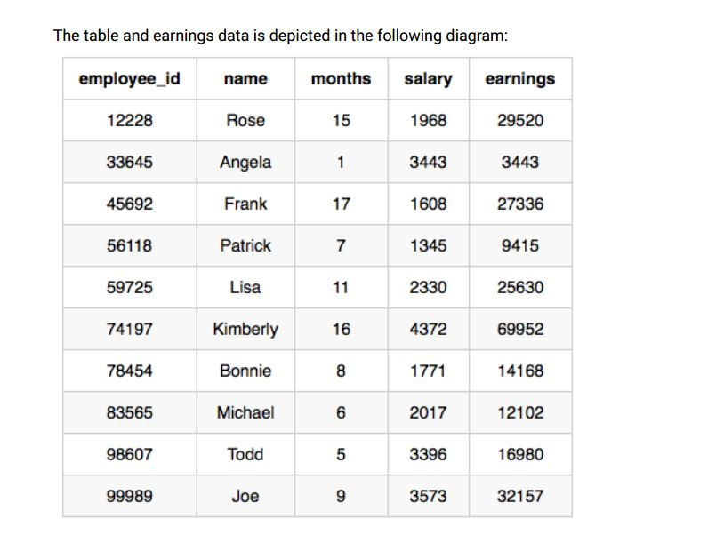

The maximum earnings value is 69952. The only employee with earnings= 69952 is Kimberly , so we

print the maximum earnings value (69952) and a count of the number of employees who have earned

$69952 (which is 1) as two space-separated values.

Ans:-

|  |
| --- |
|  |
| CREATE TABLE employee( |
|  | employee_id INT, |
|  | name VARCHAR(20), |
|  | months INT, |
|  | salary INT |
|  | ); |
|  |  |
|  |  |
|  | INSERT INTO employee VALUES |
|  | (12228,'ROSE',15,1968), |
|  | (33645,'ANGELA',1,3443), |
|  | (45692,'FRANK',17,1608), |
|  | (56118,'PATRICK',7,1345), |
|  | (59725,'LISA',11,2330), |
|  | (74197,'KIMBERLY',16,4372), |
|  | (78454,'BONNIE',8,1771), |
|  | (83565,'MICHAEL',6,2017), |
|  | (98607,"TODD",5,3396), |
|  | (99989,'JOE',9,3573); |
|  |  |
|  |  |
|  |  |
|  | SELECT |
|  | MAX(salary*months) as total_earnings, |
|  | COUNT(*) |
|  | FROM |
|  | employee |
|  | WHERE |
|  | (salary*months) in ( |
|  | SELECT |
|  | MAX(months * salary) |
|  | FROM |
|  | employee |
|  | ); |
|  |  |
|  |  |
|  |  |

Select * from employee;

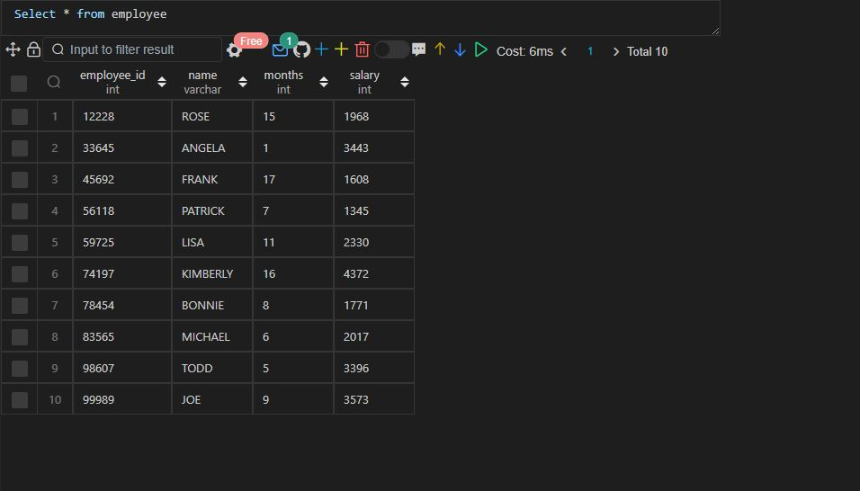

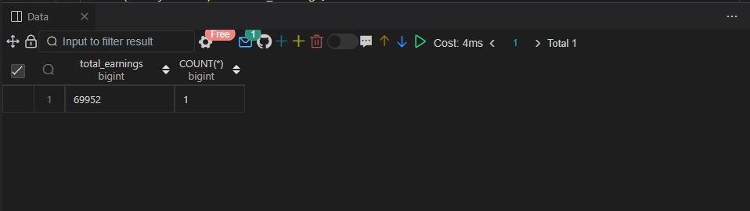

Q108.

Generate the following two result sets:

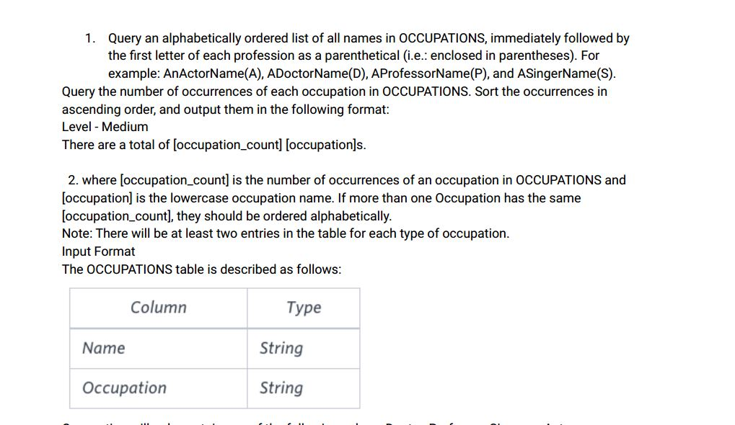

Occupation will only contain one of the following values: Doctor , Professor , Singer or Actor .

Sample Input

An OCCUPATIONS table that contains the following records:

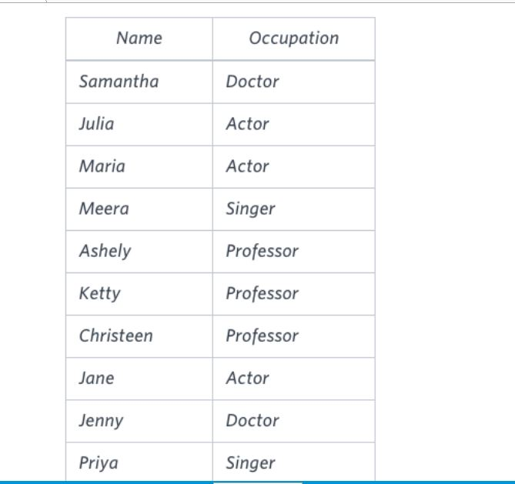

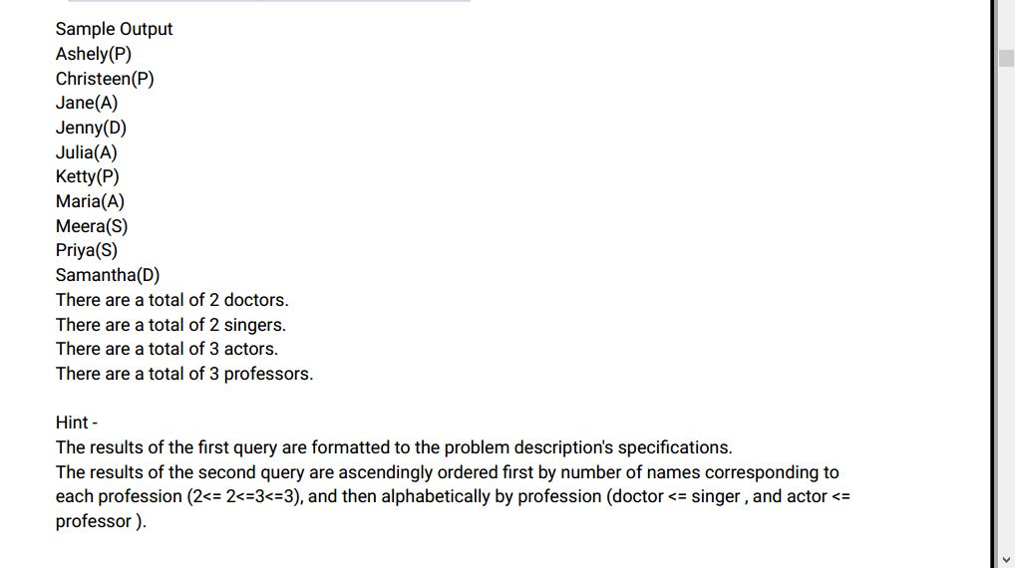

Ans:-

|  |
| --- |
|  |
| CREATE TABLE occupations( |
|  | name VARCHAR(20), |
|  | occupation VARCHAR(20) |
|  | ); |
|  |  |
|  |  |
|  | INSERT INTO occupations VALUES |
|  | ('SAMNATHA','DOCTOR'), |
|  | ('JULIA','ACTOR'), |
|  | ('MARIA','ACTOR'), |
|  | ('MEERA','SINGER'), |
|  | ('ASHLEY','PROFESSOR'), |
|  | ('KETTY','PROFESSOR'), |
|  | ('CHRISTEEN','PROFESSOR'), |
|  | ('JANE','ACTOR'), |
|  | ('JENNY','DOCTOR'), |
|  | ('PRIYA','SINGER'); |
|  |  |
|  |  |
|  |  |
|  | -- a. |
|  |  |
|  | SELECT |
|  | CONCAT(name, '(',substring(occupation, 1, 1),')') as `name(occupation)` |
|  | FROM |
|  | occupations |
|  | ORDER BY |
|  | name; |
|  |  |
|  |  |
|  |  |
|  | -- b. |
|  |  |
|  | SELECT |
|  | CONCAT("There are a total of ", |
|  | COUNT(*),' ', lower(occupation), 's.') AS info |
|  | FROM |
|  | occupations |
|  | GROUP BY |
|  | occupation |
|  | ORDER BY |
|  | COUNT(occupation), |
|  | occupation; |
|  |  |
|  |  |

Select * from occupations;

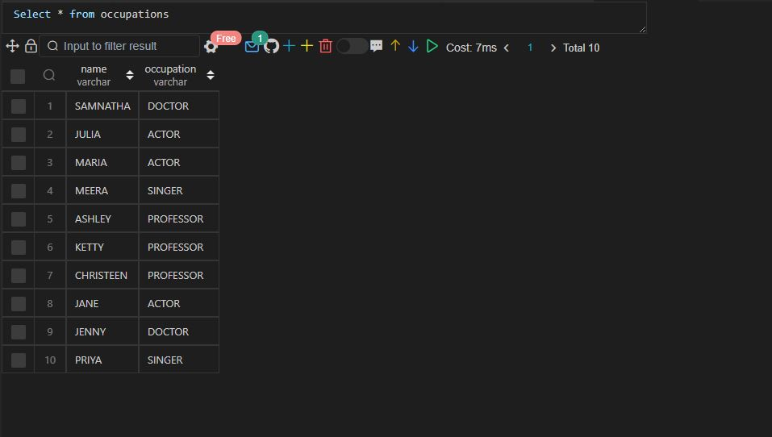

a)

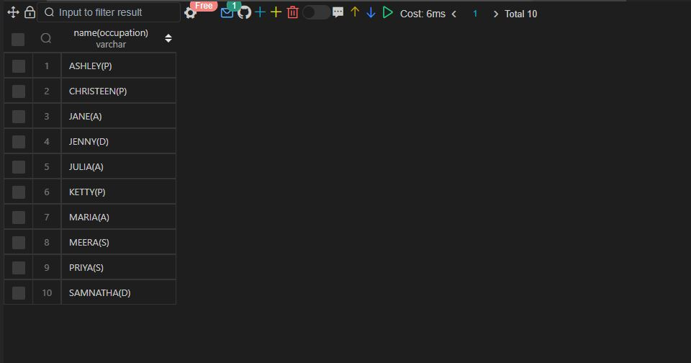

b)

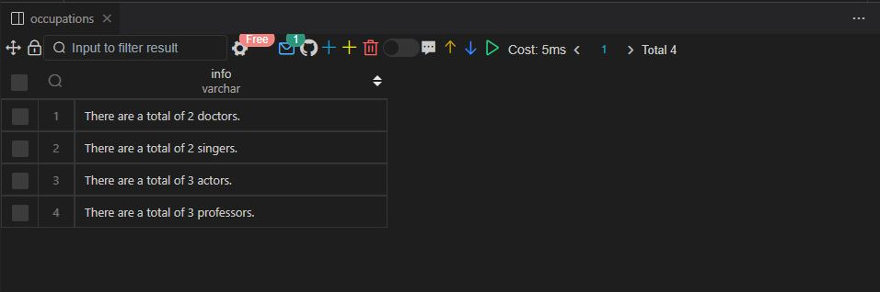

Q109 .

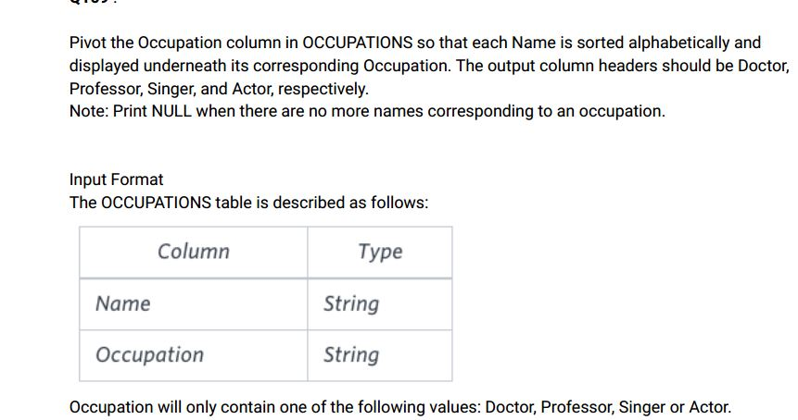

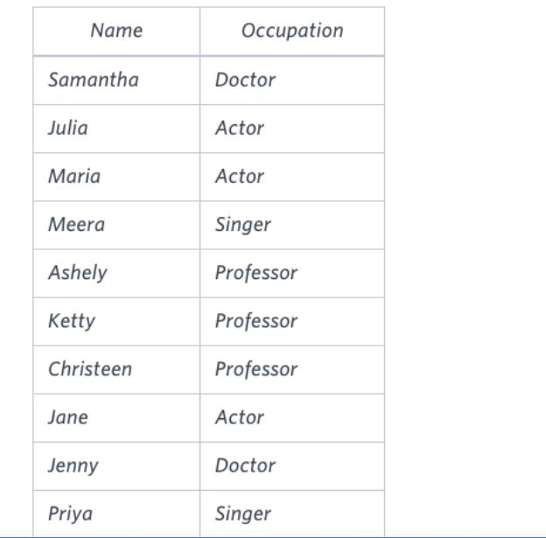

Sample Output

Jenny Ashley Meera Jane

Samantha Christeen Priya Julia

NULL Ketty NULL Maria

Hint -The first column is an alphabetically ordered list of Doctor names.

The second column is an alphabetically ordered list of Professor names.

The third column is an alphabetically ordered list of Singer names.

The fourth column is an alphabetically ordered list of Actor names.

The empty cell data for columns with less than the maximum number of names per occupation (in

this case, the Professor and Actor columns) are filled with NULL values.

Ans:-

|  |
| --- |
|  |
| CREATE TABLE occupations( |
|  | name VARCHAR(20), |
|  | occupation VARCHAR(20) |
|  | ); |
|  |  |
|  |  |
|  | INSERT INTO occupations VALUES |
|  | ('SAMNATHA','DOCTOR'), |
|  | ('JULIA','ACTOR'), |
|  | ('MARIA','ACTOR'), |
|  | ('MEERA','SINGER'), |
|  | ('ASHLEY','PROFESSOR'), |
|  | ('KETTY','PROFESSOR'), |
|  | ('CHRISTEEN','PROFESSOR'), |
|  | ('JANE','ACTOR'), |
|  | ('JENNY','DOCTOR'), |
|  | ('PRIYA','SINGER'); |
|  |  |
|  |  |
|  |  |
|  | SELECT |
|  | MAX(CASE WHEN occupation = 'Doctor' then name END) AS Doctor, |
|  | MAX(CASE WHEN occupation = 'Professor' then name END) AS Professor, |
|  | MAX(CASE WHEN occupation = 'Singer' then name END) AS Singer, |
|  | MAX(CASE WHEN occupation = 'Actor' then name END) AS Actor |
|  | FROM |
|  | ( |
|  | SELECT |
|  | name, |
|  | occupation, |
|  | row_number() over(partition by occupation order by name) AS row_num |
|  | FROM |
|  | occupations |
|  | ) AS base |
|  | GROUP BY |
|  | row_num; |
|  |  |
|  |  |
|  |  |

Select * from occupations;

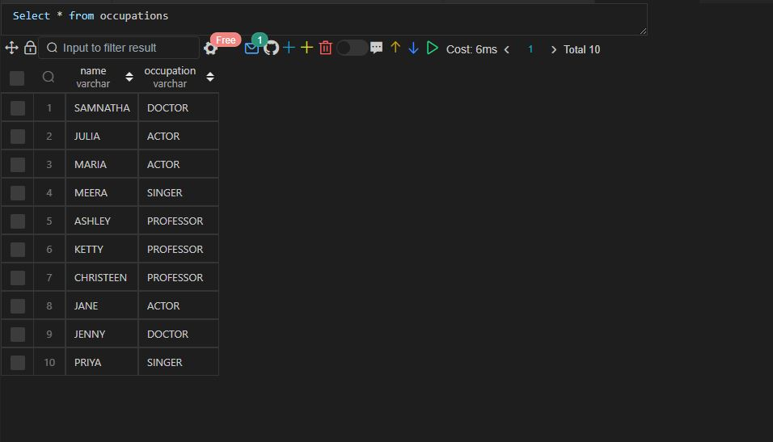

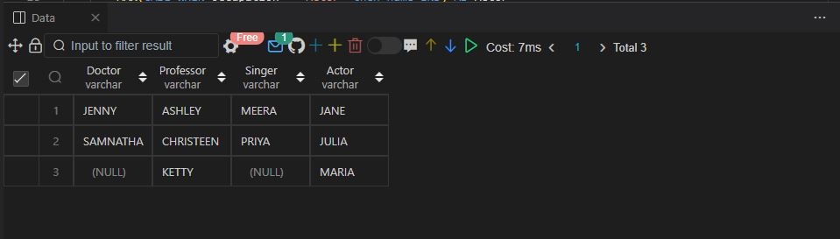

Q110.

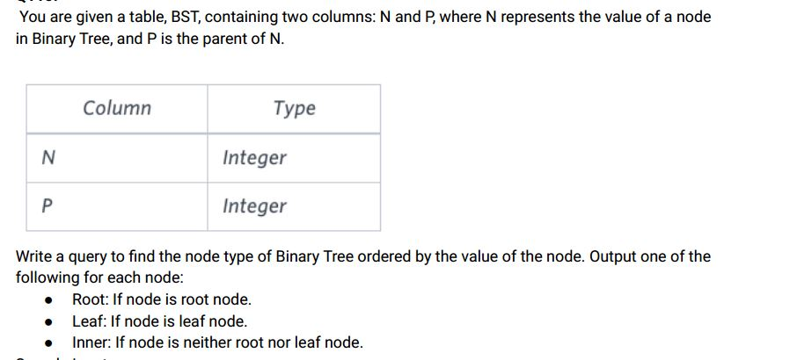

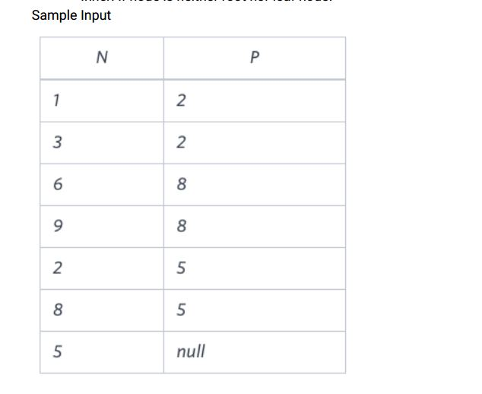

Sample Output

1 Leaf

2 Inner

3 Leaf

5 Root

6 Leaf

8 Inner

9 Leaf

Explanation

The Binary Tree below illustrates the sample:

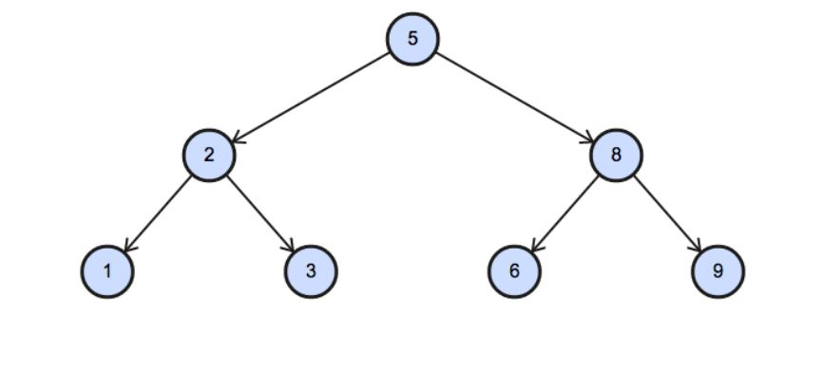

Ans:-

|  |
| --- |
|  |
| CREATE TABLE bst( |
|  | n INT, |
|  | p INT |
|  | ); |
|  |  |
|  |  |
|  | INSERT INTO bst VALUES |
|  | (1,2), |
|  | (3,2), |
|  | (6,8), |
|  | (9,8), |
|  | (2,5), |
|  | (8,5), |
|  | (5,NULL); |
|  |  |
|  |  |
|  |  |
|  | SELECT |
|  | n, |
|  | CASE |
|  | WHEN n NOT IN (SELECT DISTINCT p FROM bst WHERE p IS NOT NULL) THEN 'Leaf' |
|  | WHEN p IS NULL THEN 'Root' |
|  | ELSE 'Inner' |
|  | END AS type |
|  | FROM |
|  | bst |
|  | ORDER BY |
|  | n; |
|  |  |
|  |  |
|  |  |

Select * from bst;

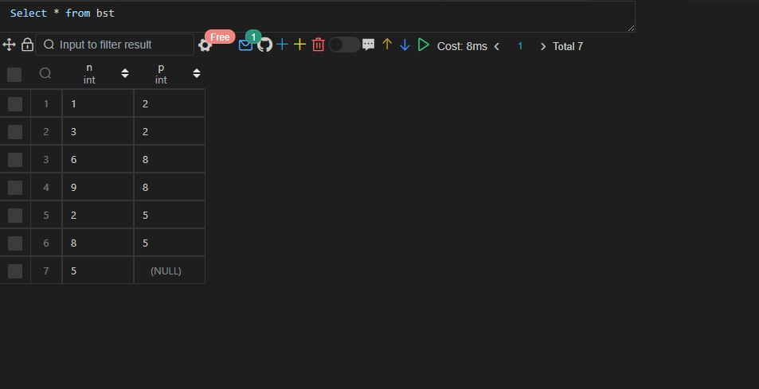

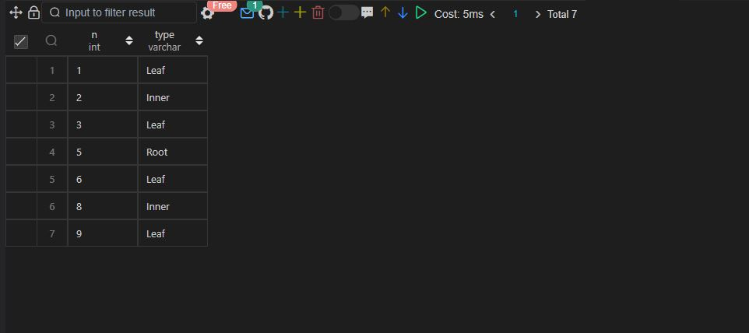

Q111 .

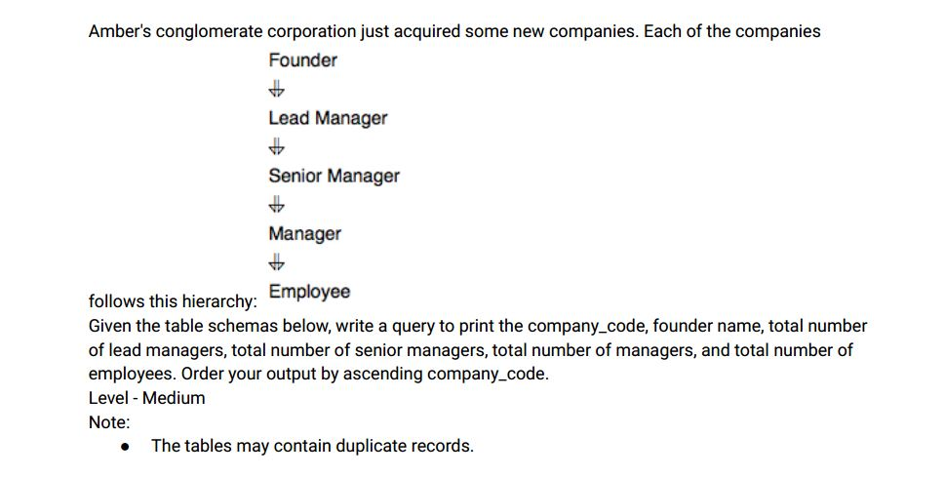

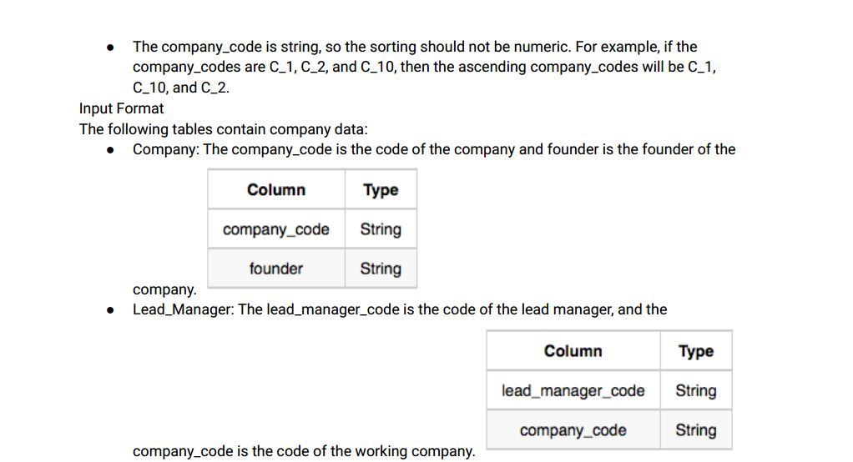

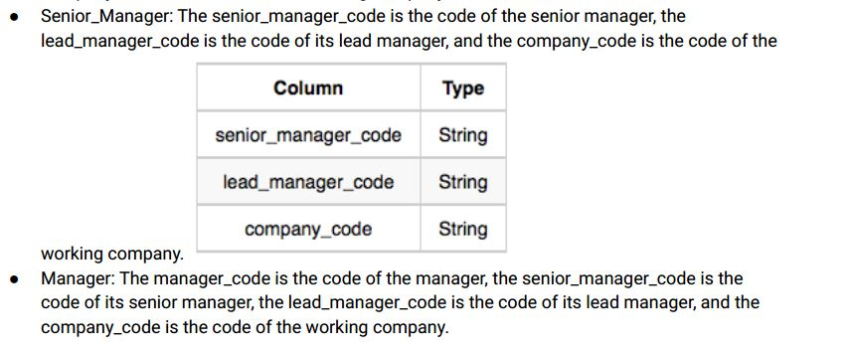

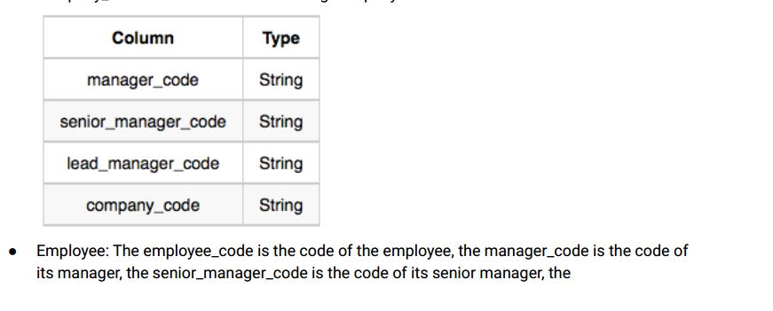

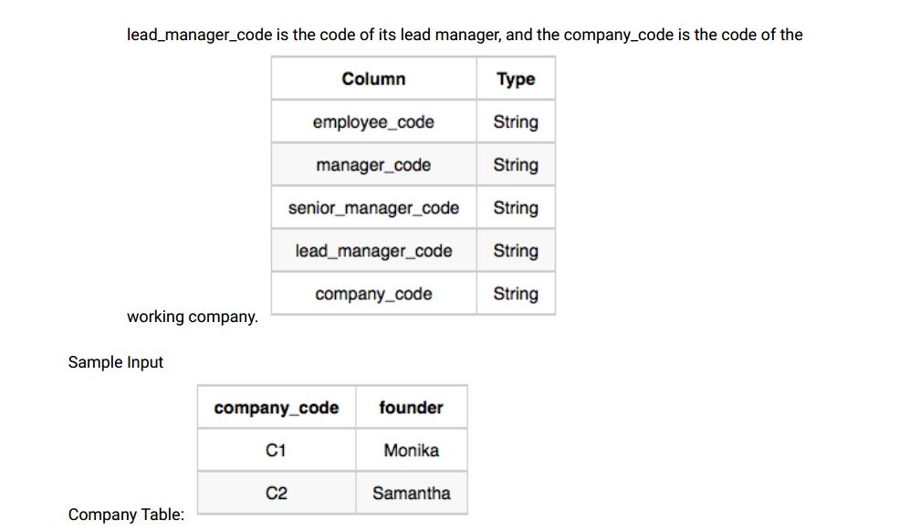

Company Table:

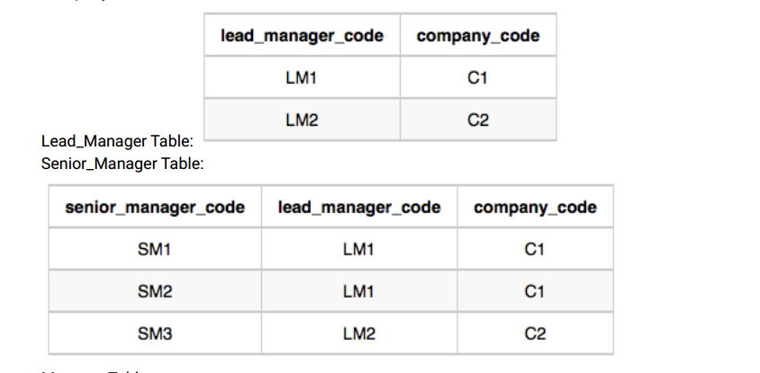

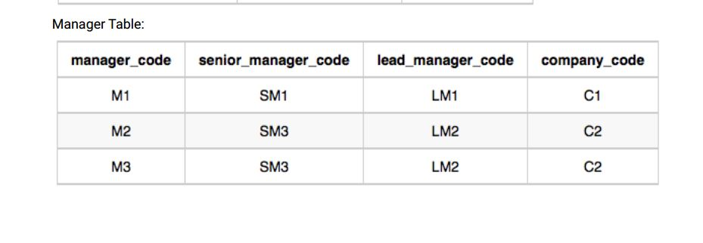

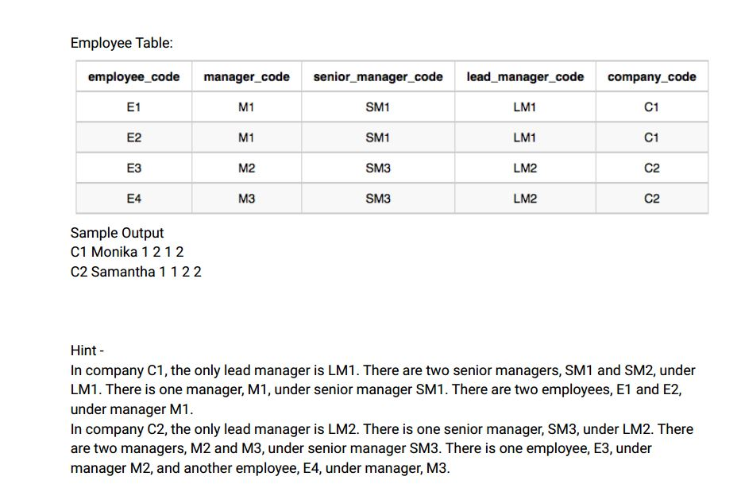

Ans:-

|  |
| --- |
|  |
| CREATE TABLE company( |
|  | company_code VARCHAR(20), |
|  | founder VARCHAR(20) |
|  | ); |
|  |  |
|  |  |
|  | CREATE TABLE lead_manager( |
|  | lead_manager_code VARCHAR(20), |
|  | company_code VARCHAR(20) |
|  | ); |
|  |  |
|  |  |
|  | CREATE TABLE senior_manager( |
|  | senior_manager_code VARCHAR(20), |
|  | lead_manager_code VARCHAR(20), |
|  | company_code VARCHAR(20) |
|  | ); |
|  |  |
|  |  |
|  | CREATE TABLE manager( |
|  | manager_code VARCHAR(20), |
|  | senior_manager_code VARCHAR(20), |
|  | lead_manager_code VARCHAR(20), |
|  | company_code VARCHAR(20) |
|  | ); |
|  |  |
|  |  |
|  | CREATE TABLE employee( |
|  | employee_code VARCHAR(20), |
|  | manager_code VARCHAR(20), |
|  | senior_manager_code VARCHAR(20), |
|  | lead_manager_code VARCHAR(20), |
|  | company_code VARCHAR(20) |
|  | ); |
|  |  |
|  |  |
|  | INSERT INTO company VALUES |
|  | ('C1','MONIKA'), |
|  | ('C2','SAMANTHA'); |
|  |  |
|  |  |
|  | INSERT INTO lead_manager VALUES |
|  | ('LM1','C1'), |
|  | ('LM2','C2'); |
|  |  |
|  |  |
|  | INSERT INTO senior_manager VALUES |
|  | ('SM1','LM1','C1'), |
|  | ('SM2','LM1','C1'), |
|  | ('SM3','LM2','C2'); |
|  |  |
|  |  |
|  | INSERT INTO manager VALUES |
|  | ('M1','SM1','LM1','C1'), |
|  | ('M2','SM3','LM2','C2'), |
|  | ('M3','SM3','LM2','C2'); |
|  |  |
|  |  |
|  | INSERT INTO employee VALUES |
|  | ('E1','M1','SM1','LM1','C1'), |
|  | ('E2','M1','SM1','LM1','C1'), |
|  | ('E3','M2','SM3','LM2','C2'), |
|  | ('E4','M3','SM3','LM2','C2'); |
|  |  |
|  |  |
|  |  |
|  | SELECT |
|  | c.company_code, |
|  | c.founder, |
|  | COUNT(DISTINCT lm.lead_manager_code), |
|  | COUNT(DISTINCT sm.senior_manager_code), |
|  | COUNT(DISTINCT m.manager_code), |
|  | COUNT(DISTINCT e.employee_code) |
|  | FROM |
|  | company c |
|  | INNER JOIN |
|  | lead_manager lm |
|  | ON |
|  | c.company_code = lm.company_code |
|  | INNER JOIN |
|  | senior_manager sm |
|  | ON |
|  | sm.lead_manager_code = lm.lead_manager_code |
|  | INNER JOIN |
|  | manager m |
|  | ON |
|  | m.senior_manager_code = sm.senior_manager_code |
|  | INNER JOIN |
|  | employee e |
|  | ON |
|  | e.manager_code = m.manager_code |
|  | GROUP BY |
|  | c.company_code, c.founder |
|  | ORDER BY |
|  | c.company_code; |
|  |  |
|  |  |
|  |  |

Select * from company;

Select * from lead_manager;

Select * from senior_manager;

Select * from manager;

Select * from employee;

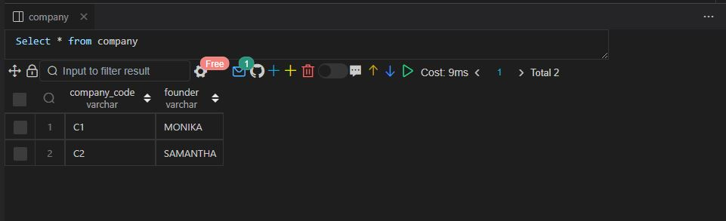

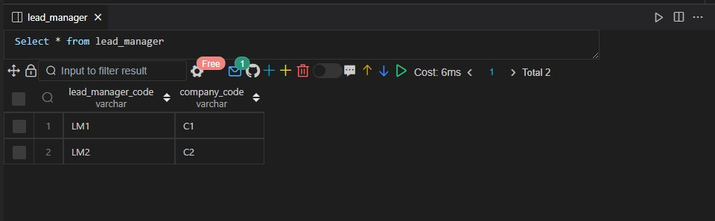

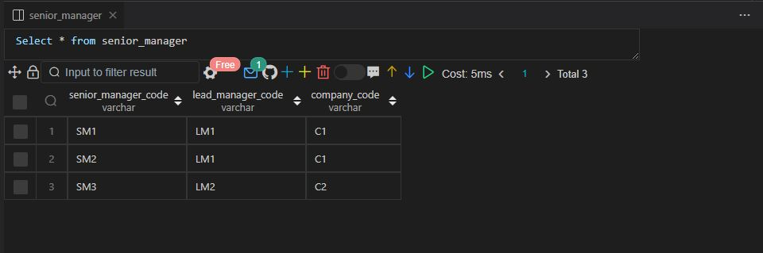

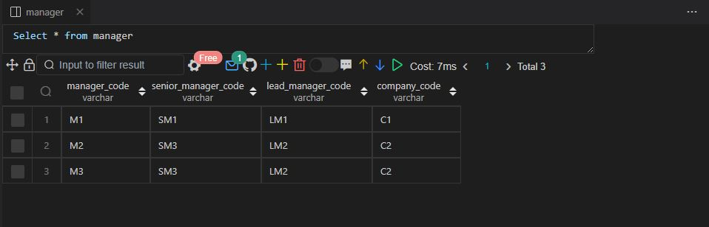

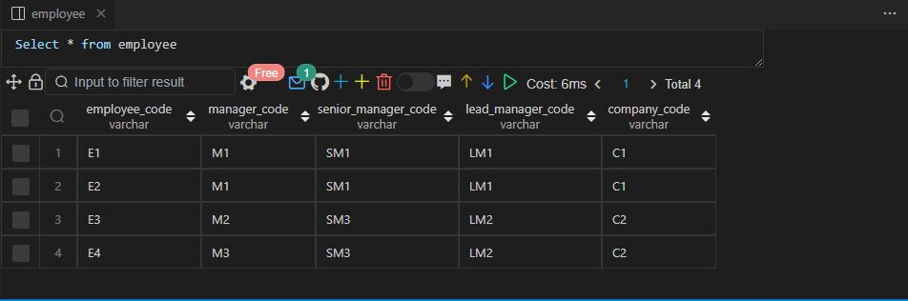

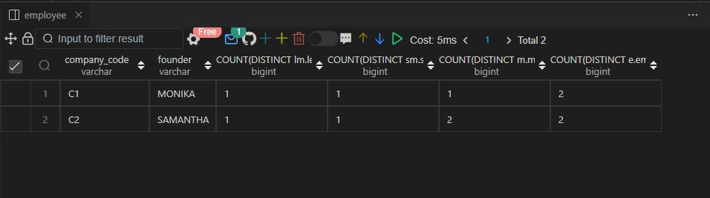

Q112.

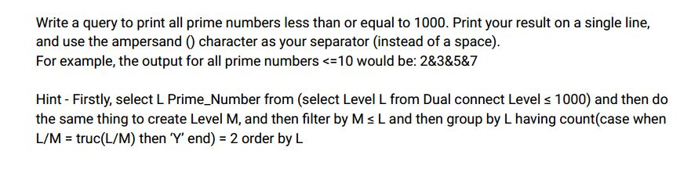

Ans:-

|  |
| --- |
|  |
| WITH RECURSIVE number_generation AS ( |
|  | SELECT |
|  | 1 num |
|  |  |
|  | UNION ALL |
|  |  |
|  | SELECT |
|  | num + 1 |
|  | FROM |
|  | number_generation |
|  | WHERE |
|  | num<1000 |
|  | ), |
|  | number_generation2 AS ( |
|  | SELECT |
|  | n1.num AS numm |
|  | FROM |
|  | number_generation n1 |
|  | INNER JOIN |
|  | number_generation n2 |
|  | WHERE |
|  | n1.num % n2.num = 0 |
|  | GROUP BY |
|  | n1.num |
|  | HAVING |
|  | COUNT(n1.num) = 2 |
|  | ) |
|  |  |
|  |  |
|  | SELECT |
|  | group_concat(numm ORDER BY numm SEPARATOR '&') AS prime_numbers |
|  | FROM |
|  | number_generation2; |
|  |  |
|  |  |
|  |  |

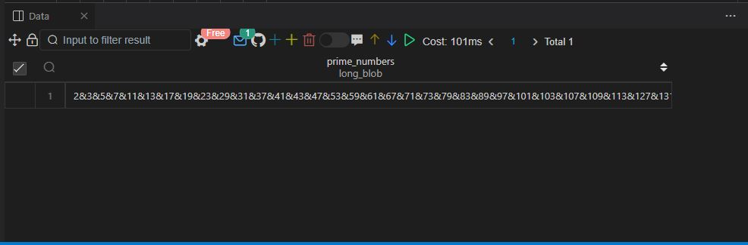

Q113.

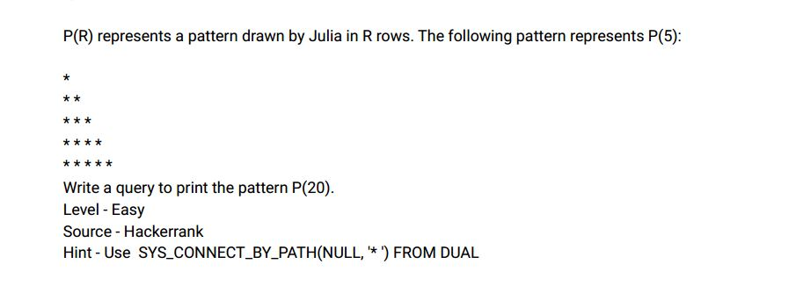

Ans:-

|  |
| --- |
|  |
| WITH RECURSIVE generate_numbers AS |
|  | ( |
|  | SELECT |
|  | 1 AS n |
|  |  |
|  | UNION |
|  |  |
|  | SELECT |
|  | n+1 |
|  | FROM |
|  | generate_numbers |
|  | WHERE |
|  | n<20 |
|  | ) |
|  |  |
|  | SELECT |
|  | repeat('*',n) |
|  | FROM |
|  | generate_numbers; |
|  |  |

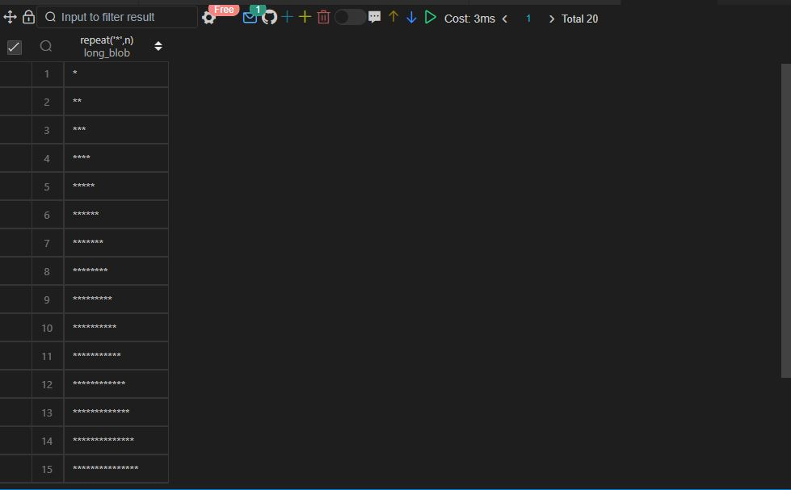

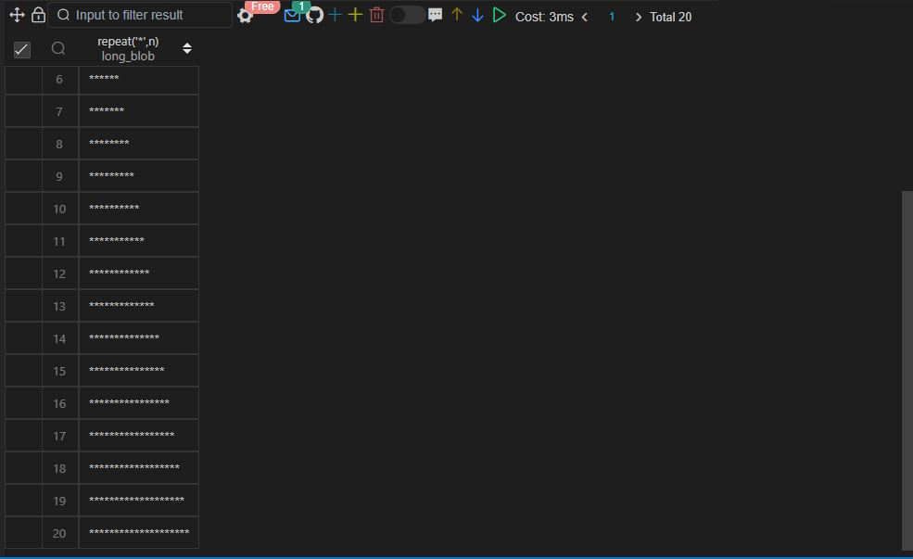

Q114.

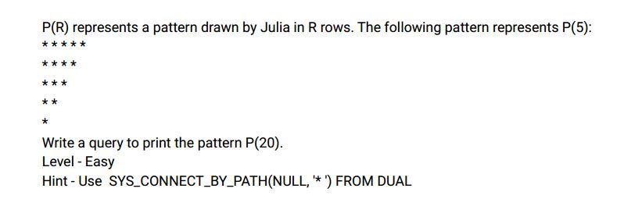

Ans:-

|  |
| --- |
|  |
| WITH RECURSIVE generate_numbers AS |
|  | ( |
|  | SELECT |
|  | 20 AS n |
|  |  |
|  | UNION |
|  |  |
|  | SELECT |
|  | n-1 |
|  | FROM |
|  | generate_numbers |
|  | WHERE |
|  | n>1 |
|  | ) |
|  |  |
|  | SELECT |
|  | repeat('*',n) |
|  | FROM |
|  | generate_numbers; |
|  |  |
|  |  |
|  |  |

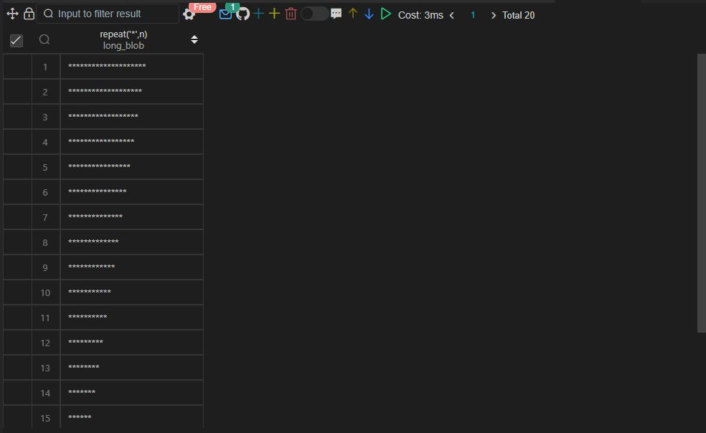

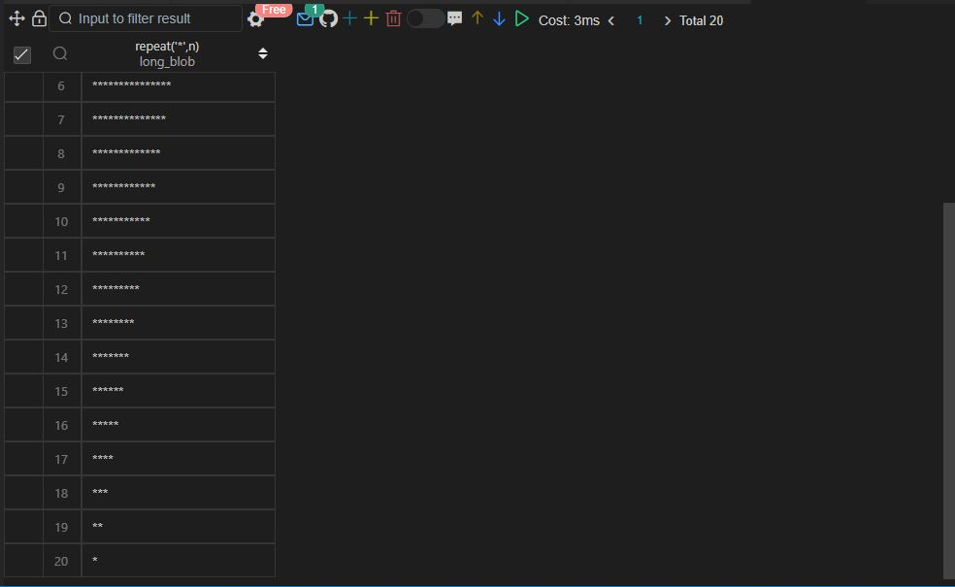

|  |
| --- |
|  |

Q.115 SAME AS Q.103

Q.116 SAME AS Q.79

Q.117 SAME AS Q.104

Q.118 SAME AS Q.105

Q.119 SAME AS Q.80

Q.120 SAME AS Q.81

Q.121 SAME AS Q.82

Q.122 SAME AS Q.83

Q.123 SAME AS Q.84

Q.124 SAME AS Q.85

Q.125 SAME AS Q.86

Q.126 SAME AS Q.87

Q.127 SAME AS Q.68

Q.128 SAME AS Q.55

Q.129 SAME AS Q.90

Q.130 SAME AS Q.91

Q.131 SAME AS Q.92

Q.132 SAME AS Q.50

Q.133 SAME AS Q.94

Q.134 SAME AS Q.94

Q.135 SAME AS Q.101

Q.136 SAME AS Q.101

Q.137 SAME AS Q.106

Q.138 SAME AS Q.105

Q.139 SAME AS Q.105

Q.140 SAME AS Q.105

Q.141 SAME AS Q.110

Q.142 SAME AS Q.111

Q143 .

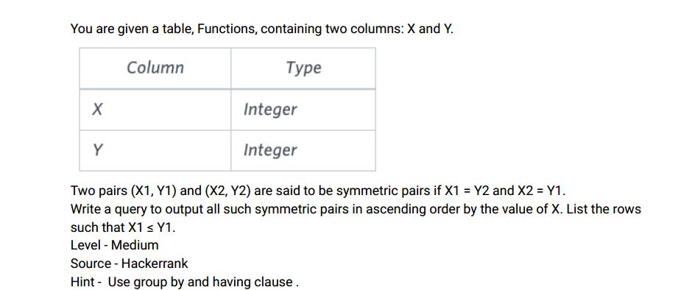

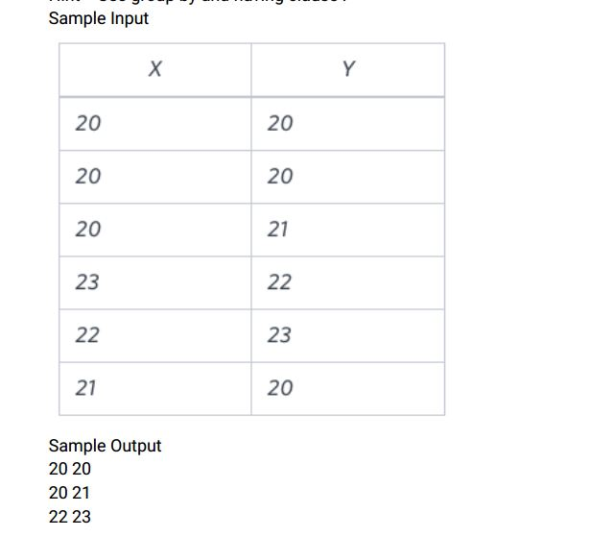

Ans:-

|  |
| --- |
|  |
| CREATE TABLE functions( |
|  | x INT, |
|  | y INT |
|  | ); |
|  |  |
|  |  |
|  | INSERT INTO functions VALUES |
|  | (20,20), |
|  | (20,20), |
|  | (20,21), |
|  | (23,22), |
|  | (22,23), |
|  | (21,20); |
|  |  |
|  |  |
|  |  |
|  | WITH temp_functions AS ( |
|  | SELECT |
|  | x, |
|  | y, |
|  | ROW_NUMBER() OVER (ORDER BY x, y) AS row_num |
|  | FROM |
|  | functions |
|  | ) |
|  |  |
|  | SELECT |
|  | DISTINCT f1.x, |
|  | f1.y |
|  | FROM |
|  | temp_functions f1 |
|  | INNER JOIN |
|  | temp_functions f2 |
|  | ON |
|  | f1.x = f2.y |
|  | AND |
|  | f1.y = f2.x |
|  | AND |
|  | f1.row_num <> f2.row_num |
|  | WHERE |
|  | f1.x <= f1.y |
|  | ORDER BY |
|  | f1.x; |
|  |  |
|  |  |
|  |  |

Select * from functions;

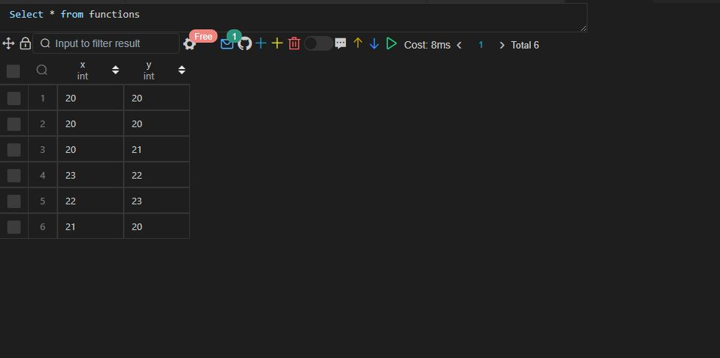

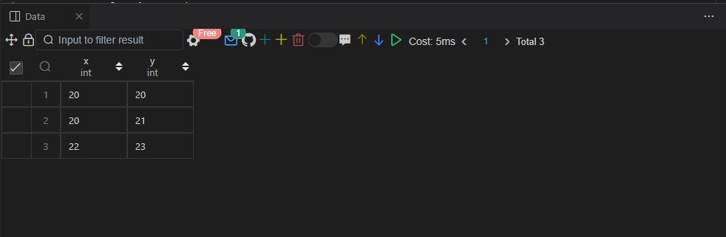

Q144 .

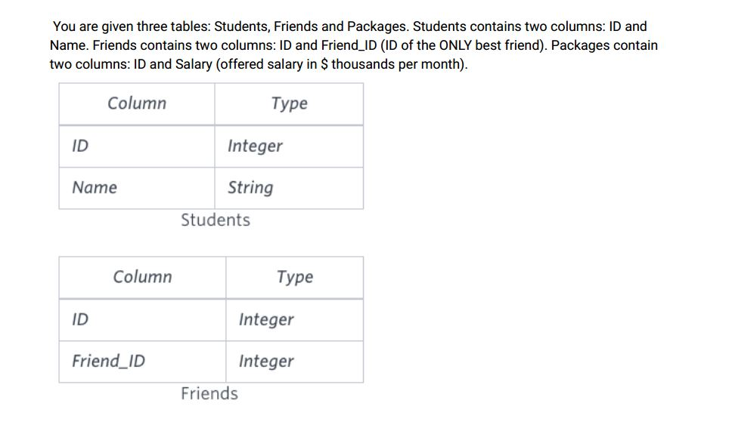

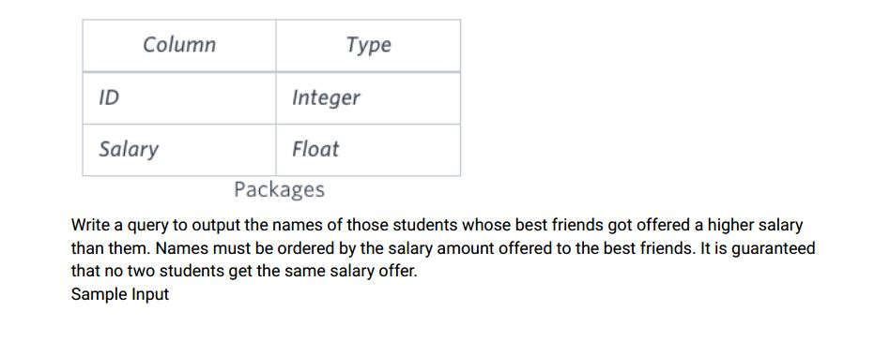

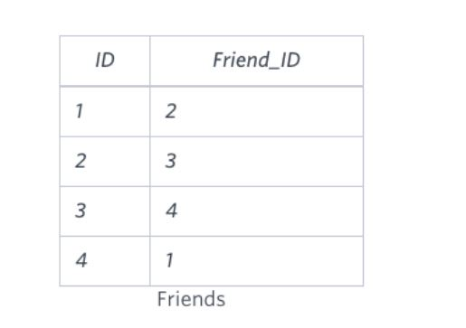

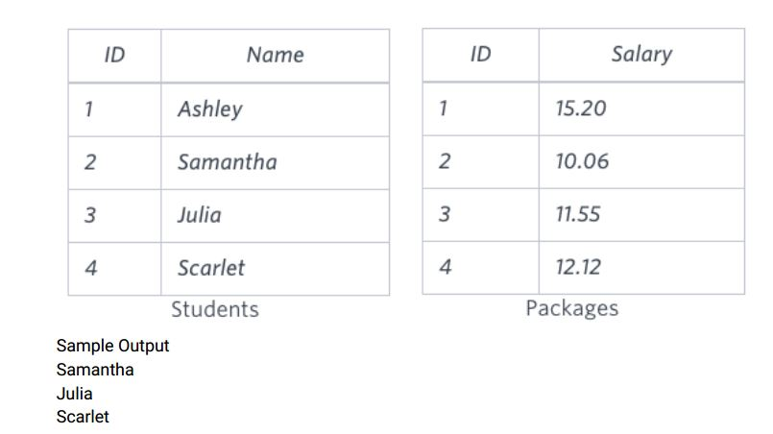

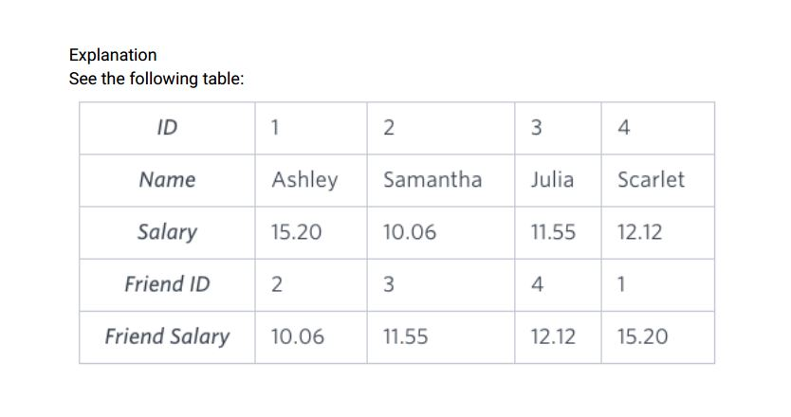

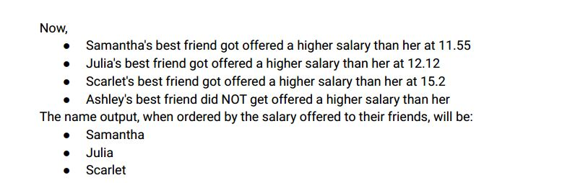

Ans:-

|  |
| --- |
|  |
| CREATE TABLE students( |
|  | id INT, |
|  | name VARCHAR(20) |
|  | ); |
|  |  |
|  |  |
|  | CREATE TABLE friends( |
|  | id INT, |
|  | friend_id INT |
|  | ); |
|  |  |
|  |  |
|  | CREATE TABLE packages( |
|  | id INT, |
|  | salary FLOAT |
|  | ); |
|  |  |
|  |  |
|  | INSERT INTO students VALUES |
|  | (1,'ASHLEY'), |
|  | (2,'SAMANTHA'), |
|  | (3,'JULIA'), |
|  | (4,'SCARLET'); |
|  |  |
|  |  |
|  | INSERT INTO friends VALUES |
|  | (1,2), |
|  | (2,3), |
|  | (3,4), |
|  | (4,1); |
|  |  |
|  |  |
|  | INSERT INTO packages VALUES |
|  | (1,15.20), |
|  | (2,10.06), |
|  | (3,11.55), |
|  | (4,12.12); |
|  |  |
|  |  |
|  |  |
|  | SELECT |
|  | s1.name |
|  | FROM |
|  | friends f1 |
|  | INNER JOIN |
|  | students s1 |
|  | ON |
|  | f1.id = s1.id |
|  | INNER JOIN |
|  | students s2 |
|  | ON |
|  | f1.friend_id = s2.id |
|  | INNER JOIN |
|  | packages p1 |
|  | ON |
|  | f1.id = p1.id |
|  | INNER JOIN |
|  | packages p2 |
|  | ON |
|  | f1.friend_id = p2.id |
|  | WHERE |
|  | p1.salary < p2.salary |
|  | ORDER BY |
|  | p2.salary; |
|  |  |
|  |  |
|  |  |

Select * from students;

Select * from friends;

Select * from packages;

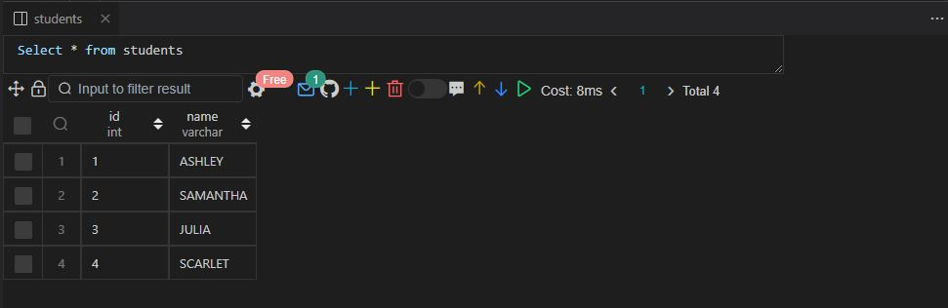

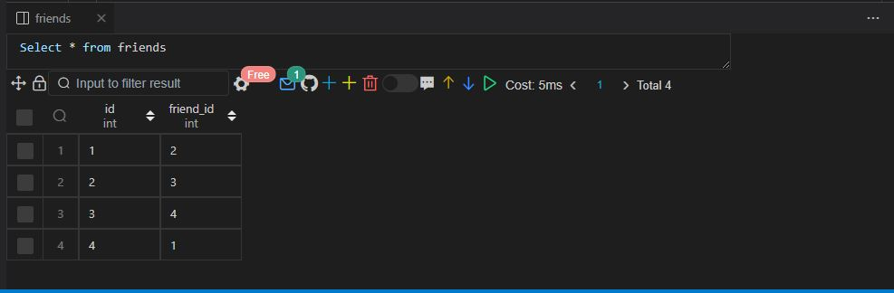

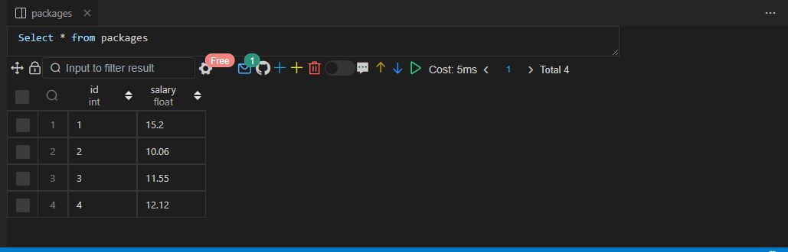

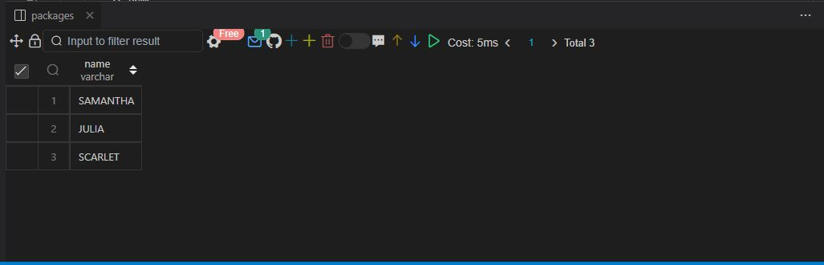

Q145.

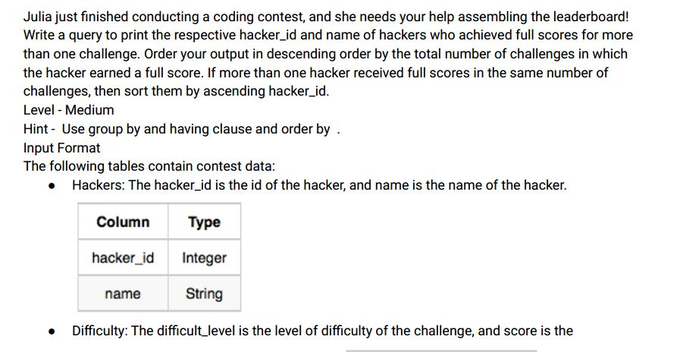

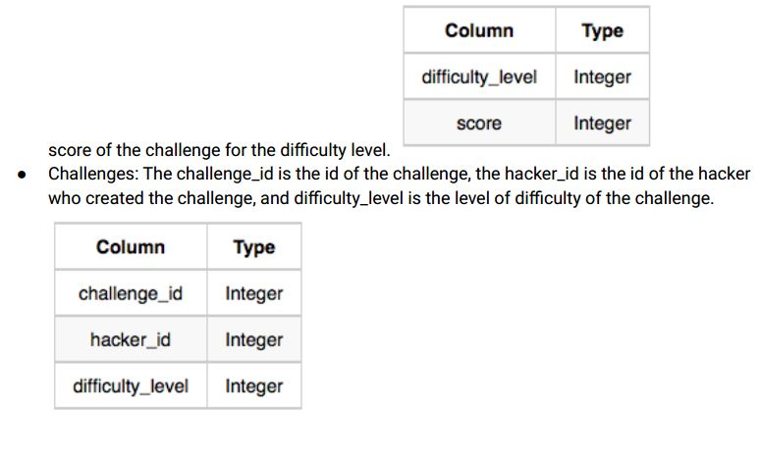

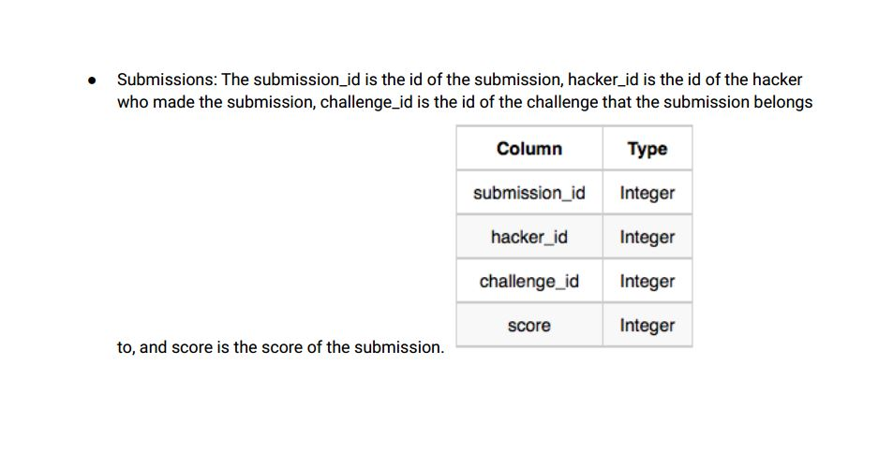

Sample Input

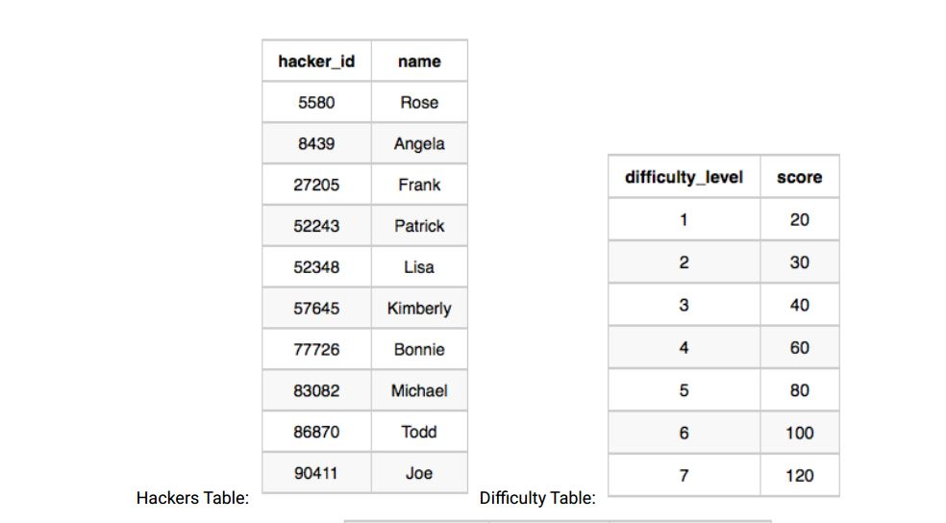

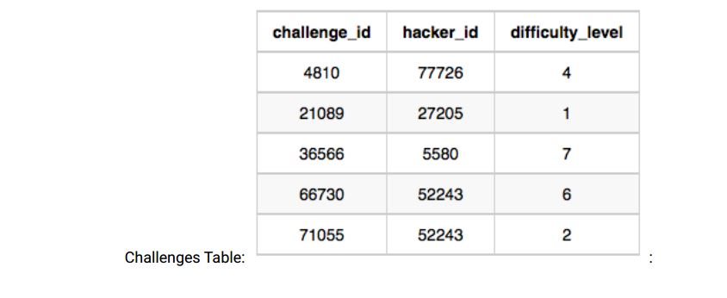

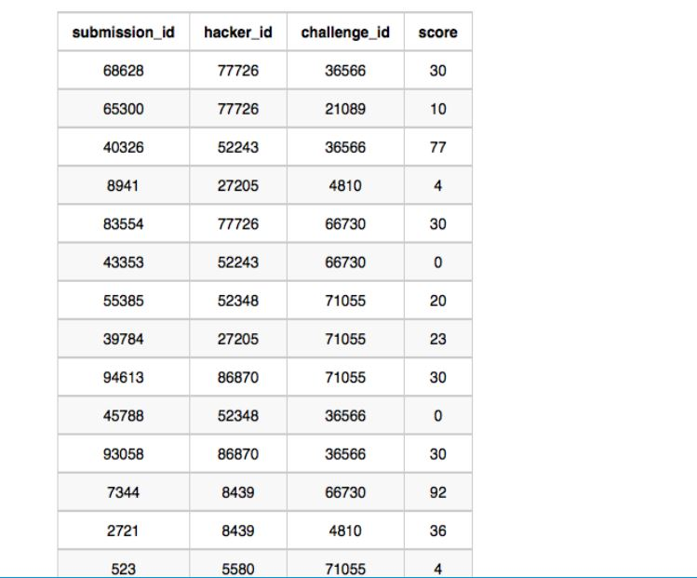

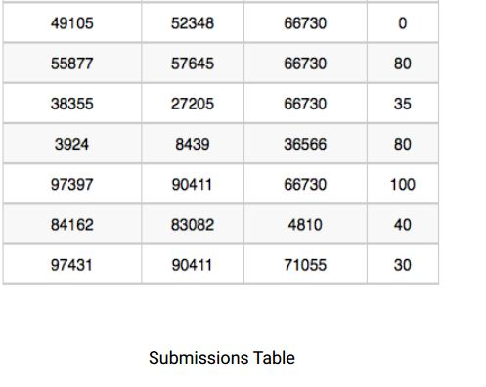

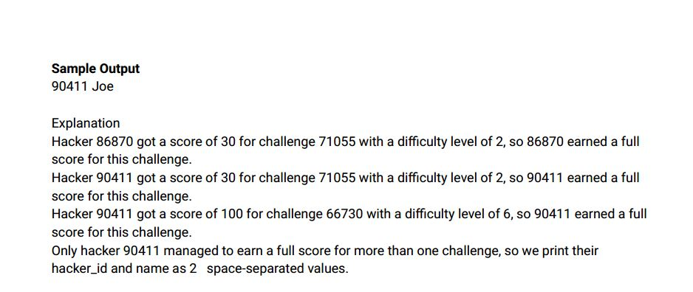

Ans:-

|  |
| --- |
|  |
| CREATE TABLE hackers |
|  | | ( |
|  | | hacker_id INT, |
|  | | name VARCHAR(25) |
|  | | ); |
|  | |  |
|  | | CREATE TABLE difficulty |
|  | | ( |
|  | | difficulty_level INT, |
|  | | score INT |
|  | | ); |
|  | |  |
|  | | CREATE TABLE challenges |
|  | | ( |
|  | | challenge_id INT, |
|  | | hacker_id INT, |
|  | | difficulty_level INT |
|  | | ); |
|  | |  |
|  | | CREATE TABLE submissions |
|  | | ( |
|  | | submission_id INT, |
|  | | hacker_id INT, |
|  | | challenge_id INT, |
|  | | score INT |
|  | | ); |
|  | |  |
|  | | INSERT INTO hackers VALUES(5580, 'Rose'); |
|  | | INSERT INTO hackers VALUES(8439, 'Angela'); |
|  | | INSERT INTO hackers VALUES(27205, 'Frank'); |
|  | | INSERT INTO hackers VALUES(52243, 'Patrick'); |
|  | | INSERT INTO hackers VALUES(52348, 'Lisa'); |
|  | | INSERT INTO hackers VALUES(57645, 'Kimberly'); |
|  | | INSERT INTO hackers VALUES(77726, 'Bonnie'); |
|  | | INSERT INTO hackers VALUES(83082, 'Michael'); |
|  | | INSERT INTO hackers VALUES(86870, 'Todd'); |
|  | | INSERT INTO hackers VALUES(90411, 'Joe'); |
|  | |  |
|  | | INSERT INTO difficulty VALUES(1, 20); |
|  | | INSERT INTO difficulty VALUES(2, 30); |
|  | | INSERT INTO difficulty VALUES(3, 40); |
|  | | INSERT INTO difficulty VALUES(4, 60); |
|  | | INSERT INTO difficulty VALUES(5, 80); |
|  | | INSERT INTO difficulty VALUES(6, 100); |
|  | | INSERT INTO difficulty VALUES(7, 120); |
|  | |  |
|  | | INSERT INTO challenges VALUES(4810, 77726, 4); |
|  | | INSERT INTO challenges VALUES(21089, 27205, 1); |
|  | | INSERT INTO challenges VALUES(36566, 5580, 7); |
|  | | INSERT INTO challenges VALUES(66730, 52243, 6); |
|  | | INSERT INTO challenges VALUES(71055, 52243, 2); |
|  | |  |
|  | | INSERT INTO submissions VALUES(68628, 77726, 36566, 30); |
|  | | INSERT INTO submissions VALUES(65300, 77726, 21089, 10); |
|  | | INSERT INTO submissions VALUES(40326, 52243, 36566, 77); |
|  | | INSERT INTO submissions VALUES(8941, 27205, 4810, 4); |
|  | | INSERT INTO submissions VALUES(83554, 77726, 66730, 30); |
|  | | INSERT INTO submissions VALUES(43353, 52243, 66730, 0); |
|  | | INSERT INTO submissions VALUES(55385, 52348, 71055, 20); |
|  | | INSERT INTO submissions VALUES(39784, 27205, 71055, 23); |
|  | | INSERT INTO submissions VALUES(94613, 86870, 71055, 30); |
|  | | INSERT INTO submissions VALUES(45788, 52348, 36566, 0); |
|  | | INSERT INTO submissions VALUES(93058, 86870, 36566, 30); |
|  | | INSERT INTO submissions VALUES(7344, 8439, 66730, 92); |
|  | | INSERT INTO submissions VALUES(2721, 8439, 4810, 36); |
|  | | INSERT INTO submissions VALUES(523, 5580, 71055, 4); |
|  | | INSERT INTO submissions VALUES(49105, 52348, 66730, 0); |
|  | | INSERT INTO submissions VALUES(55877, 57645, 66730, 80); |
|  | | INSERT INTO submissions VALUES(38355, 27205, 66730, 35); |
|  | | INSERT INTO submissions VALUES(3924, 8439, 36566, 80); |
|  | | INSERT INTO submissions VALUES(97397, 90411, 66730, 100); |
|  | | INSERT INTO submissions VALUES(84162, 83082, 4810, 40); |
|  | | INSERT INTO submissions VALUES(97431, 90411, 71055, 30); |
|  | |  |
|  | |  |
|  | | SELECT |
|  | | h.hacker_id, |
|  | | h.name |
|  | | FROM |
|  | | submissions s |
|  | | JOIN challenges c ON c.challenge_id = s.challenge_id |
|  | | JOIN difficulty d ON d.difficulty_level = c.difficulty_level |
|  | | JOIN hackers h ON h.hacker_id = s.hacker_id |
|  | | WHERE |
|  | | s.score = d.score |
|  | | GROUP BY |
|  | | h.hacker_id, |
|  | | h.name |
|  | | ORDER BY |
|  | | COUNT(*) DESC, |
|  | | h.hacker_id |
|  | | LIMIT 1; |
|  | | Select * from hackers;  Select * from difficulty;  Select * from challanges;  Select * from submissions;  output.JPG  output2.JPG  output4.JPG  output5.JPG  output5.1.JPG  output7.JPG  output7.JPG |
|  | |  |
|  | |  |

Q146.

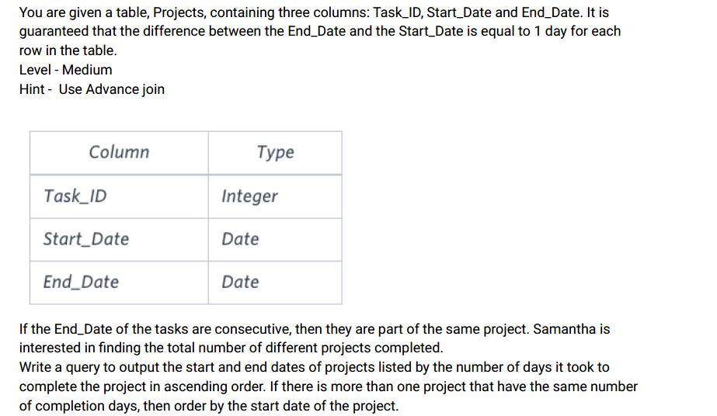

Sample Input

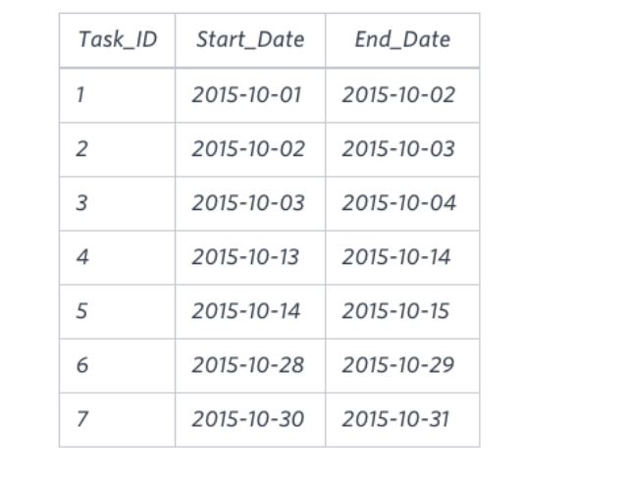

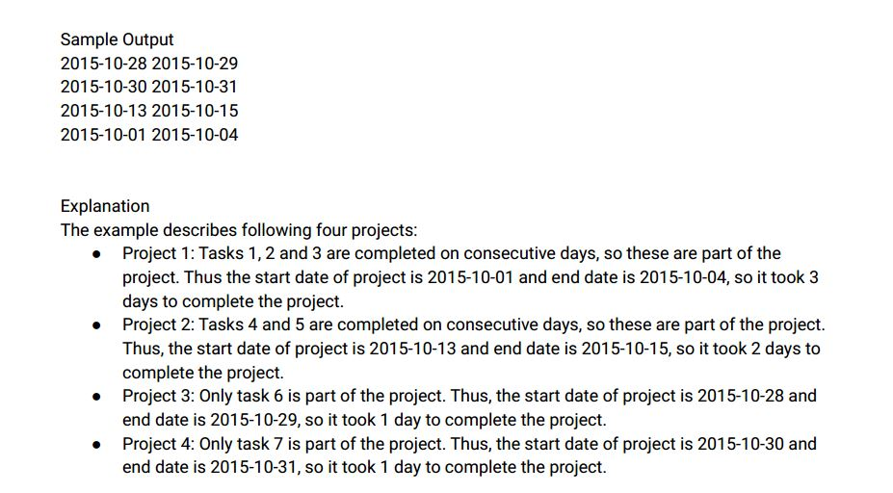

Ans:-

|  |
| --- |
|  |
| CREATE TABLE projects( |
|  | task_id INT, |
|  | start_date DATE, |
|  | end_date DATE |
|  | ); |
|  |  |
|  |  |
|  | INSERT INTO projects VALUES |
|  | (1,'2015-10-01','2015-10-02'), |
|  | (2,'2015-10-02','2015-10-03'), |
|  | (3,'2015-10-03','2015-10-04'), |
|  | (4,'2015-10-13','2015-10-14'), |
|  | (5,'2015-10-14','2015-10-15'), |
|  | (6,'2015-10-28','2015-10-29'), |
|  | (7,'2015-10-30','2015-10-31'); |
|  |  |
|  |  |
|  |  |
|  | -- Approach 1 |
|  |  |
|  |  |
|  | WITH project_start AS |
|  | ( |
|  | SELECT |
|  | start_date, |
|  | ROW_NUMBER() OVER() AS ps_rownum |
|  | FROM |
|  | projects |
|  | WHERE start_date not in ( |
|  | SELECT |
|  | end_date |
|  | FROM |
|  | projects |
|  | ) |
|  | ), |
|  | project_end AS |
|  | ( |
|  | SELECT |
|  | end_date, |
|  | ROW_NUMBER() OVER() AS pe_rownum |
|  | FROM |
|  | projects |
|  | WHERE |
|  | END_date not in ( |
|  | SELECT |
|  | start_date |
|  | FROM |
|  | projects |
|  | ) |
|  | ) |
|  |  |
|  | SELECT |
|  | project_start.start_date, |
|  | project_end.end_date |
|  | FROM |
|  | project_start |
|  | INNER JOIN |
|  | project_end |
|  | on |
|  | project_end.pe_rownum = project_start.ps_rownum |
|  | ORDER BY |
|  | DATEDIFF(project_start.start_date, project_end.end_date) desc, |
|  | project_start.start_date; |
|  |  |
|  |  |
|  |  |
|  | -- Approach 2 |
|  |  |
|  |  |
|  |  |
|  | WITH temp_project AS ( |
|  | SELECT |
|  | temp.start_date, |
|  | temp.end_date, |
|  | SUM( |
|  | CASE |
|  | WHEN previous_end_date IS NULL THEN 0 |
|  | WHEN DAY(end_date) - DAY(previous_end_date) = 1 THEN 0 |
|  | ELSE 1 |
|  | END |
|  | ) OVER(ORDER BY start_date) AS project_num |
|  | FROM ( |
|  | SELECT |
|  | start_date, |
|  | end_date, |
|  | LAG(end_date) OVER (ORDER BY start_date) AS previous_end_date |
|  | FROM |
|  | projects |
|  | ) temp |
|  | ) |
|  |  |
|  | SELECT |
|  | MIN(start_date) AS project_start_date, |
|  | MAX(end_date) as project_end_date |
|  | FROM |
|  | temp_project |
|  | GROUP BY |
|  | project_num |
|  | ORDER BY |
|  | DAY(MAX(end_date))-DAY(MIN(start_date)); |
|  |  |
|  |  |
|  |  |
|  | -- Approach 3 |
|  |  |
|  |  |
|  |  |
|  | WITH temp_project AS ( |
|  | SELECT |
|  | temp.start_date, |
|  | temp.end_date, |
|  | SUM( |
|  | CASE |
|  | WHEN previous_end_date IS NULL THEN 0 |
|  | WHEN DAY(end_date) - DAY(previous_end_date) = 1 THEN 0 |
|  | ELSE 1 |
|  | END |
|  | ) over(order by start_date range between unbounded preceding and current row) AS project_num |
|  | FROM ( |
|  | SELECT |
|  | start_date, |
|  | end_date, |
|  | LAG(end_date) OVER (ORDER BY start_date) AS previous_end_date |
|  | FROM |
|  | projects |
|  | ) temp |
|  | ) |
|  |  |
|  | SELECT |
|  | MIN(start_date) AS project_start_date, |
|  | MAX(end_date) AS project_end_date |
|  | FROM |
|  | temp_project |
|  | GROUP BY |
|  | project_num |
|  | ORDER BY |
|  | DAY(MAX(end_date))-DAY(MIN(start_date)); |
|  |  |
|  |  |
|  |  |
|  |  |

Select * from projects;

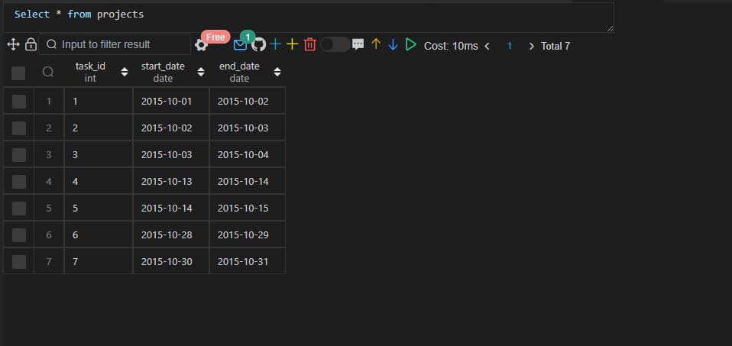

Approach 1

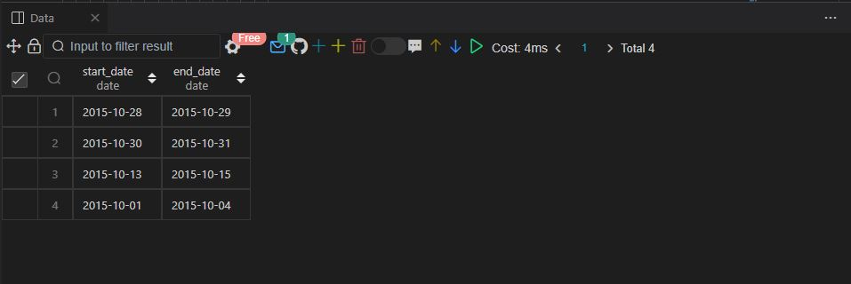

Approach 2

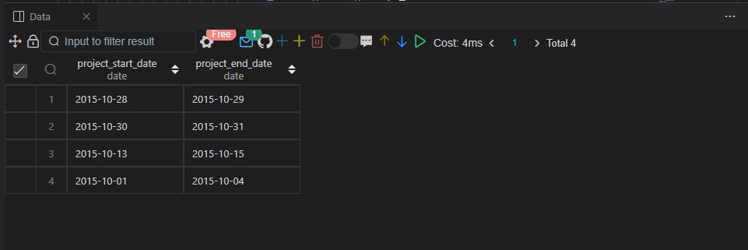

Approach 3

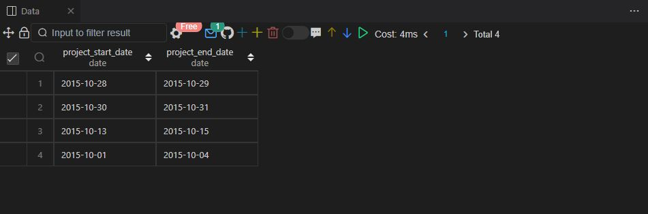

Q147.

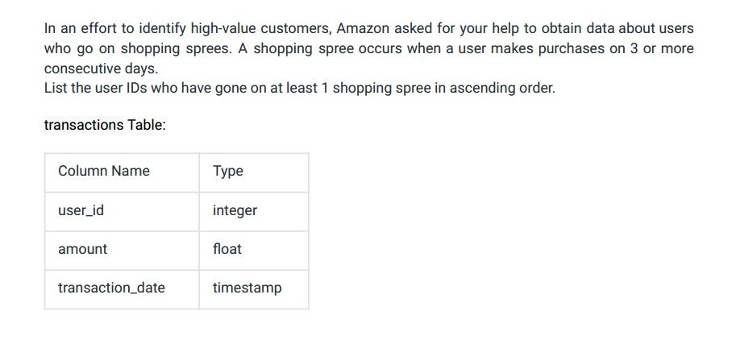

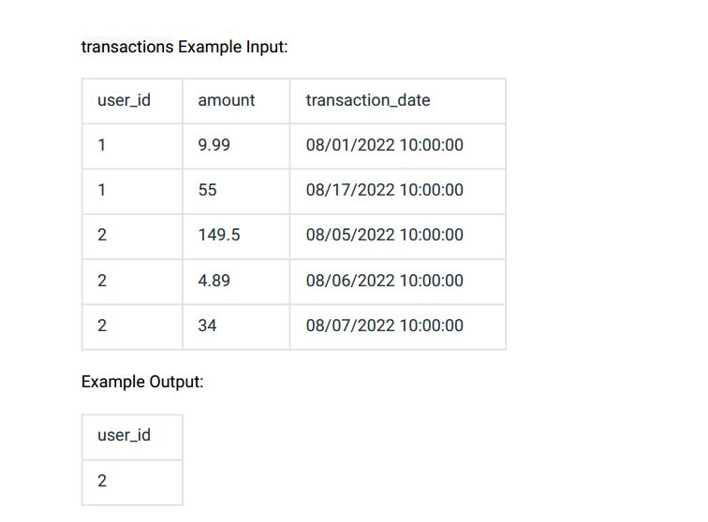

Ans:-

|  |  |  |  |  |  |  |  |  |  |  |  |  |  |  |  |  |  |  |  |  |  |  |  |  |  |  |  |  |  |  |  |  |  |  |  |  |  |  |  |  |  |  |  |  |  |  |  |  |  |  |  |  |  |  |  |  |  |  |  |  |  |  |  |  |  |  |  |  |  |  |  |  |  |  |
| --- | --- | --- | --- | --- | --- | --- | --- | --- | --- | --- | --- | --- | --- | --- | --- | --- | --- | --- | --- | --- | --- | --- | --- | --- | --- | --- | --- | --- | --- | --- | --- | --- | --- | --- | --- | --- | --- | --- | --- | --- | --- | --- | --- | --- | --- | --- | --- | --- | --- | --- | --- | --- | --- | --- | --- | --- | --- | --- | --- | --- | --- | --- | --- | --- | --- | --- | --- | --- | --- | --- | --- | --- | --- | --- |
| |  | | --- | | CREATE TABLE transactions | |  | ( | |  | user_id INT, | |  | amount DECIMAL(10,2), | |  | transaction_date TIMESTAMP | |  | ); | |  |  | |  | INSERT INTO transactions VALUES(1, '9.99', '2022-08-01 10:00:00'); | |  | INSERT INTO transactions VALUES(1, '55', '2022-08-17 10:00:00'); | |  | INSERT INTO transactions VALUES(1, '149.5', '2022-08-05 10:00:00'); | |  | INSERT INTO transactions VALUES(1, '4.89', '2022-08-06 10:00:00'); | |  | INSERT INTO transactions VALUES(1, '34', '2022-08-07 10:00:00'); | |  |  | |  |  | |  | SELECT | |  | *, | |  | DATEDIFF(LEAD(transaction_date) OVER(PARTITION BY user_id ORDER BY transaction_date), transaction_date) AS diff1, | |  | DATEDIFF(transaction_date, LAG(transaction_date) OVER(PARTITION BY user_id ORDER BY transaction_date)) AS diff2 | |  | FROM | |  | transactions; | |  |  | |  | SELECT | |  | distinct user_id | |  | FROM( | |  | SELECT | |  | *, | |  | DATEDIFF(LEAD(transaction_date) OVER(PARTITION BY user_id ORDER BY transaction_date), transaction_date) AS diff1, | |  | DATEDIFF(transaction_date, LAG(transaction_date) OVER(PARTITION BY user_id ORDER BY transaction_date)) AS diff2 | |  | FROM | |  | transactions | |  | ) AS trx_with_date_diff | |  | WHERE | |  | trx_with_date_diff.diff1 = 1 | |  | AND trx_with_date_diff.diff2 = 1; | |  |  | |  |  | |  |  | |  |
|  |  |
|  |  |

Select * from transactions;

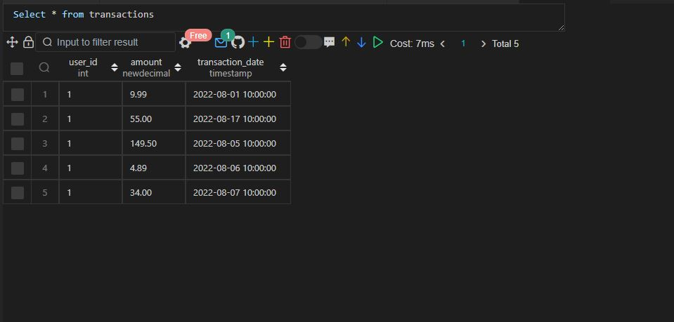

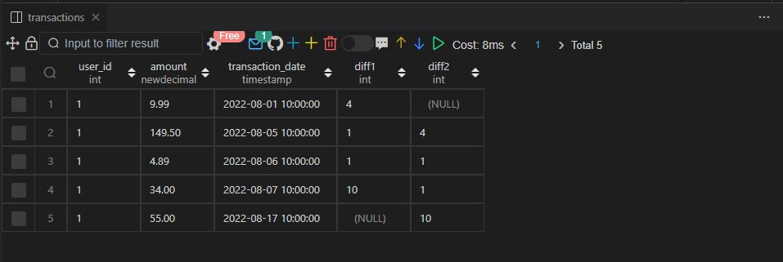

Q148 .

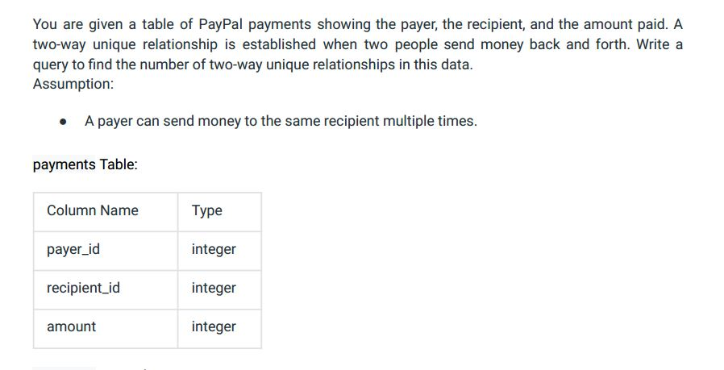

payments Example Input:

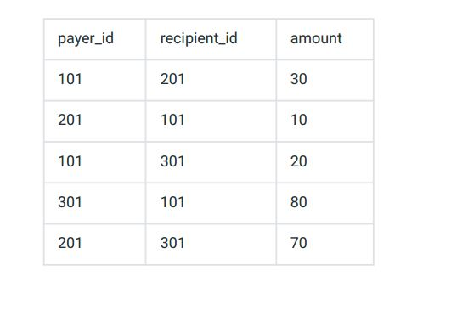

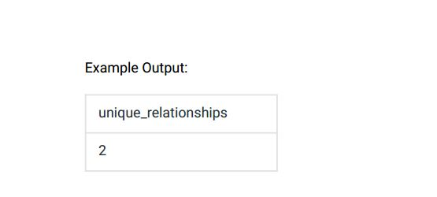

Ans:-

|  |
| --- |
|  |
| CREATE TABLE payments( |
|  | payer_id INT, |
|  | recipient_id INT, |
|  | amount INT |
|  | ); |
|  |  |
|  |  |
|  | INSERT INTO payments VALUES |
|  | (101,201,30), |
|  | (201,101,10), |
|  | (101,301,20), |
|  | (301,101,80), |
|  | (201,301,70); |
|  |  |
|  |  |
|  | WITH temp_payments AS ( |
|  | SELECT |
|  | DISTINCT p1.payer_id, |
|  | p1.recipient_id |
|  | FROM |
|  | payments p1 |
|  | INNER JOIN |
|  | payments p2 |
|  | ON |
|  | p1.payer_id = p2.recipient_id |
|  | AND |
|  | p2.payer_id = p1.recipient_id |
|  | AND |
|  | p1.payer_id < p2.payer_id |
|  | ) |
|  |  |
|  | SELECT |
|  | COUNT(*) unique_relationships |
|  | FROM |
|  | temp_payments; |
|  |  |
|  |  |
|  |  |

Select * from payments;

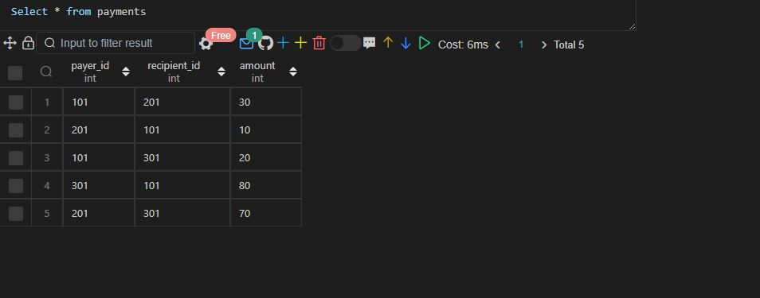

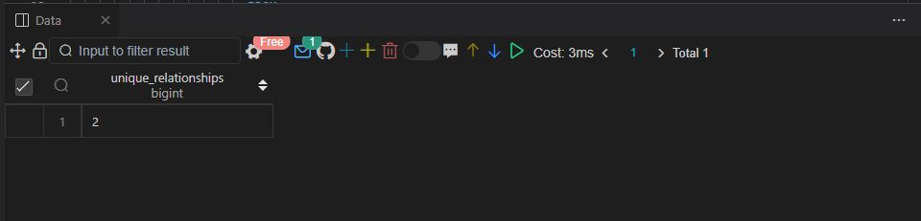

Q149.

Assume you are given the table below on user transactions. Write a query to obtain the list of

customers whose first transaction was valued at $50 or more. Output the number of users.

Clarification:

● Use the transaction_date field to determine which transaction should be labeled as the first

for each user .

● Use a specific function (we can 't give too much away!) to account for scenarios where a user

had multiple transactions on the same day , and one of those was the first.

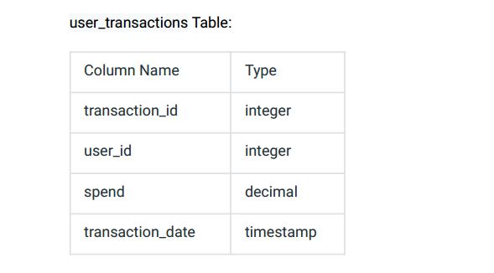

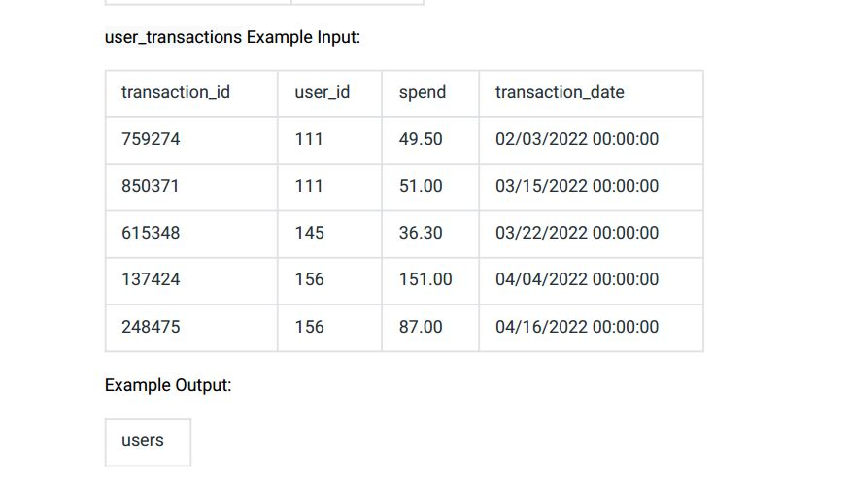

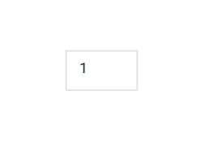

Ans:-

|  |
| --- |
|  |
| CREATE TABLE user_transactions( |
|  | transaction_id INT, |
|  | user_id INT, |
|  | spend FLOAT, |
|  | transaction_date VARCHAR(30) |
|  | ); |
|  |  |
|  |  |
|  | INSERT INTO user_transactions VALUES |
|  | (759274,111,49.50,'02/03/2022 00:00:00'), |
|  | (850371,111,51.00,'03/15/2022 00:00:00'), |
|  | (615348,145,36.30,'03/22/2022 00:00:00'), |
|  | (137424,156,151.00,'04/04/2022 00:00:00'), |
|  | (248475,156,87.00,'04/16/2022 00:00:00'); |
|  |  |
|  |  |
|  |  |
|  | WITH temp_transactions AS ( |
|  | SELECT |
|  | user_id, |
|  | transaction_date, |
|  | spend, |
|  | ROW_NUMBER() OVER(PARTITION BY user_id ORDER BY transaction_date) row_num |
|  | FROM |
|  | user_transactions |
|  | ) |
|  |  |
|  | SELECT |
|  | COUNT(DISTINCT user_id) as users |
|  | FROM |
|  | temp_transactions |
|  | WHERE |
|  | row_num = 1 |
|  | and |
|  | spend >= 50; |
|  |  |
|  |  |
|  |  |

Select * from user_transactions;

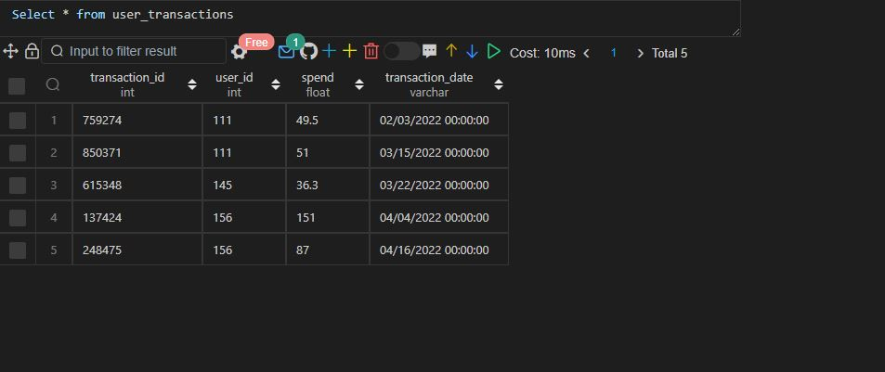

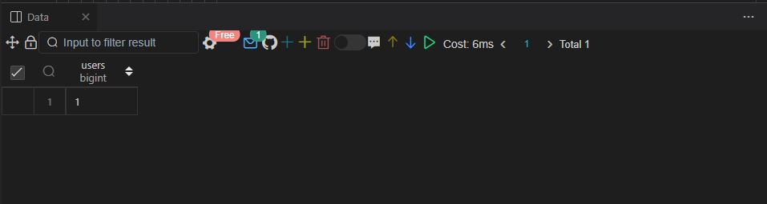

Q150.

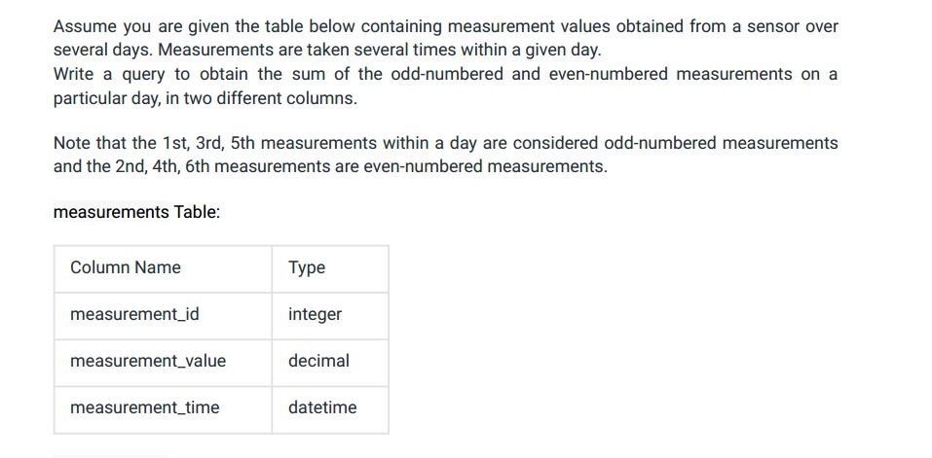

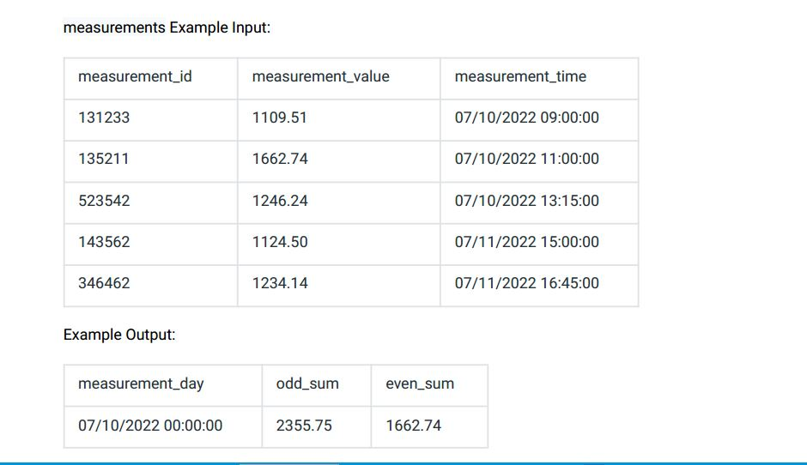

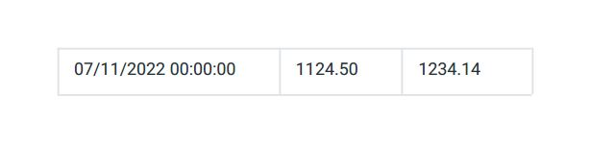

Ans:-

|  |
| --- |
| CREATE TABLE measurements |
|  | ( |
|  | measurement_id INT, |
|  | measurement_value DECIMAL(10,2), |
|  | measurement_time TIMESTAMP |
|  | ); |
|  |  |
|  | INSERT INTO measurements VALUES(131233, 1109.51, '2022-07-10 09:00:00'); |
|  | INSERT INTO measurements VALUES(135211, 1662.74, '2022-07-10 11:00:00'); |
|  | INSERT INTO measurements VALUES(523542, 1246.24, '2022-07-10 13:15:00'); |
|  | INSERT INTO measurements VALUES(143562, 1124.50, '2022-07-11 15:00:00'); |
|  | INSERT INTO measurements VALUES(346462, 1234.14, '2022-07-11 16:45:00'); |
|  |  |
|  |  |
|  | WITH daily_measurement AS( |
|  | SELECT |
|  | *, |
|  | DATE_FORMAT(measurement_time, '%m/%d/%Y 00:00:00') AS measurement_day, |
|  | DENSE_RANK() OVER(PARTITION BY DATE_FORMAT(measurement_time, 'm%/%d/%Y') ORDER BY measurement_time) AS serial |
|  |  |
|  | FROM |
|  | measurements |
|  | ) |
|  | SELECT |
|  | measurement_day, |
|  | SUM(CASE |
|  | WHEN serial % 2 = 1 |
|  | THEN measurement_value |
|  | END) as odd_sum, |
|  | SUM(CASE |
|  | WHEN serial % 2 = 0 |
|  | THEN measurement_value |
|  | END) as even_sum |
|  | FROM |
|  | daily_measurement |
|  | GROUP BY |
|  | measurement_day; |
|  |  |
|  |  |
|  |  |
|  |  |

Select * from measurements;

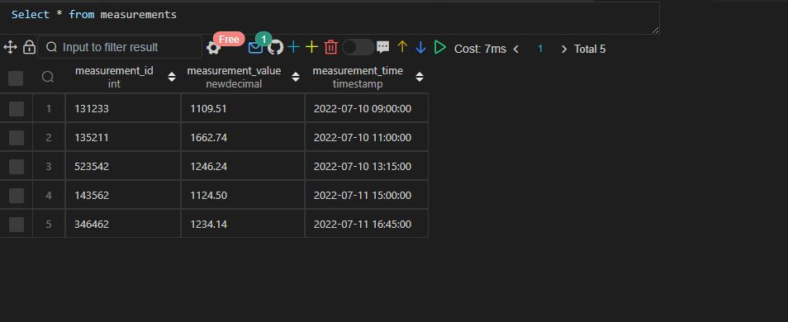

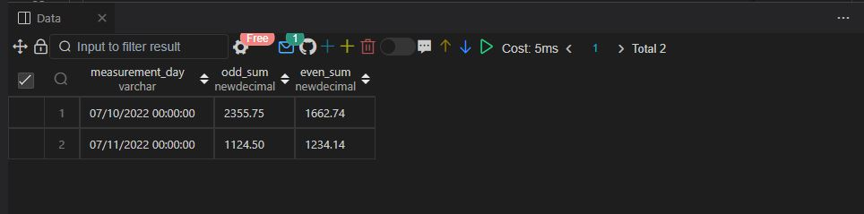

Q152.

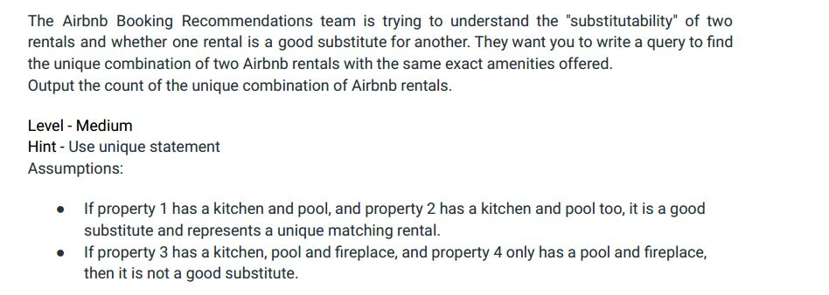

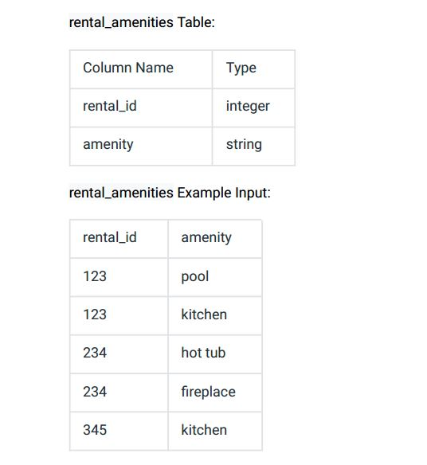

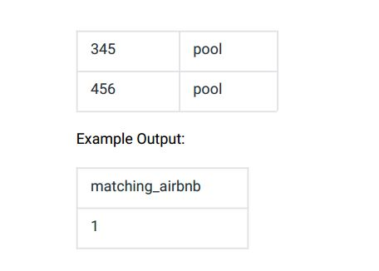

Ans:-

|  |
| --- |
|  |
| CREATE TABLE rental_amenities( |
|  | rental_id INT, |
|  | amenity VARCHAR(20) |
|  | ); |
|  |  |
|  |  |
|  | INSERT INTO rental_amenities VALUES |
|  | (123,'POOL'), |
|  | (123,'KITCHEN'), |
|  | (234,'HOT TUB'), |
|  | (234,'FIREPLACE'), |
|  | (345,'KITCHEN'), |
|  | (345,'POOL'), |
|  | (456,'POOL'); |
|  |  |
|  |  |
|  |  |
|  | WITH temp_amenities AS ( |
|  | SELECT |
|  | rental_id, |
|  | amenity, |
|  | COUNT(amenity) over(partition by rental_id) AS no_of_amenities |
|  | FROM |
|  | rental_amenities |
|  | ), |
|  |  |
|  | temp_amenities2 AS ( |
|  | SELECT |
|  | COUNT(*) |
|  | FROM |
|  | temp_amenities a |
|  | inner join |
|  | temp_amenities b |
|  | on |
|  | a.no_of_amenities = b.no_of_amenities |
|  | AND |
|  | a.amenity = b.amenity |
|  | AND |
|  | a.rental_id<>b.rental_id |
|  | GROUP BY |
|  | a.rental_id, |
|  | b.rental_id, |
|  | a.no_of_amenities |
|  | HAVING |
|  | COUNT(*) = a.no_of_amenities |
|  | ) |
|  |  |
|  |  |
|  | SELECT |
|  | CEIL(COUNT(*)/2) as matching_airbnb |
|  | FROM |
|  | temp_amenities2; |
|  |  |
|  |  |
|  |  |
|  |  |

Select * from rental_amenities;

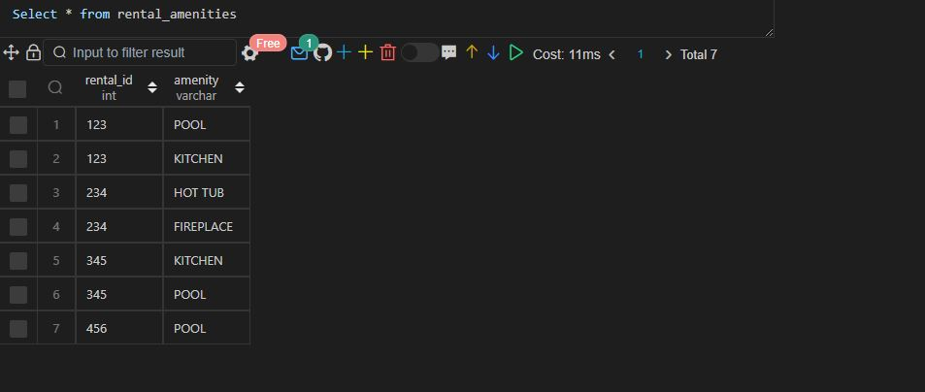

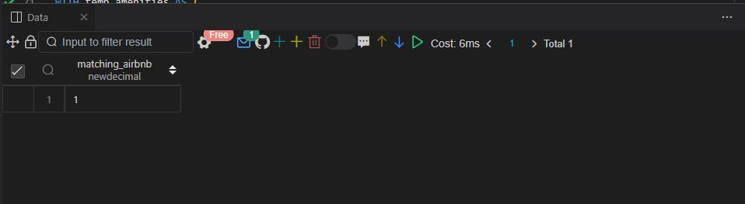

Q153.

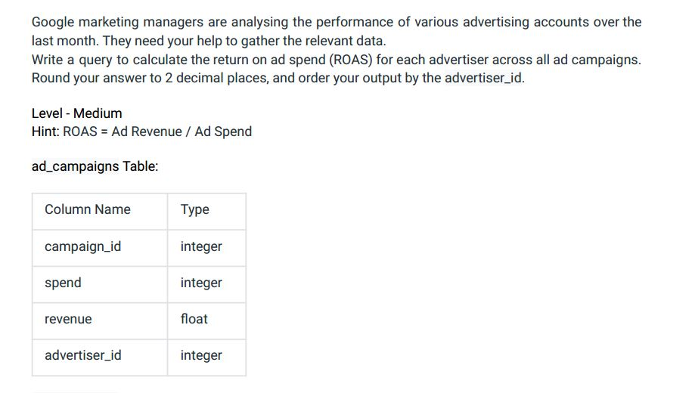

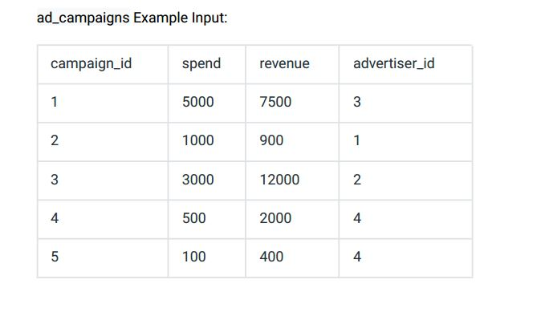

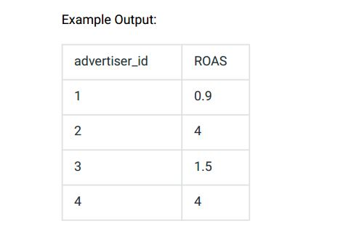

Ans:-

|  |
| --- |
|  |
| CREATE TABLE ad_campaigns( |
|  | campaign_id INT, |
|  | spend INT, |
|  | revenue FLOAT, |
|  | advertiser_id INT |
|  | ); |
|  |  |
|  |  |
|  | INSERT INTO ad_campaigns VALUES |
|  | (1,5000,7500,3), |
|  | (2,1000,900,1), |
|  | (3,3000,12000,2), |
|  | (4,500,200,4), |
|  | (5,100,400,4); |
|  |  |
|  |  |
|  | SELECT |
|  | advertiser_id, |
|  | CAST(SUM(revenue) / SUM(spend) AS Decimal(8,2)) AS ROAS |
|  | FROM |
|  | ad_campaigns |
|  | GROUP BY |
|  | advertiser_id |
|  | ORDER BY |
|  | advertiser_id; |
|  |  |
|  |  |
|  |  |

Select * from ad_campaigns;

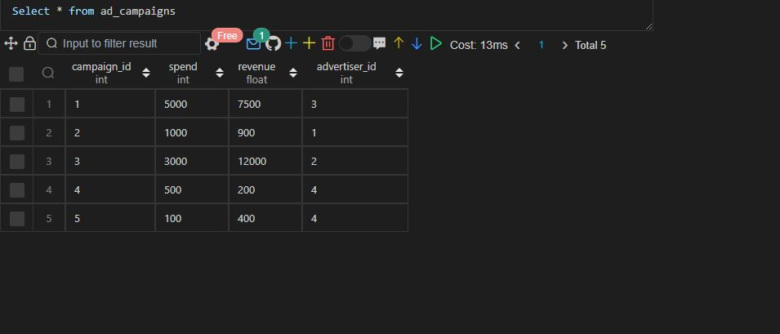

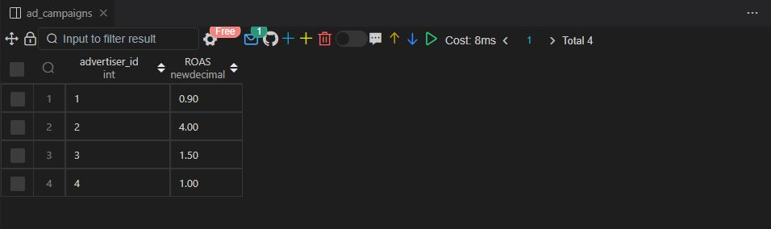

|  |
| --- |
|  |
| Q.154 Write a query that shows the following data for each compensation outlier:  employee ID, salary, and whether they are potentially overpaid or potentially underpaid  CREATE TABLE employee_pay(  employee_id INT,  salary INT,  title VARCHAR(20)  );  INSERT INTO employee_pay VALUES  (101,80000,'DATA ANALYST'),  (102,90000,'DATA ANALYST'),  (103,100000,'DATA ANALYST'),  (104,30000,'DATA ANALYST'),  (105,120000,'DATA SCIENTIST'),  (106,100000,'DATA SCIENTIST'),  (107,80000,'DATA SCIENTIST'),  (108,310000,'DATA SCIENTIST');  WITH temp_compensation AS (  SELECT  employee_id,  salary,  title,  ROUND(AVG(salary) over(PARTITION BY title),2) AS avg_salary  FROM  employee_pay  ),  temp_compensation2 AS (  SELECT  employee_id,  salary,  CASE  WHEN salary > 2 * avg_salary THEN 'Overpaid'  WHEN salary < avg_salary/2 THEN 'Underpaid'  END AS status  FROM  temp_compensation  )  SELECT  employee_id,  salary,  status  FROM  temp_compensation2  WHERE  status is not null;  Select * from employee_pay;  output27.JPG  output29.JPG  Q.155 SAME AS 148  Q.156 Assume you are given the table below containing information on user  purchases. Write a query to obtain the number of users who purchASed the  same product on two or more different days. Output the number of unique users.  CREATE TABLE purchases(  user_id INT,  product_id INT,  quantity INT,  purchase_date DATETIME  );  INSERT INTO purchases VALUES  (536,3223,6,'2022-01-11 12:33:44'),  (827,3585,35,'2022-02-20 14:05:26'),  (536,3223,5,'2022-03-02 09:33:28'),  (536,1435,10,'2022-03-02 08:40:00'),  (827,2452,45,'2022-04-09 00:00:00');  SELECT  COUNT(DISTINCT user_id) AS repeat_purchasers  FROM (  SELECT  user_id  FROM  purchases  GROUP BY  user_id,  product_id  HAVING  COUNT(DISTINCT purchase_date) > 1  ) temp; |

Select * from purchases;

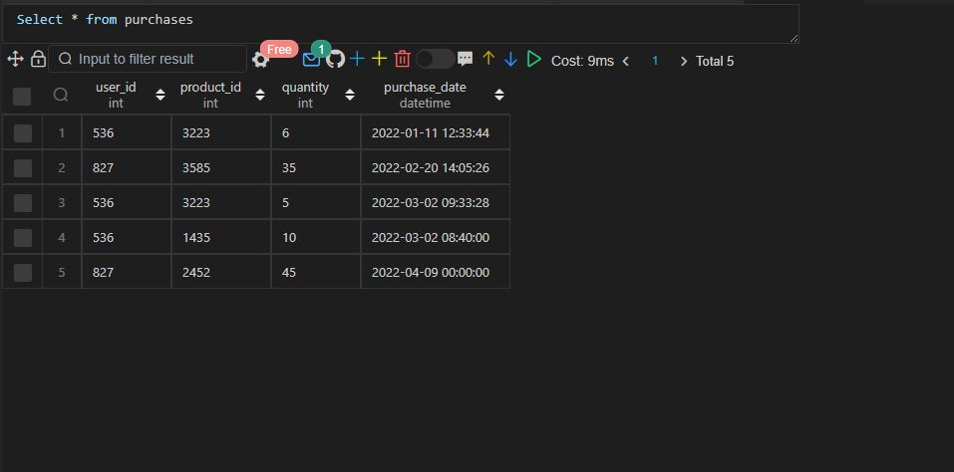

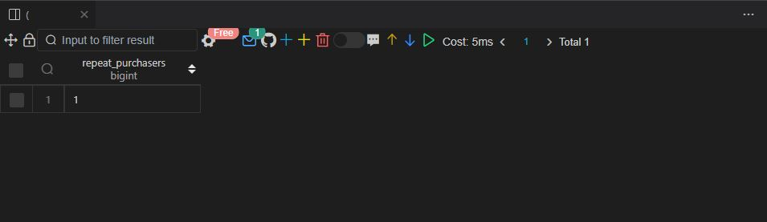

Q.157 Say you have access to all the transactions for a given merchant acCOUNT.

Write a query to print the cumulative balance of the merchant acCOUNT at the END

of each day, WITH the total balance reset back to zero at the END of the month.

Output the transaction date and cumulative balance.

Ans:-

|  |
| --- |
| CREATE TABLE transactions |
|  | ( |
|  | transaction_id INT, |
|  | type VARCHAR(20), |
|  | amount DECIMAL(10, 2), |
|  | transaction_date TIMESTAMP |
|  | ); |
|  |  |
|  | INSERT INTO transactions VALUES(19153, 'deposit', 65.90, '2022-07-10 10:00:00'); |
|  | INSERT INTO transactions VALUES(53151, 'deposit', 178.55, '2022-07-08 10:00:00'); |
|  | INSERT INTO transactions VALUES(29776, 'withdrawal', 25.90, '2022-07-08 10:00:00'); |
|  | INSERT INTO transactions VALUES(16461, 'withdrawal', 45.99, '2022-07-08 10:00:00'); |
|  | INSERT INTO transactions VALUES(77134, 'deposit', 32.60, '2022-07-10 10:00:00'); |
|  |  |
|  | WITH daily_balance AS ( |
|  | SELECT |
|  | DATE_FORMAT(transaction_date, '%Y-%m') AS transaction_month, |
|  | DATE_FORMAT(transaction_date, '%m/%d/%Y') AS transaction_date, |
|  | SUM(CASE |
|  | WHEN type = 'deposit' |
|  | THEN amount |
|  | WHEN type = 'withdrawal' |
|  | THEN amount * (-1) |
|  | END) AS balance |
|  |  |
|  | FROM |
|  | transactions |
|  | GROUP BY |
|  | DATE_FORMAT(transaction_date, '%m/%d/%Y'), |
|  | DATE_FORMAT(transaction_date, '%Y-%m') |
|  | ) |
|  | SELECT |
|  | CONCAT(transaction_date , ' 12:00:00') AS transaction_date, |
|  | SUM(balance) OVER( PARTITION BY transaction_month ORDER BY transaction_date) AS balance |
|  | FROM |
|  | daily_balance |
|  | ; |

Select * from transactions;

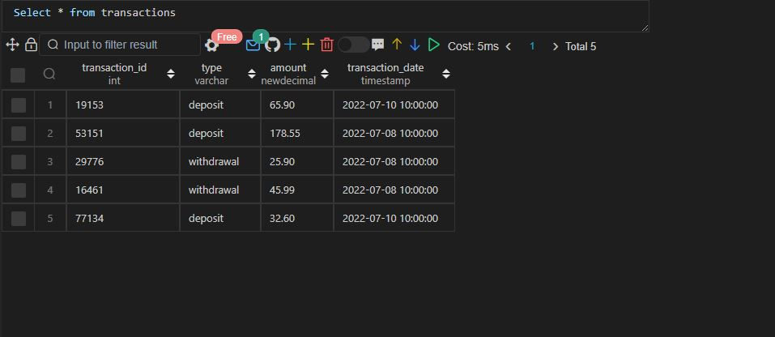

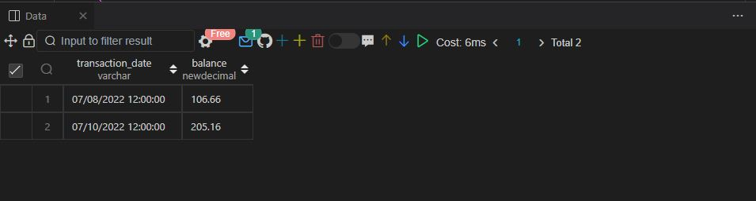

Q.158 Assume you are given the table below containing information on

Amazon customers and their spend on products belonging to various

categories. Identify the top two highest-grossing products within each

category in 2022. Output the category, product, and total spend.

Ans:-

|  |
| --- |
|  |
| CREATE TABLE product_spend |
|  | ( |
|  | category VARCHAR(20), |
|  | product VARCHAR(30), |
|  | user_id INT, |
|  | spend DECIMAL(10, 2), |
|  | transaction_date TIMESTAMP |
|  | ); |
|  |  |
|  | INSERT INTO product_spend VALUES('appliance', 'refrigerator', 165, 246.00, '2021-12-26 12:00:00'); |
|  | INSERT INTO product_spend VALUES('appliance', 'refrigerator', 123, 299.99, '2022-03-02 12:00:00'); |
|  | INSERT INTO product_spend VALUES('appliance', 'washing machine', 123, 219.80, '2022-03-02 12:00:00'); |
|  | INSERT INTO product_spend VALUES('electronics', 'vacuum', 178, 152.00, '2022-04-05 12:00:00'); |
|  | INSERT INTO product_spend VALUES('electronics', 'wireless headset', 156, 249.90, '2022-07-08 12:00:00'); |
|  | INSERT INTO product_spend VALUES('electronics', 'vacuum', 145, 189.00, '2022-07-15 12:00:00'); |
|  |  |
|  | WITH category_product_spend_2022 AS( |
|  | SELECT |
|  | category, |
|  | product, |
|  | sum(spend) AS total_spend, |
|  | DENSE_RANK() OVER(PARTITION BY category ORDER BY sum(spend)) AS serial |
|  | FROM |
|  | product_spend |
|  | WHERE |
|  | DATE_FORMAT(transaction_date, '%Y') = '2022' |
|  | GROUP BY |
|  | category, |
|  | product |
|  | ) |
|  | SELECT |
|  | category, |
|  | product, |
|  | total_spend |
|  | FROM |
|  | category_product_spend_2022 |
|  | WHERE |
|  | serial <= 2; |
|  |  |

Select * from product_spend;

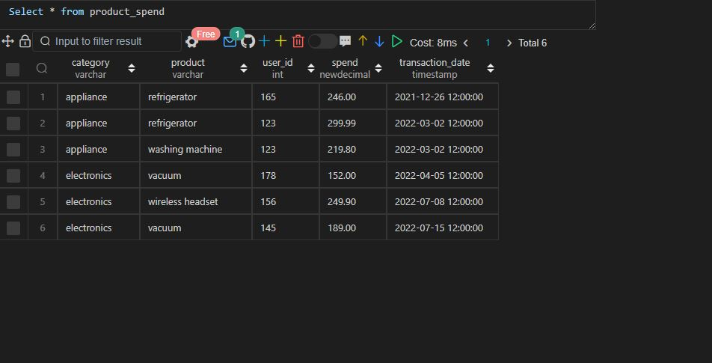

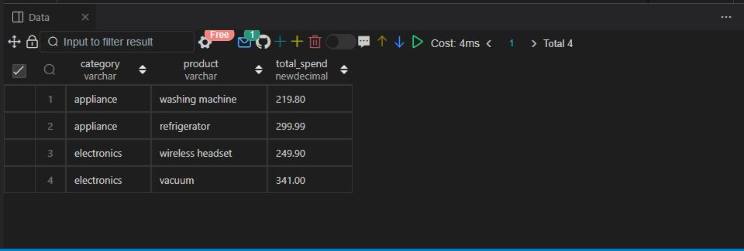

Q.159 Facebook is analysing its user signup data for June 2022.

Write a query to generate the churn rate by week in June 2022.

Output the week number (1, 2, 3, 4, ...) and the corresponding

churn rate rounded to 2 decimal places.

CREATE TABLE users(

user_id INT,

signup_date DATETIME,

last_login DATETIME

);

INSERT INTO users VALUES

(1001,'2022-06-01 12:00:00','2022-07-05 12:00:00'),

(1002,'2022-06-03 12:00:00','2022-06-15 12:00:00'),

(1004,'2022-06-02 12:00:00','2022-06-15 12:00:00'),

(1006,'2022-06-15 12:00:00','2022-06-27 12:00:00'),

(1012,'2022-06-16 12:00:00','2022-07-22 12:00:00');

-- Approach 1

WITH temp_churn_rate AS (

SELECT

user_id,

signup_date,

last_login,

DATEDIFF(last_login, signup_date) diff,

EXTRACT(WEEK FROM signup_date) AS week_no,

WEEK(signup_date,5) - WEEK(DATE_SUB(signup_date, INTERVAL DAYOFMONTH(signup_date)-1 DAY),5)+1 AS ranking

FROM

users

WHERE

EXTRACT(MONTH FROM signup_date) = 6

AND

EXTRACT(YEAR FROM signup_date) = 2022

),

temp_churn_rate2 AS (

SELECT

ranking,

COUNT(ranking) AS total_users,

COUNT(

CASE

WHEN diff <= 28 THEN 1

END

) AS total_churns

FROM

temp_churn_rate

GROUP BY

ranking

)

SELECT

ranking AS week,

ROUND((total_churns/total_users) * 100 ,2) AS churn_rate

FROM

temp_churn_rate2

ORDER BY

ranking;

-- Approach 2

WITH temp_churn_rate AS (

SELECT

user_id,

signup_date,

last_login,

DATEDIFF(last_login, signup_date) diff,

EXTRACT(WEEK FROM signup_date) AS week_no,

DENSE_RANK() OVER(ORDER BY EXTRACT(WEEK FROM signup_date)) ranking

FROM

users

WHERE

EXTRACT(MONTH FROM signup_date) = 6

AND

EXTRACT(YEAR FROM signup_date) = 2022

),

temp_churn_rate2 AS (

SELECT

ranking,

COUNT(ranking) AS total_users,

COUNT(

CASE

WHEN diff <= 28 THEN 1

END

) AS total_churns

FROM

temp_churn_rate

GROUP BY

ranking

)

SELECT

ranking AS week,

ROUND((total_churns/total_users) * 100 ,2) AS churn_rate

FROM

temp_churn_rate2

ORDER BY

ranking;

Select * from users;

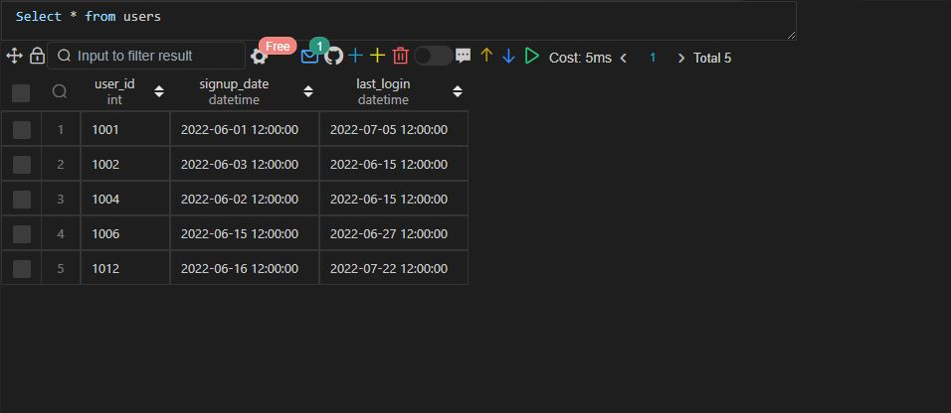

Approach 1

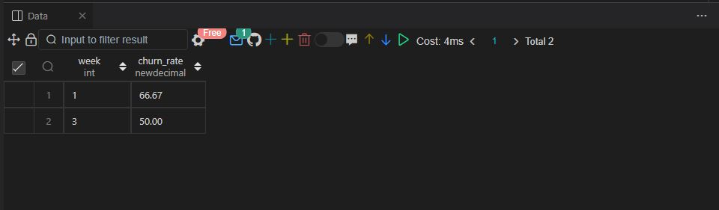

Approach 2

